ASSIGNMENT 4
Megan Holford
2020-09-28

Markdown Basics

## Favorite Foods
1.Pot Roast
2.Ice Cream
3.Tomatoes

## Images
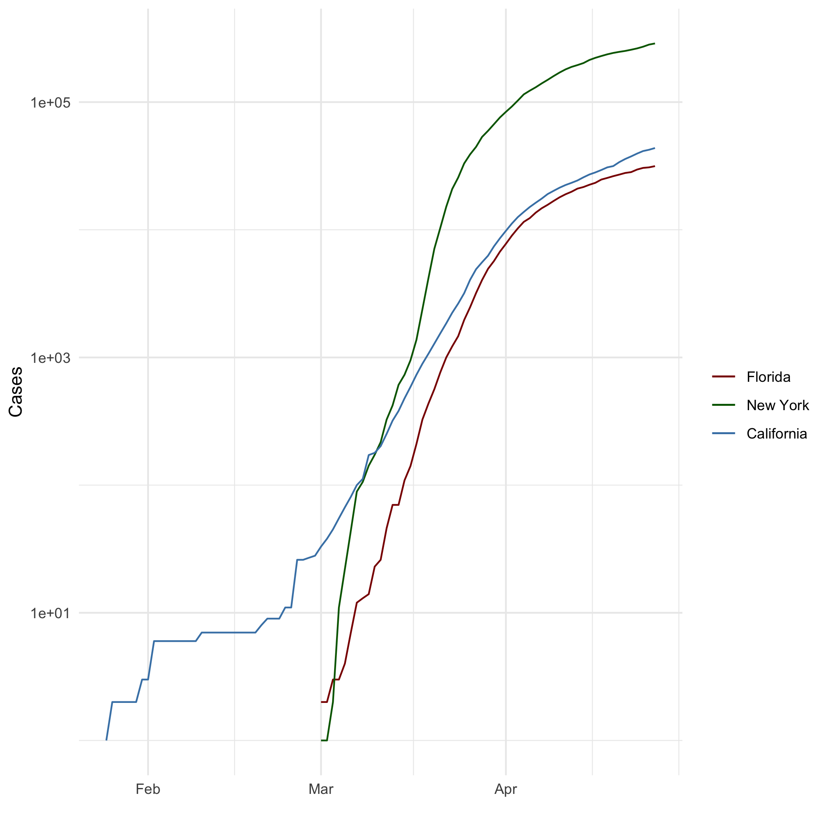
All Cases (Log Plot)

## Add a Quote
The way to get started is to quit talking and begin doing. -Walt Disney

## Add an Equation
$$E=mc^{2}$$

## Add a Footnote
This is a footnote

## Add Citations
- R for Everyone (Lander 2014)
- Discovering Statistics Using R (Field, Miles, and Field 2012)

# Inline Code

## NY Times COVID-19 Data
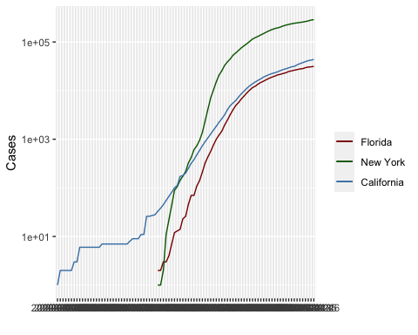

## R4DS Height vs Earnings
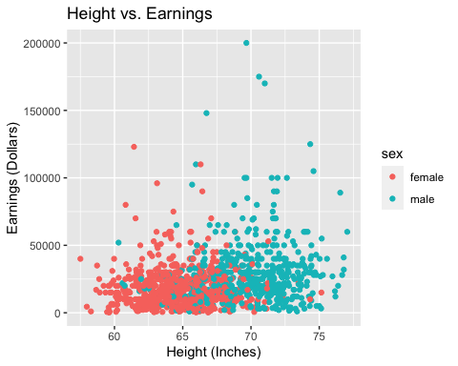

# Tables

## Knitr Table with Kable
One Ring to Rule Them All
name | race | in_fellowship | ring_bearer | age
Aragon | Men | TRUE | FALSE | 88
Bilbo | Hobbit | FALSE | TRUE | 129
Frodo | Hobbit | TRUE | TRUE | 51
Galadriel | Elf | FALSE | FALSE | 7000
Sam | Hobbit | TRUE | TRUE | 36
Gandalf | Maia | TRUE | TRUE | 2019
Legolas | Elf | TRUE | FALSE | 2931
Sauron | Maia | FALSE | TRUE | 7052
Gollum | Hobbit | FALSE | TRUE | 589

## Pandoc Table
Name Race In Fellowship? Is Ring Bearer? Age _________ ________ __________________ ___________________ ______ Aragon Men True False 88 Bilbo Hobbit False True 129 Frodo Hobbit True True 51 Sam Hobbit True True 36 Sauron Maia False True 7052 _________ ________ __________________ ___________________ ______

References
Field, A., J. Miles, and Z. Field. 2012. Discovering Statistics Using R. SAGE Publications. https://books.google.com/books?id=wd2K2zC3swIC.
Lander, J. P. 2014. R for Everyone: Advanced Analytics and Graphics. Addison-Wesley Data and Analytics Series. Addison-Wesley. https://books.google.com/books?id=3eBVAgAAQBAJ.

The footnote.

