Q8(b)

No, because the minimum of buffer space (receiver window) shown at gaia.cs.umass.edu for entire trace is 29200 bytes which shows the first acknowledgment from server. The sender is never throttled due to lacking of receiver buffer by inspecting this trace.

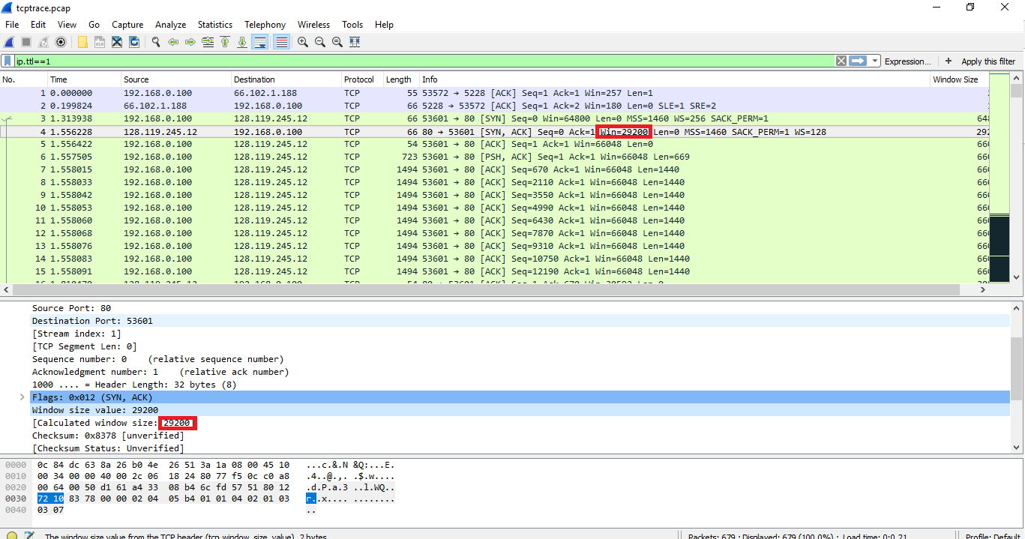

**Figure 1: TCP-Trace**

Q9

There are no retransmitted segments in the trace file. We can check this by looking at the sequence numbers of the TCP segments in the trace file. In the Time-Sequence-Graph(Stevens) of this trace. All sequence numbers from source IP 196.168.0.100 to destination IP 128.119.245.12 are in an increasing manner with respect to time. If any of retransmitted segments would be shown, they should be smaller than those of its neighboring segments.

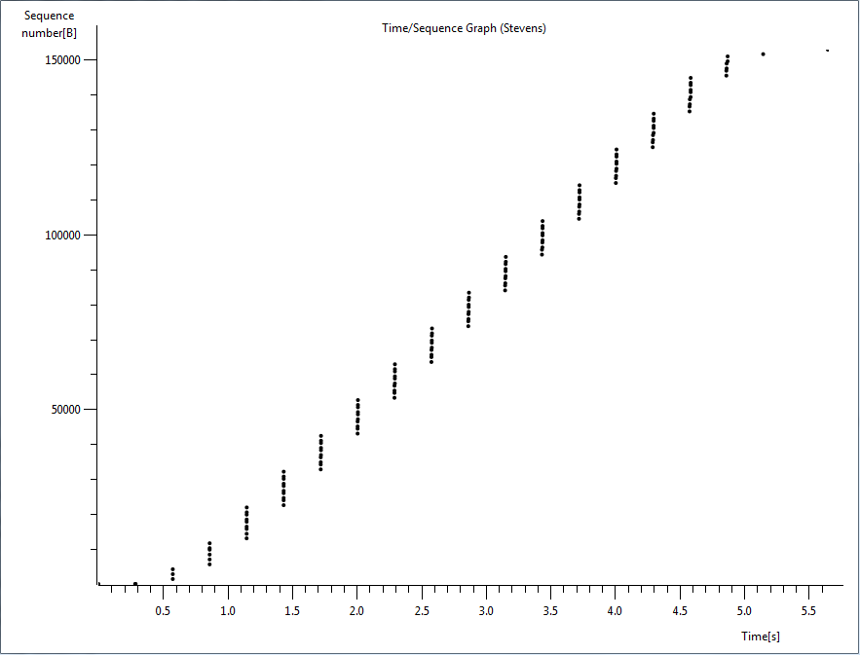

**Figure 2: TCP Graph: tcp-wifi-trace-196.168.0.100->128.119.245.12**

Q13

No, the IP datagram has not been fragmented. This is determined by looking at fragment offset if it’s equal to 0 then no if equal to 1 then yes in our trace it is 0 hence data is not fragmented.

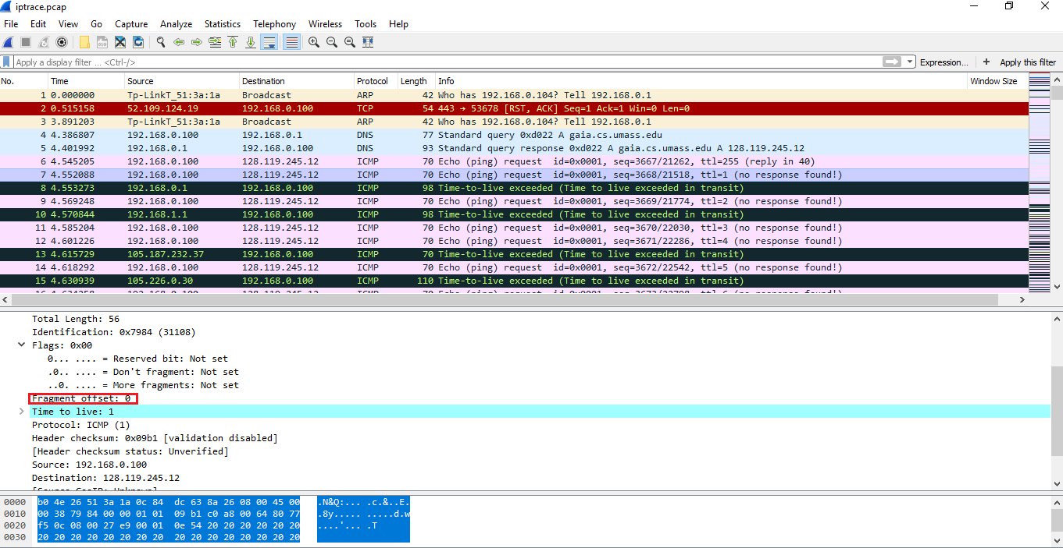

Q14

Header bytes: 20 (as seen in screenshot)

Payload bytes: 36 (total length 56 minus the header bytes = 36)

Q15

The identification field is increasing always (IP packets must have different Ids)

Time to live is also increasing (traceroute increments each subsequent packet)

Header checksum (since header changes, so must checksum)

Q16

The fields that stay constant across the IP datagrams are:

• Version (since we are using IPv4 for all packets)

• header length (since these are ICMP packets)

• source IP (since we are sending from the same source)

• destination IP (since we are sending to the same destination)

• Differentiated Services (since all packets are ICMP they use the same

Type of Service class)

• Upper Layer Protocol (since these are ICMP packets)

The fields that must stay constant are:

• Version (since we are using IPv4 for all packets)

• header length (since these are ICMP packets)

• source IP (since we are sending from the same source)

• destination IP (since we are sending to the same destination)

• Differentiated Services (since all packets are ICMP they use the same

Type of Service class)

• Upper Layer Protocol (since these are ICMP packets)

The fields that must change are:

• Identification (IP packets must have different ids)

• Time to live (traceroute increments each subsequent packet)

• Header checksum (since header changes, so must checksum)

Q17

The noticeable conjecture is that the IP header identity fields increment with each ICMP Echo request.

Q17

These information in the IP field screenshot shows it below

Identification: 20619

TTL: 64

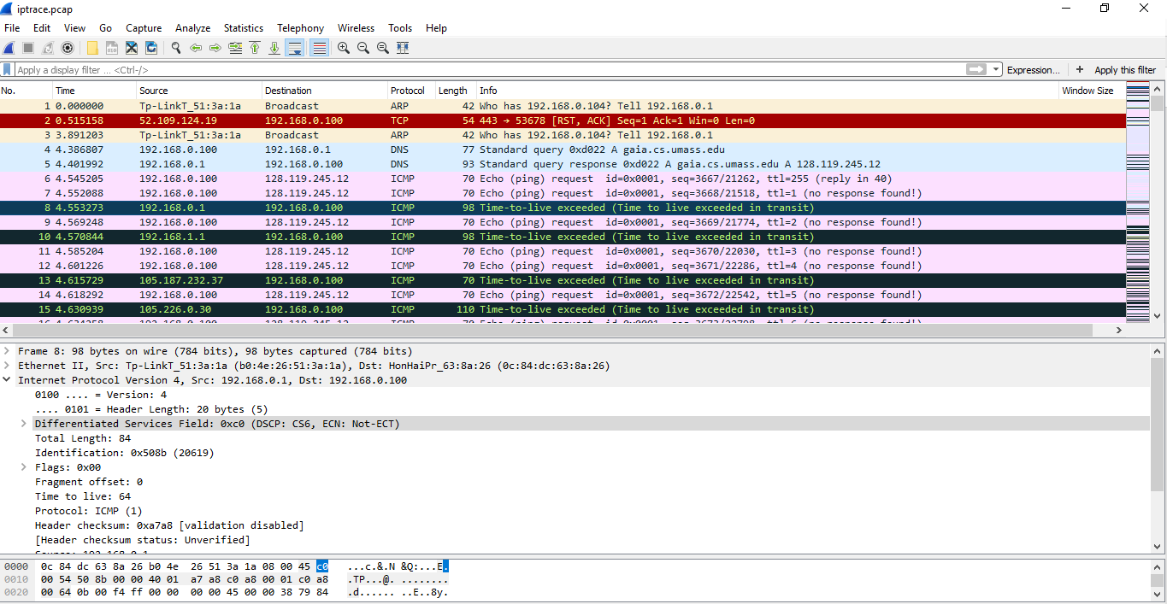

Q18

The identification field changes for all the ICMP TTL-exceed replies because identification field should be a unique value. When two or more datagrams have the same identification value, then it means these IP datagrams are fragments of a single large IP datagram. The TTL field remains unchanged because the TTL for the first hop router is always the same.