# ECU1 Dynamic Design

## Draw a state machine diagram for each ECU component

There are mainly three ECU components: Light Switch and door sensor, speed sensor. The light switch and door sensor have the same debouncing state machine, so they inherit it from the switch state machine.

### The switch state machine

The idea of the state machine is to double check the switch to make sure that’s pressed/released.

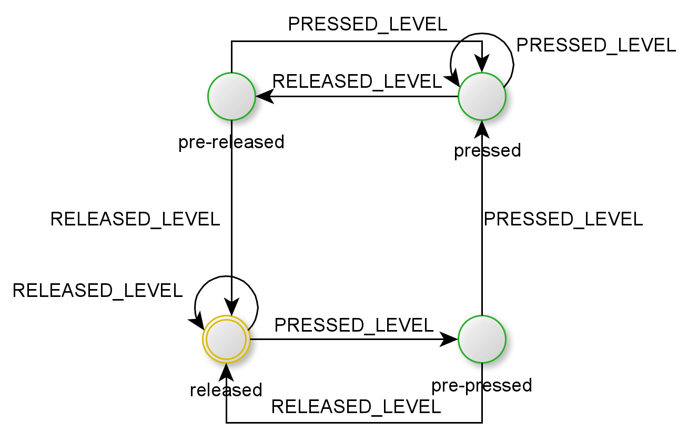

Figure Switch state machine

### The speedometer

Finding the period can be done by calculating the time between two rising edges. Each rising edge is an internal state machine at its own.

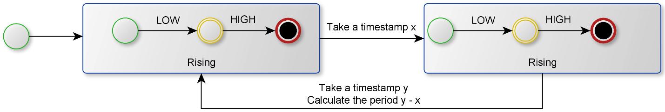

Figure The Speedometer Time measurement State Machine

## Draw a state machine diagram for the ECU operation

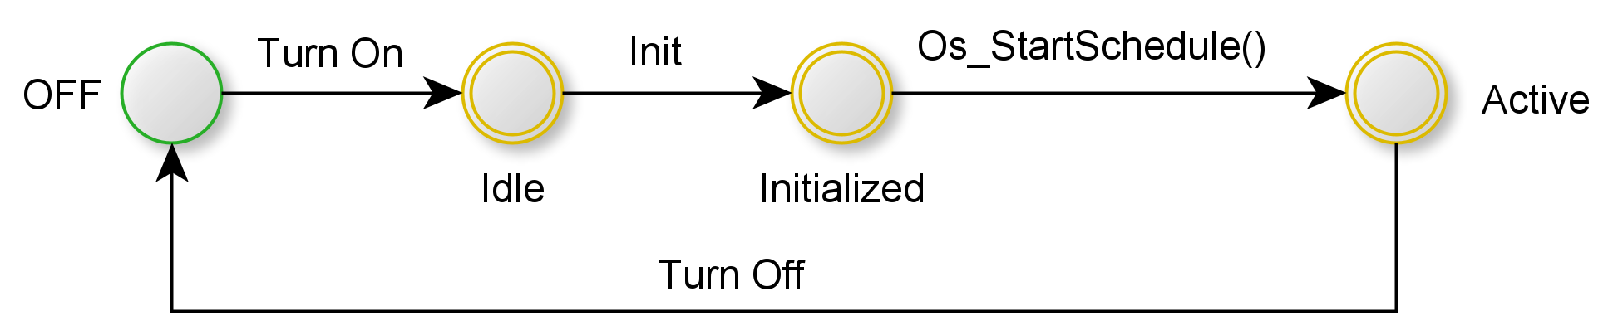

Figure ECU1 State Machine

## Draw the sequence diagram for the ECU

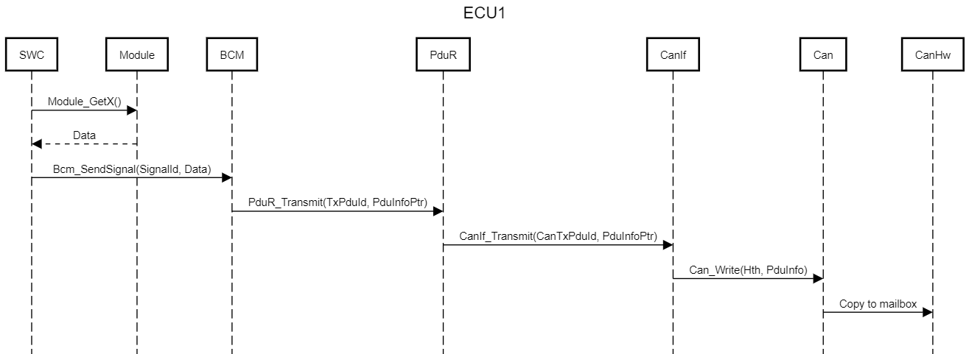

Figure : Sequence Diagram for ECU1

## Calculate CPU load for the ECU

The following table contains the execution time for non-IO tasks. The execution time is to be assumed.

|  |  |  |
| --- | --- | --- |
| Task | Execution time in ms | Period in ms |
| Speedometer_Update() | 2 | 10 |
| DoorStatus_Update() | 1 | 10 |
| LightStatus_Update() | 1 | 20 |
| SpeedStatus_Update() | 1 | 5 |

The CPU load:

$$\sum_{i=1}^{n=4}{\frac{e_{i}}{p_{i}}}=\frac{2}{10}+\frac{1}{10}+\frac{1}{20}+\frac{1}{5}=0.55$$

# ECU2 Dynamic Design

## Draw a state machine diagram for each ECU component

There are mainly two ECU components: Light and buzzer controllers.

### The light controller state machine

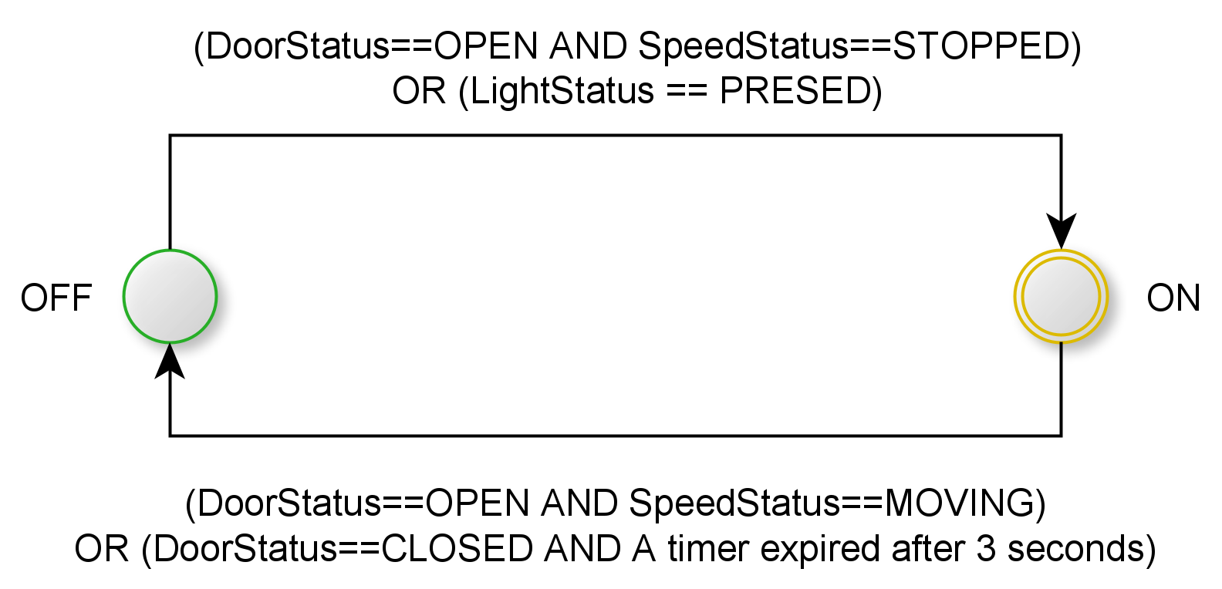

Figure Light controller state machine

### The Buzzer Controller state machine

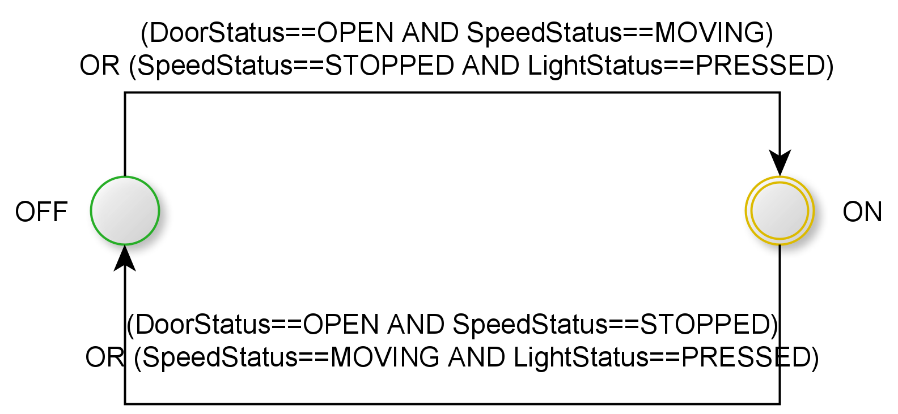

Figure Buzzer State Machine

## Draw a state machine diagram for the ECU operation



Figure ECU2 State Machine

## Draw the sequence diagram for the ECU

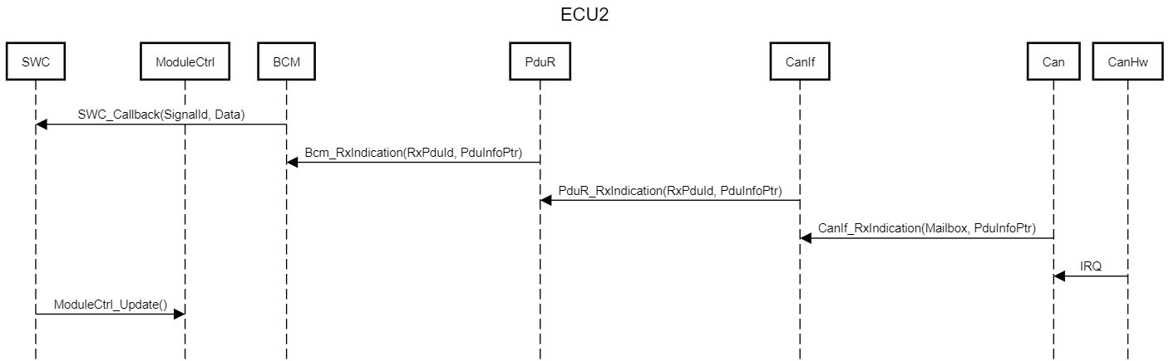

Figure : Sequence Diagram for ECU2

## Calculate CPU load for the ECU

The following table contains the execution time for non-IO tasks. The execution time is to be assumed.

|  |  |  |
| --- | --- | --- |
| Task | Execution time in ms | Period in ms |
| BuzzerCtrl_Update() | 1 | 10 |
| LightCtrl_Update() | 1 | 10 |

The CPU load:

$$\sum_{i=1}^{n=4}{\frac{e_{i}}{p_{i}}}=\frac{1}{10}+\frac{1}{10}=0.2$$