Project Proposal

For

Elevate

Instructor: | Professor Bruce Char
Team Members: | Jake Rauchen, Kevin Tayah, Matthew Horger
Cycle: | 1
Date Submitted: | 2/5/2017

Document template copyright 2015, CCI Faculty, Version 2.0. Use permitted under Creative Commons license CC-BY-NC-SA. See http://creativecommons.org/licenses/by-nc-sa/3.0/

Grading Rubric – Project Proposal

This rubric outlines the grading criteria for this document. Note that the criteria represent a plan for grading. Change is possible, especially given the dynamic nature of this course. Any change will be applied consistently for the entire class.

Achievement | Minimal | Exemplary | Pts | Score
Content | Section(s) missing, not useful, inconsistent, or wrong. | Provides all relevant information correctly and with appropriate detail
Project |  |  | 30
Team |  |  | 10
Timeline |  |  | 30
Grammar and Spelling | Many serious mistakes in grammar or spelling | Grammar, punctuation, and spelling all correct | 10
Expression | Hard to follow or poor word choices | Clear and concise. A pleasure to read | 10
Tone | Tone not appropriate for technical writing | Tone is consistently professional
Organization | Information difficult to locate | All information is easy to find and important points stand out | 10
Layout | Layout is inconsistent, visually distracting, or hinders use | Layout is attractive, consistent, and helps guide the reader
Late Submission
Total |  |  | 100

Project Proposal

This report documents the initial definition of the project. It includes an abstract and project overview. It also includes a summary of issues related to the project and to the team.

Project

Project Name: Elevate

Abstract
This project will develop a modular helmet that allows users to detect blind spots, record collisions, and monitor GPS coordinates and features to track their rides. The helmet will be developed with an Arduino Nano processor (the heart of our modules), HC-SR04 ultrasonic modules to detect objects in blind spots, collision sensors to detect impacts, and a GPS breakout module; all powered by a 9v battery. The hardware portion of this project, which will not be challenging, will be accompanied by a mobile app (which will be challenging to develop), initially for the Android platform, that allows users to pinpoint specific routes with detailed elevation maps using Google’s JSON API’s. The purpose of this app is for users, such as skaters and cyclists, to initially test inspect their desired route to determine the rate of elevation change for their riding purposes, such as workout, coasting, etc. This initial testing phase will be free for users. However, this project could be potentially sold to skating and racing companies to increase the safety of the participants. It could also be sold to supply companies to increase the demand of these custom designed helmets. The app, upon commercialization, could also be downloaded for free by multitudes of recreational riders who look to plan and enhance their ride per how they would like their ride to be.

Project Deliverables

With this product, we will be able to enhance the user’s non-automotive experience whether the user is using a bike, longboard, or any other type of non-vehicular transportation device. The app itself will give the rider a way to get from point A to point B with minimal time, not based on the shortest distance from A to B, but finding the most downhill route increasing time and decreasing effort spent on the rider. This in turn gives the rider a better commuting experience.

Alongside this application, a separate helmet will be available for consumers either from the professional or recreational market. This helmet will warn the user of any potential dangers for the user’s safety from any of the user’s blind spots. These combined can be used in a professional scene to allow professionals to get from point A to point B quickly, non-strenuously and safely.

Resources
- Arduino Nano Microprocessor
- HC-SR04 module to detect objects in blind spots
- GPS Breakout Module

Expertise
- Google API

Google API will be learned over time through Google’s free tutorials on Google’s website: https://developers.google.com/maps/documentation/android-api/start
- Android Studio

Android Studio will be downloaded by all team members and learned through tutorials found on: https://www.tutorialspoint.com/android/android_studio.htm
- Graphic Design
- C++

All members of the team are currently learning C++ through university classes and will have necessary skills to complete parts of product that will require C++.

Team

Team Members and Roles

Figure 1, below, identifies all the team members and the initial role assigned to each person.
Name | Role
Jake Rauchen | Business Developer and Lead Design
Kevin Tayah | Software Developer and Tester
Matthew Horger | Lead Hardware Developer
Figure 1 - Team Members and Roles

Timeline

The figure below shows the initially identified set of activities for this cycle.

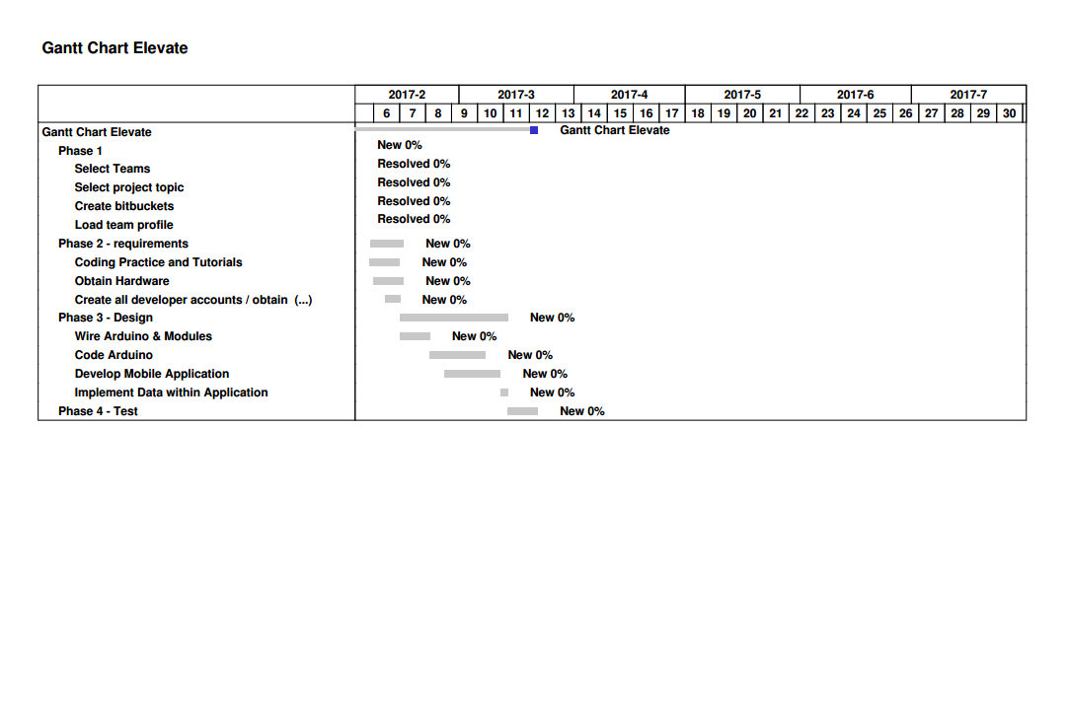

Figure 2 – Project Timeline

