*Automotive Door Control System*

Dynamic Design

Owner: Mohamed Hossam , Email: [mohamed.hossam.1183@gmail.com](mailto:mohamed.hossam.1183@gmail.com)

# ECU_1

## ECU State Machine Diagram

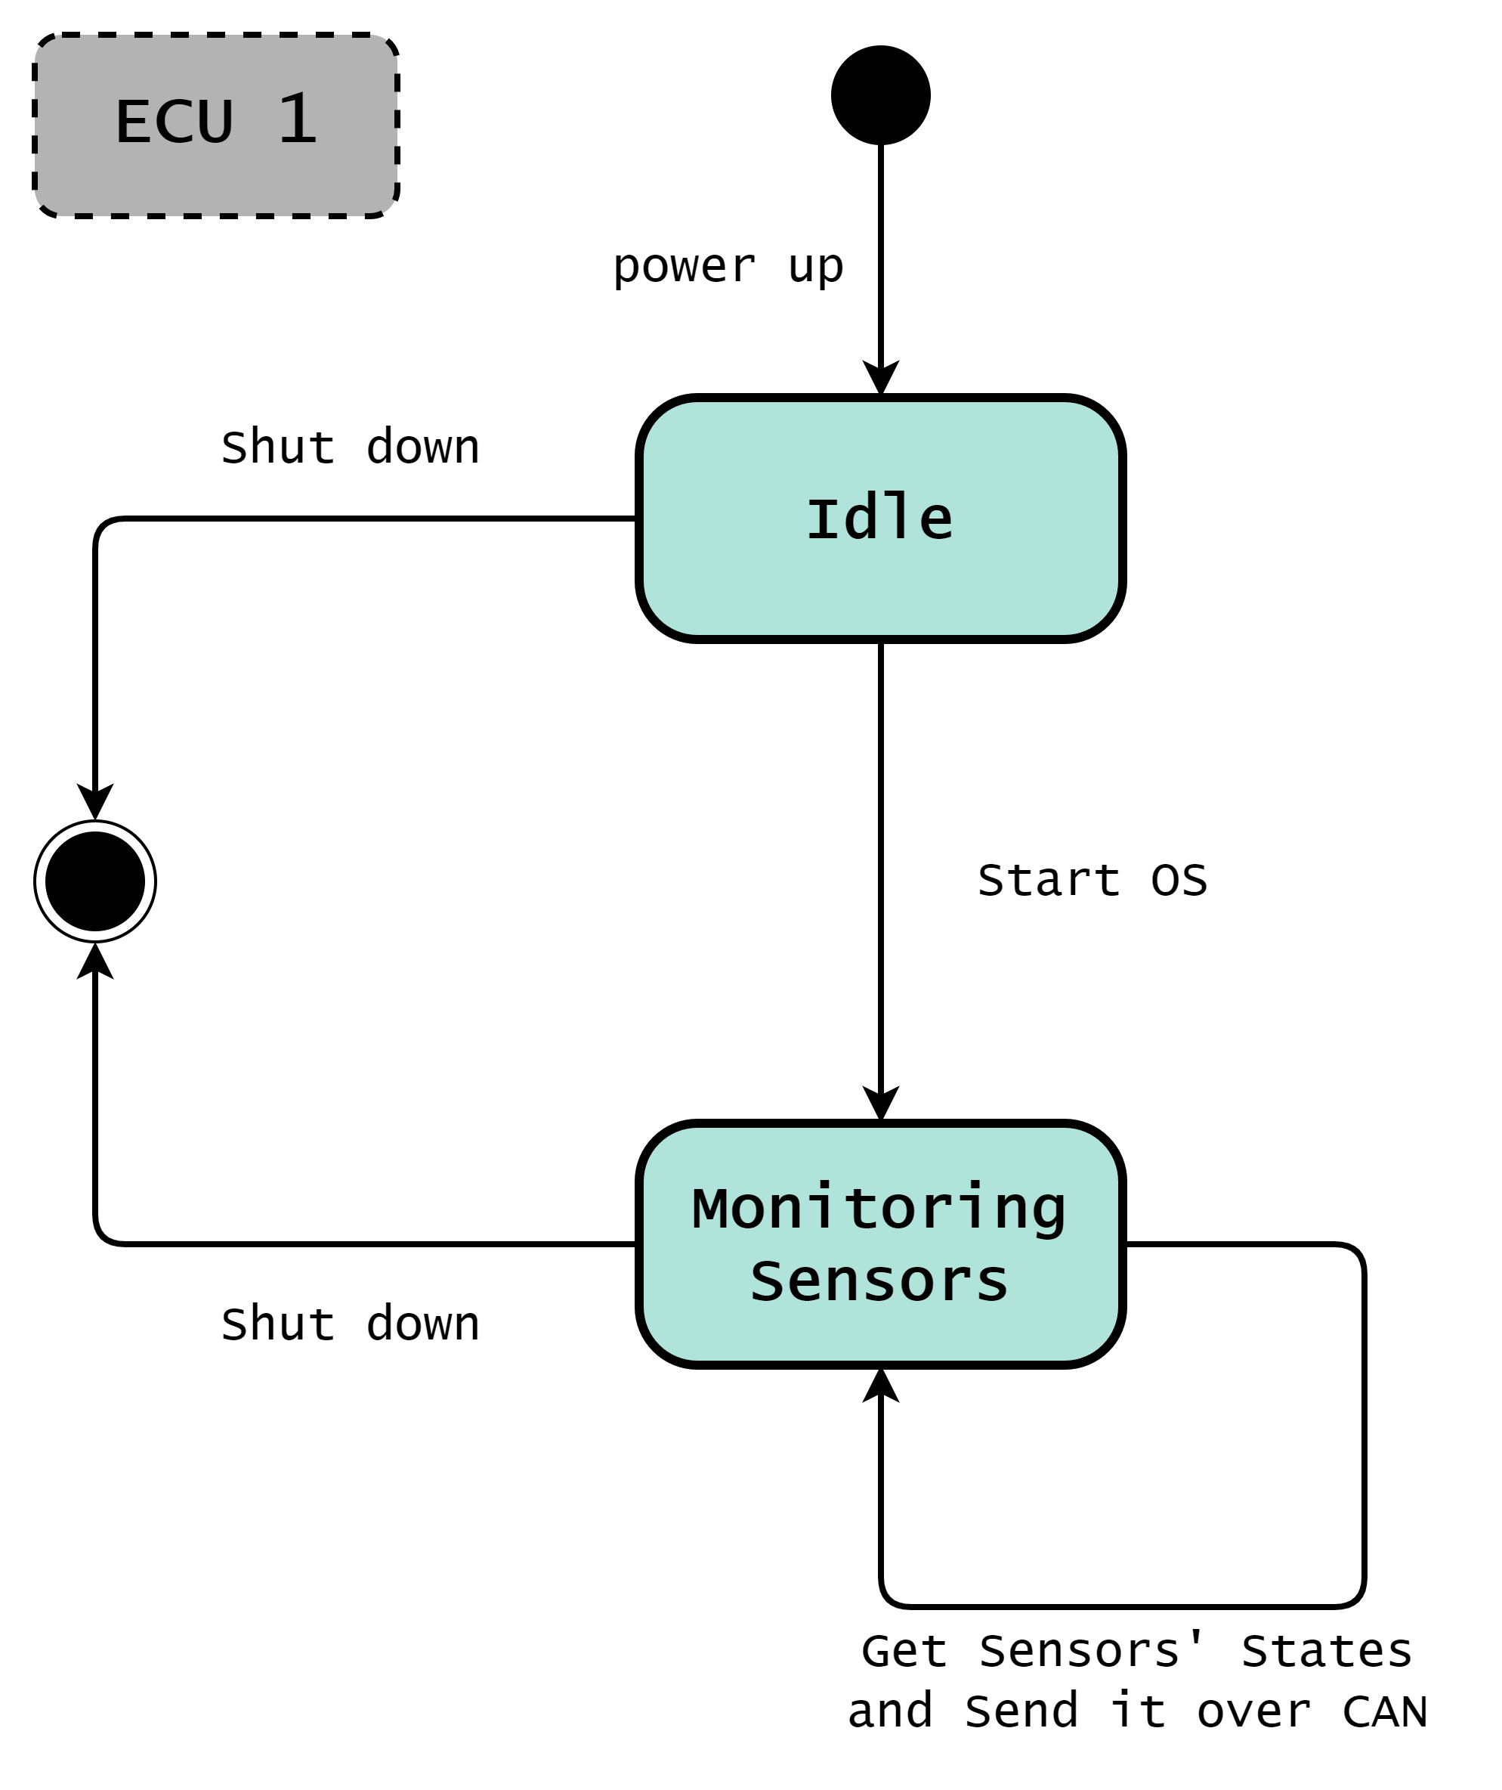

## ECU Sequence Diagram

See “Raw_Diagrams” folder for high resolution image.



## CPU Load

* WCET (worst case execution time) analysis:  
  utilization factor of one frame = execution time * frequency = execution time / Period  
  CPU Load = summation of utilization factor for all tasks
* Door state message will be sent by ECU_1 every **10 ms** to ECU_2.
* Light switch state message will be sent by ECU_1 every **20 ms** to ECU_2.
* Speed state message will be sent by ECU_1 every **5 ms** to ECU_2.
* In ECU 1, assuming tasks required to periodically send CAN status frames are identical,  
  & also assuming to have an execution time of (**1 ms**).
* CPU Load for ECU 1 =  
  ( 1 / 10 ) + ( 1 / 20 ) + ( 1 / 5 ) = **0.35** = **35 %**

## ECU Components State Machine Diagrams

* ( OS - BCM - VIM - DS_drv - LS_drv - SS_drv - GPIO - CAN_If - CAN_drv )  
    
  Diagrams collected inside “ECU_1_Components_State_Diagrams” folder.

# ECU_2

## ECU State Machine

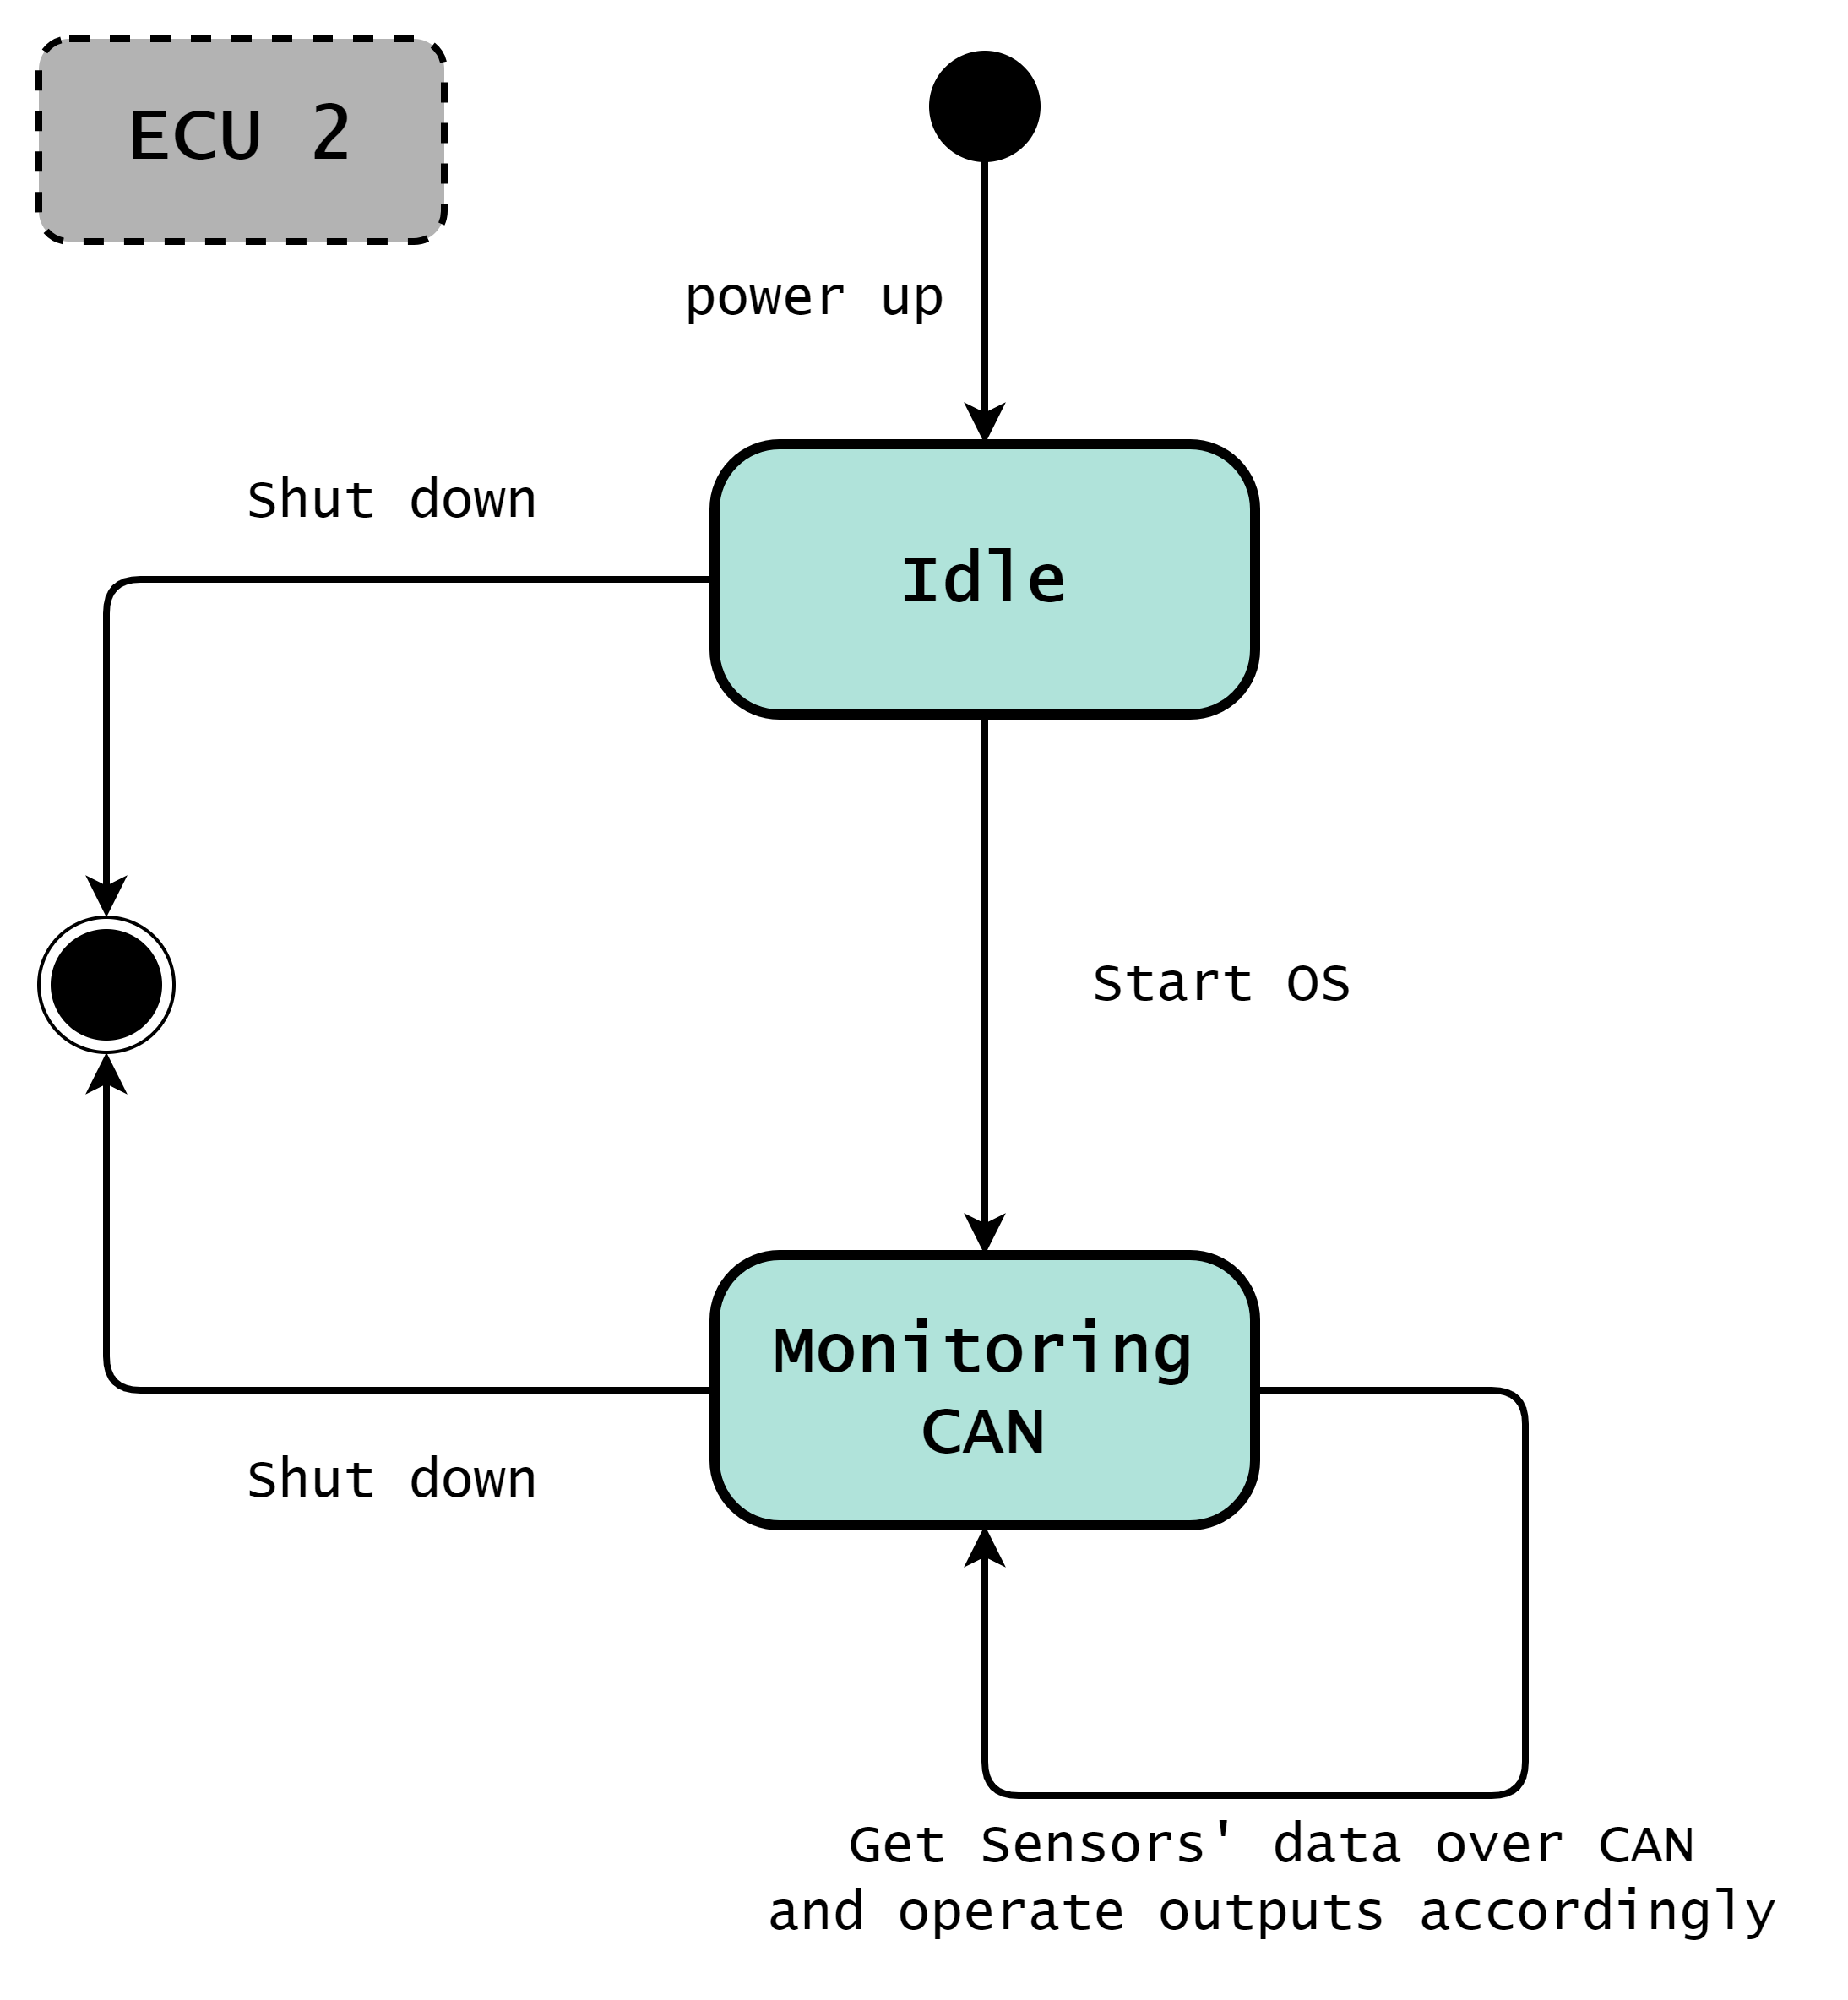

## ECU Sequence Diagram

See “Raw_Diagrams” folder for high resolution image.



## CPU Load

* WCET (worst case execution time) analysis:  
  utilization factor of one frame = execution time * frequency = execution time / Period  
  CPU Load = summation of utilization factor for all tasks
* In ECU 2, assuming tasks required to periodically receive CAN status frames are identical,  
  & also assuming to have an execution time of (**1 ms**).
* ECU_2 has a periodic task to call the "VIO_Main" API to evaluate sensor values and operate warnings accordingly.  
  This task is called every (**5 ms**)
* And Assuming the task, required to call the "VIO_Main" API, has an execution time of (**2 ms**).
* CPU Load for ECU 2 =  
  ( 1 / 10 ) + ( 1 / 20 ) + ( 1 / 5 ) + ( 2 / 5 ) = **0.75** = **75 %**

## ECU Components State Machine Diagrams

* ( OS - BCM - VIO - Bz_drv - Li_drv - GPIO - CAN_If - CAN_drv )  
    
  Diagrams collected inside “ECU_2_Components_State_Diagrams” folder.

## VIO_Main function Flowchart

Periodically evaluate sensor values and operate warnings accordingly.

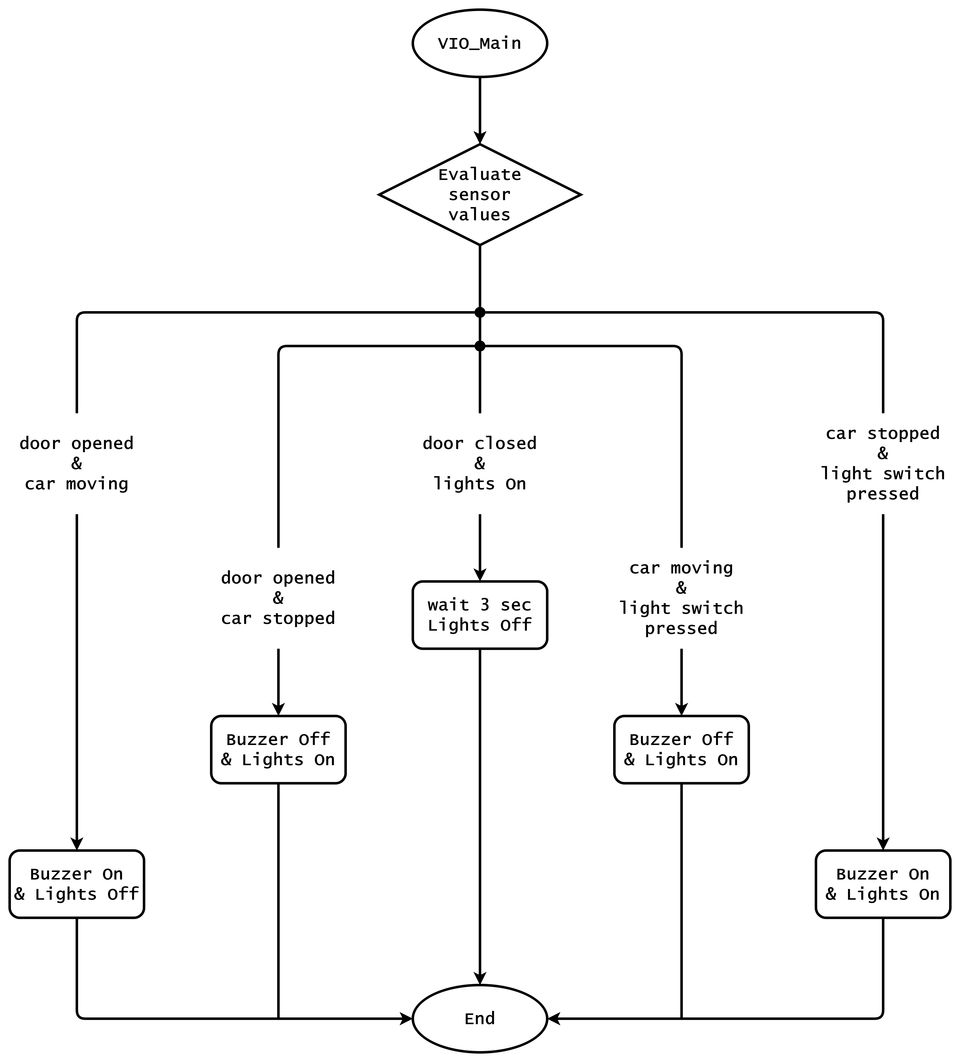

# CAN Bus Load

* Regarding CAN bus load calculation, assuming “standard CAN” frame consist of below fields:  
    
  - Start-of-frame (1 bits): Denotes the start of frame transmission  
    
  - Identifier (11 bits): unique identifier, also represents message priority  
    
  - Remote transmission request (RTR) (1 bits): dominant (0) for data frames, and recessive (1) for request frames.  
    
  - Identifier extension bit (IDE) (1 bits): It indicates standard CAN frame is being transmitted with no extension.  
    
  - Reserved bit (r0) (1 bits): Must be dominant (0).  
    
  - Data length code (DLC) (4 bits): Number of bytes of data (0–8 bytes)  
    
  - Data field (red) (0-64 bits): Data to be transmitted.  
    
  - CRC (15 bits): Cyclic redundancy check  
    
  - Bit stuffing is possible in some of the above fields around (18 bits) in the worst case.  
    
  - CRC delimiter (1 bits): Must be recessive (1)  
    
  - ACK slot (1 bits): Transmitter sends recessive (1) and any receiver can assert a dominant (0)  
    
  - ACK delimiter (1 bits): Must be recessive (1)  
    
  - End-of-frame (EOF) (7 bits): Must be recessive (1)  
    
  - Inter-frame spacing (IFS) (3 bits): Must be recessive (1)
* So 1 CAN frame contains approximately **125 bit**.  
    
  Assuming we are using **500 kBit/s** bit rate.  
    
  bit time = 1 / bit rate = 1 / (500 * 1000) s = **0.002 ms**  
    
  This means 1 bit will take 0.002 ms to transfer on bus when using 500 kBit/s.  
    
  So the time to transfer 1 frame carrying 125 bits is (0.002 ms/bit * 125 bit) = **0.25 ms**.
* Door state message will be sent every 10ms.  
  Light switch state message will be sent every 20ms.  
  Speed state message will be sent every 5ms.  
    
  Assuming all 3 frames are identical  
  i.e same transmission time (0.25 ms).
* WCET (worst case execution time) analysis:  
  utilization factor of one frame = transmission time * frequency = transmission time / Period
* Bus Load = summation of utilization factor for all frames =  
  ( 0.25 / 10 ) + ( 0.25 / 20 ) + ( 0.25 / 5 ) = **0.0875** = **8.75 %**