Howard-Exercise-3.2-NodeSecuirty

1. A User can have Many Link_User_Role
2. Many Link_User_Roles can be associated to One Role
3. One Role can have Many Link_User_Permissions
4. 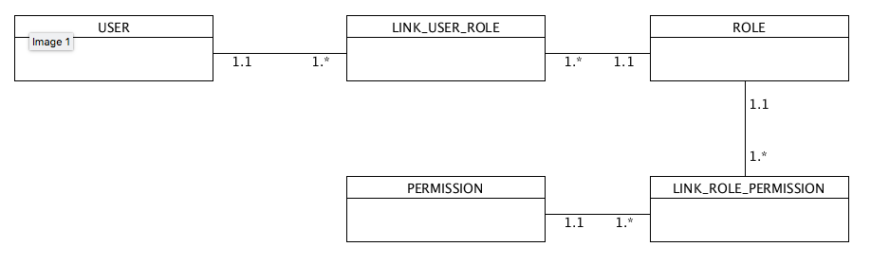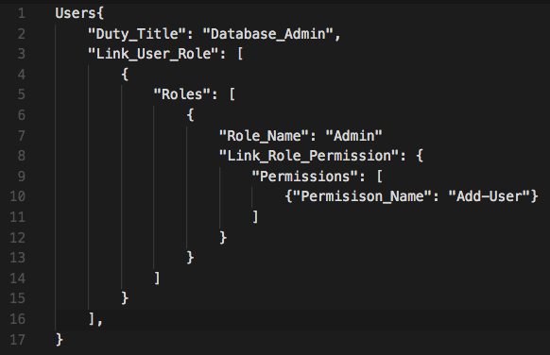Many Link_Role_Permission can be assigned to One Permission