Howard-Exercise-3.3-NodeBookCo-19-May-2018

|  |  |  |  |  |  |  |  |  |  |
| --- | --- | --- | --- | --- | --- | --- | --- | --- | --- |
| Publisher_name | Book_name | Author_Phone1  Author_Phone2 | Publisher_code | Book_Price1  Book_Price2 | Author_Email1  Author_Emal2 | Publisher_Address | Author_Frist_Name | Author_Last_Name | Book_ISBN |

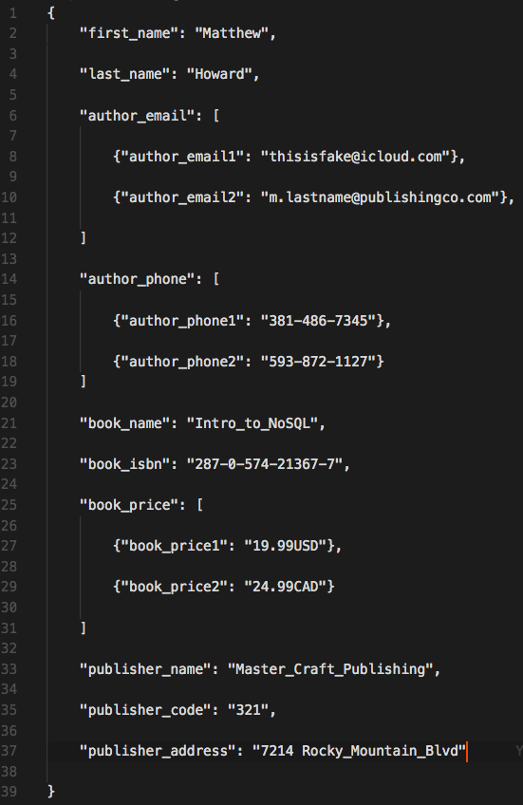

A book can have only one publisher

A publisher can publish many books

A publisher can have only one publisher code

A publisher can have only one address

A book can have only one ISBN

A book can have only one name

A book can have many prices

A book can have multiple authors

An author has only one first name

An author has only one last name

An author can have multiple phone numbers

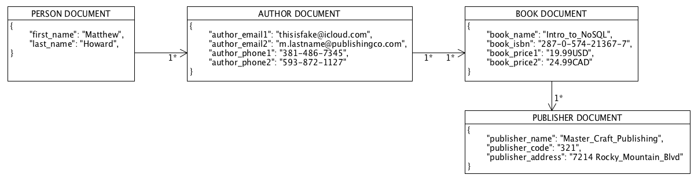An author can have multiple email addresses