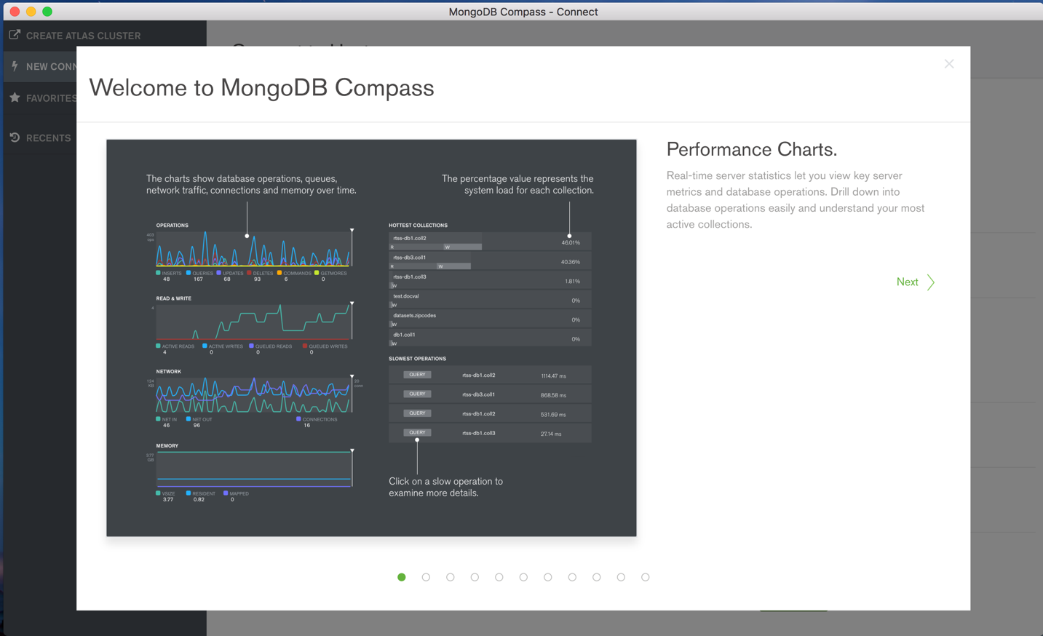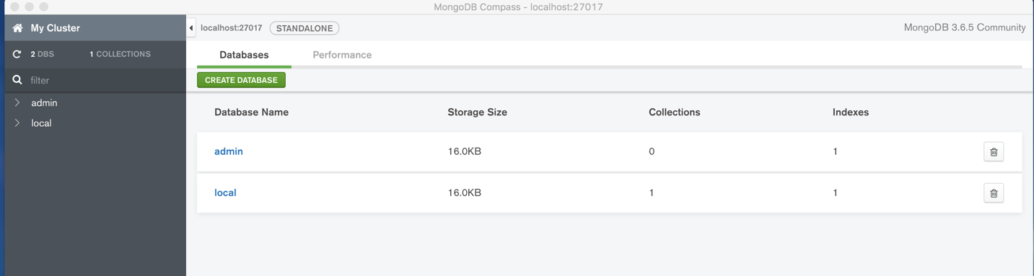Howard-exercise-4.2-24May18