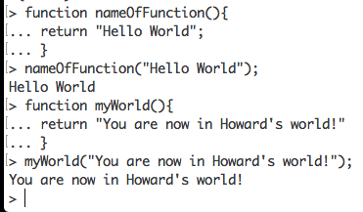Howard-Exercise-4.3-27May18