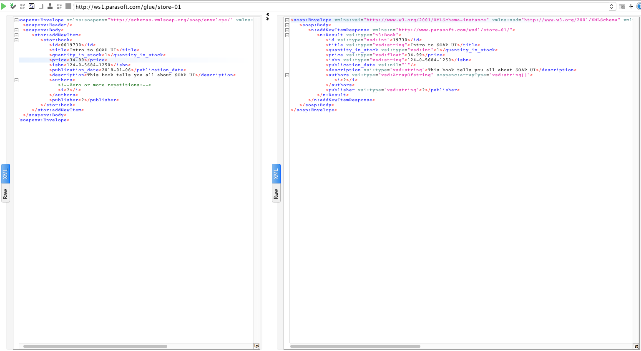Howard-exercise-5.2-1Jun18