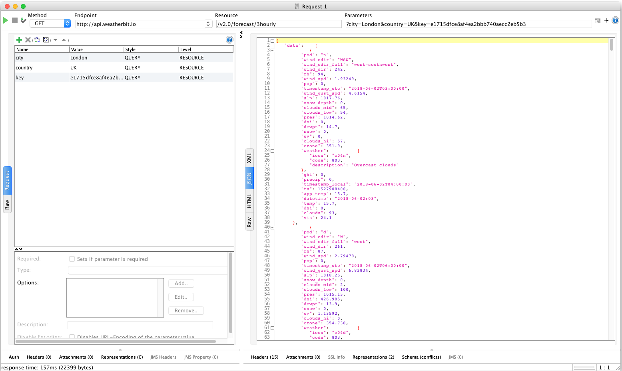Howard-Exercise-5.3-1Jun18