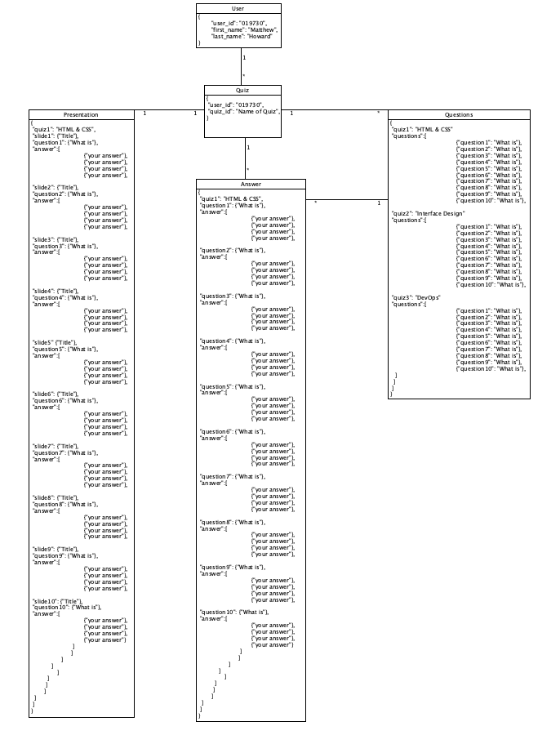

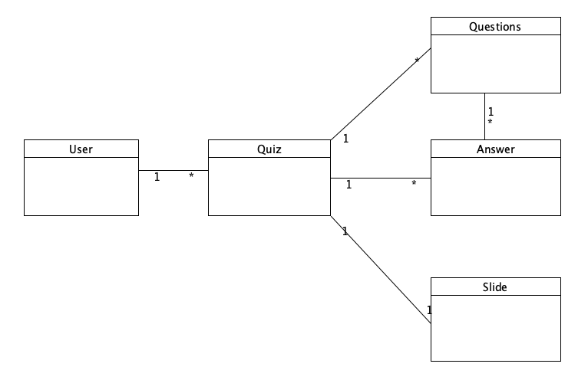JSON NoSQL Data Structure is located in the Week-2 folder of my GitHub repository.