Bob’s Computer Repair Shop

Technical Design Document (TDD)

By

Matthew Howard & William Simpson

WEB 450

Prof. Richard Krasso

Bellevue University

1. Introduction
   1. Purpose

The purpose of the project is to develop an end-to-end computer repair commerce site for Bob’s Computer Repair Shop. Utilizing an Angular based front-end environment to develop an easy to use interface for their employees, administrators and owners, combined with a streamlined Node.js and Express back-end and server management to create a self-contained system of that will allow account creation for customers, account management privileges for admins and employees, account recovery capabilities, and custom error management. It will also enable customers to select services they desire, and receive custom invoices. It will also provide employees and owners with product statistics and other invoice pages. Our design will incorporate the best development concepts to ensure a standardized and well thought out project that will persist with minimal management and will be able to have new products added to it.

* 1. Terminology

Angular- A JavaScript based framework and coding language used to create user interfaces and control the front-end logic of the website.

Node.js- A server environment which uses the JavaScript language to enable database management for the back-end.

Express- A framework that sits on top of Node.js making it easier to use and adding more features.

Front-end- Any part of the site that would be “facing” the user, and that the user would interact with, e.g. log in screens and clickable menus.

Back-end- Any part of the site that pulls or stores information inside of the database that is then presented by the Front-end.

* 1. User Personas

See next page.

**Michael | Computer Repair Technician**



Profile Attributes  
Age: 25  
Experience: 10 years  
Personal details: Single, 0 kids  
Computer Skill Level: Advanced  
Personality: Family-oriented, Funny

Profile: Michael is a computer repair technician. He is single, has no children and lives alone.

Michael is a new full-time computer repair technician, though he’s been doing it for years as a hobby. When Michael was a teenager, his mother would bring home old PCs from her office and give them to him to take apart. This really piqued his interest in the innerworkings of computers. Since the age of 16, he’s built his own gaming PCs. He enjoys the complexity of how a few silicon components can make a machine work the way computers work. He also enjoys adjusting the clock speed on his processors and pushing his systems to their limit.

Michael uses the computer for everyday use as well as gaming. He holds a Bachelor’s degree in Information Management Systems. After college, he worked on getting his certificates. He holds certificates in CompTIA A+, Apple Certified Macintosh Technician (ACMT), Cisco Certified Technician (CCT), and Windows Hardware Certification.

Michael is a healthy, active man, who eats like any regular 25-year old and exercises often. He runs about 15-miles, a week.

Features: The features that Michael would use most often are:

* Sign-in Page
* User Registration
* Service Repair Page
* Invoice Summary Page

The features the Michael would use the least are:

* Managing Users
* Log Files
* Statistics

Needs: Some needs that the application can meet for this persona are:

* Needs to be easy to use with quick navigation.

Key Drivers/Motivation: What drives Michael to be a computer repair technician, is the hands-on work he gets to have with the computer. He enjoys making something out of nothing and improving what is already there.

Validations: What validates Michael’s decision to use our app is its user-friendly interface and quick navigation options. He knows that he can get anywhere with just a few clicks and likes that he can get customers in and out.

**Amy | Sales Representative**

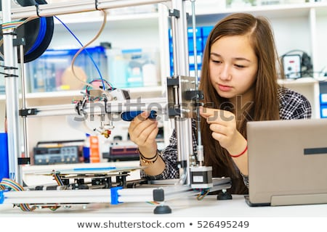

Profile Attributes  
Age: 17  
Experience: 2 years  
Personal details: Single  
Computer Skill Level: Novice  
Personality: Reserved, Great sense of humor, Studious

Profile: Amy is the oldest of 3 children. Though she is still in High School, she knows that she enjoys the working of a computer. She knows the very basics of computer repair and is looking to expand her skills. She’s working at Bob’s Computer Repair Shop as part of a High School Co-Op program where High School Seniors get Intern-like experience in learning a skill in exchange for High School Credit Hours.

Amy uses the web for home, personal use. She’s honed most of her skills through trial and error, and computer classes at school. Though she’s only working on the registers because she’s not certified, working at Bob’s Computer Repair Shop has taught her a lot and she now knows her passion and her focus when she goes off to college.

Features: The features that Amy would use most often are:

* Invoice Summary Page
* Service Repair Page
* Sign-in Page
* User Management Page

The features the Amy would use the least are:

* Logs Files
* Statistics Page

Needs: Some needs that the application can meet for this persona are:

* Recall previous orders and invoices.
* Easy navigation.

Key Drivers/Motivation: What drives Amy, is that she enjoys working with machines. She feels computer are a great tool to help make life easier and loves putting them together.

Validations: What validates Amy’s decision to use our app is the ease of use it offers. It’s a clean, well-designed app that allows the user to go anywhere they wish with a few clicks. It’s organized, well developed and offers everything she could need in one place.

**Ryan** **|** **Lead IT Systems Engineer**



Profile Attributes  
Age: 45  
Experience: 25 years  
Personal details: Married, 3 kids  
Computer Skill Level: Expert  
Personality: Funny, Practical, Kind

Profile: Ryan is a full-time, IT Systems Engineer. He’s been working in this field in various positions for 25 years and holds just about every certification there is. He’s a mentor to the younger workers and enjoys teaching them the ins and outs of computer repair.

Ryan uses the web for work and for personal use. When he’s not checking his email or playing games, he is keeping up-to-date with his many certifications. Though he enjoys hardware/software installation and troubleshooting, his real bread and butter is cyber security. Ryan is a certified cyber security expert and holds a Certified Information Systems Security Professional (CISSP). He mainly focuses on Malware Removal and re-imaging PCs

Ryan enjoys spending as much time with his family as possible. They often go on hikes and to the park. Ryan is fit and enjoys keeping fit. He’s adamant about exercise as it’s his main source to let out stress and re-focus.

Features: The features that Ryan would use most often are:

* Password Recovery Page
* Security Question Page
* User Management Page
* User Permissions

The features the Ryan would use the least are:

* Invoice Summary Page
* Service Repair Page

Needs: Some needs that the application can meet for this persona are:

* Easy navigation.
* Clean design.

Key Drivers/Motivation: What drives Ryan is the technical ability needed to do what he does. He enjoys the security aspect computers and strives to make each of their customers computers as safe as it possibly be. He likes to teach customer about safe computer habits and how to avoid malware/spyware.

Validations: What validates Ryan’s decision to use our app is the quality of the design. He knows that when he uses it, it’s a well-thought out, well-developed product that will allow him to get to where he needs to go to fix their customers computers.

* 1. User Stories

User Stories for Persona 1:

1. As a user I would like to sign into the website using my credentials so that I can access customer information.
2. As a user I need access to the service repair page so that I can select which services a customer would like.
3. As a user I would like to see the service invoice of the customer so I can verify the cost and use It to track what the customer needs.
4. As a user I will occasionally need to pull up sales and Inventory statistics to spot customer trends and use the data for advanced analytics.
5. As a user I will need to be able to reset my password in the even that I forget It, and can't access my account.

User Stories for Persona 2:

1. As a user I need to access the Invoice summary page so that I can charge customers for their services.
2. As a user I need access to service Invoices so that I can confirm what services a customer Is going to get and make any changes that might be necessary.
3. As a user I will need to register my account so that I can have access to the Computer Repair Shop's website and the tools that I will be allowed to use.
4. As a user I will be managing the various users in the company, and adding new ones as they come to work with us, so that the admins can focus on assigning groups and deleting users.
5. As a user I need to an easily accessible Interface that will display all the Information I need quickly, so that I won't waste time navigating around a confusing website while I'm with customers.

User Stories for Persona 3:

1. As a user I will be accessing and modifying the user management page to give new employees the tools that they need, and to remove them from those leaving the company.
2. As a user I will need access to user permissions as well so that each user will be able to do what they need to and nothing more.
3. As a user I will want a robust security questions page to ensure that no one Is able to try and steal account recoveries by using stolen Information.
4. As a user I need the users and their permissions displayed in a logical and clean manner so that I can easily tell what I am doing with each user.
5. As a I will need an effective password recovery system that does not release the old password, but Instead creates a new password for the user.
   1. Time Estimations

|  |  |  |
| --- | --- | --- |
| **Work Phases** | **Hour Estimate** | **Price** |
| Research and Planning | 20 | $500 |
| Prototyping/wireframes | 20 | $500 |
| UI and Feature Consolidation | 30 | $750 |
| Front-End Angular Development | 50 | $1,250 |
| Back-End Node/Express Dev. | 50 | $1,250 |
| Refactoring Code | 10 | $250 |
| Styling and UI Application | 10 | $250 |
| Initial Feature Testing* | 7 | $175 |
| Addressing Feedback/Code Revision* | 7 | $175 |
| Secondary Feature Testing* | 2 | $50 |
| Feedback/Code Revision* | 7 | $175 |
| Full Website Testing* | 7 | $175 |
| Feedback/Code Revision* | 5 | $125 |
| Q&A Testing* | 5 | $125 |
| User Testing* | 5 | $125 |
| Final Product Inspection | 5 | $125 |
| **TOTAL** | 240 | $6,000.00 |

* Subject to time variation due to project complexity.

1. Process Design  
     
   See next page.
   1. 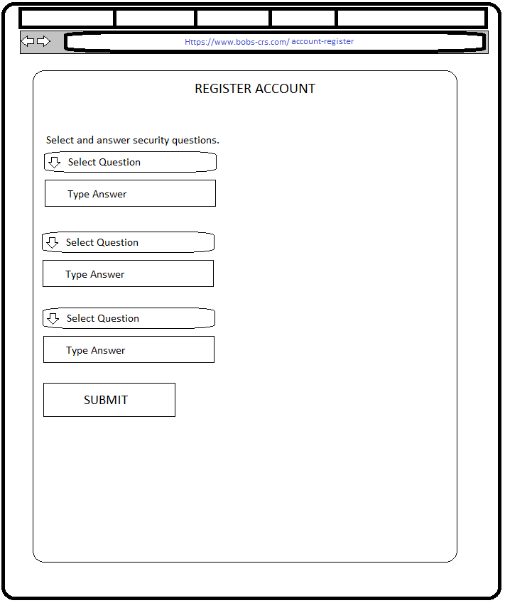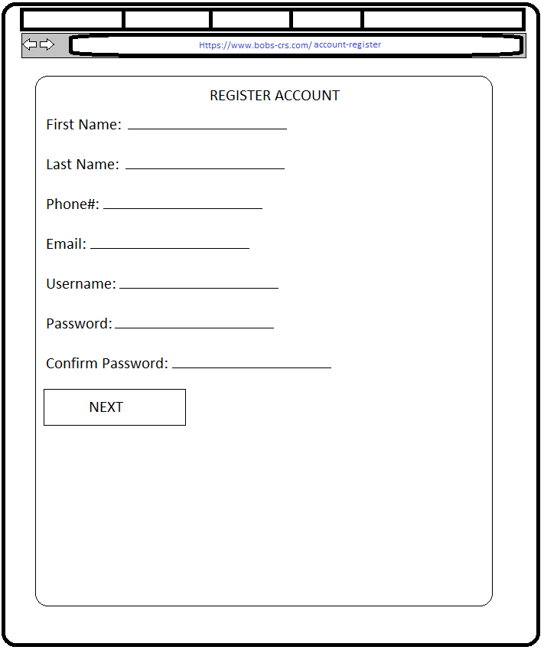Prototype

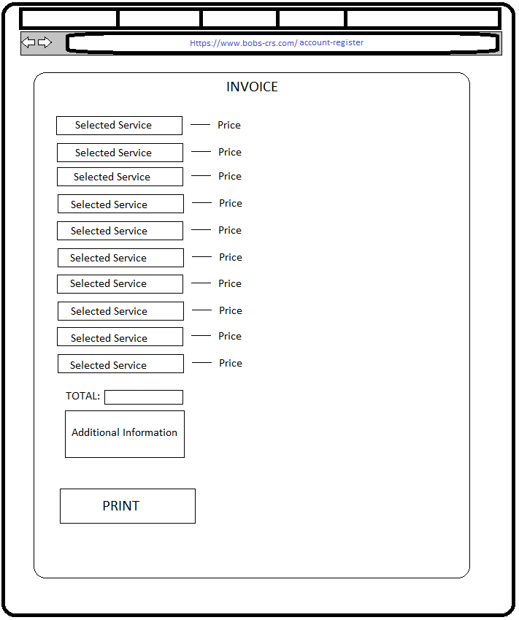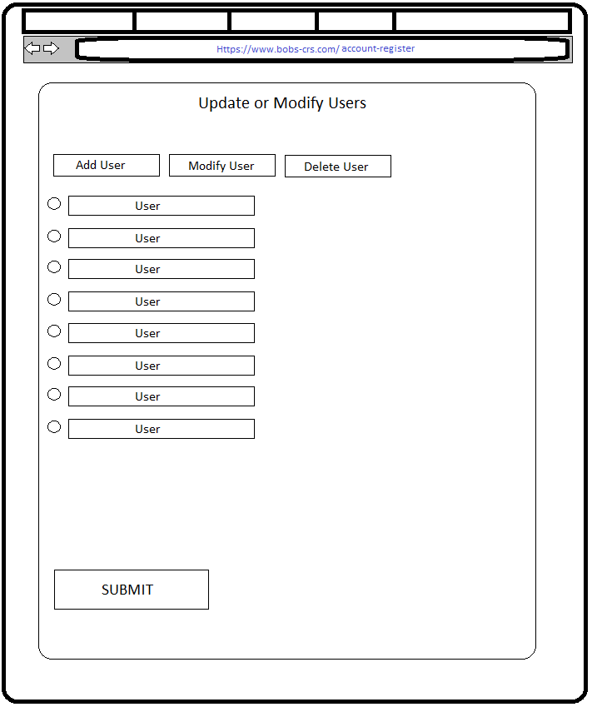

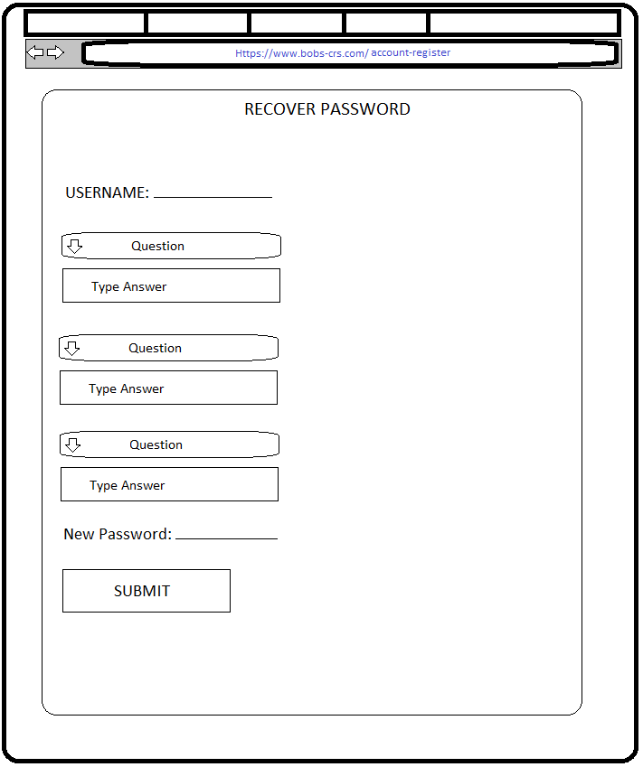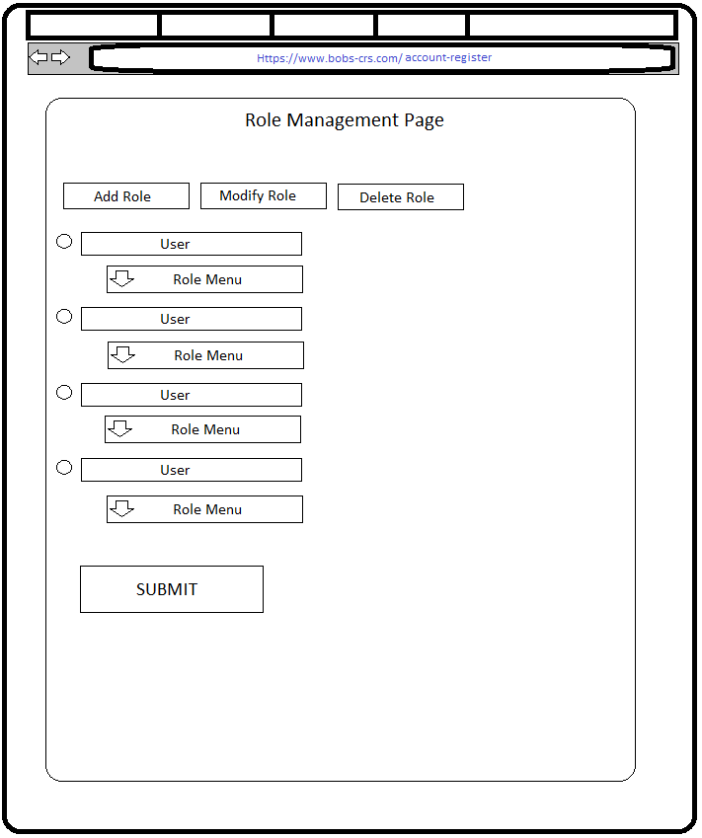

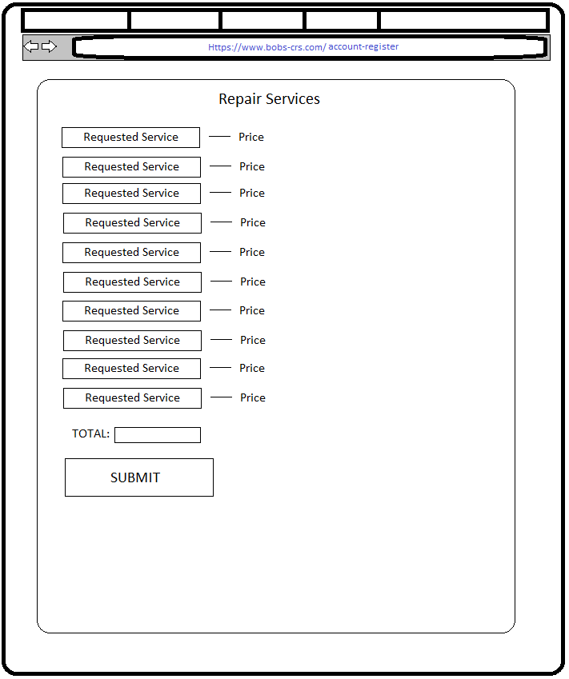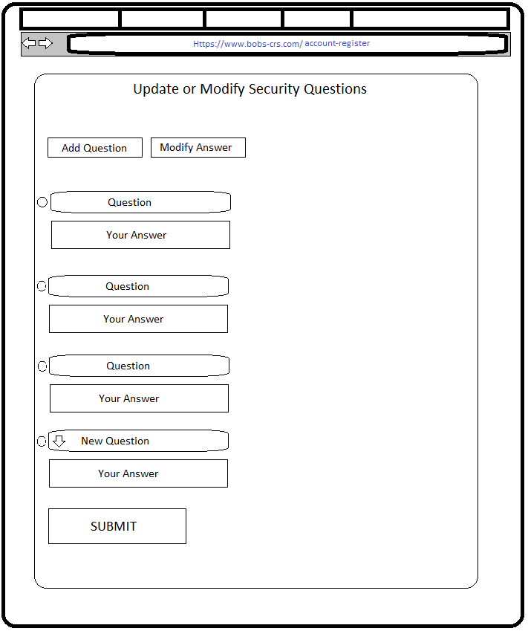

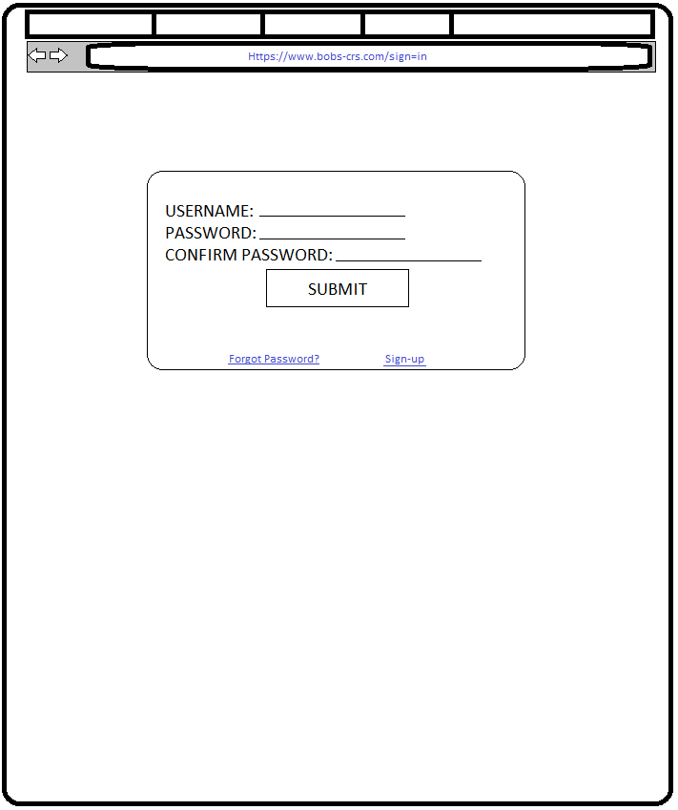

* 1. ORD

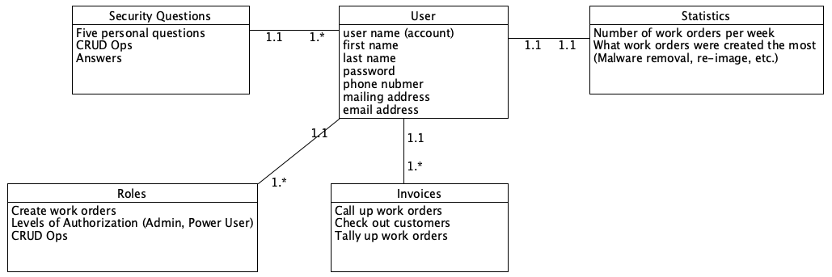

* 1. NoSQL Document Diagram

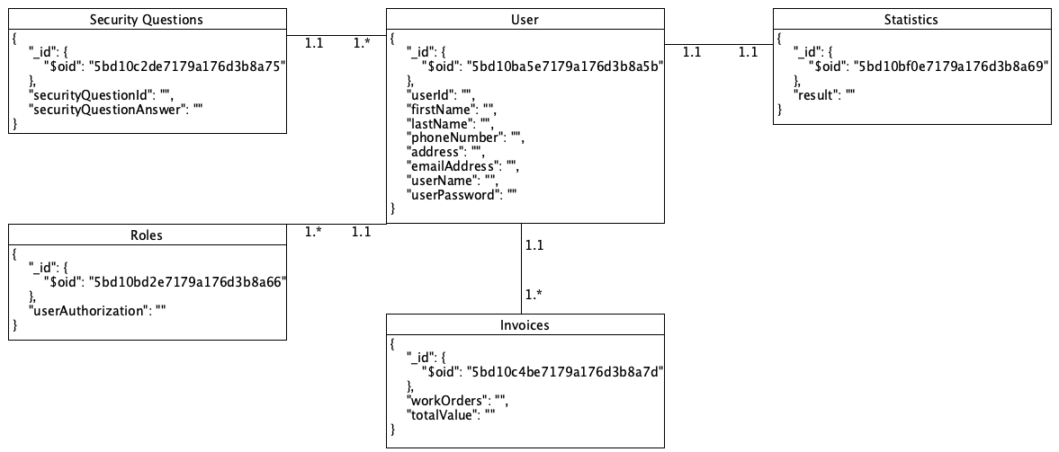

* 1. NoSQL Data Structure

Invoices:

{

"_id": {

"$oid": "5bd10c4be7179a176d3b8a7d"

},

"workOrders": "",

"totalValue": ""

}

Security Questions:

{

"_id": {

"$oid": "5bd10c2de7179a176d3b8a75"

},

"securityQuestionId": "",

"securityQuestionAnswer": ""

}

Statistics:

{

"_id": {

"$oid": "5bd10bf0e7179a176d3b8a69"

},

"result": ""

}

User Roles:

{

"_id": {

"$oid": "5bd10bd2e7179a176d3b8a66"

},

"userAuthorization": ""

}

Users:

{

"_id": {

"$oid": "5bd10ba5e7179a176d3b8a5b"

},

"userId": "",

"firstName": "",

"lastName": "",

"phoneNumber": "",

"address": "",

"emailAddress": "",

"userName": "",

"userPassword": ""

}

1. QA Testing