Vision-based human-body observation
HOBBIT PT2
Specifications-Implementation Module Input / Output
Kostas Papoutsakis (papoutsa@ics.forth.gr)
Ammar Qammaz (ammar@ics.forth.gr)
Contents
SHORT NOTE 2
(A) rgbd_acquisition/ 3
USER DETECTOR-TRACKER 3
INSTALLATION-DEPENDENCIES OF RGB ACQUISITION MODULE 3
HOW TO LAUNCH 4
Topics published by RGBD acquisition node 5
Services provided by RGBD acquisition node 5
Messages used by RGBD acquisition node 6
(B) hand_gestures/ - Hand detection, tracking and gesture recognition 7
Topics published by hand_gestures node 7
Services provided by hand_gestures node 7
Messages used by hand_gestures node 8
GESTURES – USE GUIDE 9
(C) emergency_detector 10

SHORT NOTE
(5/2/2014)
Current status of vision-based modules for RGBD data acquisition and human observation.
We are currently working on three new ROS packages that will support vision-based human observation for PT2.
They are:
(A) rgbd_acquisition/ ROS node that incorporates two functional modules:
(A1) RGB acquisition module for publishing depth and rgb streams for a single RGBD camera of the platform. You can roslaunch the node for the head (upper) camera or the body (bottom) camera of the robot.
(A2) User detector-tracker (3D skeleton detection and tracking + face detector). 3D skeleton tracking and face detector are combined together and packed under this node for enhanced performance towards lower (topic) traffic load and consumption of computational resources.
The user detector can be launched simultaneously with the head camera acquisition, if needed. One can enable/disable/pause the user detector at will while the RGBD acquisition of the corresponding camera will continue working.
(B ) hand_gestures/ ROS node for Gesture Recognition Interface

(C) emergency_detector/ ROS node for emergency function
TBD

More details for each of the nodes are provided below.
The libraries required for running the node are uploaded inside the bin/ subdirectory so this means that one does not need to download any external libraries and set them up ( although I could also provide the tarballs for all the dependencies

(A) rgbd_acquisition/
New RGBD acquisition ROS node is provided that will replace the native ROS openni2_camera node.
It should be launched separately for each of the onboard cameras for visual data acquisition. It publishes depth, rgb and calibration data, see Table 1.
Moreover, the user detector-tracker can be launched for the launched camera, if needed, as this node incorporates functionality of A2, see below.
USER DETECTOR-TRACKER
3D skeleton full/upper body tracking based on OpenNI2.2 and NITE2.2 combined with a face tracker is incorporated in A, in the same ROS node.
This is an one-way solution for now, given that we chose to rely on NITE people tracker. NITE implicitly acquires data from OpenNI SDK. There is no way to feed it with raw depth + rgb data. Moreover, it could not be created as a separate ROS node that will be launched simultaneously with RGBD acquisition.
We keep using the OpenNI / NITE skeleton tracking algorithm (upgraded to version 2.x) that is an efficient approach given the constraints of the project (limited computational resources of the on-board the platform, need for real-time performance, full/upper body tracking to feed fitness function that will follow as a PT2 feature), but not perfect though as abrupt movements of the head-camera or if no relative movements of the user with respect to the camera and vice versa exists, recognition performance is poor. We empower the functionality of it simply by combining with a face detector to fuse their results to a single output of the user-tracking function. Face detector is implicitly executed by enabling user-detector-tracker, no separate command or any further action is required.
Moreover, skeleton poses (positions of skeletal joints) for the tracked persons are provided using TF nodes
These can be visualized with rqt_rviz like following
http://cvrlcode.ics.forth.gr/web_share/Hobbit/2014-01-29-181216_1920x1080_scrot.png

INSTALLATION-DEPENDENCIES OF RGB ACQUISITION MODULE
The single requirement for this node is to execute the following command in order to install ROS/OS Openni2.x version after having update your working Hobbit repository with our node.
sudo apt-get install ros-hydro-openni2-launch ros-hydro-openni2-camera
NITE is also a dependency but its installation is configured automatically.
So, in order to reduce the size of the repository due to NiTE having 150 MB of data files (that we need ) we have added a small script than on the first run of our node checks if the NiTE subdirectory exists
See https://repo.acin.tuwien.ac.at/v4r/trunk/ros/hobbit_hydro_src/rgbd_acquisition/bin/downloadDependencies.sh and if it doesnt it downloads it and extracts it , so from there on this is not needed
This file is currently hosted in our web server ( http://cvrlcode.ics.forth.gr/web_share/Hobbit/rgbd_acquisition_data.tar.gz ) but maybe you want to host it in the same machine as the rest of the project and give your own path there.. In any case so large binary files will just clutter the svn repository so I think it is a good idea to include them on a separate file serve
Please send to us for support if anything is not working as described here.

HOW TO LAUNCH

ROSLAUNCH file
<launch>
<node name="rgbdacquisition" pkg="rgb_acquisition" type="rgb_acquisition" >
<param name="name" value="rgb_acquisition" />
<param name="useSkeleton" value="0" />
<param name="useDevice" value="0" />
</node>
</launch>

useSkeleton parameter can be 0 or 1 to enable or not the user detector-tracker submodule.
useDevice parameter can be:
a) the id of the camera as provided by the serializer of OpenNI API
b) the URI of the device
c) the name of an ONI file to get acquired.
i.e To launch the TOP camera, without the user detector-tracker disabled:

roslaunch rgbd_acquisition rgbd_acquisition.launch useSkeleton:=0 useDevice:=1 name:="TopCamera"
To launch the TOP camera, with the user detector-tracker enabled:
roslaunch rgbd_acquisition rgbd_acquisition.launch useSkeleton:=1 useDevice:=1 name:="TopCamera"

To launch the BOTTOM camera, without the user detector-tracker:
roslaunch rgbd_acquisition rgbd_acquisition.launch useSkeleton:=0 useDevice:=1 name:="BottomCamera"

To sum up, we can launch RGBD-acquisition node for the top camera with or without user-tracker.
RGBD-acquisition node can also be launched with different parameters for the bottom camera (with user-tracker disabled as it is not functional given that field of view.

Topics published by RGBD acquisition node

- rostopic list
Table 1: RGBD acquisition topics
rostopic list
/camera/depth_registered/camera_info
/camera/depth_registered/image_raw
/camera/depth_registered/image_raw/compressed
/camera/depth_registered/image_raw/compressed/parameter_descriptions
/camera/depth_registered/image_raw/compressed/parameter_updates
/camera/depth_registered/image_raw/compressedDepth
/camera/depth_registered/image_raw/compressedDepth/parameter_descriptions
/camera/depth_registered/image_raw/compressedDepth/parameter_updates
/camera/depth_registered/image_raw/theora
/camera/depth_registered/image_raw/theora/parameter_descriptions
/camera/depth_registered/image_raw/theora/parameter_updates
/camera/rgb/camera_info
/camera/rgb/image_color
/camera/rgb/image_color/compressed
/camera/rgb/image_color/compressed/parameter_descriptions
/camera/rgb/image_color/compressed/parameter_updates
/camera/rgb/image_color/compressedDepth
/camera/rgb/image_color/compressedDepth/parameter_descriptions
/camera/rgb/image_color/compressedDepth/parameter_updates
/camera/rgb/image_color/theora
/camera/rgb/image_color/theora/parameter_descriptions
/camera/rgb/image_color/theora/parameter_updates
/gestures
/persons
/pointEvents
/rosout
/rosout_agg
/tf

Services provided by RGBD acquisition node

rosservice list gives the following services
/camera/depth_registered/image_raw/compressed/set_parameters
/camera/depth_registered/image_raw/compressedDepth/set_parameters
/camera/depth_registered/image_raw/theora/set_parameters
/camera/rgb/image_color/compressed/set_parameters
/camera/rgb/image_color/compressedDepth/set_parameters
/camera/rgb/image_color/theora/set_parameters
/hand_gestures/pause
/hand_gestures/resume
/hand_gestures/set_quality
/hand_gestures/terminate
/hand_gestures/visualize_off
/hand_gestures/visualize_on
/hand_gestures15728/get_loggers
/hand_gestures15728/set_logger_level
/rgbd_acquisition/pause_peopletracker
/rgbd_acquisition/pause_pointing_gesture_messages
/rgbd_acquisition/resume_peopletracker
/rgbd_acquisition/resume_pointing_gesture_messages
/rgbd_acquisition/setQuality
/rgbd_acquisition/terminate
/rgbd_acquisition/visualize_off
/rgbd_acquisition/visualize_on
/rgbd_acquisition15589/get_loggers
/rgbd_acquisition15589/set_logger_level
/rgbd_acquisition17510/get_loggers
/rgbd_acquisition17510/set_logger_level
/rosout/get_loggers
/rosout/set_logger_level

Messages used by RGBD acquisition node

Person.msg
#Confidence is a float ranging 0.0 to 1.0
float32 confidence
int32 inFieldOfView
#pose
float32 x
float32 y
float32 z
float32 theta
#Timestamps are actually the number of the frame
int32 timestamp

PointEvents.msg
#Start Of the joint
float32 x
float32 y
float32 z
#Vector direction
float32 vectorX
float32 vectorY
float32 vectorZ
int8 leftHand
int8 rightHand
int32 timestamp

SetQuality.srv
#Quality Setting 0.0 = 0% quality 100% performance
# 1.0 = 100% quality 0% performance
float32 quality
---
uint8 ok

(B) hand_gestures/ - Hand detection, tracking and gesture recognition
No dependencies on OpenNI and NITE.
Relies on raw depth data acquired by rgbd_acquisition node.

Topics published by hand_gestures node

rostopic list

/gestures

Services provided by hand_gestures node

/hand_gestures/pause
/hand_gestures/resume
/hand_gestures/set_quality
/hand_gestures/terminate
/hand_gestures/visualize_off
/hand_gestures/visualize_on
/hand_gestures15728/get_loggers
/hand_gestures15728/set_logger_level

Messages used by hand_gestures node

HandGesture.msg
#Confidence is a float ranging 0.0 to 1.0
float32 confidence

#G_CANCEL , G_HELP , G_YES , G_NO , G_REWARD , G_POINT
string gesture

#pose
float32 x
float32 y
float32 z
float32 theta

#pose2d
float32 x2D
float32 y2D

#Timestamps are actually the number of the frame
int32 timestamp

SetQuality.srv
#Quality Setting 0.0 = 0% quality 100% performance
# 1.0 = 100% quality 0% performance
float32 quality
---
uint8 ok

GESTURES – USE GUIDE

Note: Pointing gesture is provided by the rgbd_acquisition node, publishing the results to /pointEvents topic.

Based on the latest Annual report and D5.2.
Table 1: Set of predefined hand gestures and upper body postures implemented for PT2 gestural interface of HOBBIT.
User Command | Gesture/Posture | Robot commands |  | Usage in  PT2 Scenarios  (listed in D1.6)
Yes | Thumb up  -palm closed  (close-up- range interaction) |  | Provides a positive response to confirmation dialogues. YES gesture. | All
No | Index finger up and waving, palm is closed  (close-up- range interaction) |  | Provides a negative response to confirmation dialogues.  NO gesture. | All
Cancel a task | Both open palms towards the robot  (close-up-range or normal- range interaction) |  | Terminates an on-going robot behaviour/command. | All
Pointing | Extended arm pointing a direction in 3D space (provided by user-tracker-detector for now. Need to activate user-tracker from rbgd_acquisition node, then pointing data with be published under /pointEvents topic) |  | Pointing to an object or place in 3D space using an extended arm for 2-3 seconds | IV. Pick up an (unknown) object
Reward the robot | Circle gesture  -open palm circular movement towards the robot (at least one complete circle is needed)  (close-up- range or normal- range interaction) |  | Rewards the robot for an accomplished action/task. | All
Emergency | Cross hands pose (normal- range interaction) |  | Signifies an emergency situation. | II-Emergency

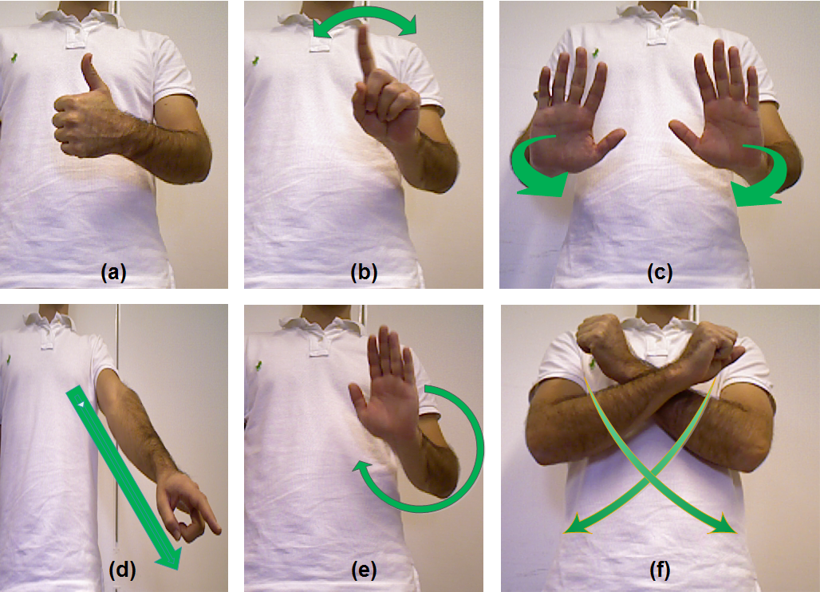
Figure 1: The set of hand gestures that will be integrated in PT2. (a) YES and (b) NO gestures utilized for confirmation dialogues. (c) cancel command that can be used for close-up- and n-range interaction. (d) the pointing gesture indicates an object on the floor to be picked up. (provided by user-tracker-detector for now. Need to activate user-tracker from rbgd_acquisition node, then pointing data with be published under /pointEvents topic) (e) a reward gesture can be performed to thank the robot for an accomplished task (one or more circles). (f) the gesture that a user can use and trigger the emergency task (triggered while releasing the arms-moving them downward).

(C) emergency_detector

TBD

