Scenario-Based Validation POC
NVIDIA Cosmos on AWS | plan and execution checklist

Prepared: 18 June 2026 Domain: Autonomous driving / ADAS Infrastructure: Self-hosted Cosmos on AWS GPUs
Objective
Stand up the NVIDIA Cosmos world foundation models on AWS and build a closed-loop scenario-based validation harness for an ADAS function. From a small set of seed clips we generate a large set of safety-relevant edge cases, run the system under test against them, and use an automated judge to score behaviour and surface failures. The output is a dashboard and an auditable validation report aligned to SOTIF (ISO 21448) and ISO 26262 thinking.
Solution at a glance
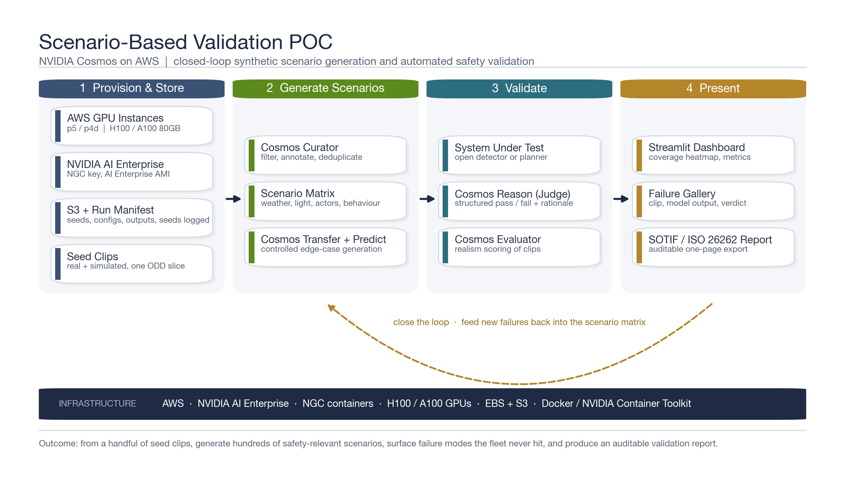
Figure 1. Four-phase pipeline: provision, generate, validate, present. The loop feeds new failures back into the scenario matrix.
Execution checklist
Owners and dates are placeholders for the kickoff meeting. Start Phase 1 quota requests on day one; they have the longest lead time.
Phase 0 - Scope and demo narrative Day 1
 | Task | Owner | Acceptance criteria
☐ | Confirm the single ODD slice to validate (e.g. urban intersection, pedestrian crossing) | Lead | One slice agreed in writing
☐ | Select the system under test (open detector or simple planner) | ML | Model runs on a sample clip
☐ | Write the one headline claim the demo must prove | Lead | One sentence approved
☐ | Define success metrics (scenarios generated, failures found, coverage) | Lead | Metric targets set
Phase 1 - Provision AWS and NVIDIA AI Enterprise Days 1 to 3
 | Task | Owner | Acceptance criteria
☐ | File GPU quota increase for p5 / p4d and g6e | Cloud | Quota approved by AWS
☐ | Subscribe to NVIDIA AI Enterprise in AWS Marketplace and capture the NGC key | Cloud | NGC login works
☐ | Launch generation node from the NVIDIA AI Enterprise AMI | Cloud | nvidia-smi and GPU docker test pass
☐ | Launch the small judge node (L40S or A100) | Cloud | Node reachable, GPU visible
☐ | Create S3 bucket and attach EBS gp3 volume | Cloud | Read and write verified
☐ | docker login nvcr.io and set the Hugging Face token | ML | Auth confirmed
Phase 2 - Stand up Cosmos Days 3 to 4
 | Task | Owner | Acceptance criteria
☐ | Clone cosmos-predict2.5, cosmos-transfer2.5, cosmos-reason2, cosmos-cookbook | ML | Repos cloned
☐ | Pull model checkpoints from Hugging Face | ML | Checkpoints downloaded
☐ | Run one sample inference per model from the Cookbook | ML | Each model produces output
☐ | Record per-model VRAM and runtime for sizing | ML | Sizing table filled
Phase 3 - Generate scenarios Days 4 to 7
 | Task | Owner | Acceptance criteria
☐ | Ingest seed clips and run Cosmos Curator (filter, annotate, deduplicate) | ML | Clean seed set ready
☐ | Author the scenario matrix config (weather, light, actors, behaviour, geometry) | ML | Matrix reviewed
☐ | Generate variants with Cosmos Transfer using structured controls | ML | Variants render correctly
☐ | Roll futures with Cosmos Predict for hazardous moments | ML | Future clips generated
☐ | Write every clip and its metadata to the S3 manifest | ML | Manifest complete and reproducible
Phase 4 - Validate Days 7 to 10
 | Task | Owner | Acceptance criteria
☐ | Run the system under test on every clip and capture outputs | ML | Outputs stored per clip
☐ | Configure the Cosmos Reason rubric and return structured JSON verdicts | ML | Verdicts parse cleanly
☐ | Score clip realism with Cosmos Evaluator | ML | Realism scores attached
☐ | Calibrate the judge against Alpamayo-style references (optional) | ML | Calibration documented
☐ | Aggregate results into a single scored results table | ML | Results table built
Phase 5 - Present Days 10 to 12
 | Task | Owner | Acceptance criteria
☐ | Build the Streamlit dashboard (metrics, coverage heatmap, failure gallery) | ML | Dashboard runs locally
☐ | Implement a mock mode so the dashboard runs without a GPU | ML | Runs on laptop
☐ | Add the SOTIF / ISO 26262 one-page PDF export | ML | PDF exports correctly
☐ | Pre-generate all demo assets | ML | Demo runs offline
Phase 6 - Rehearse and present Day 12
 | Task | Owner | Acceptance criteria
☐ | Dry-run the demo end to end | Lead | No live GPU dependency
☐ | Lock the headline claim and the single dramatic failure clip | Lead | Story rehearsed
☐ | Prepare the cost summary and the next-step ask | Lead | One-slide ask ready
What a strong result looks like
✓ From a handful of seed clips, generate several hundred safety-relevant scenarios with no extra data collection.
✓ Surface failure modes the test fleet never encountered, each shown as a clip with the model output and a written verdict.
✓ Show coverage of the ODD as a heatmap, so gaps are visible at a glance.
✓ Export a one-page validation report that a safety lead can read and sign.
Key risks and mitigations
Risk | Mitigation
GPU quota approval is slow | File on day one. Validate the judge node and Cosmos Reason while the large-instance quota is pending.
Generation throughput is limited | Keep clip counts modest. Generate in short batches, snapshot to S3, stop the large node between runs.
Judge reliability is questioned | Use a fixed rubric, add Cosmos Evaluator realism scores, and calibrate against Alpamayo-style references.
Scope creep | One ODD slice and one system under test for the POC. Depth over breadth.
Cost overrun | Run generation in bursts and shut the p5 / p4d node down. Keep only the small judge node warm.

