**Evaluating the Impact of Renewable Energy Adoption on Economic Growth in Latin America**

MD MAINUL HAQUE - 23003992

1. **Introduction**

This study investigates the impact of renewable energy adoption on economic growth in Latin America. By analyzing GDP growth data and renewable energy metrics from 2018–2022, this report explores correlations, trends, and patterns. Results indicate a weak correlation (0.075) between renewable energy share in electricity generation and GDP growth. Countries like Paraguay and Costa Rica lead in renewable energy adoption but show varying GDP growth trends. Regional patterns reveal steady growth in renewable energy adoption, contrasting with the volatility of GDP growth. These findings underscore the influence of external factors and the need for integrated policies.

Latin America faces the dual challenge of fostering economic growth while adopting sustainable energy practices. Renewable energy, with its promise of environmental and economic benefits, has become a strategic priority for many countries in the region. By examining data-driven trends and patterns, this report aims to guide policymakers in understanding the economic impacts of renewable energy adoption and addressing related challenges. This investigation is based on the following question:

***Does renewable energy adoption contribute to economic growth in Latin America?.***

1. **Used Data**
   1. **Sources**

This analysis relies on two datasets to explore the relationship between renewable energy adoption and economic growth. The GDP data was sourced from the World Bank, providing annual GDP growth rates for Latin American countries from 2018 to 2022. This dataset serves as a vital economic performance indicator for the region. The renewable energy data, obtained from the International Renewable Energy Agency (IRENA), includes the renewable energy share in electricity generation and capacity. This dataset highlights renewable energy adoption trends and its role in shaping the energy landscape of Latin America.

* 1. **Structure**

The combined dataset integrates information from the GDP and renewable energy datasets. **For GDP Growth data**, columns include **Country Name, Country Code, Indicator Name,** **Indicator Code,Year, and GDP Growth (%),** while the **renewable energy dataset** contains **Region/Area, Year, Renewable Energy Share of Electricity Generation** (%),**Renewable Energy Share of Capacity (%).** These datasets were merged using the country and year as common keys, creating a comprehensive structure suitable for comparative analysis. The resulting dataset provides an aligned view of economic performance and renewable energy metrics across Latin America.A screenshot of a computer

Fig. 1. Renewable energy table structure

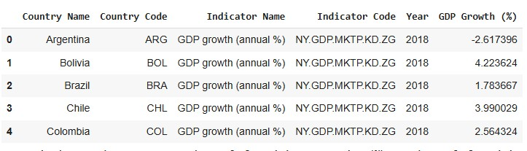

Fig. 2. GDP Growth table structure

* 1. **License**

To Compliance with data source licenses is a fundamental aspect of this analysis. Proper attribution is provided to the World Bank and IRENA, ensuring transparency and adherence to licensing requirements. Any derived datasets respect the licensing terms of the original datasets, upholding ethical standards and supporting open data practices.

**3. Analysis**

**A. Methodology and Results**

1. **Data Integration**: The datasets for GDP growth and renewable energy share were merged based on common columns: Country and Year. This alignment ensured a unified dataset covering 85 records of Latin American countries between 2018 and 2022. The integration process revealed that while most countries had complete records for both metrics, a few countries had missing data for specific years, which was addressed through imputation where necessary.
2. **Correlation Analysis**: A correlation analysis was performed to explore the relationship between GDP growth and renewable energy share. The calculated correlation coefficient was 0.075, indicating a weak positive association. This suggests that while renewable energy adoption might contribute to economic growth, it is not a dominant factor, and other economic variables likely play a more significant role. Scatter plots further highlighted variability in the data, with no clear trend across countries.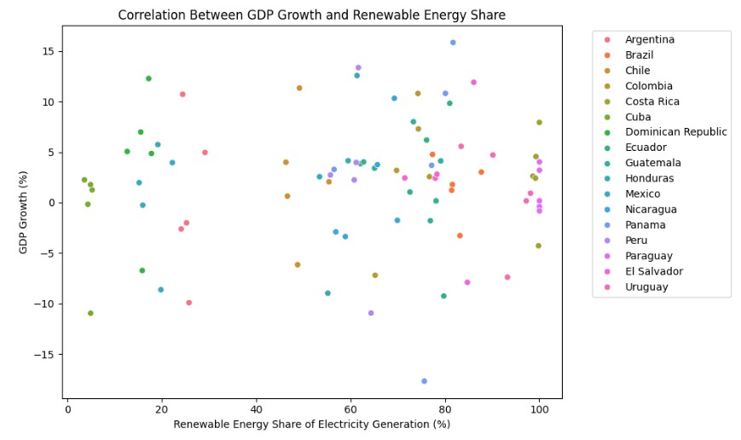

Fig. 3. Correlation Analysis

1. **Regional Trends**: A time-series analysis of the standardized data revealed distinct patterns:

* **Renewable Energy Share:** Steadily increased across the region, with averages ranging from 20% to 100% over the study period. This consistent growth highlights the prioritization of renewable energy policies in Latin America.
* **GDP Growth:** Displayed significant volatility, with sharp declines in years of global economic challenges (e.g., 2020). This variability underscores the sensitivity of GDP to external economic shocks, independent of energy trends.

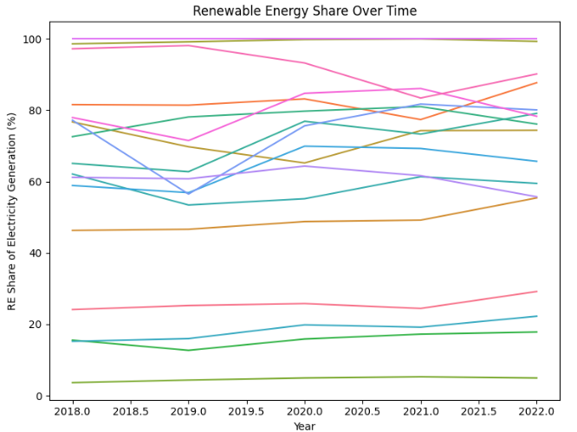

Fig. 4. Time-Series Line Plot for GDP Growth and Renewable Energy Share

1. **Country-Specific Insights**: The analysis identified the top-performing countries in renewable energy adoption:

* **Paraguay** maintained a 100% renewable energy share, driven by its reliance on hydropower, but its GDP growth remained moderate, reflecting limited economic diversification.
* **Costa Rica**, with a 99.37% renewable energy share, demonstrated stable GDP growth, supported by sustainable tourism and a diversified economy.
* **Uruguay** achieved a 92.43% renewable energy share, with consistent economic stability attributed to strong governance and energy policies.

Fig. 5. Bar Chart for Average GDP Growth & Renewable Energy Share by Country

**4. Conclusions**

This analysis demonstrates that renewable energy adoption has a weak direct relationship with GDP growth in Latin America. The findings highlight the complexity of economic growth, which is influenced by multiple factors beyond energy policies. While renewable energy adoption is growing steadily, its full economic potential requires integration with broader economic strategies.

**4.1 Limitations**

The weak correlation observed in this study may stem from unaccounted confounding factors, such as trade policies, geopolitical events, or regional disparities within countries. Aggregating data at the country level could obscure significant intra-country variations, affecting the precision of the analysis. Additionally, missing data for specific countries or years limits the scope of the study. Incomplete coverage of renewable energy metrics further reduces the granularity of insights, restricting a deeper understanding of its nuanced effects on economic growth.

**4.2 Recommendations**

To maximize the benefits of renewable energy adoption, policymakers should align energy strategies with broader economic frameworks. Addressing data gaps by incorporating more granular metrics and expanding dataset coverage would enhance the robustness of future analyses. Furthermore, investigating external factors such as trade policies, international investments, and geopolitical influences would provide a clearer understanding of their interplay with renewable energy adoption, enabling more targeted and effective policy interventions.