# Module 4 Assignment 2

## Madison Rauscher

parole <- read_csv("parole.csv")

##   
## ── Column specification ────────────────────────────────────────────────────────  
## cols(  
## male = col_double(),  
## race = col_double(),  
## age = col_double(),  
## state = col_double(),  
## time.served = col_double(),  
## max.sentence = col_double(),  
## multiple.offenses = col_double(),  
## crime = col_double(),  
## violator = col_double()  
## )

parole <- parole %>%  
 mutate(male=as_factor(male)) %>%  
 mutate(race=as_factor(race)) %>%  
 mutate(state=as_factor(state)) %>%  
 mutate(crime=as_factor(crime)) %>%  
 mutate(multiple.offenses=as_factor(multiple.offenses)) %>%  
 mutate(violator=as_factor(violator)) %>%  
 mutate(male = fct_recode(male, "No" = "0", "Yes" = "1")) %>%   
 mutate(race = fct_recode(race, "Other" = "2", "White" = "1")) %>%   
 mutate(state = fct_recode(state, "Kentucky" = "2", "Louisiana" = "3", "Virginia" = "4", "Other" = "1")) %>%   
 mutate(crime = fct_recode(crime, "Larceny" = "2", "Drug-related" = "3", "Driving-related" = "4", "Other" = "1")) %>%   
 mutate(multiple.offenses = fct_recode(multiple.offenses, "Yes" = "1", "No" = "0")) %>%  
 mutate(violator = fct_recode(violator, "Yes" = "1", "No" = "0"))

**Task 1**

set.seed(12345)  
parole_split= initial_split(parole, prob = 0.70, strata=violator)  
train= training(parole_split)  
test= testing(parole_split)

**Task 2**

parole_recipe= recipe(violator ~., train) %>%  
 step_dummy(all_nominal(), -all_outcomes())  
  
tree_model = decision_tree() %>%  
 set_engine("rpart", model=TRUE) %>%  
 set_mode("classification")  
  
parole_wflow =  
 workflow() %>%  
 add_model(tree_model) %>%  
 add_recipe(parole_recipe)  
  
parole_fit= fit(parole_wflow, train)

**Task 3**

tree = parole_fit %>%  
 pull_workflow_fit() %>%  
 pluck("fit")  
  
fancyRpartPlot(tree)

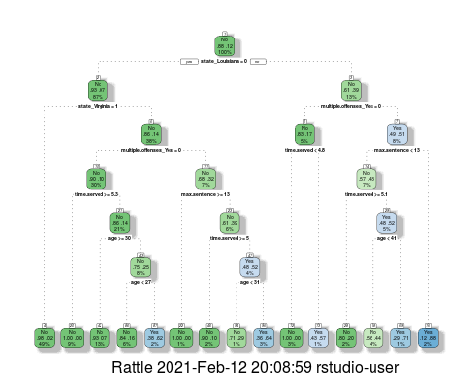 This person would be classified as not a violator. You walk through the tree by starting at the top and which says they are not from Louisiana, but they are so you move to the right. You are now at multiple offenses and it says yes=0 which is not true, there are multiple offenses, so you move the right. You are now at max sentence and since it is less than 13 years we move to the left. Time served is not greater than 5.1 years so we move to the right. Age is less than 41 years so you go to the left and find that the final answer is no they are not a violator. 55% of people in this demographic were not violators while 44% were.

**Task 4**

parole_fit$fit$fit$fit$cptable

## CP nsplit rel error xerror xstd  
## 1 0.03389831 0 1.0000000 1.000000 0.1223796  
## 2 0.02542373 3 0.8983051 1.101695 0.1275886  
## 3 0.01694915 5 0.8474576 1.084746 0.1267465  
## 4 0.01355932 6 0.8305085 1.084746 0.1267465  
## 5 0.01129944 11 0.7627119 1.186441 0.1316539  
## 6 0.01000000 14 0.7288136 1.152542 0.1300561

The optimal cp value is .0338. The tree from Task 2 is not associated with this optimal cp.

**Task 5**

set.seed(123)  
folds= vfold_cv(train, v=5)

parole_recipe= recipe(violator ~., train) %>%  
 step_dummy(all_nominal(), -all_outcomes())  
  
tree_model = decision_tree(cost_complexity= tune()) %>%  
 set_engine("rpart", model=TRUE) %>%  
 set_mode("classification")  
  
tree_grid= grid_regular(cost_complexity(), levels = 25)  
  
parole_wflow =  
 workflow() %>%  
 add_model(tree_model) %>%  
 add_recipe(parole_recipe)  
  
tree_res =  
 parole_wflow %>%  
 tune_grid(resamples=folds, grid=tree_grid)

##   
## Attaching package: 'rlang'

## The following objects are masked from 'package:purrr':  
##   
## %@%, as_function, flatten, flatten_chr, flatten_dbl, flatten_int,  
## flatten_lgl, flatten_raw, invoke, list_along, modify, prepend,  
## splice

##   
## Attaching package: 'vctrs'

## The following object is masked from 'package:dplyr':  
##   
## data_frame

## The following object is masked from 'package:tibble':  
##   
## data_frame

tree_res

## # Tuning results  
## # 5-fold cross-validation   
## # A tibble: 5 x 4  
## splits id .metrics .notes   
## <list> <chr> <list> <list>   
## 1 <split [405/102]> Fold1 <tibble [50 × 5]> <tibble [0 × 1]>  
## 2 <split [405/102]> Fold2 <tibble [50 × 5]> <tibble [0 × 1]>  
## 3 <split [406/101]> Fold3 <tibble [50 × 5]> <tibble [0 × 1]>  
## 4 <split [406/101]> Fold4 <tibble [50 × 5]> <tibble [0 × 1]>  
## 5 <split [406/101]> Fold5 <tibble [50 × 5]> <tibble [0 × 1]>

tree_res %>%  
 collect_metrics() %>%  
 ggplot(aes(cost_complexity, mean)) +  
 geom_line(size=1.5, alpha=0.6) +  
 geom_point(size=2)+  
 facet_wrap(~.metric, scales="free", nrow=2)

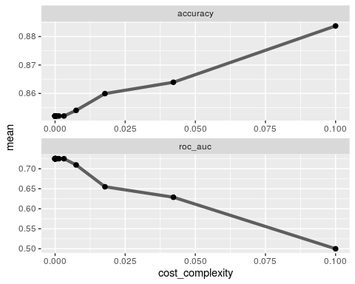

**Task 6**

best_tree=tree_res %>%  
 select_best("accuracy")  
  
best_tree

## # A tibble: 1 x 2  
## cost_complexity .config   
## <dbl> <chr>   
## 1 0.1 Preprocessor1_Model25

The cp value .1 yields the optimal accuracy value.

**Task 7**

final_wf=  
 parole_wflow %>%  
 finalize_workflow(best_tree)  
  
final_fit = fit(final_wf, train)  
  
tree = final_fit %>%  
 pull_workflow_fit() %>%  
 pluck("fit")  
  
#fancyRpartPlot(tree, tweak = 1.5)

**Task 8**

table(train$violator)

##   
## No Yes   
## 448 59

The accuracy of the root is 88%. I found this by taking the number of non-violators in the training set and dividing it over the total number of observations in the set which is 507. I did this because the root model assumes all are not violators so we can the actual amount of non-violators to tell how accurate this is.

**Task 9**

Blood <- read_csv("Blood.csv")

##   
## ── Column specification ────────────────────────────────────────────────────────  
## cols(  
## Mnths_Since_Last = col_double(),  
## TotalDonations = col_double(),  
## Total_Donated = col_double(),  
## Mnths_Since_First = col_double(),  
## DonatedMarch = col_double()  
## )

Blood <- Blood %>%  
 mutate(DonatedMarch=as_factor(DonatedMarch)) %>%  
 mutate(DonatedMarch=fct_recode(DonatedMarch, "No"= "0", "Yes" = "1"))

set.seed(1234)  
Blood_split= initial_split(Blood, prob = 0.70, strata=DonatedMarch)  
train2= training(Blood_split)  
test2= testing(Blood_split)

set.seed(1234)  
folds= vfold_cv(train2, v=5)

Blood_recipe= recipe(DonatedMarch ~., train2) %>%  
 step_dummy(all_nominal(), -all_outcomes())  
  
tree_model2 = decision_tree(cost_complexity= tune()) %>%  
 set_engine("rpart", model=TRUE) %>%  
 set_mode("classification")  
  
tree_grid2= grid_regular(cost_complexity(), levels = 25)  
  
Blood_wflow =  
 workflow() %>%  
 add_model(tree_model2) %>%  
 add_recipe(Blood_recipe)  
  
tree_res2 =  
 Blood_wflow %>%  
 tune_grid(resamples=folds, grid=tree_grid2)  
  
tree_res2

## # Tuning results  
## # 5-fold cross-validation   
## # A tibble: 5 x 4  
## splits id .metrics .notes   
## <list> <chr> <list> <list>   
## 1 <split [449/113]> Fold1 <tibble [50 × 5]> <tibble [0 × 1]>  
## 2 <split [449/113]> Fold2 <tibble [50 × 5]> <tibble [0 × 1]>  
## 3 <split [450/112]> Fold3 <tibble [50 × 5]> <tibble [0 × 1]>  
## 4 <split [450/112]> Fold4 <tibble [50 × 5]> <tibble [0 × 1]>  
## 5 <split [450/112]> Fold5 <tibble [50 × 5]> <tibble [0 × 1]>

tree_res2 %>%  
 collect_metrics() %>%  
 ggplot(aes(cost_complexity, mean)) +  
 geom_line(size=1.5, alpha=0.6) +  
 geom_point(size=2)+  
 facet_wrap(~.metric, scales="free", nrow=2)

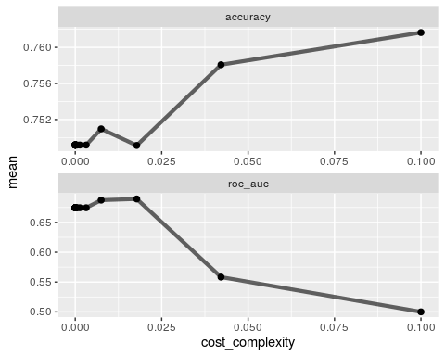

best_tree2=tree_res2 %>%  
 select_best("accuracy")  
  
best_tree2

## # A tibble: 1 x 2  
## cost_complexity .config   
## <dbl> <chr>   
## 1 0.1 Preprocessor1_Model25

The cp value of about .04 appears to be optimal to maximize accuracy because it is there where it begins to plateau.

**Task 10**

Blood_recipe= recipe(DonatedMarch ~., train2) %>%  
 step_dummy(all_nominal(), -all_outcomes())  
  
tree_model3 = decision_tree(cost_complexity= tune()) %>%  
 set_engine("rpart", model=TRUE) %>%  
 set_mode("classification")  
  
tree_grid3= expand.grid(cost_complexity=seq(0.001,0.01, by=.001))  
  
Blood_wflow =  
 workflow() %>%  
 add_model(tree_model3) %>%  
 add_recipe(Blood_recipe)  
  
tree_res3 =  
 Blood_wflow %>%  
 tune_grid(resamples=folds, grid=tree_grid3)  
  
tree_res3

## # Tuning results  
## # 5-fold cross-validation   
## # A tibble: 5 x 4  
## splits id .metrics .notes   
## <list> <chr> <list> <list>   
## 1 <split [449/113]> Fold1 <tibble [20 × 5]> <tibble [0 × 1]>  
## 2 <split [449/113]> Fold2 <tibble [20 × 5]> <tibble [0 × 1]>  
## 3 <split [450/112]> Fold3 <tibble [20 × 5]> <tibble [0 × 1]>  
## 4 <split [450/112]> Fold4 <tibble [20 × 5]> <tibble [0 × 1]>  
## 5 <split [450/112]> Fold5 <tibble [20 × 5]> <tibble [0 × 1]>

tree_res3 %>%  
 collect_metrics() %>%  
 ggplot(aes(cost_complexity, mean)) +  
 geom_line(size=1.5, alpha=0.6) +  
 geom_point(size=2)+  
 facet_wrap(~.metric, scales="free", nrow=2)

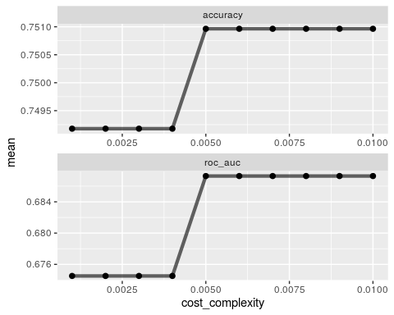

best_tree3=tree_res3 %>%  
 select_best("accuracy")  
  
best_tree3

## # A tibble: 1 x 2  
## cost_complexity .config   
## <dbl> <chr>   
## 1 0.005 Preprocessor1_Model05

final_wf2=  
 Blood_wflow %>%  
 finalize_workflow(best_tree3)  
  
final_fit2 = fit(final_wf2, train2)  
  
tree2 = final_fit2 %>%  
 pull_workflow_fit() %>%  
 pluck("fit")  
  
fancyRpartPlot(tree2, tweak = 1.5)

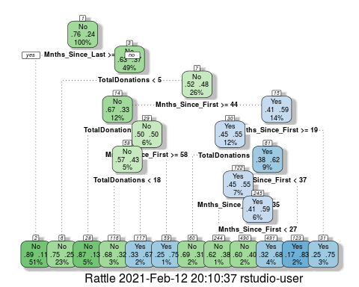

**Task 11**

treepred = predict(final_fit2, train2, type="class")  
  
confusionMatrix(treepred$.pred_class, train2$DonatedMarch, positive = "Yes")

## Confusion Matrix and Statistics  
##   
## Reference  
## Prediction No Yes  
## No 410 85  
## Yes 18 49  
##   
## Accuracy : 0.8167   
## 95% CI : (0.7822, 0.8479)  
## No Information Rate : 0.7616   
## P-Value [Acc > NIR] : 0.0009708   
##   
## Kappa : 0.3907   
##   
## Mcnemar's Test P-Value : 7.864e-11   
##   
## Sensitivity : 0.36567   
## Specificity : 0.95794   
## Pos Pred Value : 0.73134   
## Neg Pred Value : 0.82828   
## Prevalence : 0.23843   
## Detection Rate : 0.08719   
## Detection Prevalence : 0.11922   
## Balanced Accuracy : 0.66181   
##   
## 'Positive' Class : Yes   
##

treepred2 = predict(final_fit2, test2, type="class")  
  
confusionMatrix(treepred2$.pred_class, test2$DonatedMarch, positive = "Yes")

## Confusion Matrix and Statistics  
##   
## Reference  
## Prediction No Yes  
## No 136 31  
## Yes 6 13  
##   
## Accuracy : 0.8011   
## 95% CI : (0.7364, 0.8559)  
## No Information Rate : 0.7634   
## P-Value [Acc > NIR] : 0.1301   
##   
## Kappa : 0.315   
##   
## Mcnemar's Test P-Value : 7.961e-05   
##   
## Sensitivity : 0.29545   
## Specificity : 0.95775   
## Pos Pred Value : 0.68421   
## Neg Pred Value : 0.81437   
## Prevalence : 0.23656   
## Detection Rate : 0.06989   
## Detection Prevalence : 0.10215   
## Balanced Accuracy : 0.62660   
##   
## 'Positive' Class : Yes   
##

The accuracy of the tree in the training set is about 81.7% and the accuracy of the tree in the testing set is about 80.1%. This shows that there is a steady performance across both sets. The accuracy is greater than the no information rate in the training set and it is statistically significant according to the p-value so this model is and improvement over that one. The accuracy of the testing set is also greater than the no information rate but this is not statistically significant according to the p-value.