# Module 4, Assignement 3

## Madison Rauscher

drug <- read_csv("drug_data-1.csv")

##   
## ── Column specification ────────────────────────────────────────────────────────  
## cols(  
## .default = col_character(),  
## Column1 = col_double(),  
## Column2 = col_double(),  
## Column3 = col_double(),  
## Column4 = col_double(),  
## Column5 = col_double(),  
## Column6 = col_double(),  
## Column7 = col_double(),  
## Column8 = col_double(),  
## Column9 = col_double(),  
## Column10 = col_double(),  
## Column11 = col_double(),  
## Column12 = col_double(),  
## Column13 = col_double()  
## )  
## ℹ Use `spec()` for the full column specifications.

names(drug) = c("ID", "Age", "Gender", "Education", "Country", "Ethnicity",  
"Nscore", "Escore", "Oscore", "Ascore", "Cscore", "Impulsive",  
"SS", "Alcohol", "Amphet", "Amyl", "Benzos", "Caff", "Cannabis",  
"Choc", "Coke", "Crack", "Ecstasy", "Heroin", "Ketamine", "Legalh",  
"LSD", "Meth", "Mushrooms", "Nicotine", "Semer", "VSA")  
#str(drug)

drug[drug == "CL0"] = "No"  
drug[drug == "CL1"] = "No"  
drug[drug == "CL2"] = "Yes"  
drug[drug == "CL3"] = "Yes"  
drug[drug == "CL4"] = "Yes"  
drug[drug == "CL5"] = "Yes"  
drug[drug == "CL6"] = "Yes"

drug_clean = drug %>% mutate_at(vars(Age:Ethnicity), funs(as_factor)) %>%  
mutate(Age = factor(Age, labels = c("18_24", "25_34", "35_44",  
"45_54", "55_64", "65_"))) %>%  
mutate(Gender = factor(Gender, labels = c("Male", "Female"))) %>%  
mutate(Education = factor(Education, labels =  
c("Under16", "At16", "At17", "At18", "SomeCollege",  
"ProfessionalCert", "Bachelors", "Masters", "Doctorate"))) %>%  
mutate(Country = factor(Country,  
labels = c("USA", "NewZealand", "Other", "Australia",  
"Ireland","Canada","UK"))) %>%  
mutate(Ethnicity = factor(Ethnicity,  
labels = c("Black", "Asian", "White", "White/Black", "Other",  
"White/Asian", "Black/Asian"))) %>%  
 mutate_at(vars(Alcohol:VSA), funs(as_factor)) %>%  
select(-ID)

## Warning: `funs()` is deprecated as of dplyr 0.8.0.  
## Please use a list of either functions or lambdas:   
##   
## # Simple named list:   
## list(mean = mean, median = median)  
##   
## # Auto named with `tibble::lst()`:   
## tibble::lst(mean, median)  
##   
## # Using lambdas  
## list(~ mean(., trim = .2), ~ median(., na.rm = TRUE))  
## This warning is displayed once every 8 hours.  
## Call `lifecycle::last_warnings()` to see where this warning was generated.

#str(drug_clean)

drug_clean = drug_clean %>% select(!(Alcohol:Mushrooms)) %>% select(!(Semer:VSA))  
names(drug_clean)

## [1] "Age" "Gender" "Education" "Country" "Ethnicity" "Nscore"   
## [7] "Escore" "Oscore" "Ascore" "Cscore" "Impulsive" "SS"   
## [13] "Nicotine"

**Task 1**

skim(drug_clean)

Data summary

|  |  |
| --- | --- |
| Name | drug_clean |
| Number of rows | 1885 |
| Number of columns | 13 |
| _______________________ |  |
| Column type frequency: |  |
| factor | 6 |
| numeric | 7 |
| ________________________ |  |
| Group variables | None |

**Variable type: factor**

|  |  |  |  |  |  |
| --- | --- | --- | --- | --- | --- |
| skim_variable | n_missing | complete_rate | ordered | n_unique | top_counts |
| Age | 0 | 1 | FALSE | 6 | 18_: 643, 25_: 481, 35_: 356, 45_: 294 |
| Gender | 0 | 1 | FALSE | 2 | Mal: 943, Fem: 942 |
| Education | 0 | 1 | FALSE | 9 | Som: 506, Bac: 480, Mas: 283, Pro: 270 |
| Country | 0 | 1 | FALSE | 7 | UK: 1044, USA: 557, Oth: 118, Can: 87 |
| Ethnicity | 0 | 1 | FALSE | 7 | Whi: 1720, Oth: 63, Bla: 33, Asi: 26 |
| Nicotine | 0 | 1 | FALSE | 2 | Yes: 1264, No: 621 |

**Variable type: numeric**

|  |  |  |  |  |  |  |  |  |  |  |
| --- | --- | --- | --- | --- | --- | --- | --- | --- | --- | --- |
| skim_variable | n_missing | complete_rate | mean | sd | p0 | p25 | p50 | p75 | p100 | hist |
| Nscore | 0 | 1 | 0.00 | 1.00 | -3.46 | -0.68 | 0.04 | 0.63 | 3.27 | ▁▃▇▅▁ |
| Escore | 0 | 1 | 0.00 | 1.00 | -3.27 | -0.70 | 0.00 | 0.64 | 3.27 | ▁▃▇▃▁ |
| Oscore | 0 | 1 | 0.00 | 1.00 | -3.27 | -0.72 | -0.02 | 0.72 | 2.90 | ▁▃▇▆▁ |
| Ascore | 0 | 1 | 0.00 | 1.00 | -3.46 | -0.61 | -0.02 | 0.76 | 3.46 | ▁▃▇▃▁ |
| Cscore | 0 | 1 | 0.00 | 1.00 | -3.46 | -0.65 | -0.01 | 0.58 | 3.46 | ▁▃▇▃▁ |
| Impulsive | 0 | 1 | 0.01 | 0.95 | -2.56 | -0.71 | -0.22 | 0.53 | 2.90 | ▁▆▇▃▁ |
| SS | 0 | 1 | 0.00 | 0.96 | -2.08 | -0.53 | 0.08 | 0.77 | 1.92 | ▂▇▇▇▅ |

There is no missingness.

**Task 2**

set.seed(1234)   
drug_split = initial_split(drug_clean, prop = 0.7, strata = Nicotine) #70% in training  
train = training(drug_split)  
test = testing(drug_split)

**Task 3**

p1 = ggplot(train, aes(x = Age, fill = Nicotine)) + geom_bar(position = "fill")+ theme(axis.text.x = element_text(angle = 60, hjust=1))  
p2 = ggplot(train, aes(x = Gender, fill = Nicotine)) + geom_bar(position = "fill")  
p3 = ggplot(train, aes(x = Education, fill = Nicotine)) + geom_bar(position = "fill")+ theme(axis.text.x = element_text(angle = 60, hjust=1))  
p4 = ggplot(train, aes(x = Country, fill = Nicotine)) + geom_bar(position = "fill")+ theme(axis.text.x = element_text(angle = 60, hjust=1))  
p5 = ggplot(train, aes(x = Ethnicity, fill = Nicotine)) + geom_bar(position = "fill")+ theme(axis.text.x = element_text(angle = 60, hjust=1))  
grid.arrange(p1,p2,p3,p4,p5)

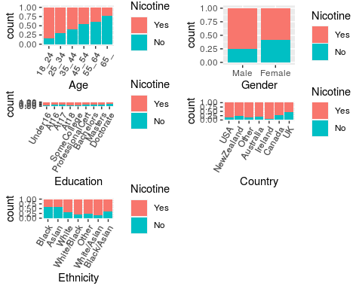

Younger people are more likely to use nicotine than older people. Males are more likely to use nicotine. Those will lower levels of education are more likely to use nicotine. People in Ireland are most likely to use nicotine while people in the UK are least likely. People who are not black or asisan are more likely to use nicotine.

p1 = ggplot(train, aes(x = Nicotine, y = Nscore)) + geom_boxplot()  
p2 = ggplot(train, aes(x = Nicotine, y = Escore)) + geom_boxplot()  
p3 = ggplot(train, aes(x = Nicotine, y = Oscore)) + geom_boxplot()  
p4 = ggplot(train, aes(x = Nicotine, y = Ascore)) + geom_boxplot()  
grid.arrange(p1,p2,p3,p4, ncol = 2)

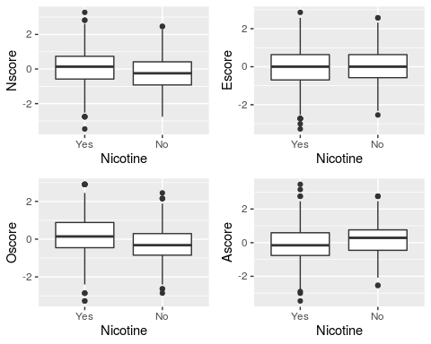

People with higher neuroticism score levels are slightly more likely to use nicotine. The use across extraversion score levels is largely similar. People with higher openness to experience score levels are more likely to use nicotine. The use across agreeableness score levels looks pretty similar especially when considering outliers.

p1 = ggplot(train, aes(x = Nicotine, y = Cscore)) + geom_boxplot()  
p2 = ggplot(train, aes(x = Nicotine, y = Impulsive)) + geom_boxplot()  
p3 = ggplot(train, aes(x = Nicotine, y = SS)) + geom_boxplot()  
grid.arrange(p1,p2,p3, ncol = 2)

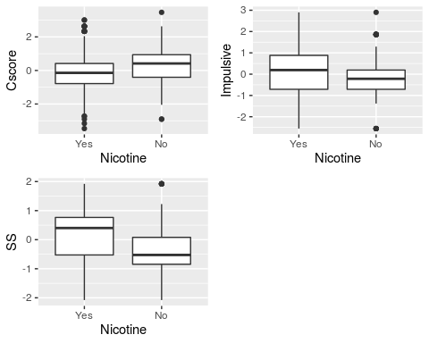

People with lower conscientiousness score levels are more likely to use nicotine. Highly impulsive people are more likely to use nicotine. People with higher sensation seeing scores are more likely to use nicotine.

**Task 4**

set.seed(123)  
rf_folds=vfold_cv(train, v=5)

drug_recipe = recipe(Nicotine ~., train) %>%  
 step_dummy(all_nominal(), -all_outcomes())  
  
rf_model = rand_forest(mtry = tune(), min_n = tune(), trees = 100) %>%   
 set_engine("ranger", importance = "permutation") %>%   
 set_mode("classification")  
  
drug_wflow =   
 workflow() %>%   
 add_model(rf_model) %>%   
 add_recipe(drug_recipe)  
  
rf_grid = grid_regular(  
 mtry(range = c(2, 8)),   
 min_n(range = c(5, 20)),   
 levels = 10)  
  
set.seed(123)  
rf_res_tuned = tune_grid(  
 drug_wflow,  
 resamples = rf_folds,  
 grid = rf_grid)

##   
## Attaching package: 'rlang'

## The following objects are masked from 'package:purrr':  
##   
## %@%, as_function, flatten, flatten_chr, flatten_dbl, flatten_int,  
## flatten_lgl, flatten_raw, invoke, list_along, modify, prepend,  
## splice

##   
## Attaching package: 'vctrs'

## The following object is masked from 'package:dplyr':  
##   
## data_frame

## The following object is masked from 'package:tibble':  
##   
## data_frame

rf_res_tuned %>%  
 collect_metrics() %>%  
 filter(.metric == "accuracy") %>%  
 select(mean, min_n, mtry) %>%  
 pivot_longer(min_n:mtry,  
 values_to = "value",  
 names_to = "parameter"  
 ) %>%  
 ggplot(aes(value, mean, color = parameter)) +  
 geom_point(show.legend = FALSE) +  
 facet_wrap(~parameter, scales = "free_x") +  
 labs(x = NULL, y = "Accuracy")

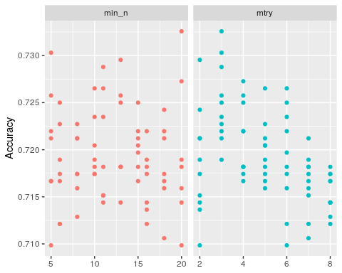

**Task 5**

best_rf = select_best(rf_res_tuned, "accuracy")  
  
final_rf = finalize_workflow(drug_wflow, best_rf)  
  
final_rf

## ══ Workflow ════════════════════════════════════════════════════════════════════  
## Preprocessor: Recipe  
## Model: rand_forest()  
##   
## ── Preprocessor ────────────────────────────────────────────────────────────────  
## 1 Recipe Step  
##   
## ● step_dummy()  
##   
## ── Model ───────────────────────────────────────────────────────────────────────  
## Random Forest Model Specification (classification)  
##   
## Main Arguments:  
## mtry = 3  
## trees = 100  
## min_n = 20  
##   
## Engine-Specific Arguments:  
## importance = permutation  
##   
## Computational engine: ranger

final_rf_fit = fit(final_rf, train)  
  
final_rf_fit %>% pull_workflow_fit() %>% vip(geom = "point")

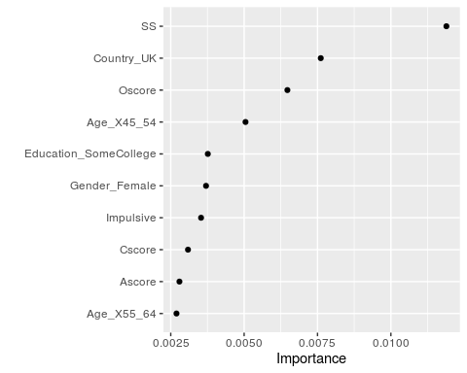

The most important variables are sensation seeing (SS), living in the UK, and openness to experience (Oscore).

**Task 6**

trainpredrf = predict(final_rf_fit, train)  
head(trainpredrf)

## # A tibble: 6 x 1  
## .pred_class  
## <fct>   
## 1 Yes   
## 2 Yes   
## 3 Yes   
## 4 No   
## 5 Yes   
## 6 Yes

confusionMatrix(trainpredrf$.pred_class, train$Nicotine,   
 positive = "Yes")

## Confusion Matrix and Statistics  
##   
## Reference  
## Prediction Yes No  
## Yes 850 171  
## No 35 264  
##   
## Accuracy : 0.8439   
## 95% CI : (0.8232, 0.8631)  
## No Information Rate : 0.6705   
## P-Value [Acc > NIR] : < 2.2e-16   
##   
## Kappa : 0.6163   
##   
## Mcnemar's Test P-Value : < 2.2e-16   
##   
## Sensitivity : 0.9605   
## Specificity : 0.6069   
## Pos Pred Value : 0.8325   
## Neg Pred Value : 0.8829   
## Prevalence : 0.6705   
## Detection Rate : 0.6439   
## Detection Prevalence : 0.7735   
## Balanced Accuracy : 0.7837   
##   
## 'Positive' Class : Yes   
##

testpredrf = predict(final_rf_fit, test)  
head(testpredrf)

## # A tibble: 6 x 1  
## .pred_class  
## <fct>   
## 1 Yes   
## 2 No   
## 3 No   
## 4 Yes   
## 5 No   
## 6 Yes

confusionMatrix(testpredrf$.pred_class, test$Nicotine,   
 positive = "Yes")

## Confusion Matrix and Statistics  
##   
## Reference  
## Prediction Yes No  
## Yes 337 121  
## No 42 65  
##   
## Accuracy : 0.7115   
## 95% CI : (0.6722, 0.7486)  
## No Information Rate : 0.6708   
## P-Value [Acc > NIR] : 0.02111   
##   
## Kappa : 0.2676   
##   
## Mcnemar's Test P-Value : 9.999e-10   
##   
## Sensitivity : 0.8892   
## Specificity : 0.3495   
## Pos Pred Value : 0.7358   
## Neg Pred Value : 0.6075   
## Prevalence : 0.6708   
## Detection Rate : 0.5965   
## Detection Prevalence : 0.8106   
## Balanced Accuracy : 0.6193   
##   
## 'Positive' Class : Yes   
##

The accuracy of the model when performed on the training set is about 84% and when performed on the test set it’s about 71%. These are slightly different so there may be some concern about consistency, but both perform much better than the no information rate of about 67%.

**Task 7**  
This model might be used in the real-world by a company that sells nicotine patches or items to stop addiction. They could use the model to understand what demographics are most likely to use nicotine and therefore who their advertisements should target the most. I would recommend this model because the accuracy is pretty high on the train and test sets but the only concern I would have is the consistency since those accuracies are slightly different from each other.