**Chapter-2**

**Organization Overview**

Chapter 2 is representing the organizational overview, mission, vision and about company’s various services. In this chapter detailed organizational overview is discussed along with the organizational hierarchy and my position over there as intern.

**2.1 Organizational Overview**

Kodeeo a full-featured web solution, software development, mobile application, graphic & multimedia, domain hosting and digital marketing service providing company in Bangladesh.

Its core with the highly qualified Designers and Developers having experience of more than 5 years in various and complex designs and development. Kodeeo has satisfied the clients with the services like Web design and development, Mobile app design and development, Software development, SEO and Social Media Designing & Development. We are customer centric and divert our efforts to act as a one-stop solution provider in the area of IT. In every area of our, operations we work hard in understanding the Client’s requirement and providing the Kodeeo solution. (Kodeeo, n.d.)

We firmly believe in the philosophy of ‘Our vision is to make every youth skilled & employed’. We take pride in a team of highly qualified, skilled and motivated Professionals who are encouraged to lead, innovate and excel. Our team consists of top professionals who share a common vision and passion, providing our clients with critical insights and advice to succeed in today’s competitive environment. We believe in delivering Expertise, Excellence Services through our past Experience and providing the highest and best end use of services to our client. (Kodeeo, n.d.)

**2.2 Organization Services**

Kodeeo is an Information Technology service provider organization which provides all kinds of professional and creative software, Enterprise software integration, Management info system, E-commerce, Game development, Web development & Mobile app solutions globally.

**Web Development**: At Kodeeo we focus on creating search engine friendly, aestheticallyappealing and interactive website designs. It is a known fact that to build a strong web presence and to secure the countless marketing opportunities available on the internet, a good website is imperative, thus triggering a race for website design while designing and developing your website, our professionals keep in mind key factors like easy-navigation, overall consistency and content quality, stipulated timeframes and budget and backend support.

**Mobile Application:** We have a strong mobile application developer team of expert engineerswhose have the experience to build versatile mobile applications for various industries. All of our expert engineer working in android and IOS platform for more than five years. We work on native android which provide faster response of app and ensure the quality. We can design, build, prototype and implement your idea through a process of planning, building, testing, and deployment.

**Domain and Hosting Service Provider:** Kodeeo offers unbeatable, unlimited & lowest costweb hosting in Bangladesh, Complete with all the tools and apps you need. Make life easy with everything under the one roof. We are offering shared hosting packages like Linux shared hosting and windows shared hosting packages. Shared hosting is a good choice for new websites. If you are having a new website then you should use shared hosting. We are offering these packages at a reasonable price. You can choose any of them as your preference.

**Digital Marketing:** Kodeeo offer various kinds of packages to make your company best in theinternet world. Digital Marketing means promoting a product or brand which is very much essential to make a business successful. It increases visibility on web to your potential customers. As much as you are visible, you are getting closer to your business goal. It’s your most important strategy to expand your business. Kodeeo is a full-service digital agency that has clients ranging from renowned companies to innovative startups. (Kodeeo, n.d.)

**2.3 Organization Location**

54/B, Molla Bari, Kawlar Bazar, Uttara, Dhaka – 1230

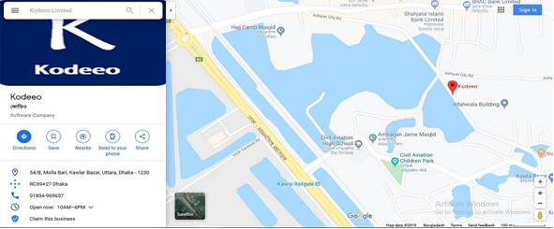

**Figure-2. 1: Organization Location**

Source (Kodeeo, n.d.)

**2.4 Organization Vision**

The mission of Kodeeo is to become a top leading IT company of Bangladesh and their vision is to empower the youth and become a successful IT company of digital Bangladesh. Kodeeo achieves competitive edge and has gained operational effectiveness and efficiency through the innovative use of technology. (Kodeeo, n.d.).

**2.5 Organization Mission**

Kodeeo was born as a one stop skills development platform provider. Their offerings coupled with the impeccable team behind it ensure satisfaction of client needs in relation to their characteristics (Kodeeo, n.d.).

**2.6 My position in this Organization**

I am an intern developer to this organization. I am guided by a supervisor in this organization. He is very helpful and informative. I really learn a lot from him. I successfully completed my project in time. It was only possible by the guidance of my supervisor. It was also a big experience to maintain the office time for me. I also maintain the other rules of this organization. I am really happy to work with this office. It’s really made me prepare for the beginning of my career. (Kodeeo, n.d.)

**2.7 Organizational Structure**

The structure of my organization is drawn below:

Founder & Chairman

Technical Lead

Team Leader

HR & Account Manager

Graphics Designer

Developer

Office Assistant

**Figure-2. 2: Organization Structure of Kodeeo**

Source (Kodeeo, n.d.)