# Chapter 1

# Project Introduction

Internship is a practical experience of theoretically gained knowledge and can measure as a groundwork trial to be aware of any organization and to make oneself confident enough to enter into service life and start building a career. And, wonderful and effective way to connect academic experience with the professional working area. It allows gaining valuable experience in the workplace, provides the opportunity for skill development, and gives a competitive edge in the job search. This chapter attempts to describe the objectives, scope and all topics of the initialization period of this project.

## 1.1 Introduction

Development of Human Resource Management System for Kodeeo is a set of process and technologies that manages and store information of employee, department, attendance, job and interview details, office holidays, notice and leave.

Preserving information of employees and store are the main goal of this project. Development of Human Resource Management System for Kodeeo is an inherently collaborative process. I have completed this project using “Incremental Process Model”. This report based on the project that I have completed in the course CSC 490. In this report I have described how I developed this system and how it will work.

## 1.2 Background of Study

Before developing the project I have studied on some human resource management system, human information management system, also studied on some documents regarding on human resource management system. By studying on them I have found some differences between the systems and manual. So, by studying on them found some points those can be implemented on a new system to make the system more convenient to the users. The aim is to automate its existing manual system by the help of computerized equipment’s and full-fledged computer software, fulfilling their requirements. So that their valuable data /information can be store for a longer period with easy accessing and manipulation of the same. Basically the project describes how to manage for good performance and better services.

## 1.3 Objectives

The main objective of the project on Human Resource Management System is to manage details of Department, Employee, Job and interview, Office holidays, Attendance, Leave and Notice. The project is totally built at administrative end. The purpose of the project is to build on application program to reduce the manual work.

### 1.3.1 Broad Objectives

The broad objective of this project is to develop software to manage all the information and track down records of Department, Employee, Job and interview, Office holidays, Attendance, Leave and Notice and other related issues.

### 1.3.2 Specific Objectives

The specific objectives of this project are:

1. To store department, employee, available jobs and interview details.

2. To manage all leave, notice and attendance record.

3. To reduce duplication of information.

4. To give power to HR(admin) to control the accessibility to the system.

5. To improve information accuracy

## 1.4 Proposed System’s Benefits

**1. Time Effective:** The “Development of Human Resource Management System for Kodeeo” will save **HR**(admin) and employee’s time. It’s easy to manage all information.

**2. Improve Efficiency:** Process automated using software would mean that the processes will be taken care of mechanically without any human intervention and this will instantly ensure improve efficiency.

**3. Data Security and Retrieve ability:** All the personal information of user is safe and secured. Only the authorized personnel getting access to it and retrieving the data in the minimum possible time.

**4. New Technology:** For building the system some new technologies are used here which makes the faster compilation of the system. This new technology added multiple validators for array method and multi-step form of Laravel.

## 1.5 Methodology

For this project in data collection phase I collected primary and secondary data. Kodeeo provided with all type of primary and secondary data needed to develop the system. The procedures and processes that I followed to develop this system are clearly described in the Analysis and Design chapter with illustrations.

### 1.5.1 Data Sources

For this project in data collection phase I collected two types of data

* Primary Data
* Secondary Data

**Primary Data:** Primary data are generated within the organization. Actually, the primary data are collected through the practical experience, observation, and face-to-face interview with both operators and user.

**Secondary Data:** Secondary data are generated by real life experience and studying different articles, newspapers, and research papers and of course information collected via Internet. Data, facts and statistics collected from different web sites and sources made us understand the project better.

## 1.6 Limitation

The project has some limitation those I have planned to develop in futures. These are

* In this software there is no forget password function.
* This system and system security must be monitored and maintained.
* Pay roll management and some other module is needed which is added later.
* There is no sign-up facility for new employee. Only HR(admin) can add new employee.

## 1.7 Process Model

In this project, the Incremental Model is being used. In an incremental model, the whole requirement is divided into various builds. Multiple development cycles take place here, making the life cycle a “multi-waterfall” cycle. Cycles are divided up into smaller, more easily managed modules. An incremental model is a type of software development model like the V-model, Agile model, etc.

Here in figure 1.1, the incremental process model is shown:

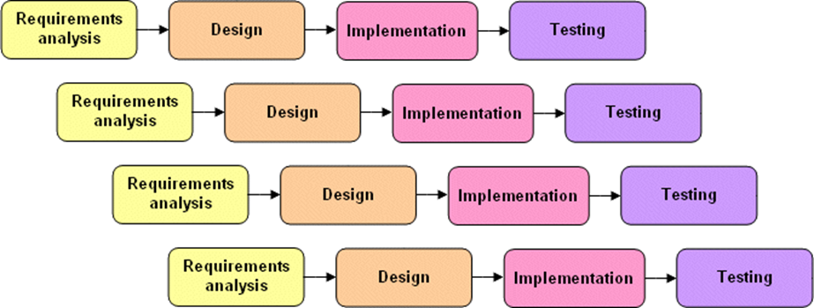

Figure 1.1 Incremental Process Model

### 1.7.1 Reason for Choosing Incremental Process Model

* Provides better support for process iteration.
* Reduces rework in the software construction process.
* As it reduces rework in coding, it is time efficient.
* Allows early delivery of parts of the system.
* Supports easier integration of sub-systems.
* Lower risk of project failure.
* Delivery priorities can be more easily set.

## 1.8 Feasibility Study

A feasibility study is made to see if the project on completion will serve the purpose of the organization for the amount of work, effort and the time that spend on it. Feasibility study lets the developer foresee the future of the project and the usefulness. A feasibility study of a system proposal is according to its workability, which is the impact on the organization, the ability to meet their user needs and the effective use of resources. Thus, when a new application is proposed it normally goes through a feasibility study before it is approved for development.

The document the feasibility of the project that is being designed and lists various areas that were considered very carefully during the feasibility study of this project such as technical, economic and operational feasibility. The following are its features:

### 1.8.1 Technical Feasibility

The system must be evaluated from the technical point of view first. The assignment of this feasibility must base on an outline design of the system requirement in terms of input, output, programs, and procedures. Having identified and outline system, the investigation must go to suggest the type of equipment, required method developing the system, of running the system once it has been designed. Technical issues are raised during the investigation are:

* Is it possible to develop the proposed system using the current technical resource?
* If not, can current technical resources be upgraded or added to in a manner that fulfills the request under consideration?
* Is there technology in existence that meets the specifications?

The project should be developed such that the necessary functions and performance are achieved within the constraints. The project is developed within the latest technology. Through the technology may become obsolete after some period of time, due to the fact that the newer version of the same software supports older versions, the system may still be used. So, there is minimal constant involved with this project. The system has developed using PHP the project is technically feasible development.

### 1.8.2 Economical Feasibility

Economic feasibility determines whether value of the investment exceeds the time and cost. The basic resources to consider our time, the cost of the full system study including the time of client and employees of the company with whom we are working, the estimate cost of hardware, the estimate cost of software, software development or software customization. The developing system must be justified by the coast and benefit. A criterion to ensure that effort is concentrated on the project, which affects the development of a new system, is the cost it would require. The following are some of the important financial questions asked during the preliminary investigation:

* The cost conducts a full system investigation.
* The cost of hardware and software.
* The benefits in the form of reduced costs or fewer costly errors.

Since the system is developed as part of project work, there is no manual cost to spend on the proposed system. Also, all the resources are already available, it gives an indication of the system is economically possible for development. Our developed system is economically feasible. When we compare the total cost and benefits from the system at that time, we see that our client will be beneficial from this system.

### 1.8.3 Operational Feasibility

Operational feasibility determines if the human resources are available to operate the system once it has been installed. Users that do not want a new system may prevent it from becoming operationally feasible. If users are virtually use the present system, see no problem with it and generally not involve in requesting a new system, resistance to implementing the new system will be strong. The new system has a low chance to become operational.

This includes the following questions:

* Will the proposed system cause harm?
* Is there sufficient support for the users?

The project would be beneficial because it satisfies the objectives when developed and installed. All behavioral aspects are considered carefully and conclude that the project is behaviorally feasible.