Question Foreach Loop
1.
$arr1=[1,2,3,4,5];
$arr2=[6,7,8,9,10];
$twodim=[$arr1,$arr2];

Output:
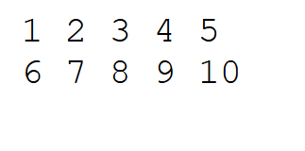
2.
$arr=array(
array(10,100,101),
array(120,130,140),
array(150,90,80)
);
Output:

