KeyClaok
WE can achieve SSO using keycloak as centeral service(IDP) for all apps or keycloak can be configured with other IDP(google, facebook etc).
There is another way such that app1 have external IDP like google and app2 have IDP keycloak. If user logged in app1 using google and then redirect to app2. App1 need to pass google token to app2 while redirecting, then app2 will use keycloak to exchange google token to get keyclaok access token.

External token to internal token exchange:
The current limitation on external token exchanges is that if the external token maps to an existing user an exchange will not be allowed unless the existing user already has an account link to the external identity provider.
External Token Exchange: This refers to the process of exchanging a token obtained from an external identity provider or authentication service for a token that can be used within a different system or service. For example, exchanging a token obtained from Google for a token that can be used to authenticate and access resources in a different service like Microsoft Azure.
Mapping to an Existing User: When a user authenticates with an external identity provider (such as Google, Facebook, etc.), they are typically assigned a unique identifier (like an ID or email address) by that provider. This unique identifier may already exist within the system or service where the token exchange is taking place.
Exchange Not Allowed: The limitation arises when the system performing the token exchange requires that the user associated with the external token already exists within its own user database or identity management system.
Existing User without Account Link: Even if the user exists within the system where the token exchange is happening, if they haven't previously linked their account to the external identity provider, the exchange won't be permitted. This means that the system requires some form of association or link between the user's existing account within the system and their external identity provider account before allowing the token exchange to proceed.

Facing challenge while exchanging external token with keycloak:
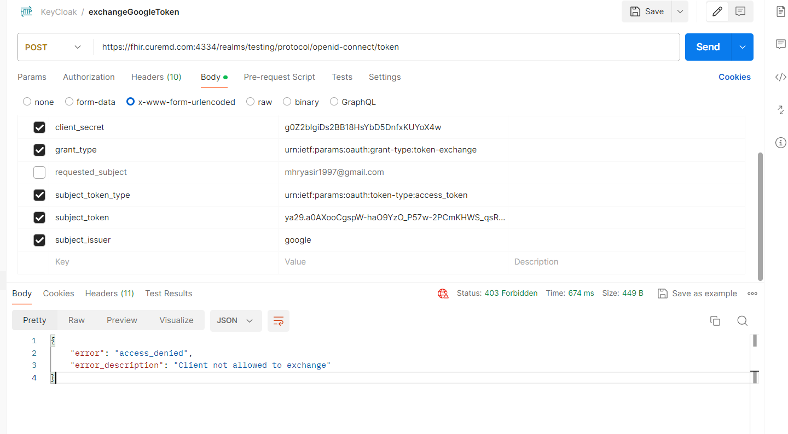

- IF user already exist in keycloak then on exchanging google token with keycloak we got this:
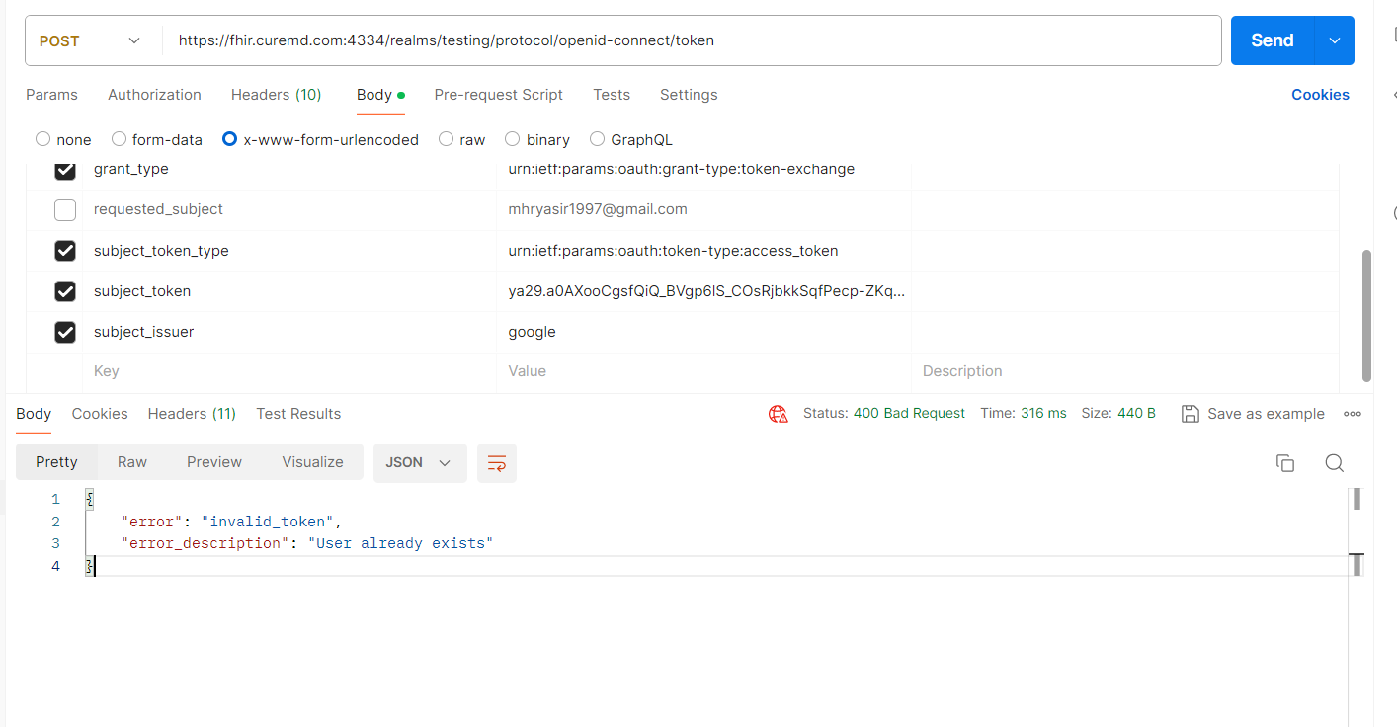
2. If user did not exist in keycloak then on exchanging google token with keycloak will return keycloak access_token and refresh token.

