Keycloak Email OTP Authenticator Configuration

Production Environment
**Email OTP Authenticator Config**
Alias: Email OTP Authenticator
Authenticator Reference:
Authenticator Reference Max Age:
Code length: 4
Time-to-live: 600
Max Resend Attempts: 10000
Resend Timer (seconds): 60
Novu URI: https://novu.novelhealth.ai/v1/events/trigger
API Key: 3645ff7f93c6c2de22957af23f4edf8a
Novu Workflow Name: keycloak-otp
Token URL: https://nhub.curemd.com/NotificationHub/connect/token
Token Request Body:
client_id=6d8ce997-3836-46e0-93fb-81aa3c850961&client_secret=07aebbe7e-cb73-4f21-b2f5-2809823af8522&username=novelhealth&password=9d887cd90ea0be0c09c97e98a30c1f752c3821347d34c5e6d1208a0373bf3b68&grant_type=password
SMS URL: https://nhub.curemd.com/NotificationHub/sms/send
SMS Message Template: Hi {otpModel.FirstName}, your LEAP verification code is {otpModel.OTP}. If not requested, please ignore.
SMS Message Type: Appointment Request

Staging Environment
**Email OTP Authenticator Config**
Alias: 2FA Auth
Authenticator Reference:
Authenticator Reference Max Age:
Code length: 4
Time-to-live: 600
Max Resend Attempts: 10000
Resend Timer (seconds): 60
Novu URI: https://kube.novelhealth.ai:3000/v1/events/trigger
API Key: 3645ff7f93c6c2de22957af23f4edf8a
Novu Workflow Name: keycloak-otp
Token URL: https://staging-nhub.curemd.com/NotificationHub/connect/token
Token Request Body:
client_id=6d8ce997-3836-46e0-93fb-81aa3c850961&client_secret=07aebbe7e-cb73-4f21-b2f5-2809823af8522&username=novelhealth&password=9d887cd90ea0be0c09c97e98a30c1f752c3821347d34c5e6d1208a0373bf3b68&grant_type=password
SMS URL: https://staging-nhub.curemd.com/NotificationHub/SMS/Send
SMS Message Template: Hi {otpModel.FirstName}, your LEAP verification code is {otpModel.OTP}. If not requested, please ignore.
SMS Message Type: Appointment Request

cURL Requests
To get Token for SMS:
curl --location 'https://nhub.curemd.com/NotificationHub/connect/token' \
--header 'Content-Type: application/x-www-form-urlencoded' \
--data-urlencode 'client_id=6d8ce997-3836-46e0-93fb-81aa3c850961' \
--data-urlencode 'client_secret=07aebbe7e-cb73-4f21-b2f5-2809823af8522' \
--data-urlencode 'username=novelhealth' \
--data-urlencode 'password=9d887cd90ea0be0c09c97e98a30c1f752c3821347d34c5e6d1208a0373bf3b68' \
--data-urlencode 'grant_type=password'
To send SMS:
curl --location 'https://nhub.curemd.com/NotificationHub/sms/send' \
--header 'Content-Type: application/json' \
--header 'Authorization: ••••••' \
--data '{
"ToNumber": "+923088976140",
"Message": "test",
"MessageType": "Appointment Request",
"RecipientConsent": false
}'
To create Novu Subscriber:
curl --location 'https://kube.novelhealth.ai:3000/v1/subscribers' \
--header 'Authorization: ApiKey 3645ff7f93c6c2de22957af23f4edf8a' \
--header 'Content-Type: application/json' \
--data-raw '{
"subscriberId": "mhryasir",
"email": "mhryrehman@gmail.com",
"firstName": "Mehar",
"lastName": "Yasir"
}'
To trigger Novu Event:
curl --location 'https://novu.novelhealth.ai/v1/events/trigger' \
--header 'Authorization: ApiKey 3645ff7f93c6c2de22957af23f4edf8a' \
--header 'Content-Type: application/json' \
--data '{
"name": "keycloak-otp",
"to": {
"subscriberId": "mhryasir"
},
"payload": {
"firstName": "Yasir",
"otp": "987654",
"expiry": "300"
}
}'

Novu Email Template

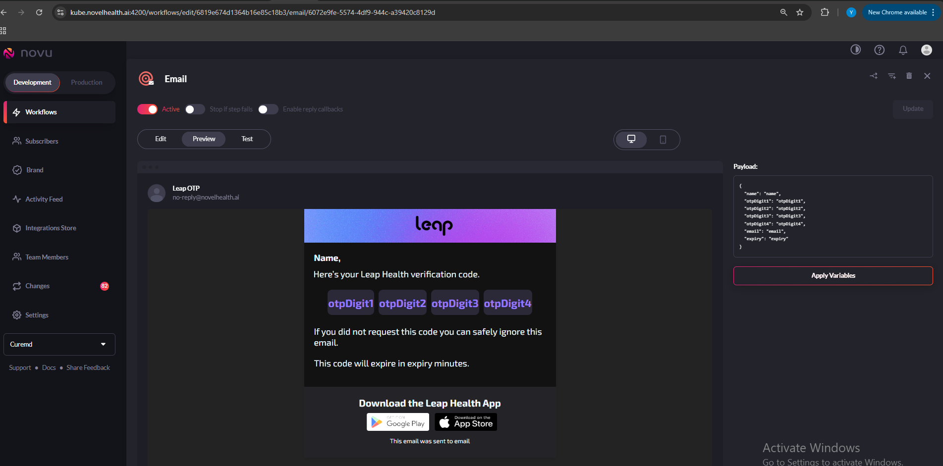

Below is the HTML template used in Novu for sending the OTP email:
<!DOCTYPE html>
<html lang="en">

<head>
<meta charset="UTF-8">
<meta name="viewport" content="width=device-width, initial-scale=1.0">
<title>Email Template</title>
<link href="https://fonts.googleapis.com/css2?family=Exo+2:wght@400;700&display=swap" rel="stylesheet">
</head>

<body style="margin: 0; padding: 0; font-family: 'Exo 2', Arial, sans-serif; background-color: #F4F4F4;">
<table width="100%" cellpadding="0" cellspacing="0" border="0" style="background-color: #F4F4F4;">
<tr>
<td align="center">
<table cellpadding="0" cellspacing="0" border="0"
style="background-color: #ffffff;border-radius: 10px; box-shadow: 0px 4px 8px rgba(0, 0, 0, 0.1); width: 500px;">
<td align="center"
style="background-image: url('https://leap-email-template.s3.amazonaws.com/templates/Leap+Images/leap-header-background.png'); background-size: cover; background-repeat: no-repeat; background-position: center center; padding: 10px 0; background-color: #7F65ED; min-height: 55px; max-height: 90px;">
<table width="100%" cellpadding="0" cellspacing="0" border="0">
<tr>
<td align="center" style="padding-left: 20px;">
<img src="https://leap-email-template.s3.amazonaws.com/templates/Leap+Images/leap-logo.png" alt="Leap Logo"
style="display: block; height: 55px; width: 110px;" height="55" width="110">
</td>
</tr>
</table>
</td>
</tr>
<!-- Greeting -->
<tr>
<td align="center" style="padding: 20px; color: #1B2228;">
<table>
<tr>
<td style="font-size: 20px; font-weight: 700;text-transform: capitalize;">{{name}},</td>
</tr>
<tr>
<td style="padding:10px 0 0; font-size: 20px; font-weight: 400;">Here’s your Leap Health verification code. </td>
</tr>

<tr>
<td style="padding:10px 20px">
<table style="width: 100%;">
<tr>
<td align="center">
<table cellspacing="10" border="0">
<tr>
<td
style="font-size: 24px; color: #7F65ED; background: #ECE8FC; border-radius: 10px; border: 0; height: 55px; width: 55px; text-align: center; font-weight: 600;">
{{otpDigit1}}</td>
<td
style="font-size: 24px; color: #7F65ED; background: #ECE8FC; border-radius: 10px; border: 0; height: 55px; width: 55px; text-align: center; font-weight: 600;">
{{otpDigit2}}</td>
<td
style="font-size: 24px; color: #7F65ED; background: #ECE8FC; border-radius: 10px; border: 0; height: 55px; width: 55px; text-align: center; font-weight: 600;">
{{otpDigit3}}</td>
<td
style="font-size: 24px; color: #7F65ED; background: #ECE8FC; border-radius: 10px; border: 0; height: 55px; width: 55px; text-align: center; font-weight: 600;">
{{otpDigit4}}</td>
</tr>
</table>
</td>
</tr>
</table>
</td>
</tr>

<tr>
<td style="font-size: 20px; font-weight: 400; padding-bottom: 20px;">If you did not
request this code you can safely ignore this email.</td>
</tr>

<tr>
<td style="font-size: 20px; font-weight: 400;padding-bottom: 20px;">This code will
expire in {{expiry}} minutes.</td>
</tr>

</table>
</td>
</tr>

<!-- Footer -->
<tr>
<td align="center" style="background-color: #F2F2F7; color: #1B2228; padding: 20px 0;">
<table width="100%">
<tr>
<td align="center" style="font-size: 22px; font-weight: 700; padding-bottom: 8px;"
colspan="2">
Download the Leap Health App</td>
</tr>
<tr>
<td align="right" style="padding-right: 10px; padding-bottom: 8px;">
<a href="https://play.google.com/store/apps/details?id=com.curemd.leap"><img
src="https://leap-email-template.s3.amazonaws.com/templates/Leap+Email+Acess/app-store.png"
alt="Download on the App Store" style="width: 140px;height: 40px;"
width="140" height="40"></a>
</td>

<td style="padding-bottom:8px;">
<a href="https://apps.apple.com/app/1659618898"><img
src="https://leap-email-template.s3.amazonaws.com/templates/Leap+Email+Acess/apple-store.png"
alt="Get it on Google Play" style="width: 140px;height: 40px;"
width="140" height="40"></a>
</td>
</tr>
<tr>
<td align="center" style="padding-bottom: 8px; font-size: 14px; font-weight: 500;"
colspan="2">
This email was sent to {{email}}</td>
</tr>

</table>
</td>
</tr>
</table>
</td>
</tr>
</table>
</body>

</html>

