**FCIT**

**FACULTY OF COMPUTING AND INFORMATION TECHNOLOGY**



**Final Project Proposal Guide**

**Version 1.0**

Table of Contents

Final Project Proposal Guide

**1. Introduction 3**

1.1 Project Title 3

1.2 Project Overview Statement 3

1.3 Project Goals & Objectives 4

1.4 High-level system components 4

1.5 List of optional functional units 4

1.6 Exclusions 5

1.7 Application Architecture 5

1.8 Gantt chart 6

1.9 Hardware and Software Specification 7

1.10 Tools and technologies used with reasoning 7

# Introduction

# Project Title

ANDROID-BASED **TUTOR HUNT** APP

# 1.2 Project Overview Statement Template

|  |
| --- |
| **PROJECT TITLE:**  ANDROID BASED **TUTOR HUNT** APP |
| **GROUP LEADER:**  IQRA JUNAID |
| **PROJECT MEMBERS:**   |  |  |  | | --- | --- | --- | | NAME | ROLL NUMBER | EMAIL ADDRESS | | MAHNOOR SHOUKAT | BSEF19A502 | bsef19a502@gmail.com | | IQRA JUNAID | BSEF19A511 | bsef19a511@gmail.com | | HASSAN ZAHID | BSEF19A513 | bsef19a513@gmail.com | | ASIM AFZAL | BSEF19A542 | bsef19a542@gmail.com | |
| **PROJECT GOAL:**  The main goal of this project is to provide an application for users to find a tutor online. |
| **OBJECTIVES:**  The objective of our project is to make a user-friendly, time and cost- efficient application of an online tutor finder through which a user can find a tutor- check his qualification, contact them, hire them and give feedback about them. |
| **PROJECT SUCCESS CRITERIA:**  A user-friendly platform where a user will find a tutor according to his/her requirements. |
| **RISKS AND OBSTACLES:**   * Time constraint due to university work load * A risk to meet user’s satisfaction as users have different requirements that are not feasible to implement all in one. * Difficulty in learning new technologies. |
| **TYPE OF PROJECT:**  Development |
| **TARGET END USERS:**  Admin and Users (Tutors, Students and Parents) |
| **DEVELOPMENT TECHNOLOGY:**   * HTML, CSS, JS and JSX * React Native for mobile app * MERN for web version |
| **PLATFORM:**  Mobile-based application |
| **PROJECT SUPERVISOR:**  Dr Shahid Farid |
| **APPROVED BY:** |
| **DATE:** |

# 1.3 Project Goals & Objectives

To develop a mobile and web based app in which tutors can register themselves and post their qualification and availability to teach. Similarly, the students can register themselves and search for tutor according to their requirements. If they find a tutor then they can communicate with him/her via this platform to discuss all the details. A student can also request for a free demo lecture online using this platform and there will be no need to communicate with them or take a demo lecture using any other app. After hiring a tutor, a student can also give a review and feedback about him/her.

# 1.4 High Level System Component

Following are the high-level system components of this application:

* Sign Up
* Login/Logout
* Register as a tutor
* Register as a student
* Search for available tutors
* View tutor details
* Choose a tutor
* Communicate with tutor
* Hire a tutor
* Give feedback and review about the hired tutor

# 1.5 List Of Optional Functional Units

Following are the optional features that we might implement according to availability of time:

* Real Time Communication with tutor on voice call and video call
* Web based version for “Tutor Hunt” mobile app

# 1.6 Exclusions

Exclusions are description of tasks that we are not including in our project scope. These exclusions are:

* Tutor payment/salary module will not be included because of time constraint, resources and real time issues.
* Visual representation of tutor’s address will also not be included.

# 1.7 Application Architecture

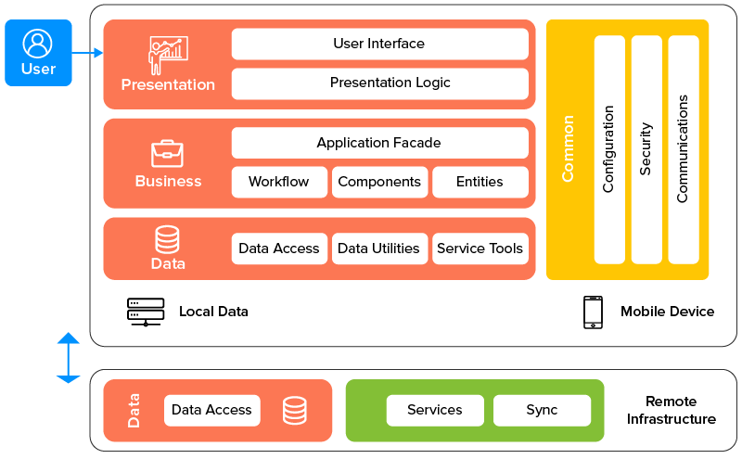

# 1.8 Gantt Chart

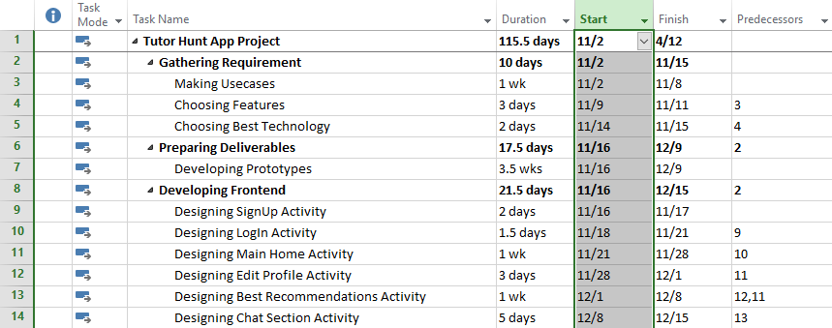

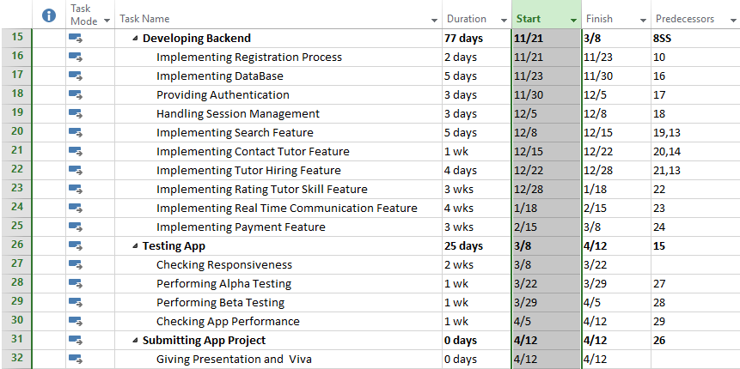

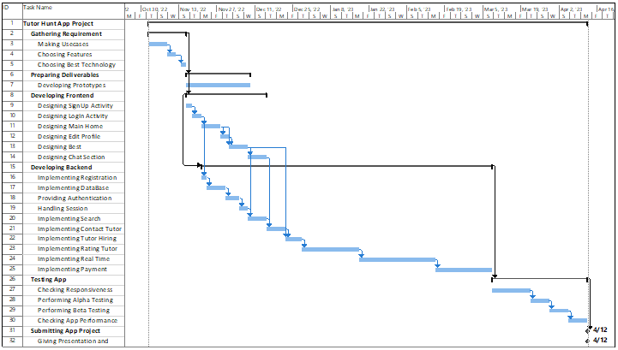

**1.9 Hardware and Software Specification**

**Hardware**

* Laptop or desktop with medium specifications
* Android mobile phone with new generations

**Software**

* Android play store
* Android emulators
* Windows
* Web browser --- Chrome

**1.10 Tools and Technologies used with reasoning**

**Technologies**

* HTML / JSX for general UI purposes
* CSS for designing purposes
* JS for some dynamic operations
* React Native --- Main Tech Stack for our tutor mobile App
* MERN --- For its web version

**Tools**

* VS Code --- IDE for coding
* Browser inspection window tool for little design manipulations testing
* Npm --- Node JS
* MongoDB Compass --- Database purposes
* JWT authentication
* Heroku --- For deployment
* Android emulators for testing and running
* GitHub Desktop for Version control system