Task 1:
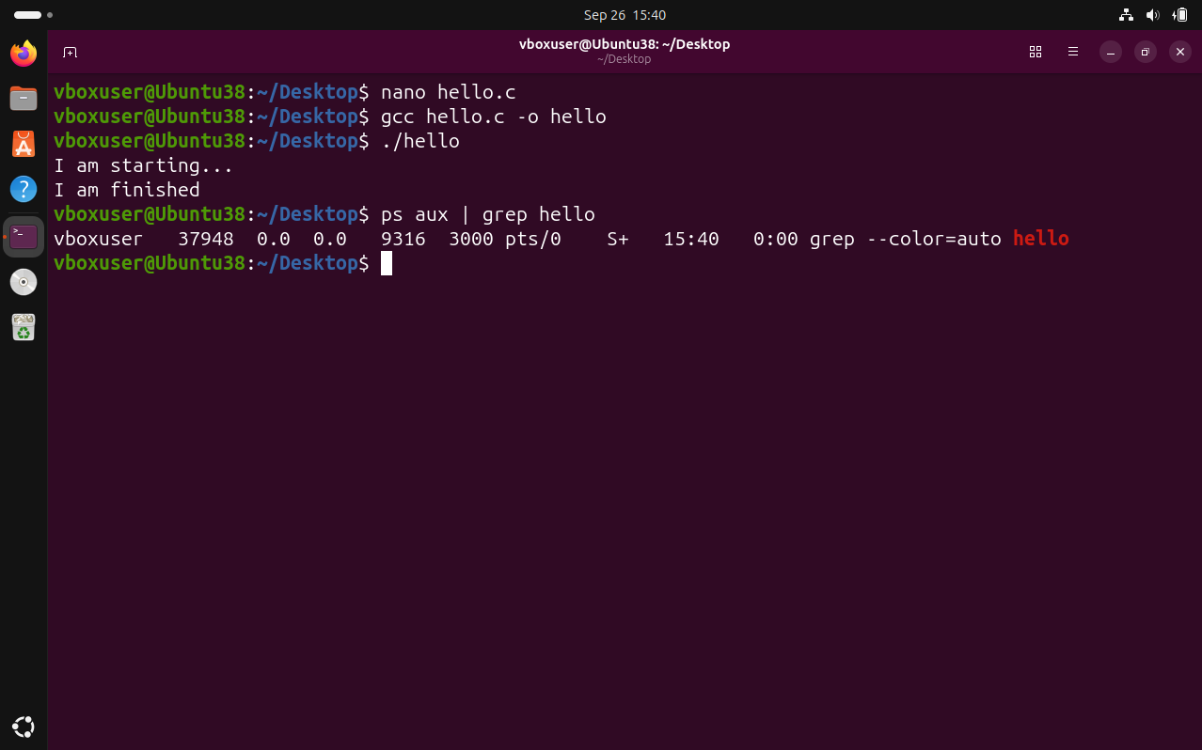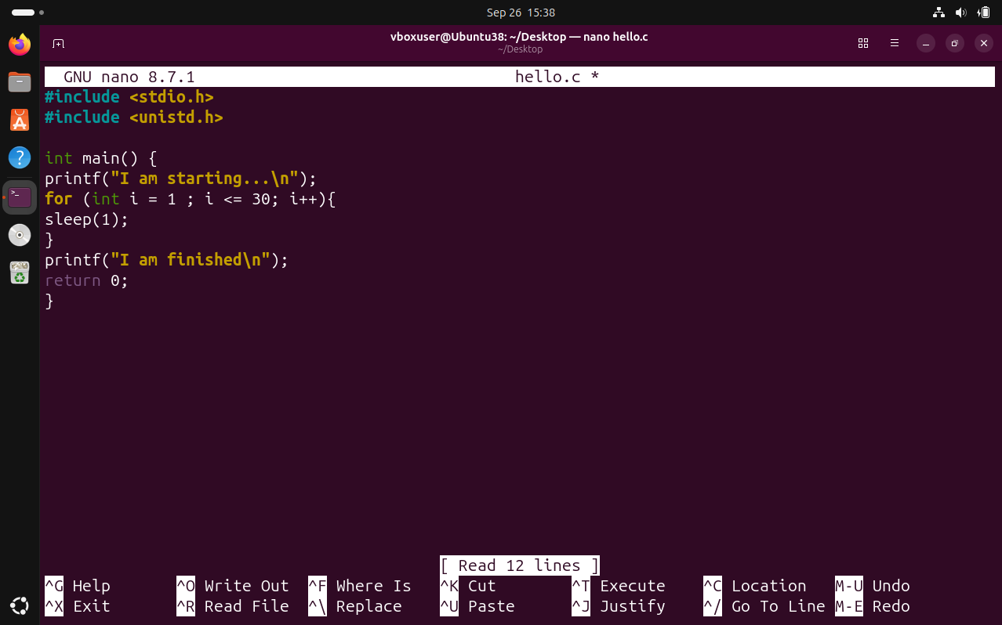

Task 2:
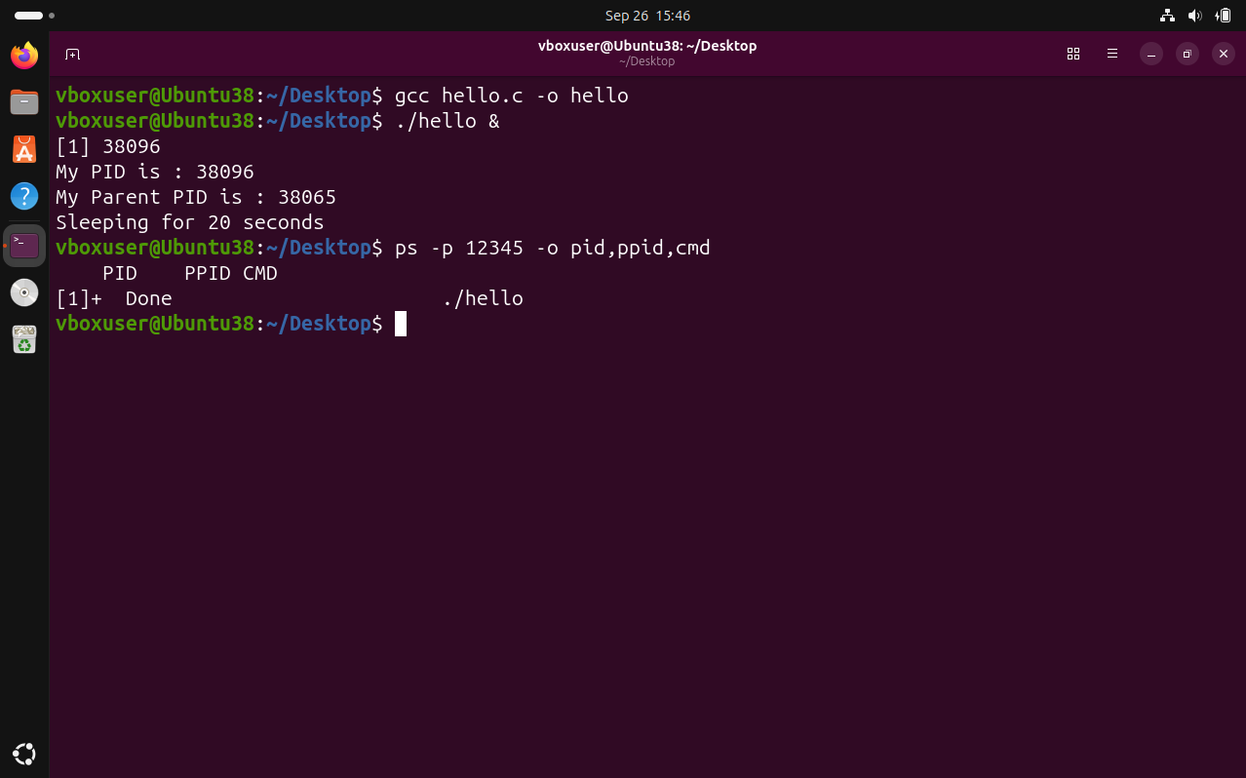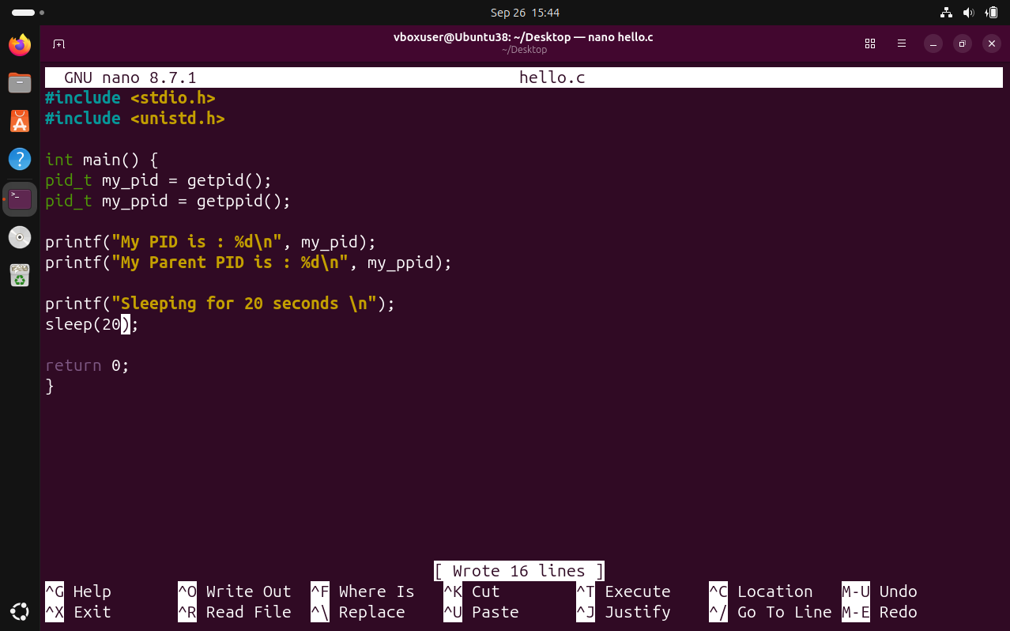

Task 3:
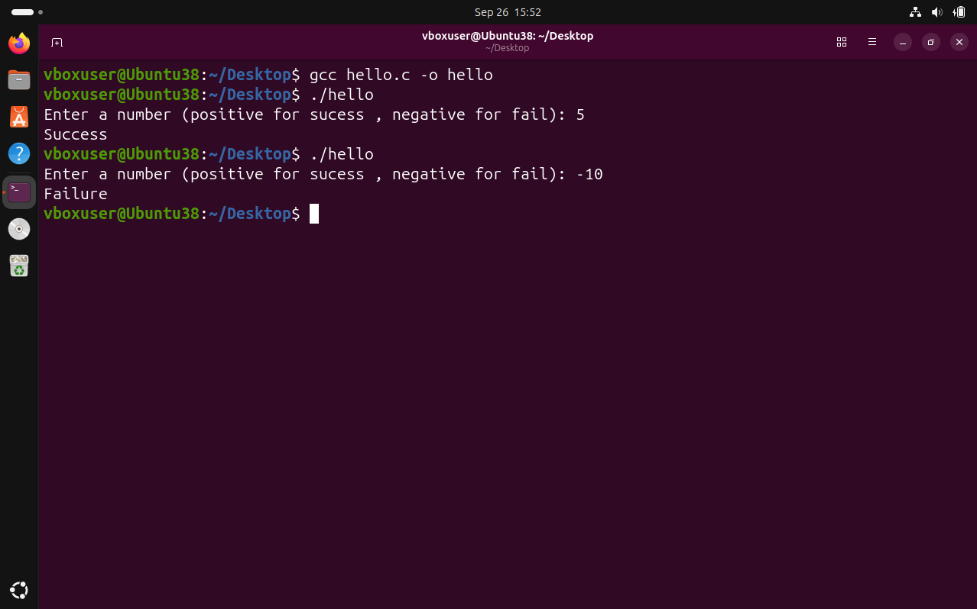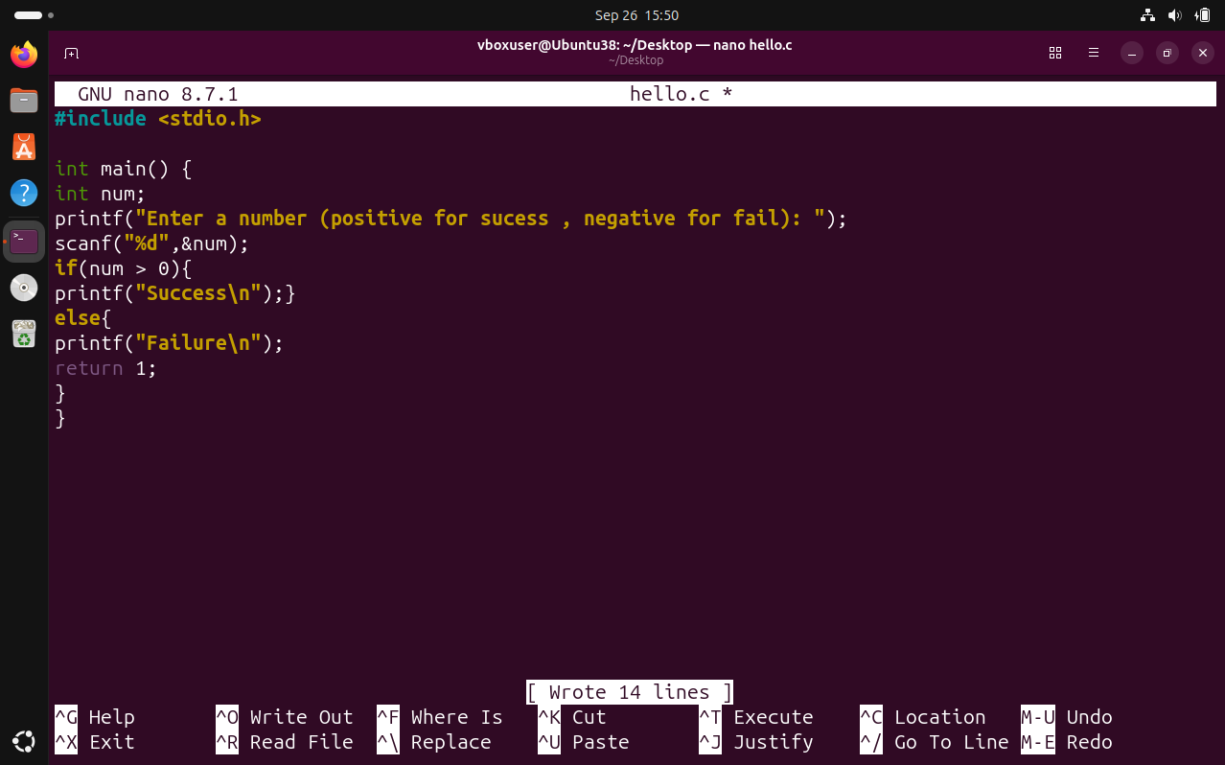

Task 4:
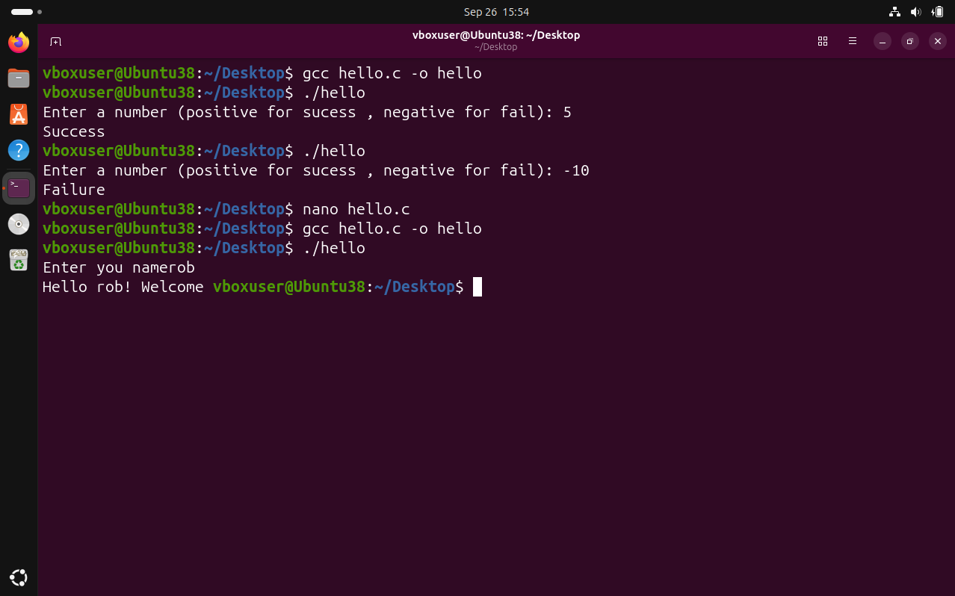
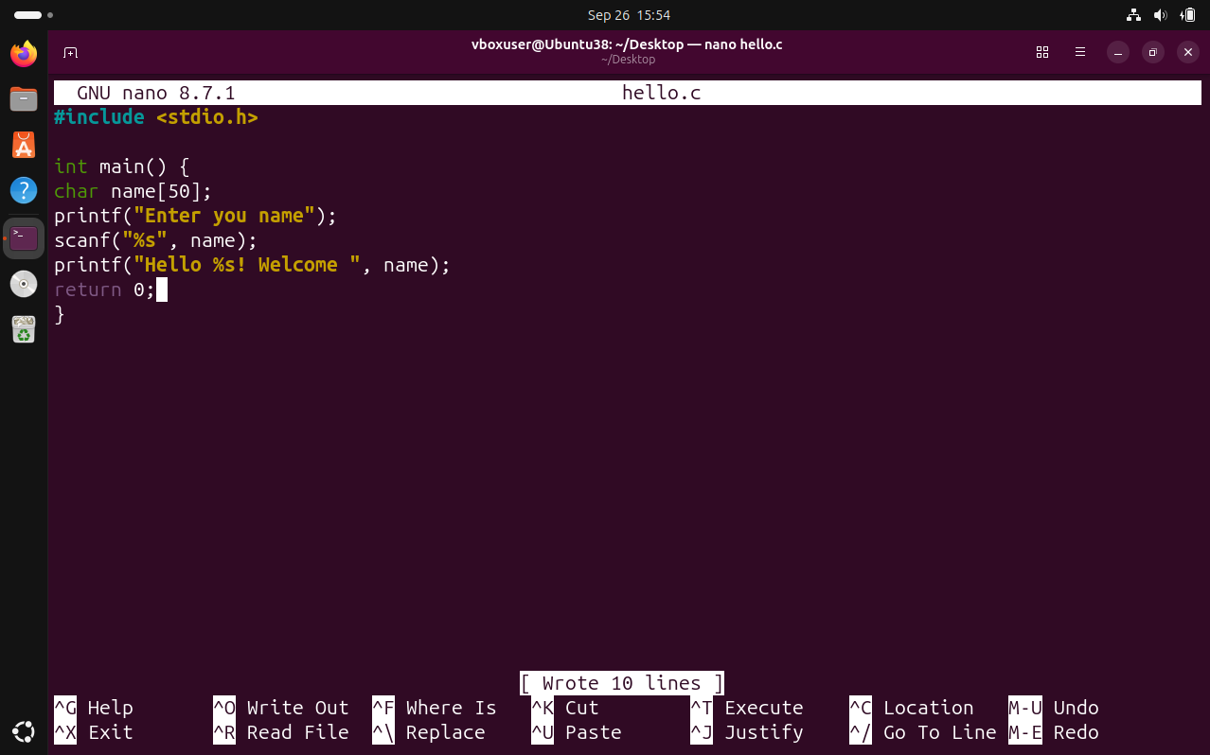

Lab 3 – OS Processes and Resources
This lab demonstrated how user programs interact with the Linux kernel to manage process identity, execution time, and I/O streams.
- Task 1 showed a long-running process (30 seconds) using sleep(). Running it in the background with & allowed real-time monitoring via ps aux, illustrating how enterprise servers keep processes alive for extended periods.
- Task 2 used getpid() and getppid() to retrieve the process's own PID and its parent's PID. The ps -p <PID> -o pid,ppid,cmd command confirmed the kernel's view matched the program's output.
- Task 3 demonstrated exit codes as OS feedback. Returning 0 signaled success and 1 signaled failure, with the shell variable $? capturing the result. This is fundamental for scripting and error handling.
- Task 4 illustrated standard I/O streams: scanf reads from stdin and printf writes to stdout, showing how the OS abstracts input/output devices for processes.
Overall, the lab connected OS theory (process management, resource monitoring, exit status, I/O abstraction) with practical Linux system programming.

