QN.1
The #include directive is a preprocessor command that inserts the contents of another file (usually a header file) into the source code before compilation. It provides access to function declarations, macros, and constants defined in libraries.

QN2.
- Preprocessing - Expands headers and macros
- Compiling - Translates C code to assembly
- Assembling - Converts assembly to machine code
- Linking - Combines object files and libraries into an executable
Qn3
- Return 0: Indicates the program executed successfully without errors. The OS receives an exit status of 0.
- Non-zero return: Indicates the program encountered an error or abnormal termination. The specific non-zero value can be used to identify the type of error.
Qn4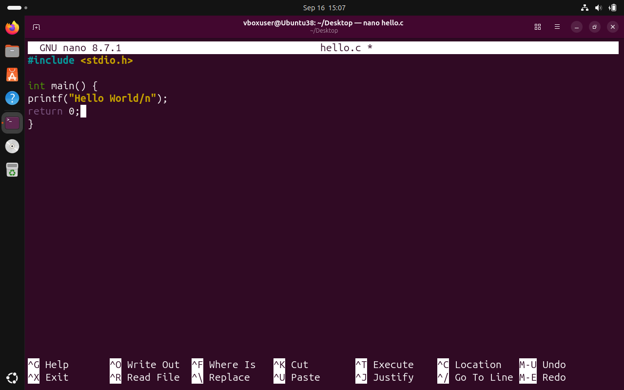

QN5
- Only preprocess a file without compiling?
- Generate assembly code but not assemble it?
- Create an object file without linking?
A:
- Preprocess only: gcc -E hello.c -o hello.i
- Generate assembly: gcc -S hello.i -o hello.s (or gcc -S hello.c -o hello.s)
- Create object file: gcc -c hello.s -o hello.o (or gcc -c hello.c -o hello.o)

Qn6.
A: C is called a compiled language because the entire source code must be translated into machine code by a compiler before it can be executed. The compilation process produces a standalone executable file.
Difference from interpreted languages:
- Compiled languages (C): Source code → Compiler → Machine code → Execution. Faster execution but requires compilation step.
- Interpreted languages (Python, JavaScript): Source code → Interpreter → Execution line by line. Slower execution, but no separate compilation step needed.

Task
1
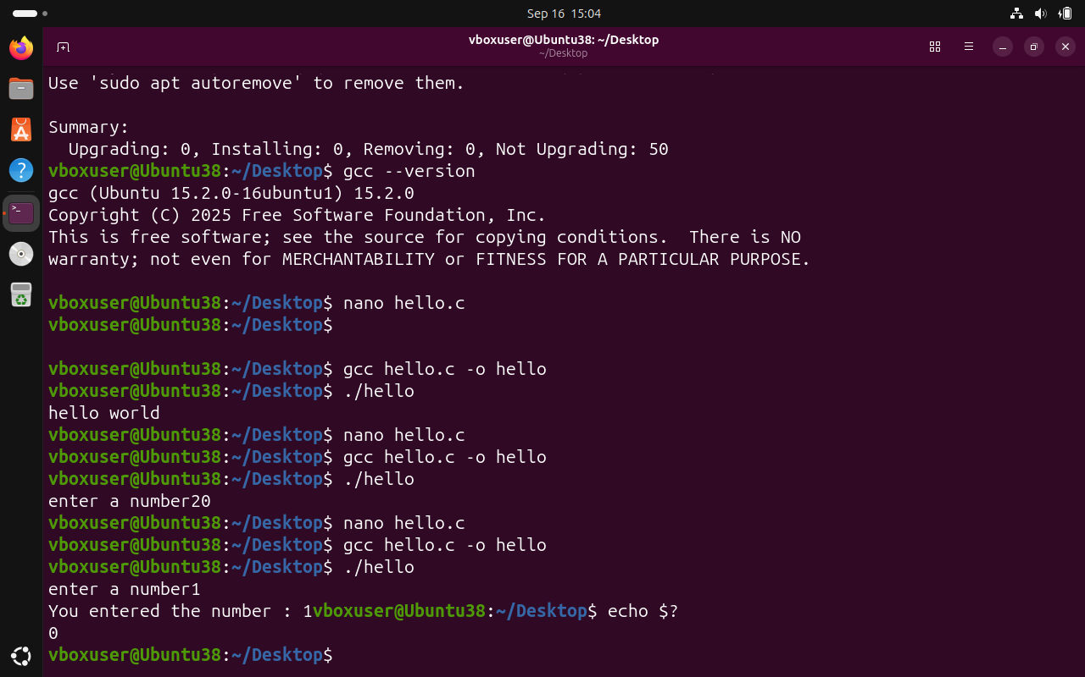

Task 2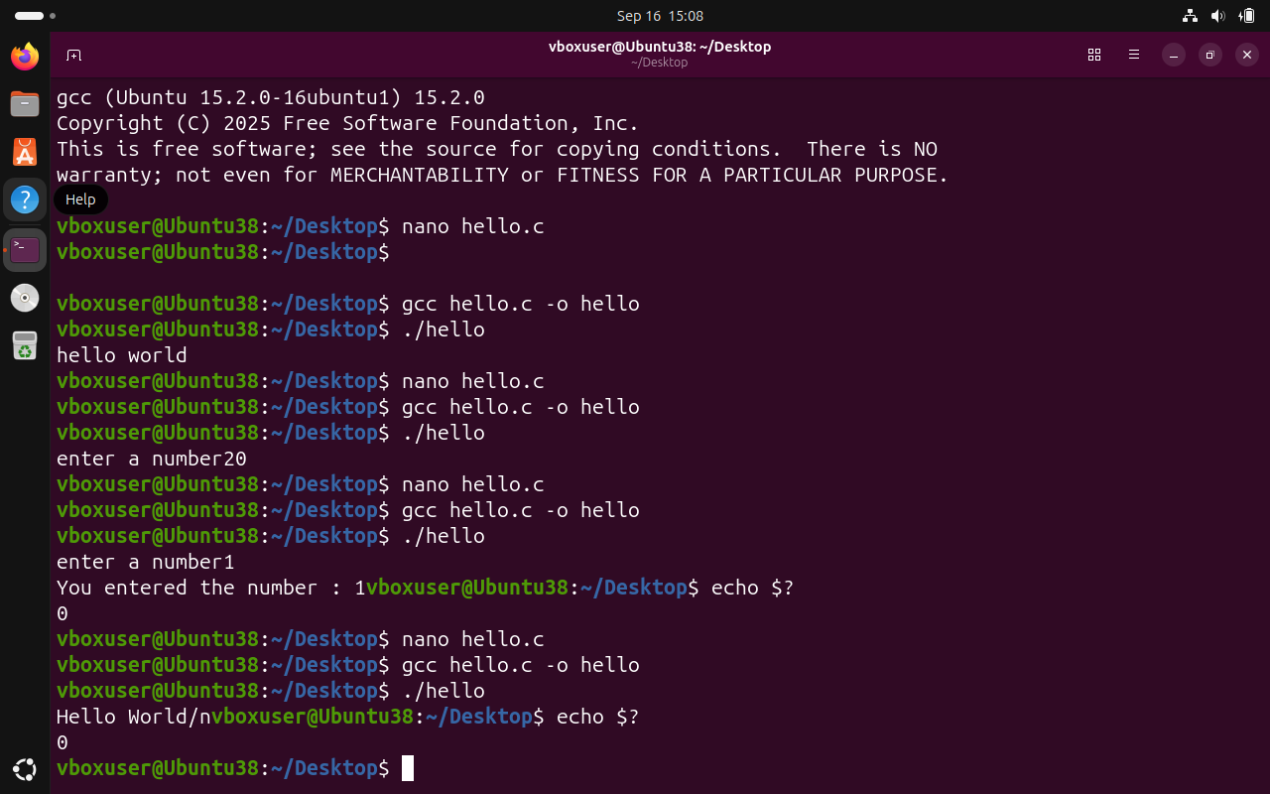

Task 3.
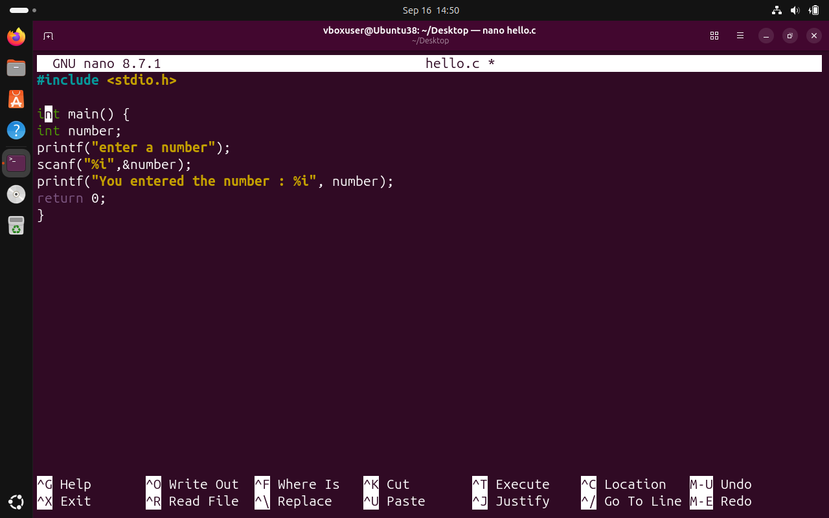

Task 4
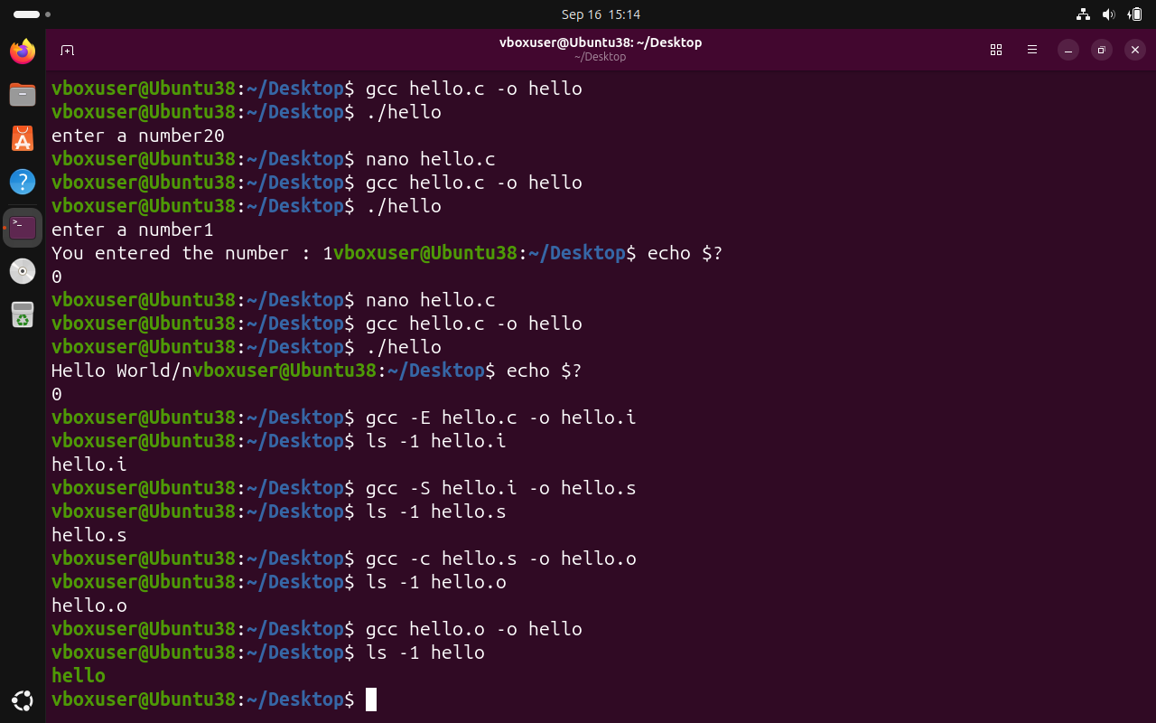

Task 5
