Task 1:
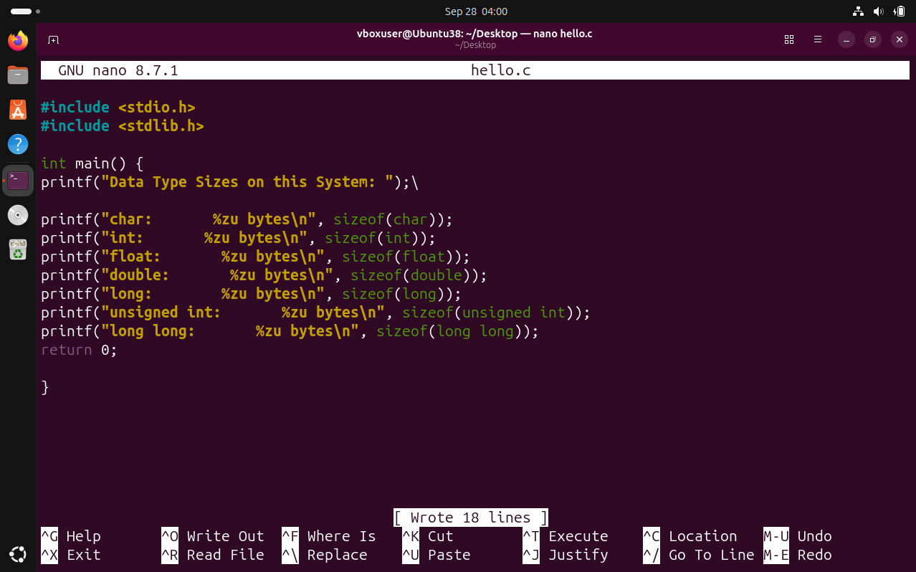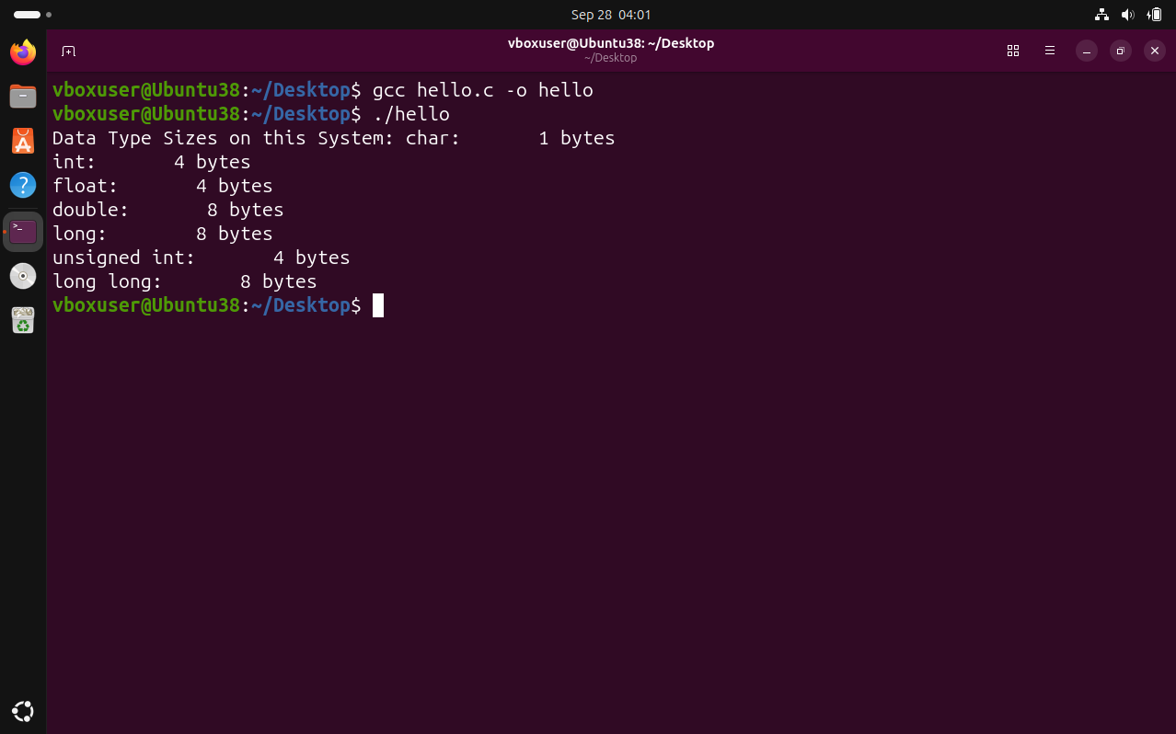
sizeof(long) differs because the C standard only guarantees that a long is at least as large as an int, not an exact size. On 32-bit systems a long is typically 4 bytes (matching the native register width), while on 64-bit systems it is 8 bytes so it can hold a full 64-bit memory address — this matters for pointer arithmetic and large file offsets in the OS.

Task 2:
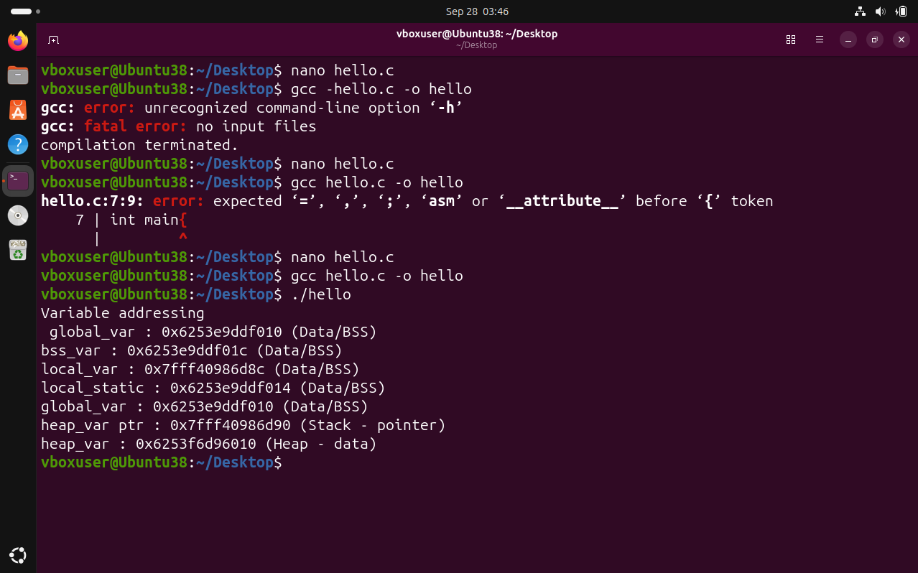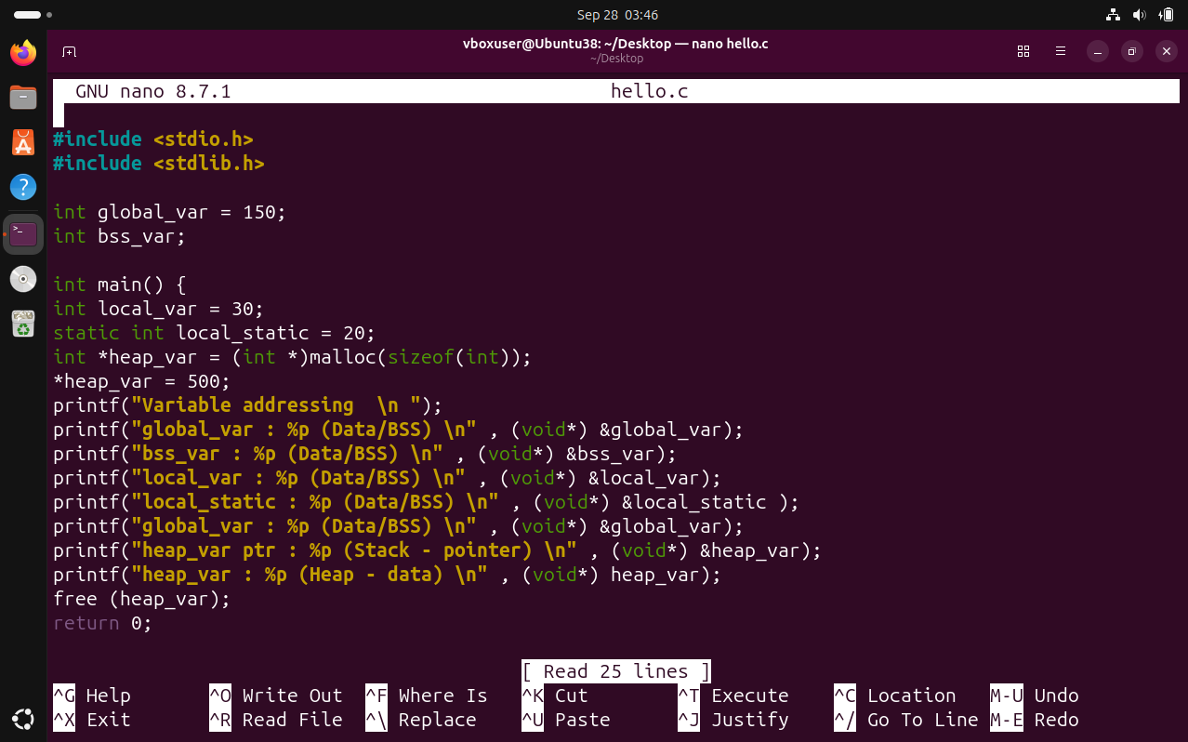
Observation: I confirmed that the OS organizes a process's virtual memory into distinct segments — global and static variables live in the low-address Data/BSS region, dynamically allocated memory lives in the Heap, and local variables and pointers live in the high-address Stack. The stack addresses (0x7ffd...) were far above the heap addresses (0x55a1...), with a gap of many terabytes, which shows that Linux deliberately separates these regions so they can grow toward each other safely. This validates the memory layout diagram: stack grows downward, heap grows upward, and both are kept apart by the OS to prevent overlap.

Task 3:
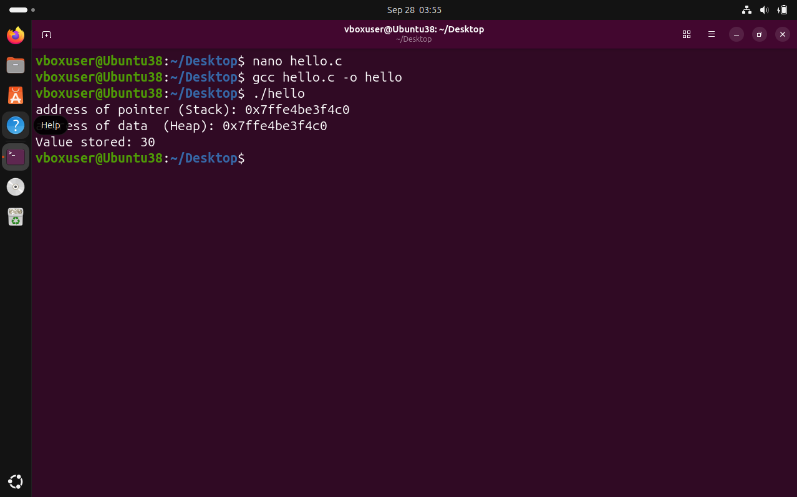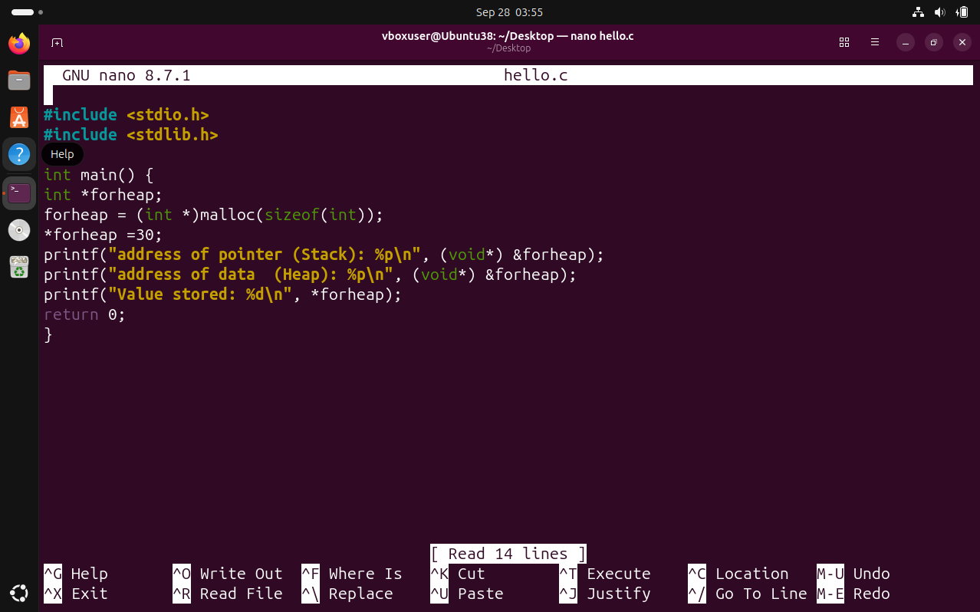

Knowledge Check Questions:
- A data type is a contract between the programmer, the compiler, and the OS that specifies: (1) how many bytes to allocate in memory, (2) how to interpret those bytes (integer, character, floating-point), and (3) which operations are valid on that data. It tells the OS exactly how much memory to reserve and how the CPU should treat the bit pattern.

- Text, Data, BSS, Heap, and Stack.

- The Data segment stores initialized global and static variables (e.g., int global_var = 150;), so their values must be stored in the executable. The BSS segment stores uninitialized global and static variables (e.g., int bss_var;), which the OS zero-fills at load time — this saves space in the executable file because zeros don't need to be stored on disk.

- Placing the text (code) at low addresses lets the OS map it as read-only and share it between processes running the same program. Placing the stack at high addresses lets it grow downward toward the heap (which grows upward), maximizing the room for both to expand without collision. This layout also matches typical hardware addressing conventions and simplifies memory protection.

- When a function returns, the CPU's stack pointer is simply moved back to where it was before the call (the stack frame is "popped"). The memory is not erased — the data remains until overwritten — but it is considered free. The compiler generates the code that adjusts the stack pointer, and the OS enforces the stack boundaries; no explicit free() is needed because stack memory is reclaimed automatically.

- The OS maintains a page table for each process that maps virtual addresses to physical frames. Each process has its own virtual address space, and the Memory Management Unit (MMU) uses the current process's page table to translate addresses on every memory access. If a process tries to access a virtual address not mapped in its page table, the MMU raises a page fault and the OS terminates the process — this is how isolation between processes is enforced.

