**Coaching Institute Management Software**

**Introduction:**

Coaching Institute Management System simplifies managing the administrative process of Institutes and Training Academies.

The features include:

1. Admin Module
2. Student Module
3. Teacher Module
4. Admission
5. Payments
6. Attendance
7. Class Routine
8. Batches
9. Study Material
10. Announcement
11. Classroom
12. SMS Notification
13. Salary Expanse

**Admin Module:** Administrators will provide with a full control over the software. Administration can send announcements of the events to all users in the institute. Students are provided with user ids and password. Through the admin module the administrator should be able to track admissions and track attendance of students.

**Student Module:** Maintaining the record of each student according to the course and batch and many events related to the student activities is controlled by the Admin. The student module enables to accumulate all personal, academic and history regarding the students.

Students will be created with the field below:

* Id No
* User Name
* Password
* First Name
* Last Name
* Gender
* Current Address
* Permanent Address
* Contact number
* Parent Contact

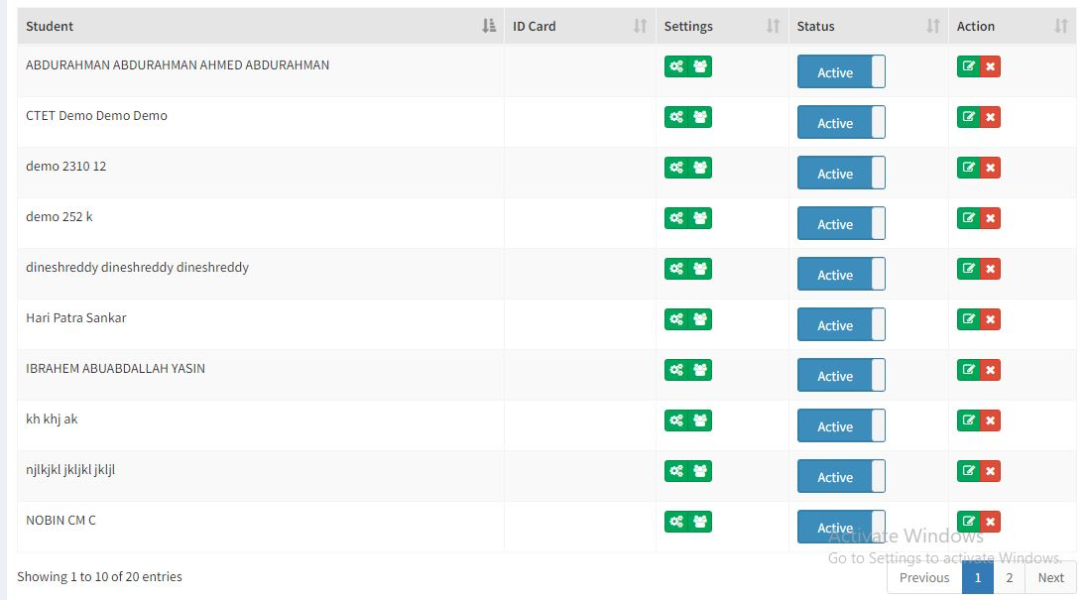

Figure: Student List

**Teacher Module:** Teacher Module will maintain teachers details information.

Teacher will be created with the field below:

* Id No
* User Name
* Password
* Teacher Name
* Subject
* Gender
* Email
* Phone
* Current Address
* Permanent Address
* Join date

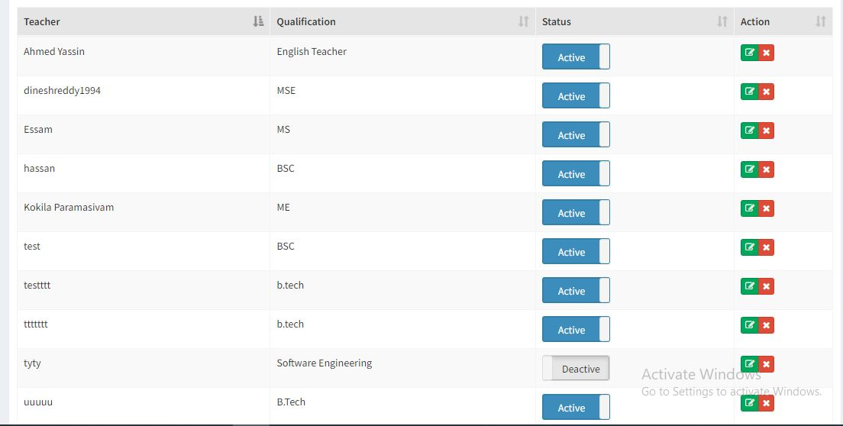

Figure: Teachers List

**Payments:** The fee module helps in maintaining registers of payment collection and the receipt can be issued on the basis of student/batch. Amount paid and amount dues can be viewed as per the classes, courses or individual student.

Here are the fields for creating payments:

* Batch name
* Id No
* Student Name
* Amount
* Paid Amount
* Due Amount

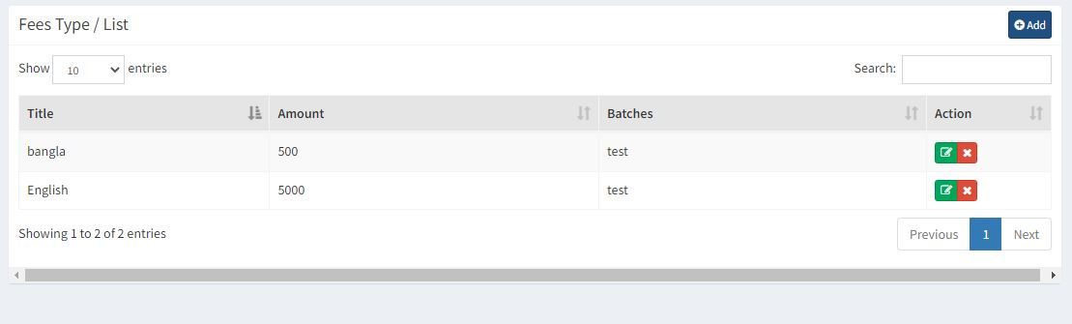

Fig: Fees List

**Attendance:** This module will help to manage attendance of students. The teachers should be able to mark attendance of the students. Absentee remarks can be managed very efficiently. Overall absentee reports with remarks can be viewed.

Attendance module will create with those fields:

* Present
* Absent
* Leave

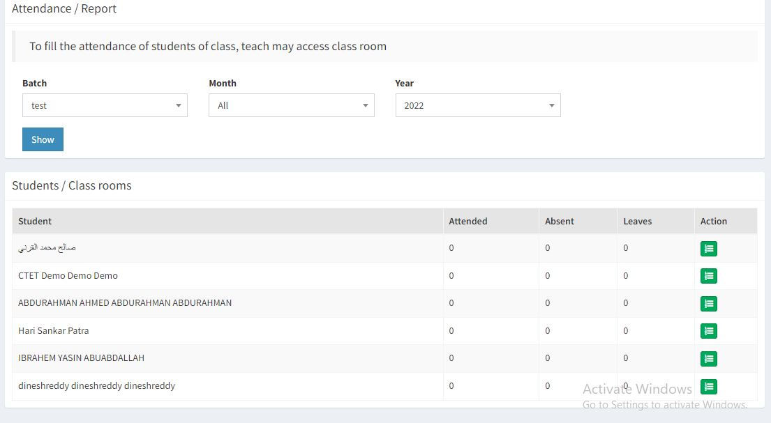

Figure: Attendance report

**Class Routine:** Class routine will manage date and time schedule of classes.

Routine module will have:

* Batch id
* Batch name
* Subject
* Teacher Name
* Days and Time

**Batches:** In this module admin can manage batches. Admin can create new batch and can assign students.

Batch module have:

* Batch id
* Batch Name
* Subject
* Teacher
* Days and Time

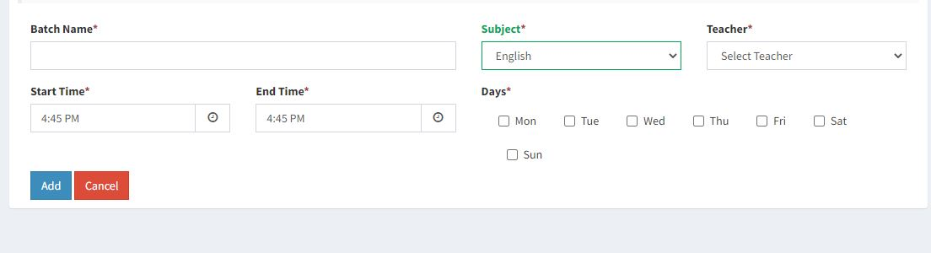

Figure: Batch creating

**Study Material:** Teacher and admin will share study material by this module. Students can download resources from study materials.

Here we creating study materials with fields below:

* Subject
* Title
* Batch
* Type

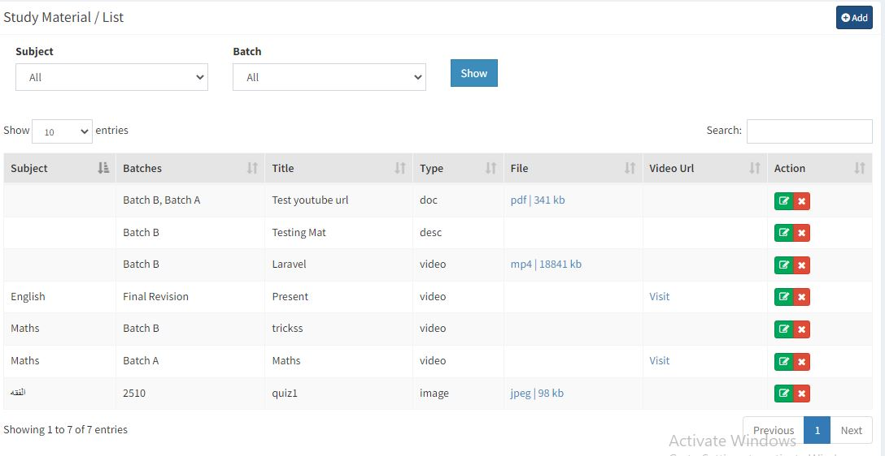

Figure: Study Materials List

**Announcement:** In this module admin can push notification for any updates to the students and teachers.

Announcement will create with the fields listed below:

* Batch
* Title
* Message

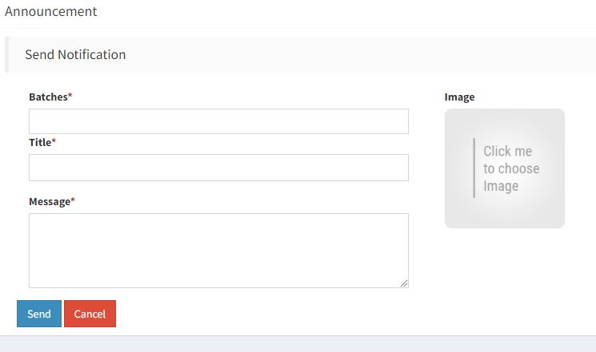

Figure: Creating Notification

**Classroom:** Here is the fields for creating classroom module

* Batch
* Type
* Class Link
* Password
* Date
* Start Time
* Duration

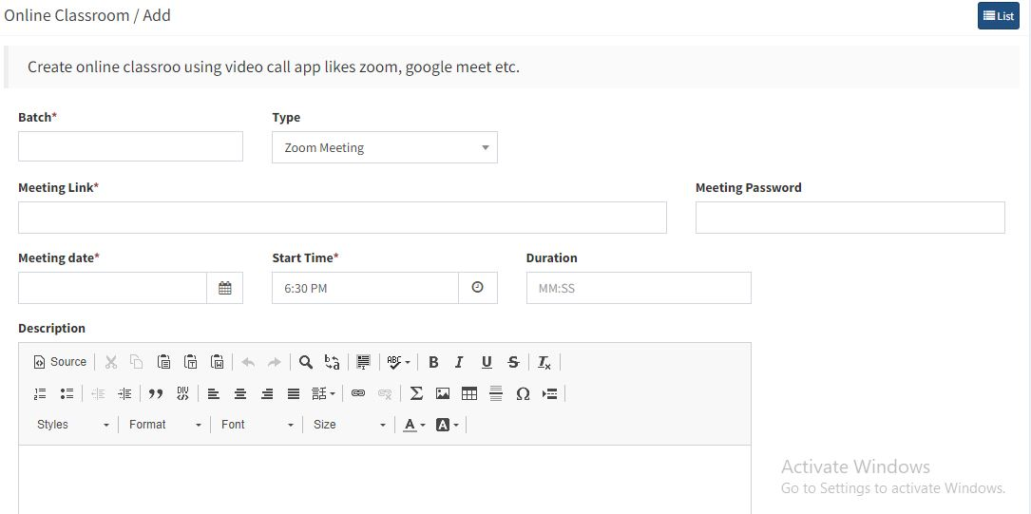

Figure: Creating Classroom

**SMS Notification**: Students or students guardian will get SMS notification through phone number. Notification will contain

SMS notification fields will have:

* Student Name
* Phone number

**Salary Expanse:** Salary expanse module will maintain the salary of the teacher.

Salary expanse module fields:

* Teacher Name
* Batch Name
* Subject
* Salary
* Paid Amount
* Due Amount