**Miramonte Consul**

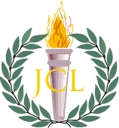

May Banquet 2017

horizontal line

Victoria et Gloria at Convention Five-Peat!

By *the Editors*

Last month, on the weekend of April 21 - 22, St. Ignatius College Prep hosted the 62nd Annual CAJCL Latin State Convention in San Francisco. There was quite the bit of pressure for Miramonte students to perform as well as they had for the past four years. Basically, we had to win for honor, of course, for our glorious state convention five-peat. Naturally, in order to prove ourselves, we must overcome challenging trials. Really it should come as no surprise that a bus broke down Saturday morning. And suddenly a quarter of our forces, along with our beloved Parliamentarian, were stuck in the Caldecott tunnel, with us only in spirit through our cheers. What can be said then, of Miramonte, that we went on to win 1st Place in Spirit and 1st Place Overall as a large high school? We made history that day. And MD certainly is proud.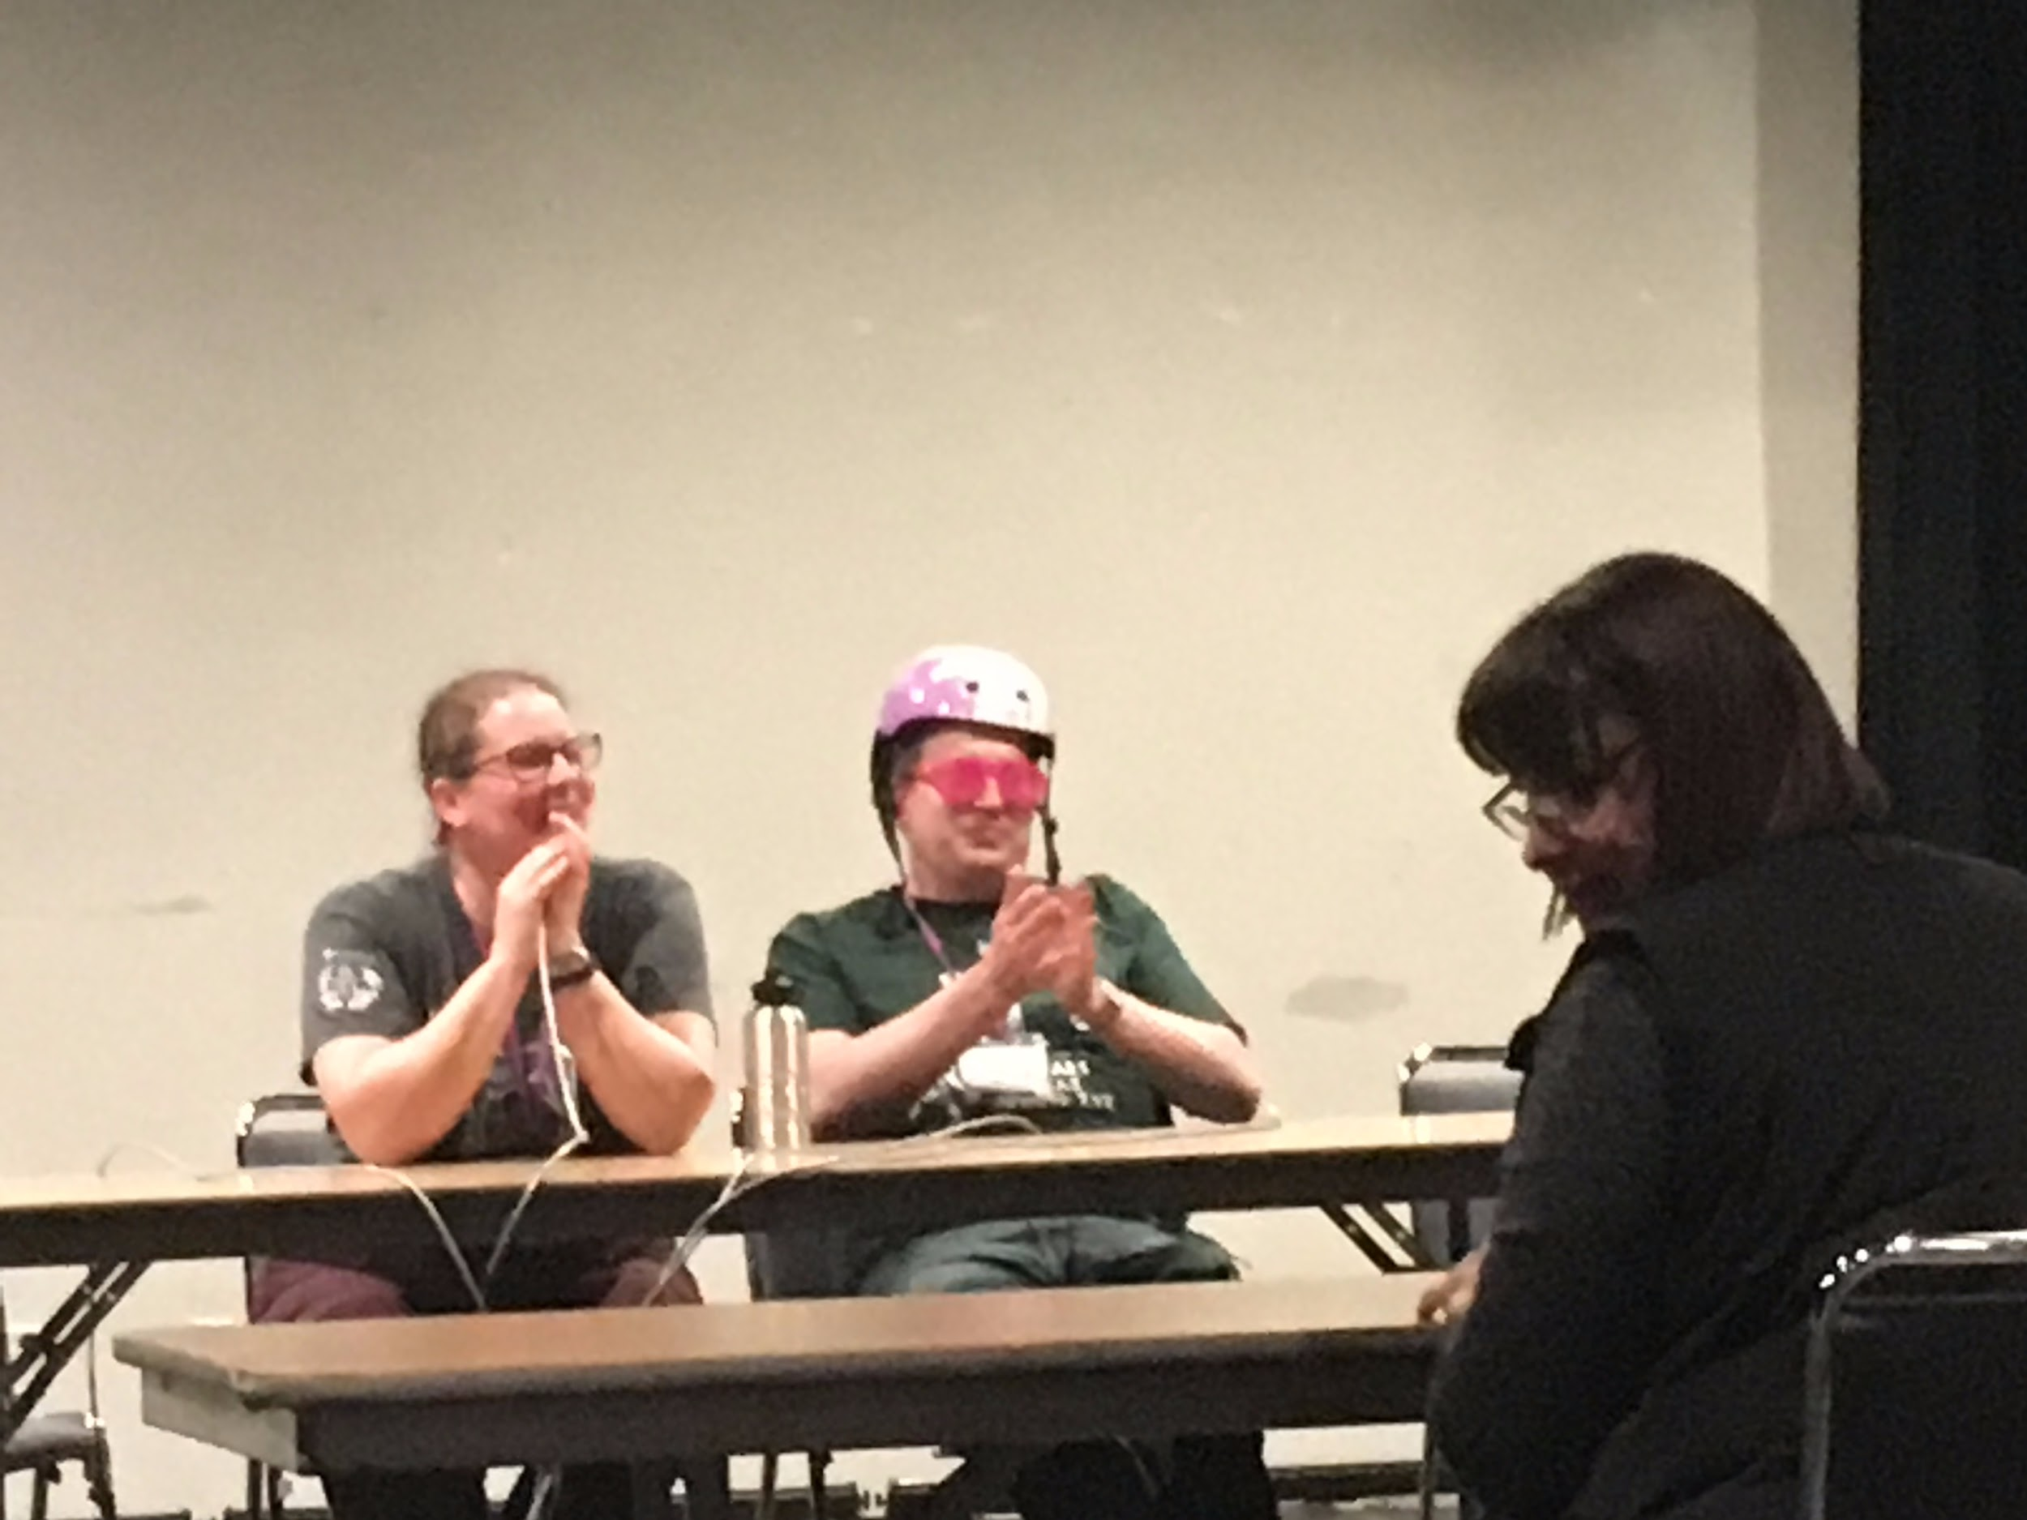

|  |  |
| --- | --- |
| Why Take Latin?  By Ellie Reed, 2015-2016 Caesar  -The Knowledge:  The English language is influenced both indirectly and directly by Latin. Students that have taken Latin are found to score better on the verbal section of the SAT. Also, when reading the Harry Potter series by JK Rowling, you’ll notice that some of the words she used for spells are actually in Latin, while others are simply made up. See? JK Rowling knows Latin (at least some Latin), so why shouldn’t you?  -The Community  The JCL (Junior Classical League) is a great place to meet fellow Latin nerds and bond over your love for history, language, culture, and chariot racing. You may even meet someone that can speak the language almost fluently.  -The Cookies  We have cookies at our meetings. This needs no further explanation.  -The Teachers  It is rare to find teachers who are so passionate, enthusiastic, and excited about a subject as Latin teachers are. Shoutout to Magister Davis and Magister Carpenter! | How to Start a Roman Cult  By Erica Stephan  Why start a cult?  In 205-202 BCE, at the close of the Second Punic War, the Romans narrowly defeated Carthage (Carthago delenda est). This victory was achieved in part due to Cybele, the earth-mother goddess. Just before Rome’s victory, Romans began worshiping Cybele on an oracle’s advice. As you can see, beginning the worship of ancient Roman deities leads to glorious victoria. So don’t wait, start your cult today!  Steps:   1. Find a deity. Many excellent options exist. In the chart below, *The Consul* recommends a few who already have their own established cult practices. 2. Find worshippers. We recommend scouring the halls of Miramonte during finals week. Focus on the crying students- they will feel the most lost and in desperate need of a deity to pray to. 3. Decide upon rituals to worship your chosen deity. Frenzied dancing, chanting, and secret practices are all recommended. 4. Don’t drink the kool-aid. You need living practitioners to keep the cult alive. Or zombies. But we don’t know of any Roman deities who reanimate the dead. |



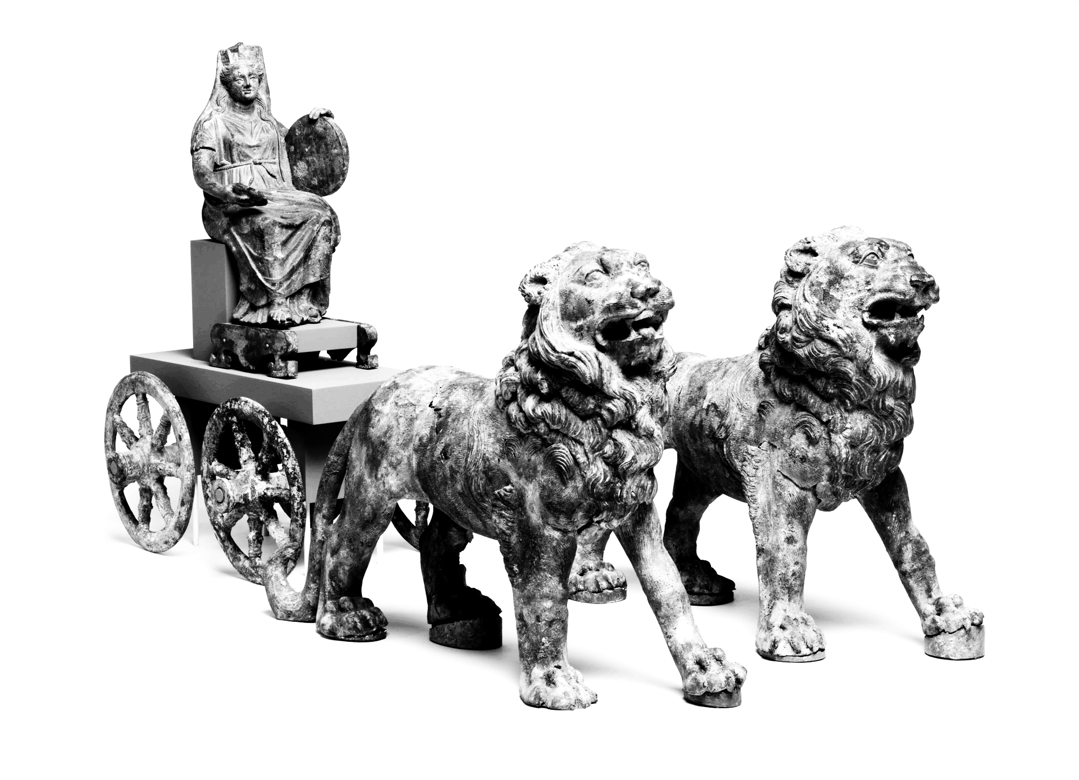 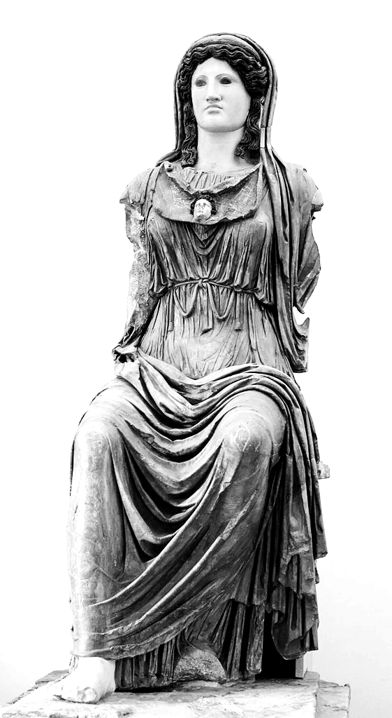 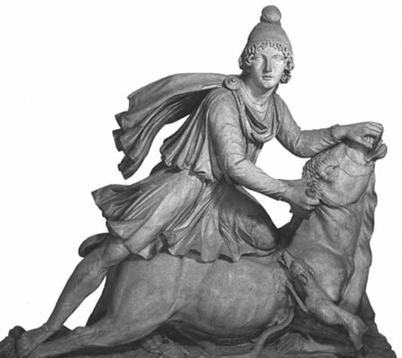

|  |  |  |
| --- | --- | --- |
| * Protects people at war, bestows fertility, linked to grain * Rites involve lamentation and wild behavior * Supplies needed to worship:   + Scanty clothing   + A government to ban practices   + Eunuchs | * Symbol of life and fertility * Rites involved music, elaborate pageantry, and mysteries * Supplies needed to worship:   + A list of her many names   + A cistern of Nile water   + Musical talent   + A chorus | * Mostly worshipped by working class Roman men * Rites involved secret temples, holy meals, and baptism in cow blood * Supplies needed to worship:   + Cow blood   + Pictures of bulls   + Dinner   + Hidden temples |

Damen, Mark. "Roman Cults and Worship." *Utah State University*. Utah State University, n.d. Web. 22 May 2017.

Caesar’s Farewell

By Caesar Sophie Hammond

|  |  |
| --- | --- |
| Salvete, omnes!  Most of you are probably reading this after watching the swearing-in of the new officers, in which case I am, in fact, no longer Caesar. But I’m still Caesar while I’m writing this, so I’m going to take advantage of my power and subject you all to some administrative announcements along with torrents of sentimentality and some ill-advised uses of hashtags. Sometimes all at the same time.  As strange as it may seem to all the graduating seniors, the Miramonte Latin Club will continue without us. The Latin Club will be participating in Orinda’s annual 4th of July parade (details will be emailed out in the near future). The *Consul*, which you’ve just been enjoying, will still be running next year, with new editors Isabella Gravano and Caroline Ricksen taking the helm. Your lovely and devastatingly sarcastic current editors will probably be crying every night in their college dorms longing for their glory days, but Isabella and Caroline have a lot of amazing ideas for putting their own spin on this Latin Club tradition. Latin Club meetings will be on Wednesdays, just like last year, and Officers’ Meetings every other Monday will deal with the administrative tasks so that Wednesday meetings can be used for fun activities like scavenger hunts and movie watching. Kiana Hu, as Parliamentarian,  once Ludi was over, I had a great time planning Christmas caroling, Movie Nights, etc. and preparing for Convention together. It’s hard addressing this to you as a group, because I know so many of you as individuals, who are important to me in specific and individual ways. But I can say, collectively, that your enthusiasm for Latin, Roman culture, and the Latin Club has impressed me deeply for the last four years, and I’m going to miss you all so much.  And finally, a special welcome to those who will be Latin I’s next year. I will never know most of you. Very few of you are even at this banquet. And yes, you are the future of the Miramonte Latin Club, and heaven and earth will tremble when faced with your glory, but also--I’m so jealous of you. You’re about to be initiated into the joy and terror that is Miramonte Latin--learning how Venus was *really* born, chanting the Exegi Rap, giving sacrifices to the gods for Augustus’s birthday, singing your lungs out at Christmas caroling, and helping Miramonte win State Convention (again! #5peat). Latin Club is like any other enthusiastic, welcoming, mildly crazy extended family--we might seem weird to you now, but I promise, we just get weirder.  For the last time--Valete, omnes!  Sophie Hammond  (Ex-)Caesar | will be there to keep admin meetings moving swiftly. Or, at least, she’ll make you all feel guilty if they don’t.  Ah, crappus. Apologies, but Sentiment Incoming.  To Mr. Davis, I owe you my eternal gratitude. Not just because you taught an entire generation to say “crappus” when they swear, but for your kindness, your humor, and your ability to make a program centered around an ancient language and culture so accessible to so many. You give so much to your students, inside and outside of the classroom, and you’ve created a monument more lasting than bronze and higher than the royal site of the pyramids. #mhslatin #4ever #twoyearsoftheTwitterProjectandIstillcantdothisright  To the Latin Club, and especially the Latin Club officers and regulars, thank you. It was a harrowing, exhilarating experience pulling off Ludi with all of you. I’m still amazed at how much labor people volunteered to take on, and how many showed up to those last-minute weekend work days. And  NLE Awards!  By Kiana Hu  Congratulations to all the students who took the NLE this year! The NLE, short for National Latin Exam, is an annual, 40-question multiple choice test given to Miramonte Latin students generally in mid-March. The NLE awards students different medals and certificates depending on the score they receive, with the cutoffs for each medal level depending on the national average. On March 16, 2017, two hundred and fifteen MHS students diligently bubbled in the mini gym for 45 minutes. Out of the 215, 139 received awards. That’s over 60%! Go Mats!  From the sixty-six Latin Is who took the NLE for the first time this year, three won a gold medal (above a 36 out of 40): freshmen Isabelle Krochmal, James Richardson, and Kenya Bertoli. In addition, three of our Latin IIs received a perfect paper (40 correct out of 40): sophomores Gil Peled, Kiana Hu, and Garrett Louie. Gloria!  One of the highest honors of the NLE is the Maureen O’Donnell Oxford Classical Dictionary Award. The famed “dictionary” is awarded to students who receive four or more gold medals. This year, FIVE of our seniors achieved this honor: Spencer Pugh, David Basili, Hannah Pan, Jessica Guo, and Jordan Grelling. What a great way to end four years of Latin learning! |

Results for 2017 CAJCL State Convention

|  |  |
| --- | --- |
| Overall  1st Place Overall Large High School  1st Place Spirit Large High School  1st Place Publicity High School  1st Place T-shirt High School  1st Place Boys Chariot  1st Place Girls Chariot  1st Place Basketball  Individual  Mary Allen-Walmisley  Abigail Allison  Caidan Anderson  Jack Anthenien  Cecily Bartsch  Layal Bata  Joseph Berck  Graham Berger  Logan Canada-Johnson  Grant Churchill  Natasha Cohen  Athena Davis  Winston Durand  Stefano Farnedi  Soren Faulkner  Isaac Fayman  Jonathan Fierro  Kyle Finger  Emily Freel  Luca Gero  Jessica Guo  Amanda Han  Amanda Han  Zahra Hasanain  Sophie Hammond  Theodore Herring  Callan Hoskins  Kiana Hu  Kennedy Joga  Julie Kadie  Phoenix Kang    Andrew Kriozere  Isabell Krochmal  Spencer Lang  Garrett Louie    Brendan McFeely  Erin Mohr  Melanie Moran  Kylie Morrison  Ella Nelson  Kate Nerone  Matthew O’Brien  Hannah Pan  Amrita Pannu  Tatiana Pecknikova  Gil Peled  Veronika Pister    Daniel Plinskin  Spencer Pugh  Bhargavi Ram  Sonika Renjen  Vasco Rodrigues  John Sanli  David Scheidinger  Chinmai Srinivas  Gauthum Srinivas  Alton Schmitt  Dory Shen  Natalie Sovocool  Erica Stephan  Alan Tang  Michelle Tang  Lauryn Trong  Biana Tung  Anastasia Ueda  Adam Warren  Zach Weiner  Emma Wilkinson  Leah Woodcox  James Zhou    Margaret Zhang | Awards  1st Place Ultimate Frisbee  1st Place Catapult  1st Place Certamen High School Level 2  2nd Place Soccer HS  3rd Place Certamen High School Level 3  3rd Place Banner  3rd Place Scrapbook  Awards:  3rd Place Water-Color HS2nd Place Pentathlon HS  2nd Place Classical Art HS3  2nd Place Maps HS  3rd Place Ancient Geography  1st Place Drawn Charts HS  1st Place Color Pencil HS  2nd Place Vocabulary HS 2  3rd Place Scrapbook HS  2nd Place Geography HS 2  2nd Place English Oratory HS 11-12  3rd Place “That’s Entertainment”  Builder of Chariot  2nd Place Track 100 Meters Boys HS  2nd Place Track 800 Meters Boys HS  1st Place (tie) Reading Comprehension HS1 1st Place Classical Art HS1  2nd Place Greeting Cards HS  3rd Place Latin Sight Reading  Spirit Leader  1st Place Small Models HS  Spirit Leader  3rd Place”That’s Entertainment”  1st Place Track 800 Meters Boys HS  3rd Place Track 400 Meters Boys HS  1st Place 1600 Meters Boys  1st Place Athletics Overall  1st Place Overall Athletics HS Adv  1st Place 800 Meters Girls HS  1st Place 1600 Meters Girls HS  3rd Place English Oratory HS 9-10  1st Place Overall Arts HS Adv  1st Place English Slogan HS11-12  2nd Place Latin Slogan HS11-12  1st Place Charcoal  3rd Place Certamen HS3  3rd Place Black/Colored Ink  Builder of the 1st Place Catapult HS  1st Place MQA HS3  3rd Place English Oratory HS 11-12  3rd Place Certamen HS3  3rd Place Essay HS 11-12  1st Place Mythology HS3  1st Place Traditional Photography HS  3rd Place Certamen HS3  1st Place Couples Costume HS 11-12  1st Place Overall HS 2  1st Place Overall Arts  1st Place Certamen HS 2  1st Place MQA HS 2  1st Place Mythology HS 2  1st Place English Slogan HS 9-10  1st Place Traditional Photography HS  2nd Place Latin Oratory  3rd Place Illustrated Quotes  3rd Place Mosaics  2nd Place Colored Pencil HS  3rd Place Certamen HS3  1st Place Latin Slogan HS 11-12  3rd Place Charcoal  3rd Place “That’s Entertainment”  1st Place (tie) Reading Comprehension HS1  3rd Place “That’s Entertainment”  Spirit Leader  1st Place Overall Academics HS 2  1st Place Overall Athletics HS 2  1st Place Certamen HS 2  1st Place Ancient Geography HS 2  1st Place Grammar II HS 2  1st Place Pentathlon HS 2  1st Place 100 Meters Boys HS  1st Place 400 Meters Boys HS  Banner Helper  1st Place Classical Art HS 2  1st Place Certamen HS 2  2nd Place “That’s Entertainment”  3rd Place Scrapbook  Helper with the scrapbook  Helper with the scrapbook  Helper with the scrapbook  1st Place Couples Costume HS 11-12  1st Place (tie) Ancient Geography HS1  3rd Place Latin Slogan HS 11-12  1st Place STEM Challenge  2nd Place Latin Sight Reading HS1  3rd Place Small Models HS  3rd Place Classical Art HS1  3rd Place Ancient Geography HS2  3rd Place Daily Life HS2  Creator of 3rd Place Banner HS  Engineer of the 1st Place Catapult HS  1st Place English Oratory HS 11-12  1st Place T-shirt HS  3rd Place “That’s Entertainment”  2nd Place MQA Adv  2nd Place Track 1600 Meters  2nd Place Drawn Charts HS  1st Place Mosaics HS  1st Place Certamen  2nd Place Constructed Charts HS  3rd Place Classical Art HS3  2nd Place Classical Art HS1  2nd Place Chess HS  3rd Place History HS1  3rd Place Pentathlon HS1  3rd Place English Slogan  3rd Place Traditional Photography HS  1st Place STEM Challenge  1st Place Pentathlon HS1  1st Place Color Pencil HS  2nd Place Mixed Doubles  2nd Place Mixed Doubles  2nd Place Latin Slogan HS 9-10  2nd Place English Slogan HS 9-10  1st Place Black Pencil HS  1st Place Mixed Media HS  1st Place Jewelry HS  3rd Place Classical Art  2nd Place English Slogan  3rd Place English Slogan HS 11-12  3rd Place Scrapbook HS  1st Place “That’s Entertainment”  3rd Place “That’s Entertainment”  Builder of the Chariot  1st Place STEM Challenge |

**Gaudeamus Igitur**

A Cheerful Medieval Student Song

|  |  |
| --- | --- |
| Gaudeamus igitur,  Juvenes dum sumus;  Gaudeamus igitur,  Juvenes dum sumus;  Post iucundum iuventutem,  Post molestam senectutem,  Nos habebit humus.  Nos habebit humus. | Let us therefore rejoice,  While we are young;  Let us therefore rejoice,  While we are young;  After our youth,  After a troublesome old age,  The ground will hold us.  The ground will hold us. |

