**Miramonte Consul**

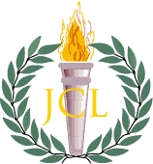

February 2016

horizontal line

Edited by Erica Stephan, Jessica Guo, and Kiana Hu

Bring Back Gladiator Fights!

*Consul Editors*

*The Consul* has recently created a 100% accurate, totally relevant survey. We

believe in keeping an eye on the pulse of the Latin Club community.

Our results confirmed what we knew in our hearts to be true- Latin Club wants to bring back gladiator fights. 88% of responders voted yes while only a mere 12% voted no.[1] Joyously, Latin Club operates on a democratic system. If gladiator fights are not brought this year, we’ll try again next year. We wish the best of luck to this year’s officers in bringing this violently fun activity to all.

Edited by Erica Stephan, Jessica Guo, and Kiana Hu

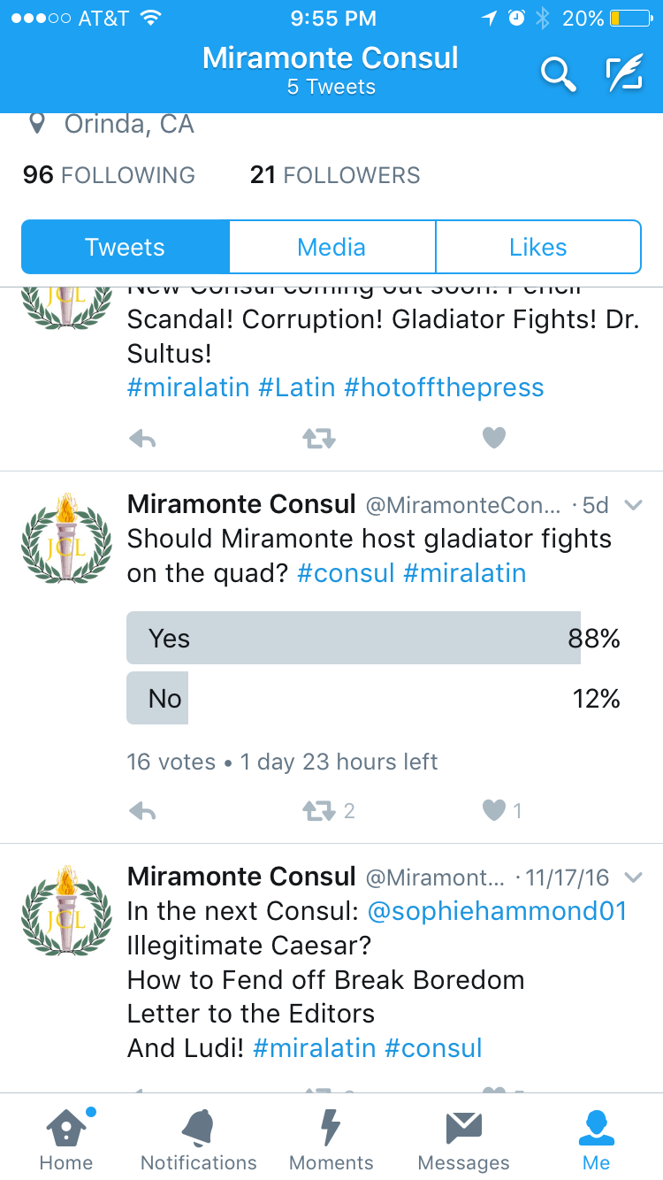

|  |  |
| --- | --- |
| Latin I Update  By Athena Davis  It’s been an exciting year so far in Latin I. Mr. Carpenter’s strange food and rousing motivational Mondays have kept us on our toes (We will always remember the Patton’s words: “[When shells are hitting all around you and you wipe the dirt from your face and you realize that it's not dirt](http://genius.com/Gen-george-patton-speech-to-the-3rd-army-annotated#note-3288486)...).  Right now we are working on the verb conjugations, and we will all pass the CPs, eventually... But we will keep learning, faster than a tree’s pace. (It must take Daphne a while to pass her CPs!).    Speaking of Daphne, we just finished translating the story of Apollo and Daphne, which taught us that asking your magical father for help isn’t a good thing, especially if his solution to ward off a lovesick Apollo is to turn you into a tree. For many of us, Ludi was our first Latin convention. We had a great time- many Latin I’s got high scores on academic testing and participated in other fun activities such as open certamen and volleyball. | Music: Our Universal Language  By Margaret Zhang  There is nothing like the sweet sound of music. Over the years, music has remained a universal language that all people of different cultures, backgrounds, and languages can communicate with. So, what was music in Ancient Rome like? Are there remnants of Ancient Roman music in the modern day?  Music was present in all aspects of ancient Roman culture. Whether in religious ceremonies or funerals, music was believed to offer an outlet for individual reflection and expression. Similar to today, music accompanied spectacles and events, remained a critical part of performing arts, and conducted contests among the Roman people. For example, during the Secular Games in 17 BC, the *Secular Ode* of Horace was commissioned by Augustus to be performed by a mixed children's choir. As an effort to ward off ill influences, the woodwind instrument *tibia* was played during sacrifices.cornu-roman-music.jpg  (cont on next page) |

Music Continued

|  |  |  |
| --- | --- | --- |
| As it turns out, the instruments used during Ancient Roman times are uncanningly similar to modern instruments. Woodwinds, brass, RomeMusicMosaic.jpg  percussion, and stringed instruments are all depicted in Roman art. As for woodwind instruments, the Roman *tuba*, a long, straight bronze trumpet, is a close relative of the modern day French horn and the *askaules* was much like a modern day bagpipe. With regard to string instruments, the *lyre* and the *lute* serve as a historical reflection of the evolved modern day harp.  Ultimately, music continues to serve as a means of celebration, mourning, and backdrop to special occasions to this day. Just as music was a critical part of Ancient Roman culture, music is a critical part of modern culture. Reflected in the extremely similar instruments and festive music events, the Ancient Roman music culture has greatly influenced modern day music.  horizontal line  The Kingly Cabbage  By Garret Louie   |  |  | | --- | --- | | The Cabbage bears the name of an ancient plant from which we humans bred many other leafy garden staples. Cauliflower. Broccoli. Kale. Brussels sprouts. They all came from the same wild cabbage. Taxonomically, all of these vegetables are the same species- Brassica oleracea. The same cabbage that the ruler of the greatest empire in the world retired to farm. That's right. On May 1, 305 CE Diocletian, augustus and ruler of the Roman Empire, handed over the purple vestments of emperor and, with the burden of rule in new hands, this place with the storms of a never-satisfied greed”. [pause for this to set in] He turned down an invitation to become the most powerful man in the world , in order to peacefully tend to his cabbages. If you give your cabbages the love that they deserve they will reward you in kind. This deepest of bonds between man and plant can provide you with unparalleled joy and satisfaction.  Even before Diocletian’s time, humans had bred the modern headed cabbage. A single 100g serving of Cabbage can contain over 60% of the daily value for Vitamin C. And if that isn't enough it also can contain over 95% of the daily value for Vitamin K as well. And if that still isn't enough cabbages have over 10% the daily value for Vitamins B6 and B9! And if you still aren't convinced, they also are an excellent source of Thiamin, Calcium, Iron, Magnesium, Phosphorus, Potassium, and of course fiber. Oh, and did I mention that the cabbage is 12% protein?  If somehow you aren't impressed yet, let's take a look at kale, the oldest variety of cultivated wild cabbage, dating back to the fourth century BCE. Kale is 16% protein. A 100g serving will contain many of the same benefits as cabbage, only several times greater. For starters, it will give you 10% the daily value for calcium, potassium, and copper, not to mention can still get something out of it.  So what are you waiting for? Get some cabbage seeds today, follow in the footsteps of the Emperor who turned Rome from a downhill path back straight again. Even a small windowsill garden can do the job. If you don't have any space you should make some space and discover a new hobby, a new passion which can last you a lifetime. | was free to return to his birthplace of Dalmatia, where he devoted the remainder of his days to the cultivation of this most noble of crops.  The benefits to casual farming are boundless. Not only does it yield a delicious and nutritious food, is also most satisfying and addictive hobby. When Diocletian was asked to return to the throne, he replied, “If you could show the cabbage that I planted with my own hands to your emperor, he definitely wouldn't dare suggest that I replace the peace and happiness of  30% for manganese. But this seems like nothing compared to a whopping 300% and 200% daily value for Vitamins A and C respectively. And at last, towering miles above them all, is Vitamin K. Even the cabbage must bow to kale’s mammoth heap of 1000% the daily value for Vitamin K. That's TEN DAYS worth. Okay let's think about this. One kale plant can yield 2-3 100g servings. That means that every kale plant you grow can provide you with 20-30 days worth of Vitamin K. If you do the math you will find that with 15 kale plants you are set for a whole year. A whole year!  Not only the Romans but also the Egyptians used cabbage to counter the effects of alcohol and the Greeks used it as a laxative. They also used its juice as an antidote for poison and eye salves. Yes, you don't need to even eat cabbage to reap its benefits. The leaves of the plant have a cooling property which soldiers in World War One used to treat trench foot. Even if you don't like the taste of cabbage you  Letters to the Editors?  *The Consul* encourages our patrons to voice their opinions about our publication by sending a letter to miramonteconsul@gmail.com or by tweeting at us @miramonteconsul. We aren’t afraid of you and we’ll never be taken alive. We look forward to hearing your comments! |   horizontal line  Convention 2016 (Get Excited!)  Do you ever have that feeling that there’s nothing to look forward in life? Well now there is! With the 2016 State Latin Convention at St. Ignatius in San Francisco, you’ll find EVERYTHING you’ve ever wanted in life from taking fun academic tests to playing bubble soccer to watching Mr. Davis crush all opposition in an all-teachers’ certamen competition.  State Latin Convention is the annual culmination of what we’ve learned in class all year. Convention offers all kinds of competitions such as history, MQA, vocab, and mytho tests, English Oratory, Dramatic Interpretation, Photography, Mosaics, and various sports for those who like winning ribbons. There is also a plethora of social activities such as scavenger hunts, bulla making, laser tag, and even glow in the dark mini golf on the night of the banquet!  The best part of all is getting to scream your lungs out during the spirit competition- there’s nothing quite like losing your voice alongside a hundred or so or your fellow Latin amici. Don’t worry, it’s all for the five-peat. Miramonte has won the ENTIRE convention FOUR times in a row (freshman, if we lose this year, it’s on you! Just kidding. We won’t lose if you all come!), and we can do it a fifth! It all depends on YOU to show up and compete and most importantly, have fun. Convention is definitely one of the highlights during the Latin year and a great time to bond with others who obsessively reference Greek myths or accidentally speak in Latin in normal conversation. We’ll see you there! |
|  |

1. Out of a total of 16 votes