Miramonte Consul

# 

January 2017

horizontal line

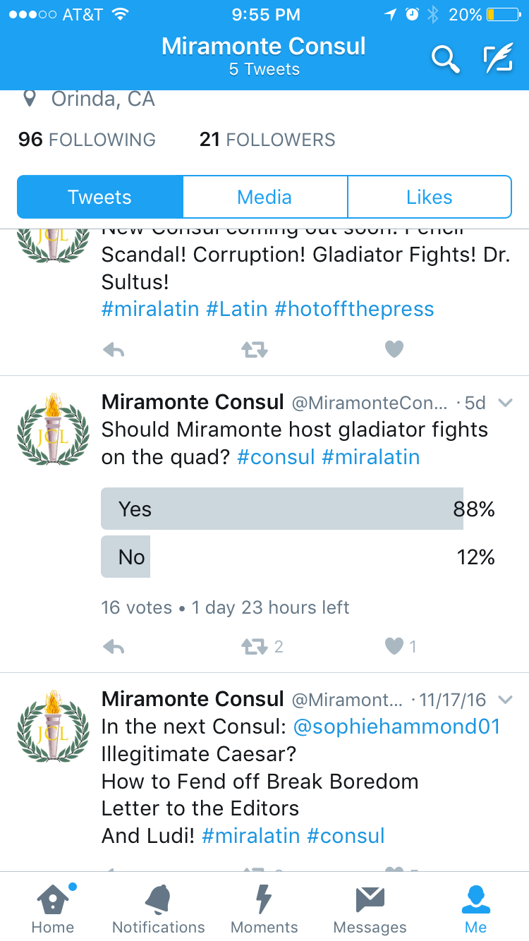

Results from *The Consul’s* Twitter Poll

By The Editors: Erica Stephan, Jessica Guo, Kiana Hu

*The Consul* has recently created a 100% accurate, totally relevant survey. We believe in keeping an eye on the pulse of the Latin Club community.

Our results confirmed what we knew in our hearts to be true- Latin Club wants to bring back gladiator fights. 88% of responders voted yes while only a mere 12% voted no.[1] Joyously, Latin Club operates on a democratic system. If gladiator fights are not brought this year, we’ll try again next year. We wish the best of luck to this year’s officers in bringing this fun activity to all.

Latin I Update

By Athena Davis

It’s been an exciting year so far in Latin I. Mr. Carpenter’s strange food and rousing motivational Mondays have kept us on our toes (We will always remember the Patton’s words: “[When shells are hitting all around you and you wipe the dirt from your face and you realize that it's not dirt](http://genius.com/Gen-george-patton-speech-to-the-3rd-army-annotated#note-3288486)...). 

Right now we are working on the future tense, and we will all pass the CP, eventually... But we will keep learning, faster than a tree’s pace. (It must take Daphne a while to pass her CPs!). Speaking of Daphne, we just finished translating the story of Apollo and Daphne, which taught us that asking your magical father for help isn’t a good thing, especially if his solution to ward off a lovesick Apollo is to turn you into a tree. For many of us, Ludi was our first Latin convention. We had a great time- many Latin I’s got high scores on academic testing and participated in other fun activities such as open certamen and volleyball.

horizontal line

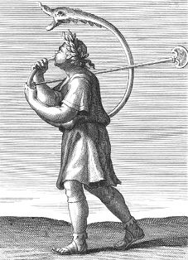

1. Out of a total of 16 votes