Miramonte Consul

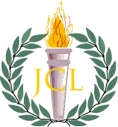

November 2016

horizontal line

Twitter Poll

By The Editors: Erica Stephan, Jessica Guo, Kiana Hu

*The Consul* has recently created a 100% accurate, totally relevant survey. We believe in keeping an eye on the pulse of the Latin Club community.

Our results confirmed what we knew in our hearts to be true- Latin Club wants to bring back gladiator fights. 88% of responders voted yes while only a mere 12% voted no.[1] Joyously, Latin Club operates on a democratic system. If gladiator fights are not brought this year, we’ll try again next year. We wish the best of luck to this year’s officers in bringing this fun activity to all.

# 

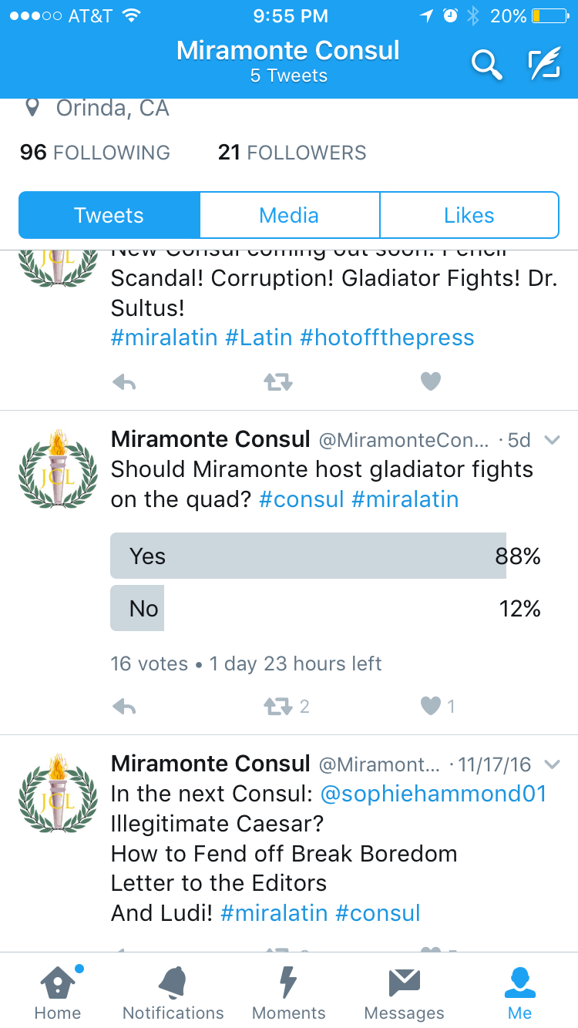

# How to Fend off Break Boredom the Roman Way

# By Erica Stephan

We here at The Consul, as fellow Miramonte students, know how much everyone dreads Thanksgiving Break and any other break from school. We understand the agonizing reality of not having four hours of homework, sports practice for another three hours, and five hours of debate work a night followed by another five hours of sleep. Break is a rough time. How can we function when we lack any sense of direction? How can we get up in the morning with a full night’s worth of sleep?

Fear not! The Consul has you covered! Just follow the activities on each day below along with whatever homework was assigned over break and all of the college apps coming up for you seniors and heck, why don’t you juniors, sophomores, and freshmen start on your college apps too, and you’ll be fine!

Just follow the schedule below:

**Schedule**

|  |  |
| --- | --- |
| Saturday | Begin by following @MiramonteConsul on Twitter. Then, read and translate the complete account of Julius Caesar’s exploits in Gaul. Follow this with a few hours practicing marching in Roman style military formation (feel free to gather your Latin and non-Latin friends). End the day by watching Disney’s *Hercules* 5 times. |
| Sunday | Prepare and sacrifice six stuffed cows to Jupiter (The Consul is not responsible for any negative effects or protests from animal rights groups). Follow with a Roman style bath while reviewing and writing a paper discussing the techniques used and connection to the ancient world in Renaissance painter Giotto di Bondone’s “School of Athens” painting. |
| Monday | Spend the day in bed, relaxing and thinking about the innocent animal lives you sacrificed. Embrace your viciousness, and then perform a sacrifice to beg the cows’ forgiveness. A human sacrifice might be fitting (again, The Consul does not claim any responsibility for your actions and does not advocate human sacrifice). |
| Tuesday | Watch the *Hercules* movie another 7 times. Chiesel a life-size granite statue of Magister Davis. Then proceed to create an action figure. Begin selling on Amazon. |
| Wednesday | Rake in your profits from the MD action figures. Use the money to research and advance science to bring the granite statue of Magister Davis to life. If Pygmalion can do it, you can too! |
| Thursday | Relax and read I, Claudius. |
| Friday | Build a Roman style ship out of Antarctic ice and return home to memorize the Odyssey in Latin and English, much like the poets of the ancient times did. Watch *Hercules* twice more. |
| Saturday | Repeat, but while standing on your hands. |

Ludi Recap!

By Kiana Hu

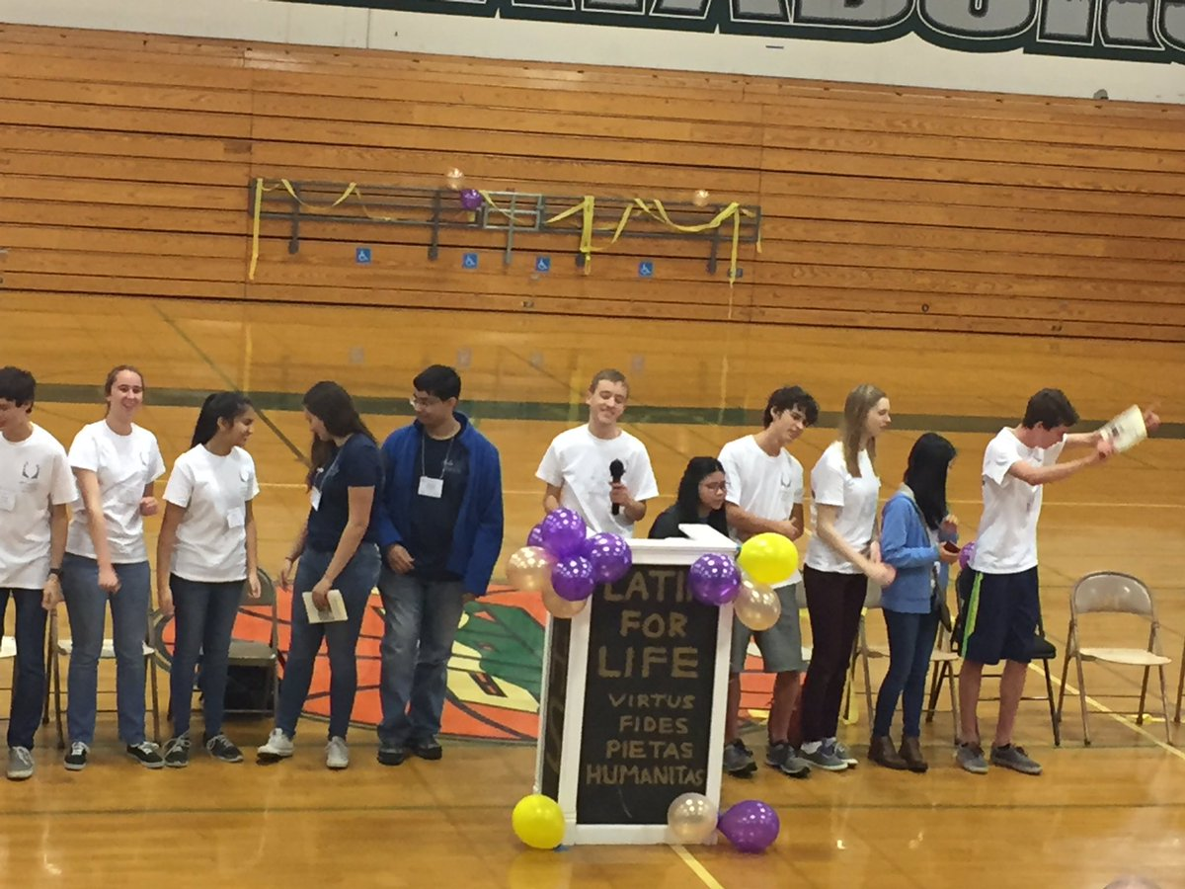

Take a deep breath. Well now, most of you should be able to do so as Ludi is over and was a huge success! *round of applause* Thanks to everyone who either helped prepare, run events, assisted during convention, and/or stayed after to clean up (whether or not it was for the extra 10 magis that Davis promised). Some of the highlights of the day had to be redirecting all the people from the unclear Open Certamen sign-ups to Winston and overwhelming our poor wizard, as well as panickingly running up and down the halls to make sure we didn’t mess up any rooms that weren’t supposed to be in use. But in all seriousness, even though the only thing I did all day was run Open Certamen with our dux Spencer Pugh, I still had a lot of fun, especially meeting up with people from other schools. 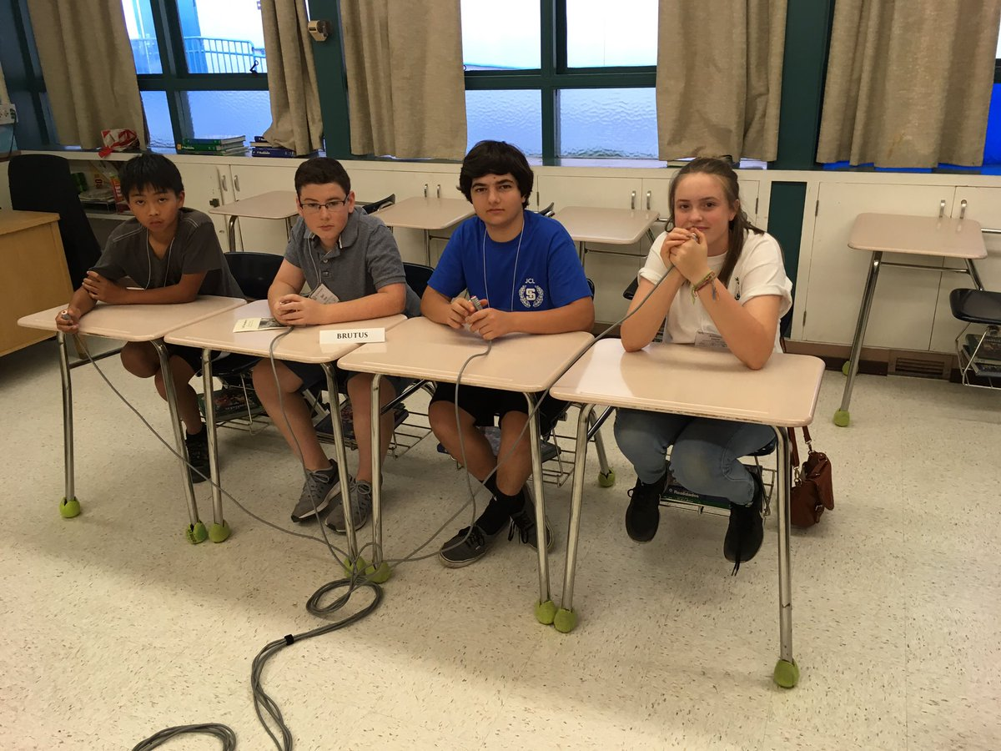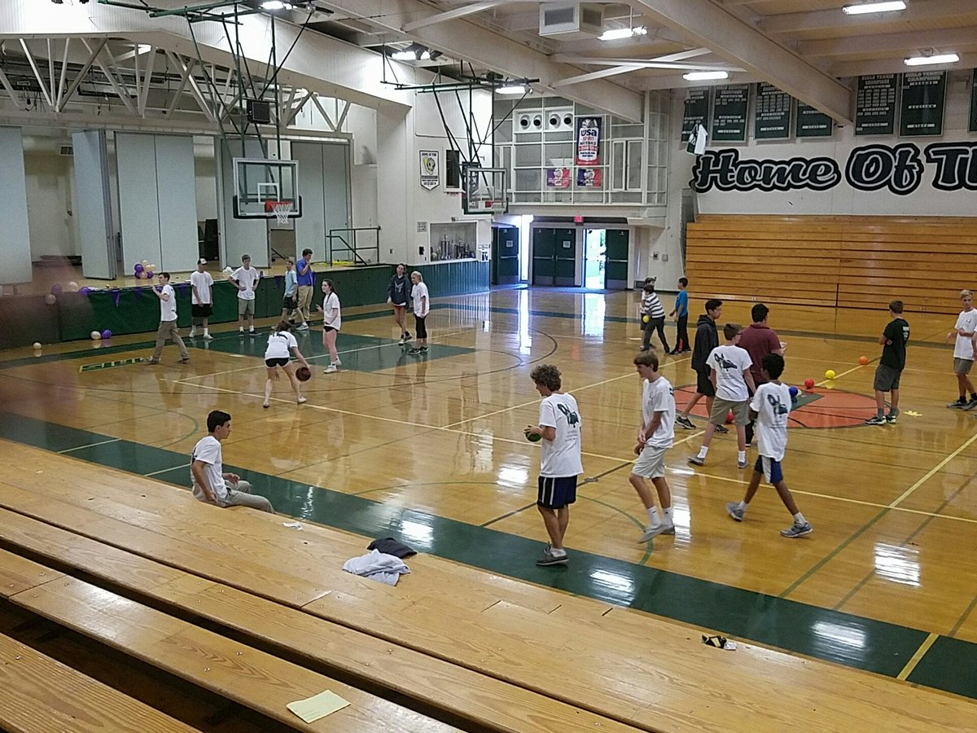

Academic testing went smoothly, and many Matadors won *gloria* and *praemium* from placing on the tests! Well done! We had some Mats on winning Certamen teams and some won awards for artistic talent in Impromptu Art. I can’t say too much about sports since again, I was stuck in the Open Certamen room. Hopefully those went well and showcased our athletic abilities.

Our esteemed food managers Erica and Gil reported that 42 extra pizzas were donated to a shelter in Berkeley, which is great news! Thecupcakes and donuts were delicious, and I definitely regret not sneaking an extra cupcake (I should have just taken Winston’s). The snack shack was also successful, and lots of attendees enjoyed Layal and Emma W.’s home-baked treats. Thanks guys! Also according to Erica, people ate salad. Good to know that people are staying healthy.

As always, Magister Davis and Carpenter played a crucial role in making sure things turned out amazing. *Perpetua gratia!* We definitely could not have done it without them. Not included in this article: TONS of other people who deserve recognition for the hard work they put in to run Ludi, including our officers and other helpful souls. Next challenge: hosting Carcer on March 18!

Pictures from the twitter accounts of: Brandon Samoranos, Magister Davis, Zachary Kumar

1. Out of a total of 16 votes