

Miramonte Consul October 2016

horizontal line

# Should We Bring Back Gladiator Fights?

An editorial by Erica Stephan

Every day, students at Miramonte frolic through hallways, burdened only by the fear of failing calculus, concerns about college, high expectations, a plethora of extracurriculars, and heavy backpacks. But in the time of Ancient Rome, many faced far heavier burdens. In this day and age, some wonder if our youth are becoming soft and weak- easy pickings for encroaching immigrants and foreign nations. In the face of this plight, a new solution has been offered: bring back gladiator fights.

Yes, public matches to the death for honor and glory. This innovative solution would begin in the Miramonte Latin Club. Members who fail to pass all of their CPs would be forced to publically fight in pairs to the death on Wednesdays, when the club meets. 

There is, however, some controversy. After interviewing Latin club members, The Consul found that members were divided over whether the gladiators should fight to the death using pool noodles or wooden clubs. Gil Peled, a Latin 2 student and the club’s Ille Honda, argues that the gladiators should use wooden sticks to bludgeon each other to death. He states that using this weapon would add an element of control to the death matches. Winston Durand, a Latin 4 student and the club’s webmaster, supports the use of pool noodles to make matches more humane.

Not everyone is in favor of this radical suggestion. Caesar Sophie is against the death matches, but mentioned that non fatal gladiator fights with pool noodles will be available at Ludi this November. Secundus Caesar Zahra Hasanain, however, is in favor of the death matches. This divide between the two Latin Club leaders raises questions about the future of the Latin club’s leadership. Will Caesar Hammond be able to bear out this political firestorm? As we all know, Julius Caesar was assassinated on the Ides of March. How will Caesar Hammond fare on the Ides of October?

horizontal line

Did the Romans Have Halloween?

By Kiana Hu

As we approach the highly anticipated, fun-filled day of Halloween which is also coincidentally the day Martin Luther published his Ninety-Five Theses (thanks, AP Euro!), many Latin students are probably asking themselves the question, did the Romans have Halloween? We’ll see that the answer is a clear no, for the following reason. The Romans simply didn’t celebrate a holiday that reflects our modern Halloween (and yes, I do know that this is not an extemp speech).

However, Romans did play an important part in spreading and developing what was originally the Celtic’s Samhain celebration into our popular festivity of dressing up and knocking on doors for candy. The Samhain (which translates into “summer’s end”) festival was a Celtic tradition that honored the dead, and its customs were incorporated into contemporary Roman festivals as Roman emperors subsequently conquered Celtic lands. Around late October, Romans were accustomed to celebrating Feralia, which similarly honored the dead, as well as observing the day of Pomona, goddess of fruit trees. Not coincidentally, the modern activity of bobbing for apples is derived from the apple as the symbol of Pomona.

Hundreds of years after Roman rule, Samhain was still a widespread event which the Catholic Church tried to extinguish, as evident when Pope Gregory IV moved All Saint’s Day or All Hallow’s Day, (the church’s version of honoring the dead created by Pope Boniface IV, originally supposed to be on May 13) to November 1st, the day after Samhain. Despite these efforts, people continued to celebrate Samhain and it became known All Hallow’s Eve, shortened to Halloween which we still use today.

The two most popular traditions today are dressing up and trick-or-treating; it’s interesting that one is a custom of the Samhain celebration, among lighting bonfires and parading, whereas trick-or-treating comes from the All Hallow’s Day tradition of a-souling, which generally consisted of people traveling door to door, asking one for food in exchange for a prayer for their deceased relatives or in some cases a performance of a song or dance.

So when we come back to our question of “Did the Romans have Halloween”, we have learned that the answer is no, although Romans did play a huge part in passing down the traditions that we celebrate in the United States today.

Works Cited:

Agomuoh, Fionna. "Ghosts of Halloween Past, Roman And Christian Influences." *International Business Times*. IBT, 30 Oct. 2013. Web. 03 Oct. 2016.

Norton, Lily. "Why Do We Dress Up on Halloween?" *LiveScience*. Purch, 29 Oct. 2010. Web. 3 Oct. 2016.

horizontal line

Ludi T-Shirt Created

By Erica Stephan

In preparation for the Ludi next November, Amanda Han has created Miramonte Latin Club’s t-shirt for the event. The design idea was a combination of different ideas from officers in Latin Club and a sketch from Erica Stephan. The front of the t-shirt has a laurel wreath and the back features Hercules slaying the Hydra. Some edits will be made to the final design, and Han has promised to add a fourth color to the back design.

This week, members voted on what quote will grace the shirt. Suggestions included: “aequam memento rebus in arduis servare mentem” - remember to keep a clear head in difficult times, “ad augusta per angusta” - to honors through difficulties, “flectere si nequeo superos, acheronta movebo” - if I cannot bend heaven, I will move hell, “ignis aurum probat miseria fortes” - fire tests gold, adversity tests the strong, and “crescit eundo - it grows as it goes”.

## Roman Halloween Costumes

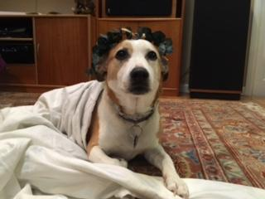

**Julius Caesar, added stab wounds recommended**

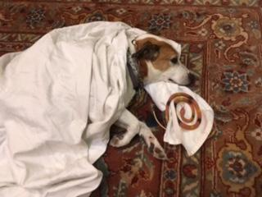

**Cleopatra dying of snake bite**



**Mr. Davis**

Augustus’s Birthday a Success!

By Sophie Hammond and Jessica Guo

*\*Note: Sophie Hammond has submitted this unfinished article to us poor overworked Consul editors. Any further additions will be in italics and from Jessica.*

*\*\*Further note: Friendly reminder - we highly encourage anyone to write for the Consul! You get published, and copious amounts of magis flow your way.*

This year’s Augustus’s birthday celebration was one of the best yet! *Of course, they continue to progressively get better every year, so that’s no surprise. This year was the first in my experience where we, as Latin IVs, celebrated the day of birth of Divus Augustus with the Latin Is next door. No, the wall was not folded to effectively double the space we had; instead, the Latin Is filed into room 184 to share seats and festivity with Latin IVs. That is to say, there were more traffic jams in the rush for food afterwards, but the energy in the room was doubled.*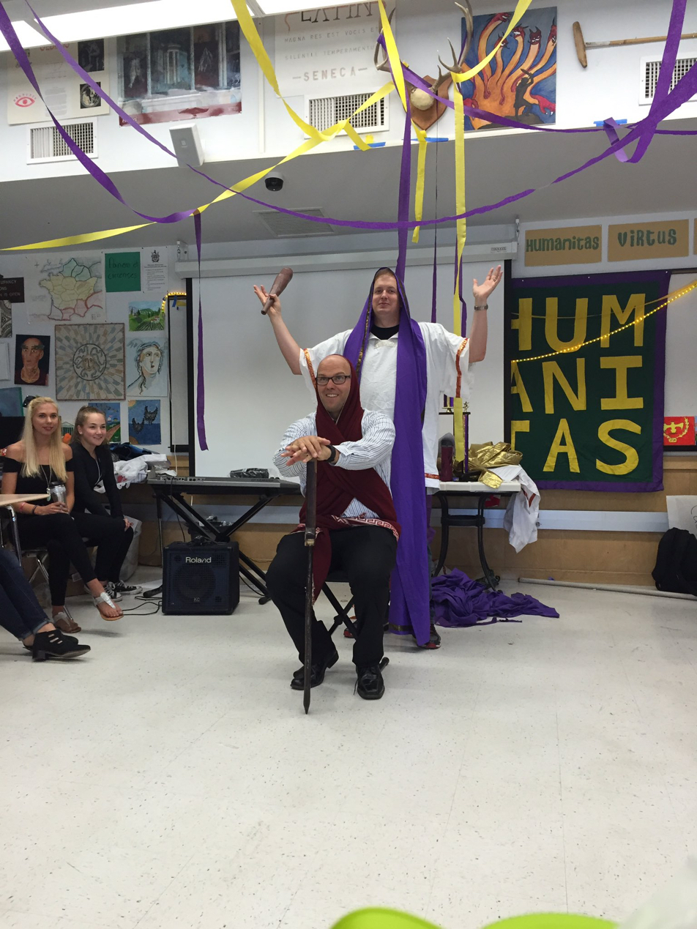

*The Exegi was twice as loud. There was a great sense of anticipation as we watched for the omen of the three-tail-feathered bird to fly from east to west. With the Latin IVs and Latin I together, here was a large selection of actors to choose from for the Augustus play and the Caesar chanting was more high-pitched with the Latin Is’ voices. The deaths of Caesar, Mark Antony, and Cleopatra were all heart-wrenching (not really), but fortunately Augustus survived and beautified Rome.*

I think that I speak for all the seniors in Latin when I say that when it comes to the things I’ll miss about the Miramonte Latin program, Augustus’s birthday is high on the list. I spent most of the celebration turning to other seniors and saying tragically, “This is our last Augustus’s birthday,” to which they replied, “Sophie, shut up and let us enjoy it!” And they were right.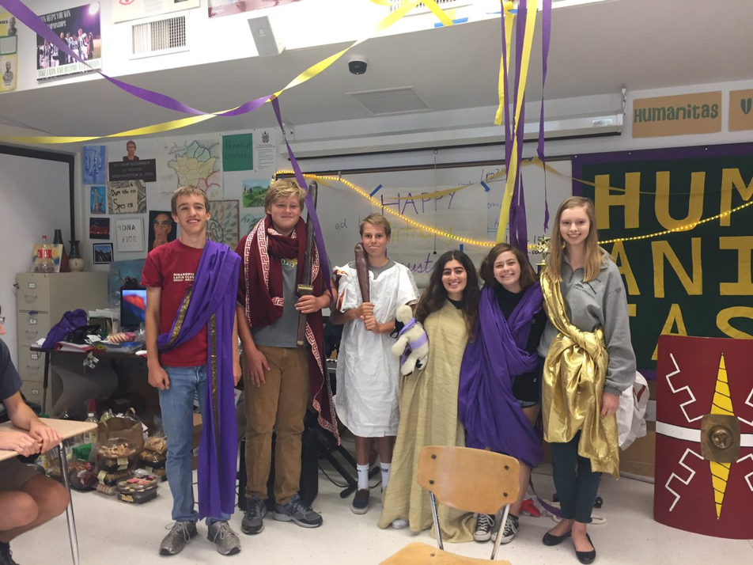

*Afterwards, as with every other year* on Augustus’s birthday we sang “Gaudeamus Igitur”, whose English title is “On the Shortness of Life”. Life is short, and our days in high school and in Miramonte Latin are even shorter. The only thing to do is “Let us rejoice, therefore / While we are young”. *Latin IVs beware - your youthful times are soon over. Images from twitter accounts of Olivia Fishlow and Ashley Abramson*