Miramonte Consul

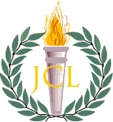

September 2016

horizontal line

# Should you Join Latin Club?

By the Editors: Erica Stephan, Kiana Hu, Jessica Guo

To any and all Latin students (and Miramonte students as well) who sit awake at night pondering this question, the answer is yes.

Latin club is a buzzing community of festivity that meets every Wednesday at lunch in room 184. There are many fun activities planned throughout the school year, including the recent “Pin the spear on Hector”/cookie decorating event we had just last week. If you have been keeping up with @MagisterDavis1 on twitter as you should, you know about all the fun things we do at lunch. Anything you might need can be found in Latin Club.

Need help studying for Latin? Come to Latin Club, and there will be plenty of eligible top-notch Latin students willing to help.

Need help studying for another class? The Latin Club community is made up of specialists in more fields than just the classics.

Need to meet more people? Latin Club is full of an amazing variety of people. Take your pick and make a friend to last the centuries.

Need a place to sit at lunch? Latin Club is host to a classroom’s supply of desks - both flat and slanted - to suit your every whim.

Bored? Come inside. We have cookies.

horizontal lineLooking for Ludi Help:

To help make Ludi a success, Latin Club needs student and parent volunteers to help out with picking up food from Costco. **Magis** will be offered to students for their work. If interested, talk to Magister Davis or Carp, or contact Sophie Hammond at sophie.hammond17@auhsdschools.org. Support the Latin Club principles of Virtus, Fides, and Humanitas by helping out!

horizontal line

Latin Twitter

By Kianna Hu and Gil Peled

Twitter, twitteri, m.? Or perhaps trittilo, the Latin word for chirp. Either way, it’s clear that Miramonte Latin has caught the Twitter worm, thanks to the program-wide Twitter project headed by Magister Davis and Magister Carpenter. On Tuesday, August 30th, eager Latin I’s and II’s crowded into the library to begin their introduction to the Latin world on one of the few things the Romans didn't invent, Twitter.

Guided by the Latin teachers and our wonderful librarian Ms. Williams, students opened professional Twitter accounts after answering a brief questionnaire on internet and Twitter etiquette. After creating the account, students were asked to answer short questions such as:

-What is the difference between “retweet” and “favorite”?

-What is a “#” used for? And what not to use it for, #swag

Following the Twitter knowledge section, various questions about Miramonte and Latin sent students on a Twitter scavenger hunt, as they tried to figure out questions such as: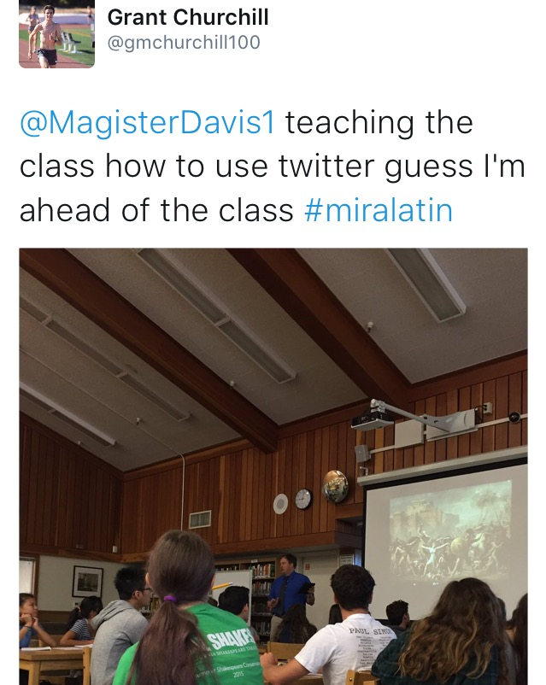

-According to @jakenabel from what Virgil quote

did Mark Zuckerberg take inspiration?

Well, it seems like the project was a success. Many students are already having fun tweeting Latin jokes, memes, and facts. In addition, having all the Latin students on Twitter will help promote Miramonte in a positive way.

In a day where social media is becoming more and more prevalent, having a school project is a great introduction on how to use social media professionally and maturely. Thanks, Magister Davis and Magister Carpenter!

## 

## 

## 

## Latin Nationals Report 2016

## By Kiana Hu

We almost missed dinner on the first day. It wasn’t a great start, but at least we got to play Mao while waiting for our connecting flight from Kansas City to Indiana. Our plane was delayed a good two hours or so, and because of the flight delay we missed the shuttle to Indiana University and had to wait two more hours. But it wasn’t too bad. Zahra and I got our violins out and practiced for the “That’s Entertainment” auditions, while providing some hearty music for those around us at the airport food court. The wait was worth it. Arriving at IU in Bloomington, we would experience a week to remember.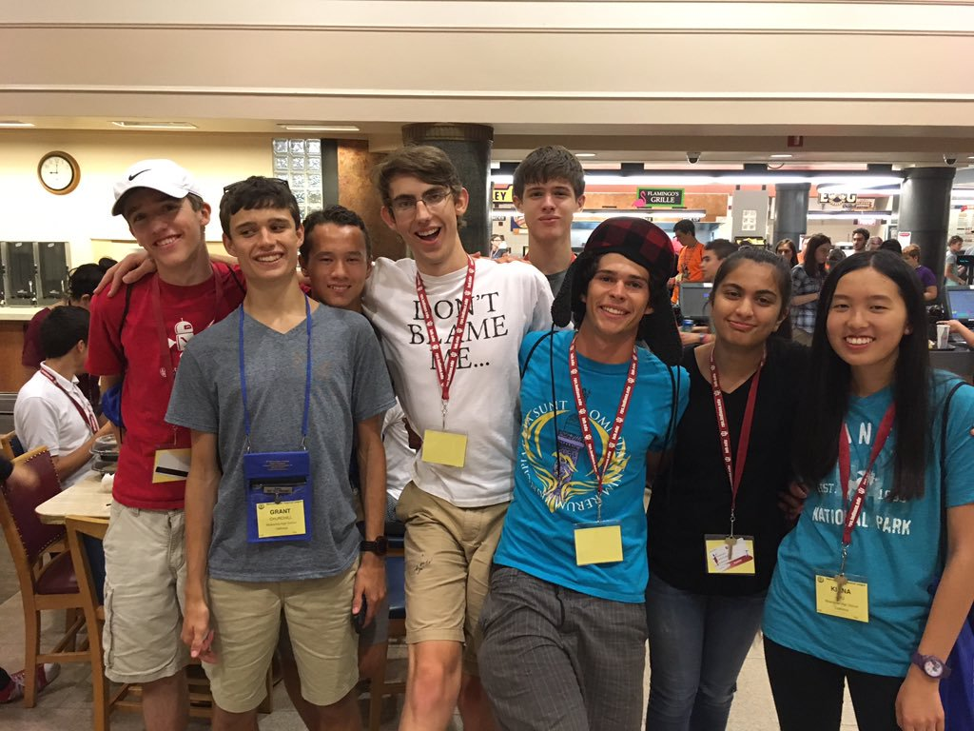

After almost missing dinner, the next activity that night was State Fellowship, where all the California attendees gathered together for a short meeting. Looking around the room, I saw mostly unfamiliar faces, with the exception of the seven Miramonte delegates, not including myself. However, throughout the week I would soon make friends with many of these people, most of whom I still talk to now.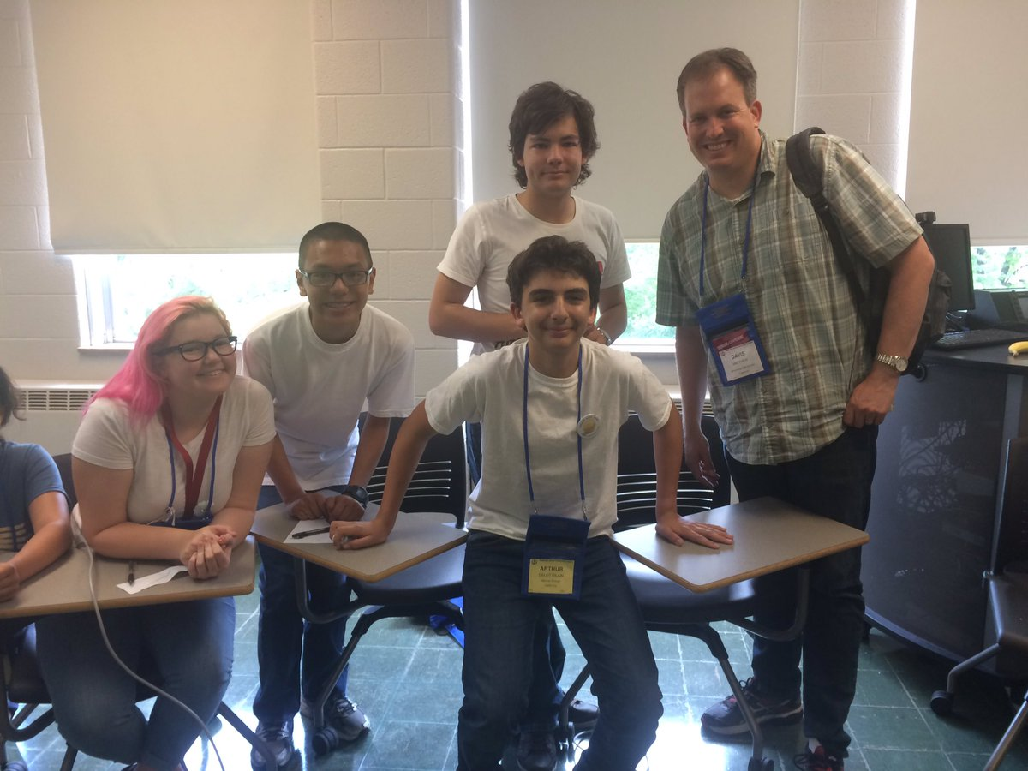

I can’t really say I remember doing much else besides certamen. Sure, the schedule was packed with various activities: Colloquia (lecture sessions), academic testing, art contests, Olympika (sport events such as track and field), dances, movies, and much more, but one thing I learned at Nationals is that doing well in certamen takes dedication. Pretty much any free time I had was spent doing certamen- before breakfast (I even got up at 5:00 A.M. to get to breakfast first), after testing sessions, before fellowship, and of course, the certamen rounds themselves. It definitely paid off. Being a smaller certamen state, California hasn’t qualified

a novice certamen team to the semi-finals in a long time. But somehow (probably due to our team’s obsession with certamen practices) we made it to semis (yay!) as did the intermediate team.

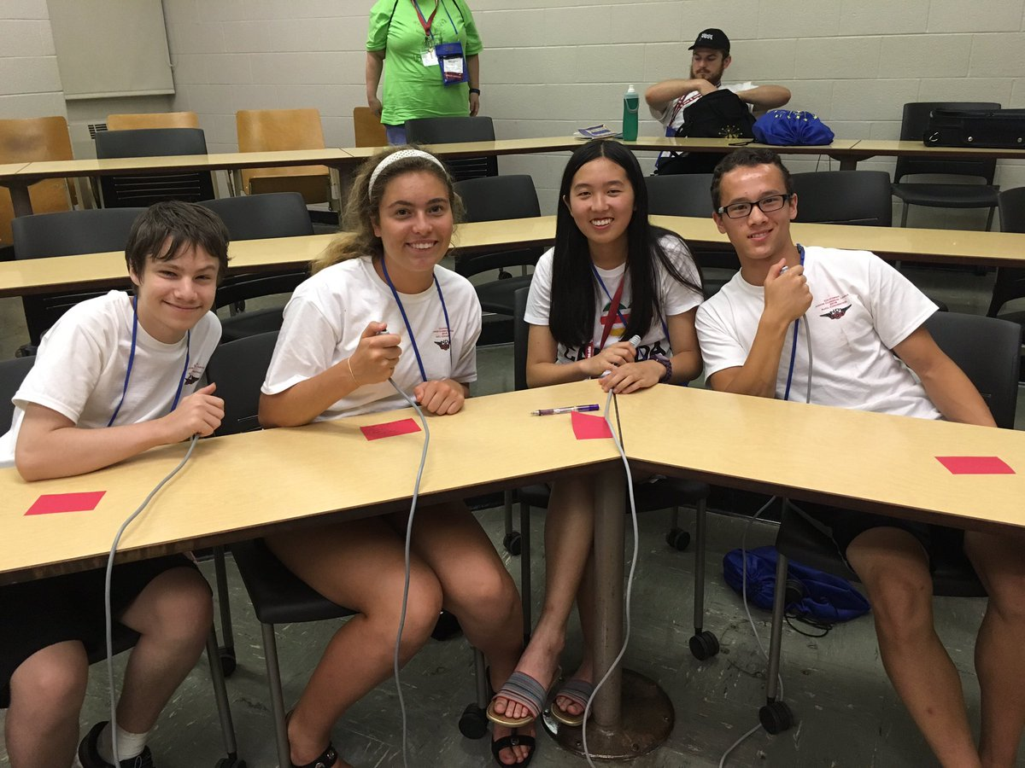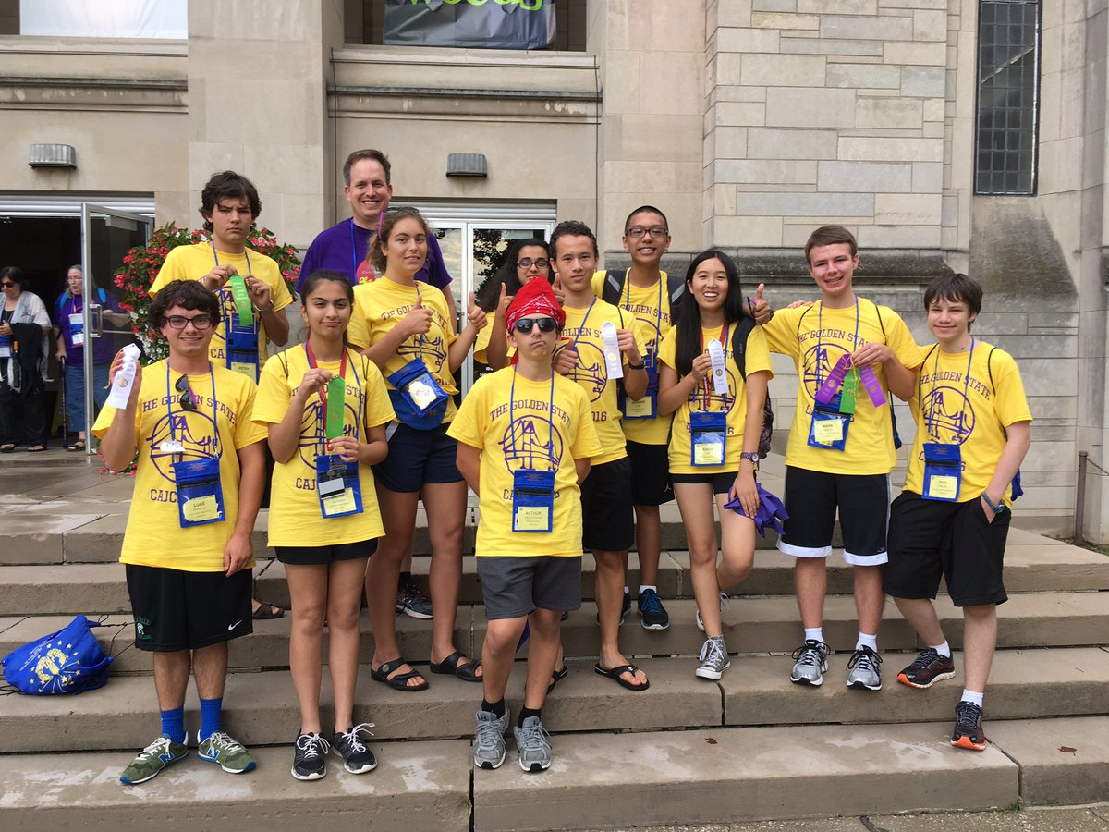

Other than certamen, the food was good and the academic tests were really fun, especially since there were tests on Greek culture and history in addition to the Roman/Latin tests at state convention. Many people from California placed in various academic tests, from Greek Life and Literature to Ancient Geography. We also did great in Olympika! Shout out to Garrett who did Miramonte and California proud by placing 1st in five different track events- earning him 8th in overall Olympika!

Leaving all the people I met at National Convention was pretty hard, especially since a lot of them are from SoCal. But it’s been really wonderful to get to know people in JCL outside of Miramonte- it’s hard to think of them as rivals now, even the ones from Woodbridge and University High. I’ll definitely be going back next year- to Troy, Alabama!

All pictures from Magister Davis’ Twitter @MagisterDavis1.

## Top Latin Tweets

