Audspect Cloud BAS Mastery: From Cloud Attack Simulation to Enterprise Cloud Resilience Validation
Audspect should not build cloud BAS as merely a collection of AWS, Azure and GCP attack scenarios. That would give you a cloud attack library, but it would not make Audspect difficult to replace.
The target should be a Cloud Security Control Validation Platform that continuously proves whether a client's cloud security controls prevent, detect, investigate and respond to realistic attack paths — across cloud infrastructure, identities, workloads, data, SaaS and hybrid environments.
For BFSI, NBFCs, manufacturing, healthcare and large enterprises in India and the UAE, the commercial value is not simply demonstrating that an attack is possible. It is answering questions their security teams, auditors and management struggle to answer:
- Can a compromised cloud identity access critical financial or customer data?
- Would the client's deployed security products detect the activity, and how quickly?
- Can an attacker move from a cloud workload to a privileged identity, storage account or production environment?
- Do security controls work across AWS, Azure, Microsoft 365, Kubernetes and on-premises Active Directory?
- Are cloud misconfigurations actually exploitable, or are they theoretical findings?
- If a cloud control fails, can Audspect prove the failure, identify the affected business service and validate remediation?
The key strategic decision is to make cloud BAS an extension of Audspect's existing scenario execution, evidence and control-efficacy architecture — not a separate product with a disconnected engine.

1. What Audspect must ultimately become
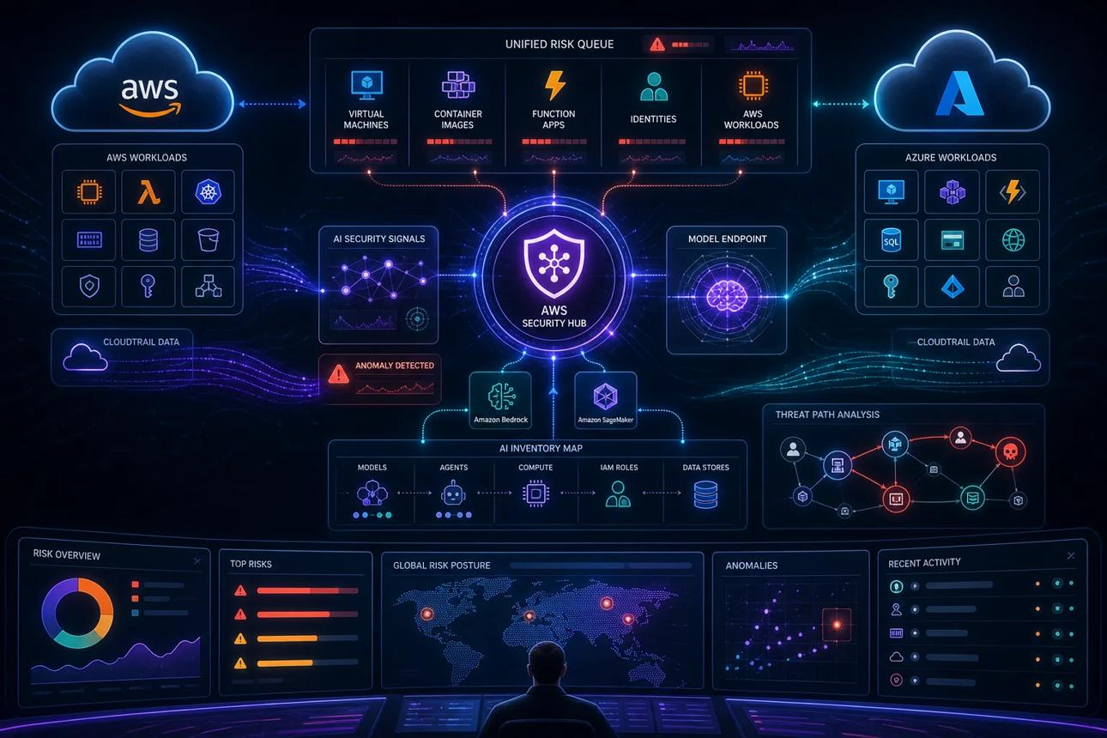
windowsforum.com
I would organize Cloud Mastery into six connected capabilities.
1. Cloud attack-path simulation
Model and validate attack paths involving cloud identities, permissions, compute, storage, networking, secrets and managed services.
Outcome: discover which combinations of weaknesses create a real attack path.
2. Security-control efficacy
Test whether IAM, CSPM, CWPP, CIEM, CNAPP, EDR, SIEM, SOAR, DSPM, WAF and cloud-native controls behave as intended.
Outcome: distinguish deployed controls from controls that demonstrably work.
3. Hybrid identity and lateral movement
Connect cloud identities to AD, federation, privileged access, service principals, workload identities and SaaS access.
Outcome: validate cross-environment attack paths rather than isolated cloud events.
4. Data exposure and business impact
Validate access boundaries around databases, object storage, backups, customer records, manufacturing data and regulated information.
Outcome: connect technical weaknesses to business assets and potential impact.
5. Detection and response validation
Correlate each simulation step with cloud audit logs, security alerts, analyst investigations, automated containment and recovery evidence.
Outcome: measure prevention, detection latency, investigation and response latency.
6. Audit and resilience evidence
Produce repeatable evidence packs with timestamps, affected resources, policy context, control verdicts, limitations and remediation verification.
Outcome: support security governance, internal audit, risk teams and compliance reporting.
These capabilities should share one evidence model, one execution framework and one reporting layer. Otherwise, Audspect risks becoming six loosely connected tools.

2. Scope the cloud estate correctly
The biggest mistake would be to define cloud as AWS + Azure + GCP. Cloud attacks span several different security planes, and each has different attack paths, telemetry and control mechanisms.
I recommend 12 cloud mastery domains.
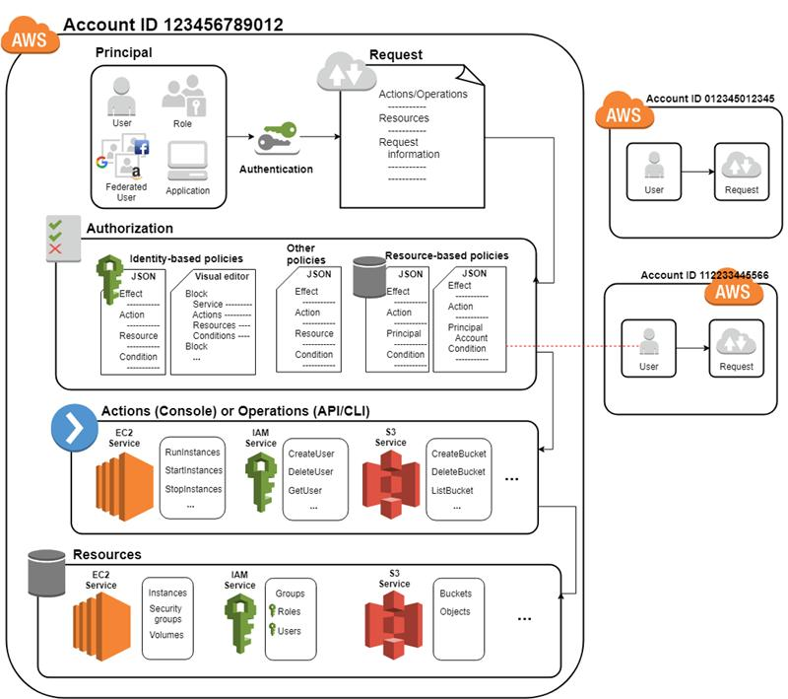
01. Cloud identity and privilege escalation
IAM users, roles, service principals, managed identities, access keys, federation, OAuth grants, cross-account trust, role chaining and excessive permissions.
Validate: can an ordinary identity obtain access to a privileged cloud role, and would the relevant identity controls block or detect it?
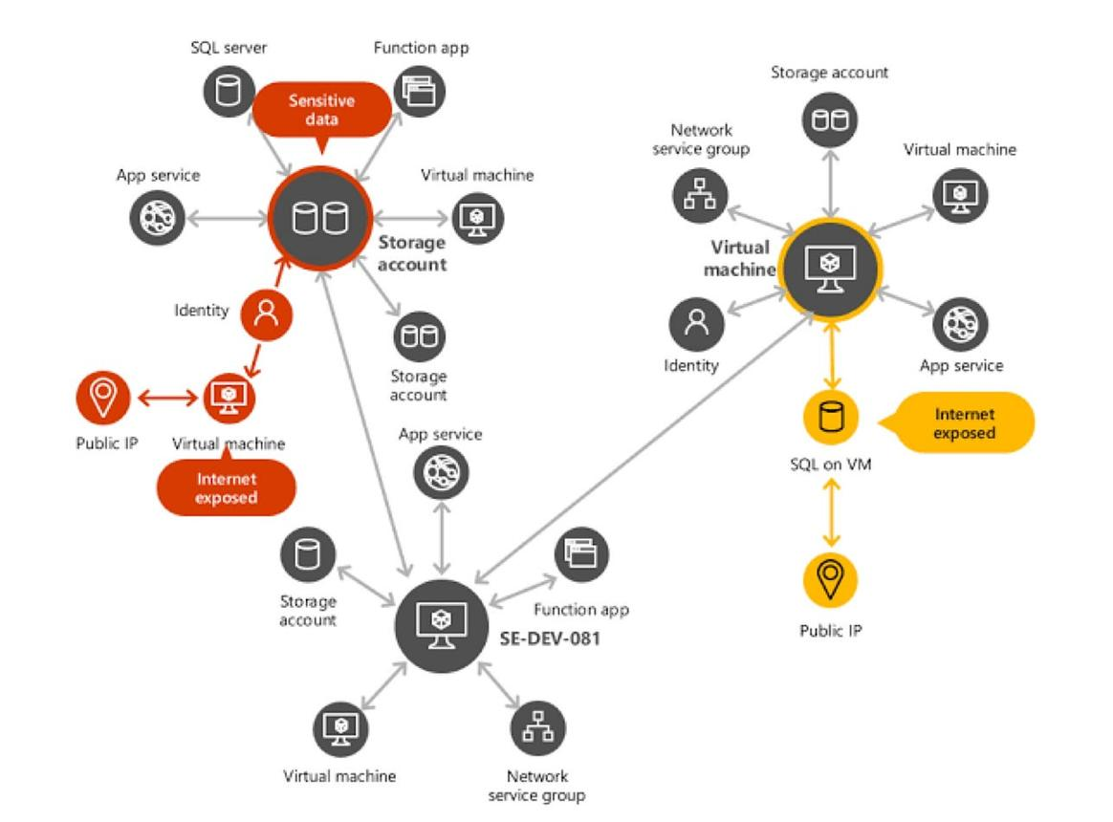
02. Cloud control-plane attacks
Unauthorized resource changes, security-group modification, audit-log tampering, security-policy weakening, role changes, snapshot exposure and persistence through cloud configuration.
Validate: are high-risk administrative actions prevented, logged, alerted on and investigated?
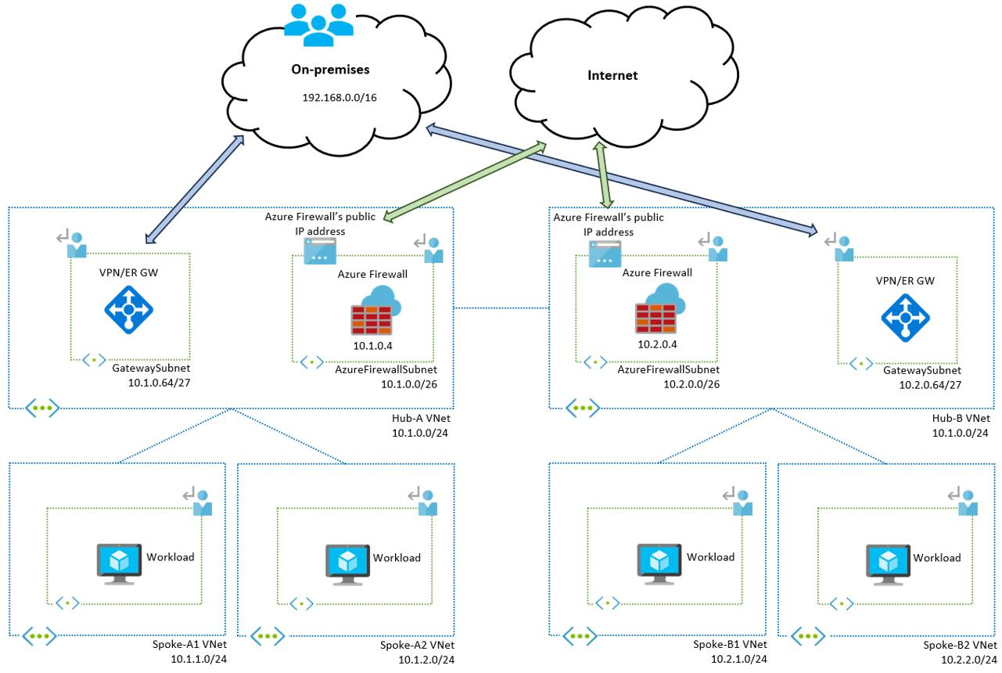
03. Cloud networking and exposure
Public management ports, exposed services, permissive security groups, network segmentation, private endpoints, DNS, hybrid connectivity and cloud-to-cloud trust.
Validate: can an attacker reach a resource that should be isolated, including through an indirect network path?
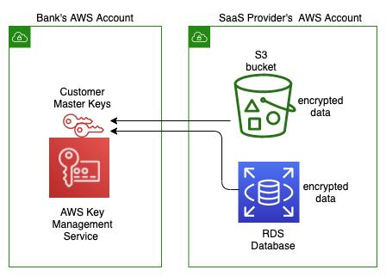
04. Data security and exfiltration
Object storage, cloud databases, data warehouses, secrets, encryption keys, backups, data classification and unauthorized export paths.
Validate: can sensitive data be accessed or exported, and does the organization detect or prevent the attempted access?
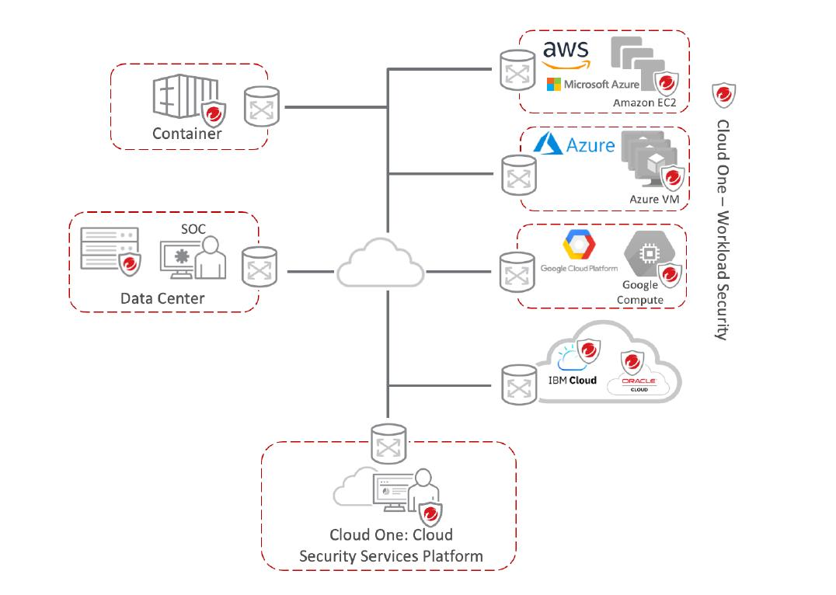
05. Compute and workload compromise
Cloud VMs, metadata services, workload credentials, container hosts, serverless functions, vulnerable services and persistence on cloud workloads.
Validate: do workload defenses stop the relevant behavior, and can workload compromise become a cloud privilege escalation?
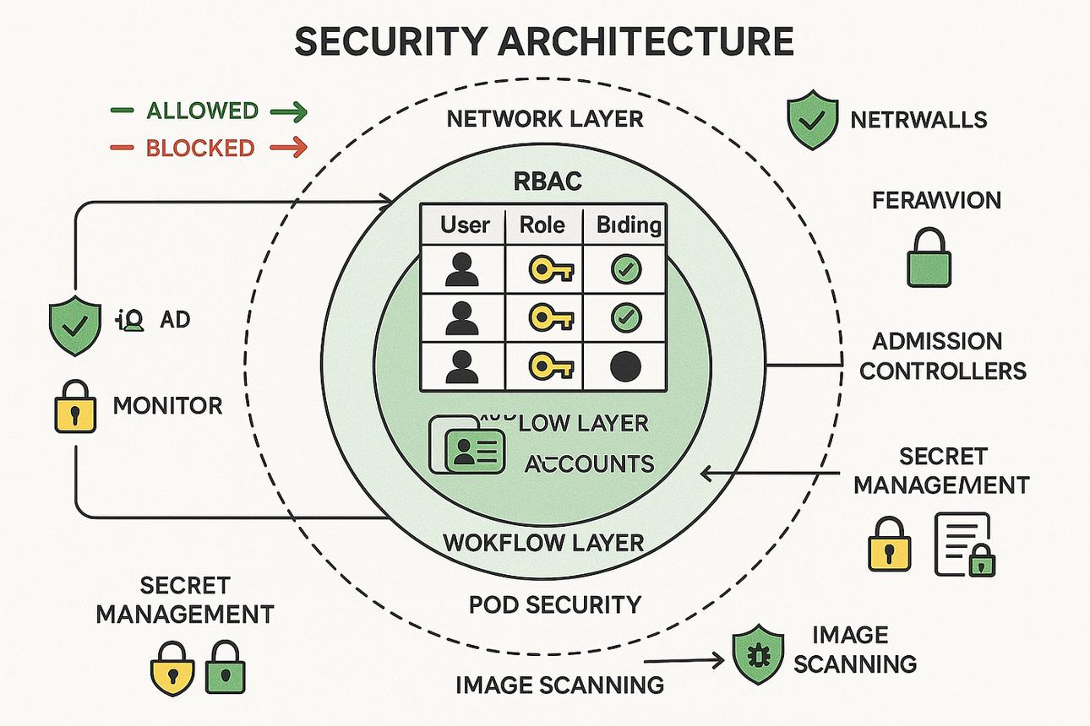
06. Kubernetes and container security
Cluster RBAC, service accounts, exposed API servers, secrets, container registry trust, privileged workloads, admission controls and movement between workloads.
Validate: can a compromised workload cross a namespace or cluster boundary, or obtain privileges it should not have?
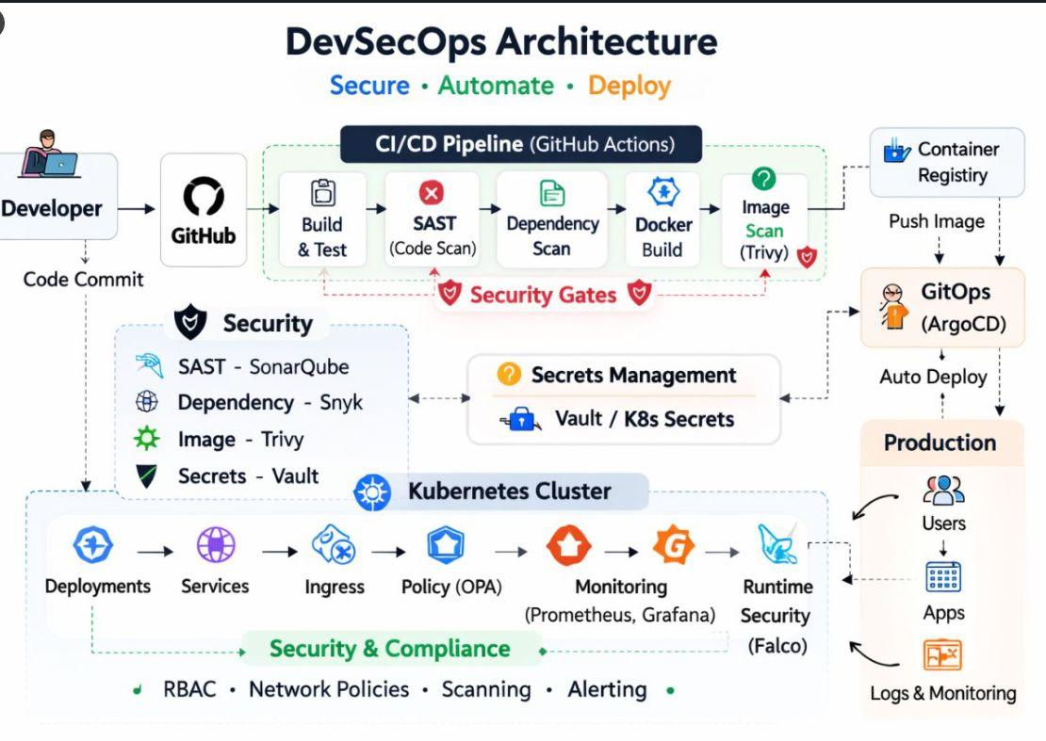
07. Cloud DevOps and software supply chain
CI/CD credentials, repository secrets, build identities, deployment permissions, infrastructure-as-code changes, artifact integrity and registry access.
Validate: can a compromised build or deployment identity alter a production workload, and do pipeline and runtime controls detect it?
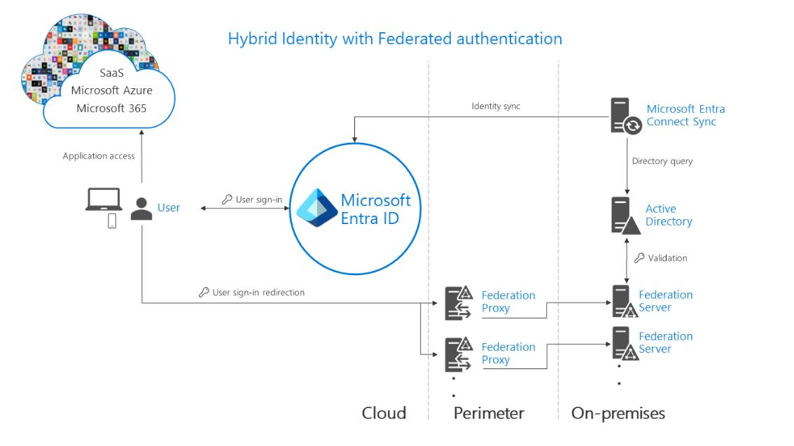
08. Hybrid identity and enterprise movement
Active Directory to cloud, cloud to on-premises, federation, synchronization, privileged identity management, remote management and trust boundaries.
Validate: does a compromise in one environment create unauthorized access in the other?
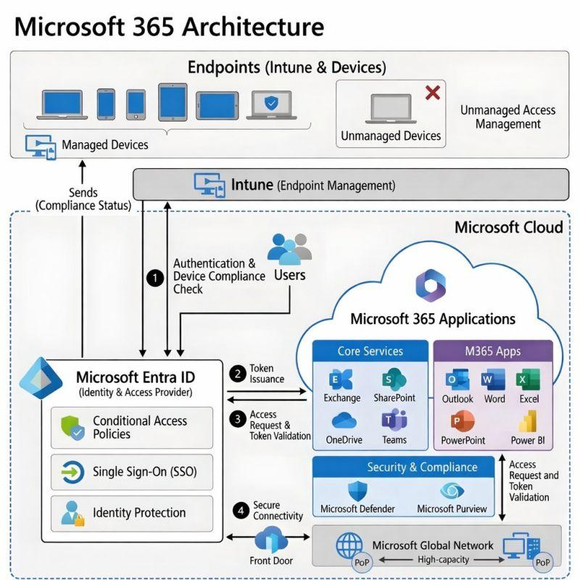
09. SaaS and cloud application security
Microsoft 365, enterprise SaaS applications, OAuth consent, application identities, mailbox and file access, token abuse, shadow SaaS and data-sharing permissions.
Validate: can an application identity or compromised user access information beyond its intended scope?
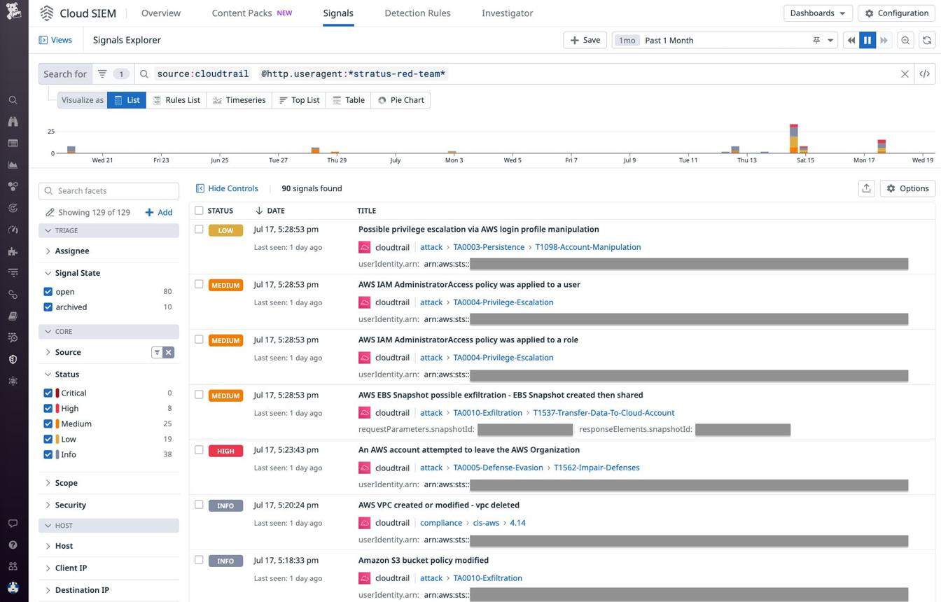
10. Cloud detection, monitoring and response
Cloud audit logs, identity alerts, workload detections, CSPM/CNAPP alerts, SIEM correlation, SOAR playbooks and incident escalation.
Validate: does the control produce useful evidence, at what latency, and does the response workflow actually execute?
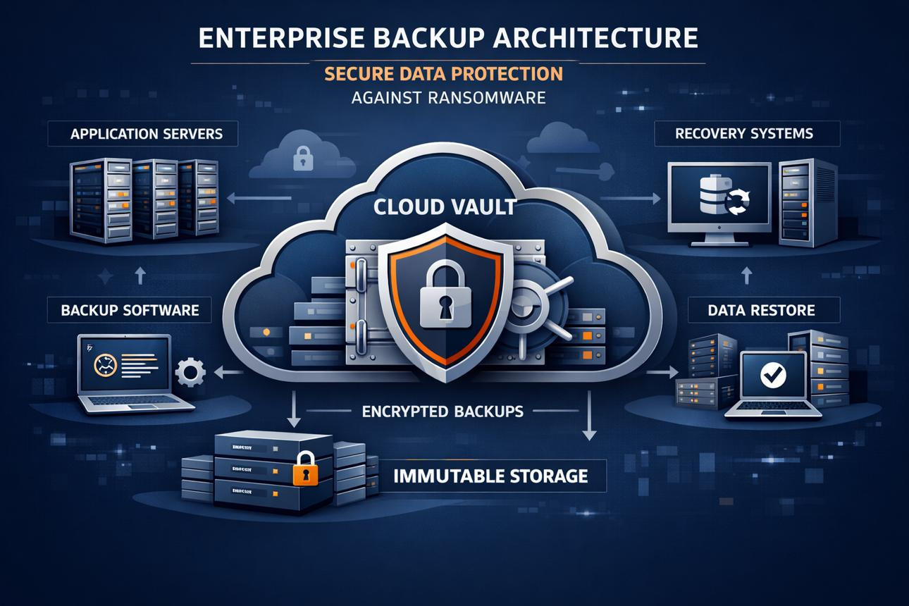
11. Cloud ransomware and resilience
Backup access, snapshot protection, deletion permissions, recovery isolation, encryption impact, storage access and restoration validation.
Validate: can ransomware-related activity reach recovery infrastructure, and can the business recover within its required objectives?
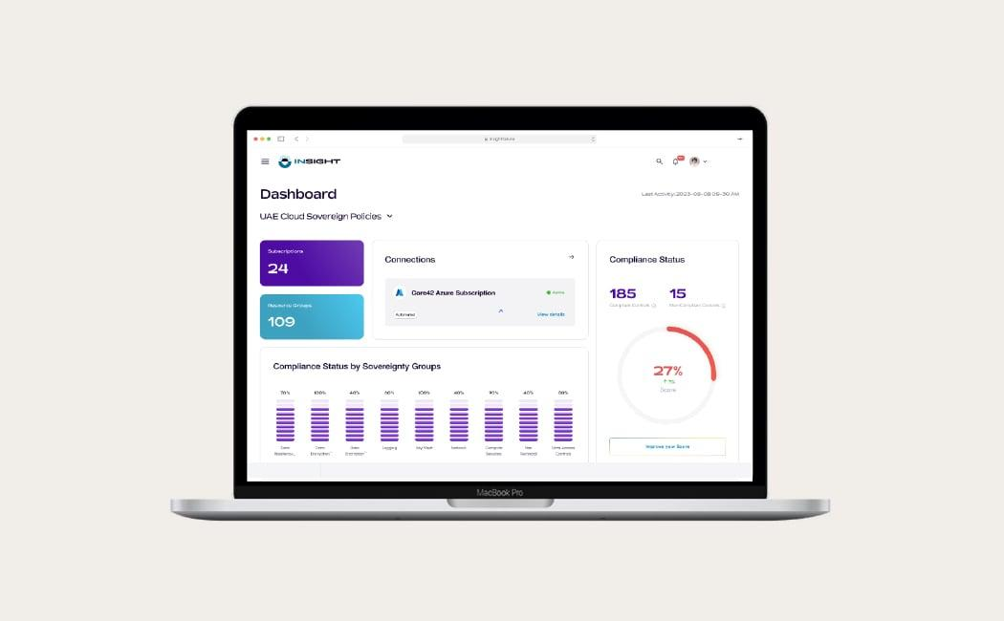
12. Governance, compliance and cloud concentration risk
Cross-account exposure, configuration drift, regional deployment, auditability, third-party access, shared responsibility, backup location and critical-service dependencies.
Validate: are the controls required by the organization's risk policies actually operating across its cloud estate?
These domains align with the direction of established cloud-security frameworks. Microsoft's Cloud Security Benchmark covers identity, privileged access, networking, data protection, logging, incident response, backup, DevOps and AI security; MITRE ATT&CK separately models cloud and SaaS attack behavior. Audspect should use these as coverage foundations, not merely reproduce their control checklists.

Microsoft Learn
+2

Which cloud providers should Audspect support first?
Do not attempt equal-depth support for every provider from day one.
Priority | Platform | Initial coverage
P0 | AWS | IAM, STS, CloudTrail, security groups, S3, EC2, KMS, CloudWatch, GuardDuty and security posture
P0 | Microsoft Azure | Entra ID, Azure RBAC, managed identities, Key Vault, Storage, Activity Logs, Defender for Cloud and Azure Monitor
P0 | Microsoft 365 | Entra-backed identity, OAuth applications, Exchange Online, SharePoint, OneDrive and audit telemetry
P1 | Kubernetes | Kubernetes RBAC, service accounts, secrets, workload identity, container registries and cluster telemetry
P1 | Google Cloud | IAM, service accounts, organization policies, audit logs, Cloud Storage, Compute Engine and Security Command Center
P2 | Hybrid and private cloud | AD, VMware and private-cloud workloads connected to public cloud
P2 | Additional SaaS | Prioritize based on actual customer deployments and available telemetry
My recommendation: launch with AWS + Azure/Entra ID + Microsoft 365 + hybrid AD. Add Kubernetes as a first-class domain early, then deepen GCP. This is a sequencing recommendation for a resource-constrained product team, not a claim that these are the exact market-share rankings in India or the UAE.
Why this sequence? It gives Audspect a coherent enterprise story: cloud infrastructure, identity, SaaS, on-premises AD and the paths between them. Supporting AWS and Azure independently is useful; proving an attack path that crosses them is much more differentiated.

3. The real differentiator: cloud attack-path mastery
A conventional cloud posture tool might tell a customer:
- An identity has excessive permissions.
- A storage resource is publicly accessible.
- Audit logging is incomplete.
- A workload has a risky configuration.
A BAS platform must go further. It should validate whether those conditions combine into a meaningful attack path and which controls detect or prevent each step.
Consider a hypothetical NBFC using Azure, Microsoft 365 and an on-premises Active Directory.
ILLUSTRATIVE ATTACK PATH
Compromised low-privilege identity
Initial access or simulated identity compromise
Over-permissioned application identity
Test whether identity controls restrict unintended privilege use
Sensitive storage or database access
Validate data authorization and security telemetry
Cross-environment privilege opportunity
Assess whether cloud-to-AD trust creates another viable path
Audspect's evidence and control verdict
Which steps were allowed, blocked, detected, investigated or contained — with proof?
The path above is a test hypothesis, not an assertion that the described identity relationships exist in every tenant. The actual path must be derived from the client's inventory, permissions, trust relationships and available evidence.
The important engineering requirement is that Audspect must distinguish three things:
- Potential attack path: configuration and relationship evidence suggests a possible path.
- Validated attack path: safe execution or authoritative evidence confirms that the relevant permissions and transitions work.
- Control-efficacy result: the deployed controls' behavior during the test is supported by correlated evidence.
Do not collapse these into one risk score. An exposed resource does not automatically mean an exploitable path; an alert does not automatically mean successful containment.

Build a cloud attack-path graph
Cloud mastery should have a first-class graph model, not only YAML scenarios.
The graph should represent:
- Nodes: users, roles, service principals, workload identities, VMs, containers, storage, databases, secrets, keys, networks and business assets.
- Edges: permission grants, role assumption, federation, trust, network reachability, data access, deployment authority and administrative control.
- Conditions: required permissions, provider-specific semantics, resource state, identity context and environmental prerequisites.
- Evidence: inventory source, observation time, confidence, provenance and validation method.
- Control overlays: preventive policies, detections, identity protection, workload controls and response actions.
- Business impact: the importance of the affected service, data and recovery dependencies.
This graph becomes the common foundation for scenario selection, attack-path prioritization, test planning and evidence reporting.
It should also connect to the AD mastery work already undertaken. The cloud graph should not reinvent identity relationships in isolation; it should consume and contribute to a common identity and attack-path model.

4. India and UAE: build for their actual business pain points
The strongest commercial opportunity is not a generic “cloud security testing” message. It is the ability to validate cloud controls against business risks that security teams and auditors can understand.
The UAE Central Bank's cloud-computing rules explicitly address materiality, governance, auditability, outsourcing risk, data location and monitoring. Its outsourcing guidance also discusses access controls, encryption, data classification and shared responsibilities. Those are direct reasons to build evidence-led cloud validation for financial institutions, rather than just attack demonstrations.

CBUAE Rulebook
+2

Priority industry use cases
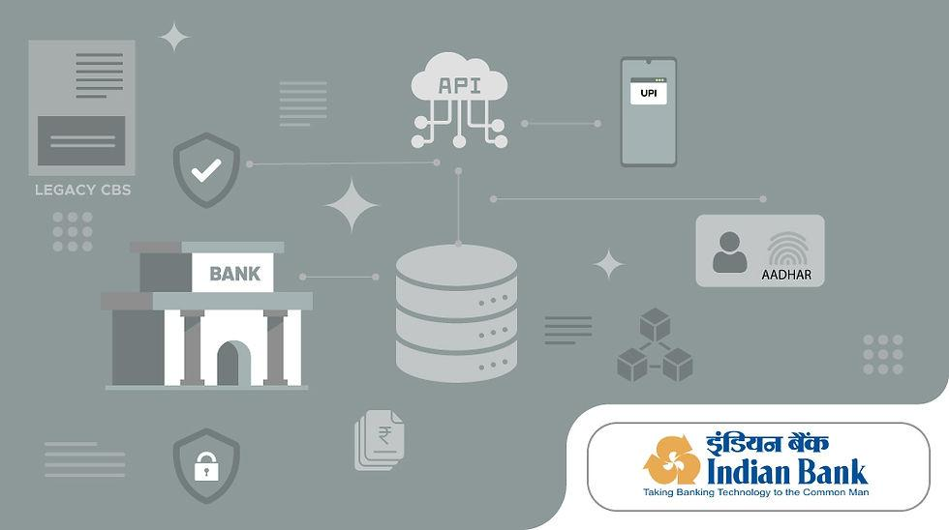
A. BFSI — banks and financial market institutions
Highest priority
Pain points: privileged identity exposure, payment-system dependencies, customer-data access, cross-account trust, cloud logging gaps, third-party access and recovery risk.
Audspect use cases:
- Validate privileged role escalation and unauthorized access paths.
- Test whether cloud security alerts capture suspicious administrative changes.
- Validate storage and database access restrictions around sensitive workloads.
- Test ransomware-related backup protection and recovery-control evidence.
- Produce evidence mapped to relevant internal control requirements and audit objectives.
What the buyer wants: defensible evidence that controls operate, not another dashboard showing compliance percentages.
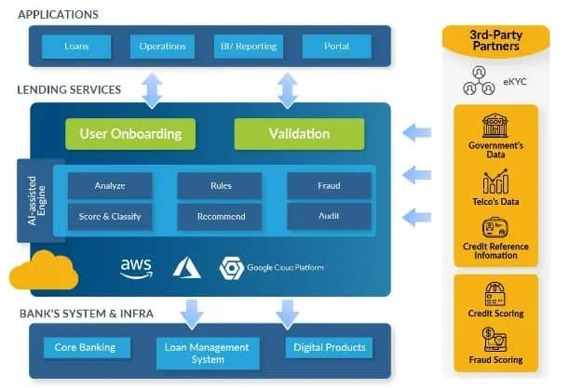
B. NBFCs, fintech and digital lending
Pain points: cloud-native applications, fast deployments, over-privileged developers, exposed APIs, customer-document storage, service credentials and limited security staffing.
Audspect use cases:
- Validate whether a compromised application identity can access other customer records.
- Test CI/CD deployment permissions and secret-handling controls.
- Validate API and storage authorization boundaries.
- Test whether security controls detect unusual cloud identity activity.
- Run repeatable tests after application releases and cloud-policy changes.
Commercial angle: an affordable, on-premises, repeatable validation platform for institutions that cannot justify multiple specialized security-testing products.
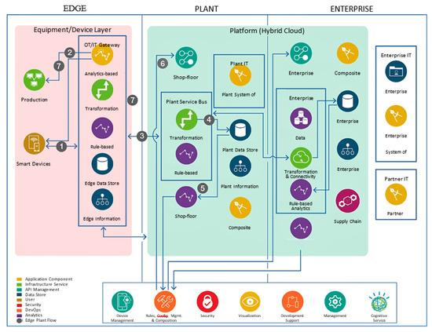
C. Manufacturing and industrial enterprises
Pain points: hybrid IT/OT environments, legacy AD, remote vendor access, cloud-hosted ERP/MES, engineering files, backup dependencies and production availability.
Audspect use cases:
- Validate whether cloud identity compromise creates a route to engineering or production-support systems.
- Test segmentation and access boundaries between corporate cloud and industrial environments.
- Validate cloud-hosted backup protection and recovery readiness.
- Test detection of suspicious remote-management and administrative activity.
- Assess cloud-hosted data and workload access without touching live control systems.
Important: use passive discovery and controlled test fixtures for OT-connected paths. Do not assume a production PLC, robot or safety controller is an acceptable BAS target.
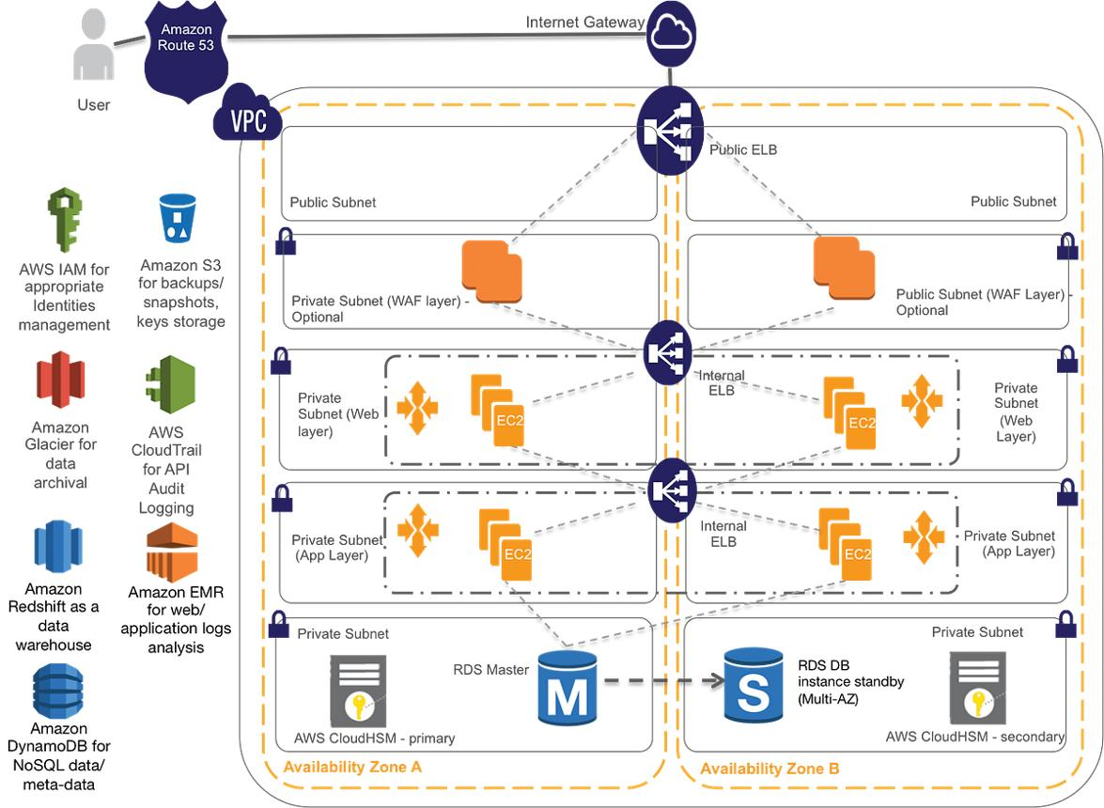
D. Healthcare and hospital groups
Pain points: sensitive patient records, medical imaging, identity sprawl, SaaS sharing, ransomware, clinical-system availability and backups.
Audspect use cases:
- Validate access boundaries around patient-data storage and databases.
- Test whether unauthorized sharing and export attempts are detected.
- Validate privileged access and backup-deletion controls.
- Test cloud-to-on-premises identity boundaries.
- Produce evidence for data protection, incident readiness and recovery testing.

E. IT services, MSPs and software companies
Pain points: multiple customer tenants, shared tooling, build pipeline credentials, cloud misconfigurations, insecure deployment identities and limited cross-customer visibility.
Audspect use cases:
- Validate tenant isolation and scoped service identities.
- Test whether a compromised deployment identity can affect unrelated projects.
- Validate secrets, artifact and registry access controls.
- Compare detection efficacy across different customer security stacks.
- Deliver repeatable validation reports to managed-service customers.

India-specific priorities
For Indian institutions, prioritize use cases that support the customer's actual regulatory obligations, internal security standards and cloud operating model:
- RBI-regulated bank and NBFC security governance, where applicable to the institution and service.
- SEBI-regulated entities and market infrastructure institutions, where applicable.
- Payment and digital-lending infrastructure, including identity, API, database and storage controls.
- Personal-data access and handling, including obligations arising under India's Digital Personal Data Protection framework where applicable.
- Audit evidence, outsourcing oversight, incident readiness, business continuity and recovery validation.
Do not label a test “RBI compliant” or “SEBI compliant” just because it maps to a requirement. Map individual tests to the precise applicable provision, record the scope and limitations, and leave compliance determinations to the appropriate assessment process.

UAE-specific priorities
Prioritize:
- CBUAE-regulated banks and other covered financial institutions, with cloud outsourcing and auditability as explicit use cases.
- DIFC and ADGM financial services organizations, considering their applicable regulatory regimes separately.
- Data classification, access controls, encryption, regional deployment and evidence of data-handling controls.
- Third-party and cloud-service-provider access, outsourcing risk and exit/recovery readiness.
- Multi-region resilience, privileged-access monitoring and incident response.
The UAE is not one uniform regulatory jurisdiction. CBUAE requirements, DIFC/DFSA rules, ADGM/FSRA requirements and other applicable laws must be mapped separately rather than merged into a single generic “UAE compliant” claim.

5. The cloud BAS scenario library: what to actually build
I would create a dedicated Cloud Mastery content library, similar to the AD and ransomware mastery work, with scenarios organized by attack technique, provider, security control, business use case and evidence requirement.
Do not chase a large scenario count before the scenarios work end-to-end.
A useful initial target is 120–180 well-specified cloud scenarios, followed by expansion based on observed gaps in real customer environments. The numbers below are proposed planning targets, not a claim about existing Audspect coverage.
Scenario family | Initial target
Cloud identity and privilege escalation | 20
Control-plane abuse and persistence | 15
Network exposure and segmentation | 15
Data access and exfiltration | 15
Compute and workload compromise | 15
Kubernetes and containers | 15
DevOps and supply chain | 12
Hybrid identity and SaaS | 15
Detection, response and resilience | 20
Total | 142
These families overlap by design: a scenario can belong to multiple families, and the count is a content-planning baseline rather than a measure of unique attack techniques.

The first 20 high-value scenarios
Here is the initial shortlist I would use to test whether the architecture covers the important cloud behaviors.
Scenario IDs below are proposed naming conventions, not existing Audspect scenario IDs.
CLD-001
Excessive cloud role permissions
IAM / CIEM
Validate whether a role can perform actions beyond its intended scope.
CLD-002
Cross-account role trust
IAM
Test unauthorized or unintended cross-account access.
CLD-003
Service principal privilege abuse
Entra / IAM
Validate application identity permissions and privileged operations.
CLD-004
Managed identity access boundaries
Cloud identity
Check whether a workload identity can access unrelated resources.
CLD-005
Stale credential and access-key risk
Credential security
Validate credential detection, rotation controls and unauthorized-use monitoring.
CLD-006
Cloud audit logging tampering
Control plane
Test whether attempts to weaken logging are blocked or detected.
CLD-007
Security-policy modification
Control plane
Validate prevention and alerting for changes to critical security settings.
CLD-008
Public storage exposure
Data security
Test public-access protections using an isolated, non-sensitive fixture.
CLD-009
Unauthorized storage data access
Data security
Validate authorization and detection for an out-of-scope read attempt.
CLD-010
Secrets-store authorization abuse
Secrets / KMS
Test unauthorized secret or key access without revealing secret values.
CLD-011
Excessive cloud network access
Networking
Validate reachability and segmentation with controlled probes.
CLD-012
Cloud workload metadata exposure
Compute
Test whether workload credentials or metadata are improperly exposed.
CLD-013
VM-to-cloud privilege transition
Compute / IAM
Validate whether workload access can obtain unintended cloud privileges.
CLD-014
Kubernetes service-account abuse
Containers
Test service-account permissions and namespace boundaries.
CLD-015
Container registry trust failure
Supply chain
Validate image provenance, registry permissions and deployment enforcement.
CLD-016
CI/CD deployment identity compromise
DevOps
Test whether pipeline credentials can alter unauthorized environments.
CLD-017
Cloud-to-AD trust boundary
Hybrid identity
Validate unintended privilege paths across cloud and on-premises identity.
CLD-018
SaaS OAuth over-privilege
SaaS
Test excessive application grants and the relevant detection coverage.
CLD-019
Backup deletion permission abuse
Resilience
Validate protection of recovery assets without deleting backups.
CLD-020
Cloud attack detection and response
Detection / response
Correlate a controlled multi-step exercise with alerting, investigation and containment evidence.
Every scenario should have provider-specific implementations, explicit prerequisites, a defined expected control outcome, evidence requirements and a cleanup or rollback plan.
One scenario name must not be treated as proof of broad provider support. For example, a generic “role escalation” scenario may need different implementations for AWS IAM, Azure RBAC and Google Cloud IAM, because their permission and trust semantics differ.

Scenario maturity levels
I recommend four explicit content maturity levels:
- Level 1 — Observational: assess configuration, inventory and control state without attempting an attack action.
- Level 2 — Controlled validation: exercise a narrowly scoped, reversible behavior in a dedicated test resource or identity.
- Level 3 — Composed attack path: link several validated steps and correlate their evidence across cloud services.
- Level 4 — Enterprise control validation: run repeatable campaigns across environments, security products and business use cases, with independently verified outcomes.
A Level 1 scenario must not be counted as proof that Level 3 attack execution or Level 4 response validation has been achieved.

6. Cloud BAS must test the customer's security products, not compete with all of them
This is one of the most important architectural decisions for Audspect.
Audspect does not need to replace every CNAPP, CSPM, CIEM, EDR, SIEM or cloud-native security product. It needs to prove whether the products already deployed by the customer are effective against the behaviors that matter.
For example:
Customer has deployed | Audspect should validate
AWS GuardDuty | Whether the relevant simulated activity produces an expected finding and whether that finding reaches the intended workflow
Microsoft Defender for Cloud | Whether supported workload, identity and cloud-control-plane behaviors produce the expected alerts or recommendations
Microsoft Sentinel or another SIEM | Whether telemetry arrives, the relevant rule fires and the event is correlated correctly
CSPM / CNAPP | Whether the tested misconfiguration is identified and whether its risk prioritization reflects the validated attack path
CIEM | Whether excessive permissions are identified and whether intended privilege boundaries are enforced
EDR / CWPP | Whether supported workload behavior is prevented or detected and whether evidence identifies the affected workload
PAM / PIM | Whether privileged access requirements are enforced for the tested identity and action
DSPM | Whether relevant data assets are classified and whether access or movement outside the intended boundary is detected
DLP / cloud access security controls | Whether controlled data-access or export attempts produce the expected policy decision
SOAR / incident response | Whether the expected playbook runs, whether the action succeeds and whether the affected resource reaches the intended state
Backup / disaster recovery | Whether protection settings are effective and whether recovery evidence supports the organization's recovery objectives
WAF / API security | Whether the selected test behavior is blocked, detected or logged as expected
These are validation objectives, not promises that every vendor exposes every event or supports every test.

Build a vendor-neutral efficacy model
Audspect already has an important foundation from the AD work: the generic control-efficacy axis and the ControlOutcome concept. Extend that model to cloud rather than creating a separate scoring system.
Each test should record distinct outcomes:
- Allowed
- Blocked
- MFAChallenged
- Terminated
- Quarantined
- Unknown
The implementation must distinguish an action that was blocked by the intended security control from an action that failed because of an API error, missing permission, network issue or unsupported environment.
I would also make the following independent measurements mandatory:
Measurement | What it answers
Prevention | Did the intended control prevent the behavior?
Detection | Did a relevant alert or finding occur?
Detection latency | How long between the test action and observable detection?
Investigation | Did the expected case or investigation workflow receive the evidence?
Response | Was the intended response action executed successfully?
Response latency | How long between detection and verified response?
Coverage | Which attack behaviors and prerequisites were actually tested?
Evidence confidence | Is the result backed by provider evidence, vendor telemetry, configuration, or only a simulated assumption?
Never treat a successful API call as proof that a security control failed, or the presence of a SIEM alert as proof that the attack was contained.
Audspect should correlate the test execution with provider audit records, security-product findings, case-management events and, where available, verified resource state. The control verdict should carry evidence provenance and a clear explanation of what was and was not established.

How to integrate vendors without owning every product
Use a tiered integration strategy.
Tier 1 — Cloud-native evidence
Read cloud audit records, provider-native findings, resource state and identity configuration. This should be the first integration layer.
Tier 2 — Security vendor evidence
Connect to documented vendor APIs, alert feeds, case systems and response-status interfaces. Start with a small number of commonly deployed products.
Tier 3 — Response verification
Verify the outcome of approved actions: policy denial, access revocation, workload isolation, identity suspension or other supported containment.
Tier 4 — Integration conformance
Provide a fake-backed test harness for each provider adapter. Validate schemas, pagination, authentication failures, rate limits, delayed events, duplicates, timeouts and missing telemetry before testing against a real product.
The fourth tier is especially important because Audspect cannot assume that a vendor integration works just because it passes unit tests. Fake providers prove adapter behavior; a real integration test in an authorized tenant is still needed to establish actual compatibility and telemetry semantics.

7. Cloud BAS architecture: how to build this inside Audspect
I would structure the engineering work into eight layers.

01
Cloud inventory and evidence ingestion
Read-only discovery of accounts, subscriptions, projects, identities, resources, policies, audit settings and security findings.

02
Canonical cloud resource model
Normalize provider-specific objects while preserving original IDs, policy semantics, provider metadata and provenance.

03
Cloud identity and attack-path graph
Represent permissions, trust relationships, reachability, resource dependencies and potential privilege transitions.

04
Scenario planner and prerequisite resolver
Choose scenarios based on observed assets, supported provider operations, required permissions and available telemetry.

05
Controlled execution adapters
Execute narrowly scoped tests through provider-specific implementations with explicit prerequisites, limits, approvals and cleanup.

06
Evidence and control-efficacy engine
Correlate actions with audit events, security findings, response outcomes and timestamps; retain Unknown when evidence is insufficient.

07
Risk and business-impact engine
Prioritize validated paths by critical asset, access scope, exposure, control failure and recovery dependency.

08
Campaigns, reporting and remediation verification
Schedule repeatable campaigns, produce evidence packs and rerun failed tests after remediation.

Cloud-specific engineering decisions
A. Separate discovery from execution.
The discovery plane should use least-privilege read-only access wherever possible. It should be useful even before the client enables any active testing.
B. Use provider-specific adapters behind a common contract.
Audspect should share scenario definitions, evidence models and efficacy semantics while keeping AWS, Azure, GCP and Kubernetes API behavior in separate implementations.
C. Model prerequisites explicitly.
Each scenario should declare required permissions, resource types, provider capabilities, telemetry prerequisites, safety constraints, evidence requirements and cleanup behavior. Unsupported prerequisites must produce a clear status, not a false pass.
D. Make cloud execution idempotent and bounded.
Every state-changing test should have an explicit scope, time limit, resource boundary and cleanup strategy. Where rollback cannot be guaranteed, use a disposable fixture or observational test instead.
E. Make cloud events first-class evidence.
Preserve event timestamps, resource identifiers, correlation IDs where available, event source, collection delay, provenance and confidence. A detection may arrive late, arrive twice or never arrive; the engine must represent all three cases correctly.
F. Do not confuse a graph edge with a proven exploit.
An IAM permission, a network route and a data-access relationship are different facts. The graph engine should represent inferred relationships separately from observed and validated transitions.
G. Extend the existing campaign model.
A cloud campaign should fan out scenarios across selected accounts, subscriptions, projects, identities and test resources — with concurrency limits and isolation boundaries. The existing Audspect campaign concept is a useful fit.
H. Remain on-premises deployable.
Cloud BAS does not require Audspect to become a SaaS product. The orchestrator can remain customer-hosted, with outbound or private API connectivity to approved cloud control planes and local evidence storage. This fits the existing on-premises, single-tenant direction.
A practical distinction: cloud control-plane testing may work from the Audspect orchestrator, but workload-level tests may need an agent, a temporary test resource or a customer-hosted runner in the relevant network. Do not force all tests through one execution mechanism.

8. Cloud Mastery roadmap: the order I would execute
Do not start by writing 142 YAML scenarios. Start by building the smallest vertical slice that proves discovery, a cloud test, evidence correlation and control efficacy work together.
This is the proposed roadmap, not a statement that these phases have already been implemented.

01
Cloud foundation
First
Phase 1 · Establish the model
- Define canonical resource, identity, permission, evidence and control models.
- Define provider capabilities and read-only discovery contracts.
- Create a synthetic cloud tenant fixture and deterministic test data.
- Define scenario maturity and evidence-confidence rules.
- Map the initial control objectives to MITRE ATT&CK, CIS and relevant cloud benchmarks.
Exit criteria: the inventory and graph represent known test fixtures correctly, preserve provenance and fail clearly on unsupported relationships.

02
First real provider — AWS
Phase 2 · Discovery and controlled validation
- Implement read-only AWS account discovery and IAM relationship mapping.
- Ingest CloudTrail and relevant native security findings.
- Implement a small set of observational and controlled scenarios.
- Add an AWS evidence adapter and deterministic fake provider.
- Validate the integration in a dedicated, authorized AWS test account.
Exit criteria: a real test produces a traceable result with the correct control verdict, evidence provenance and unsupported-state handling.

03
Azure and Entra ID
Phase 3 · Enterprise identity
- Implement Azure resource discovery, RBAC relationships and managed identities.
- Integrate Azure activity records and supported security findings.
- Connect cloud identities to the existing AD mastery model.
- Implement application identity, privilege and storage access scenarios.
Exit criteria: cloud identity and resource evidence can be correlated without duplicating or contradicting the existing AD model.

04
Control efficacy and SIEM integration
Phase 4 · Prove that controls work
- Wire the generic ControlOutcome model into cloud scenarios.
- Correlate actions with cloud audit events, alerts and cases.
- Implement detection and response latency measurements.
- Add fake-backed SIEM, CSPM and response adapters.
- Validate delayed, missing, duplicate and contradictory evidence.
Exit criteria: Audspect can distinguish a blocked action, an undetected action, an unavailable telemetry source and an inconclusive result.

05
Composed cloud attack paths
Phase 5 · Cross-service validation
- Compose identity, workload and data-access scenarios.
- Add cloud-to-AD and cloud-to-SaaS relationships.
- Validate each transition independently before composing paths.
- Add path-level evidence, risk prioritization and remediation verification.
Exit criteria: the engine can report which steps were validated, which were blocked, which remain hypothetical and why.

06
Kubernetes, DevOps and resilience
Phase 6 · Expand attack surfaces
- Add Kubernetes RBAC, workload identity and registry trust.
- Add CI/CD and infrastructure-as-code validation.
- Extend ransomware and backup-assurance scenarios into cloud environments.
- Add recovery evidence and controlled response verification.
Exit criteria: the same evidence and efficacy model works across cloud infrastructure, workloads, identity and recovery.

07
Enterprise validation and GCP
Phase 7 · Repeatability and scale
- Add GCP and customer-prioritized SaaS integrations.
- Run recurring campaigns across multiple accounts and environments.
- Add risk-based scheduling, drift-triggered retesting and remediation tracking.
- Validate concurrency, failure recovery, upgrade behavior and evidence integrity.
Exit criteria: repeatable, auditable campaigns work across the supported estate with measurable coverage and reliability.

How long should this take?
For a small, experienced engineering team, I would plan approximately 4–6 months to reach a credible AWS/Azure-focused cloud BAS release with initial control-efficacy validation, assuming the existing Audspect foundations are reusable and vendor access is available.
That is an estimate, not a commitment. Broad provider coverage, robust attack-path validation, numerous real vendor integrations and enterprise-grade reporting will take longer. The first end-to-end vertical slice should come well before the full roadmap is complete.

9. What would make Audspect genuinely difficult to replace?
No product can guarantee that customers will never consider a competitor. Audspect can, however, create meaningful switching costs by delivering capabilities that work together and become increasingly valuable as the customer uses the platform.
I would prioritize these seven differentiators.
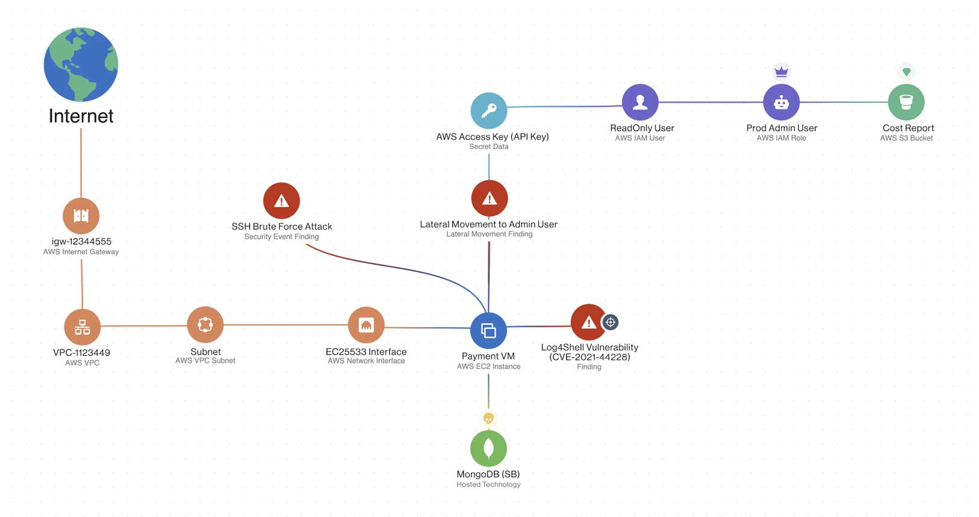
1. Business-aware cloud attack-path validation
Go beyond individual misconfiguration checks. Show how identity, network, workload and data weaknesses combine, which transitions are validated and which controls interrupt the path.
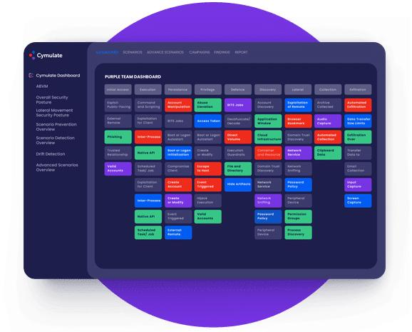
2. Vendor-neutral control efficacy
Compare actual preventive and detective behavior across the customer's existing products. Use evidence-backed verdicts rather than assuming that installed software is effective.
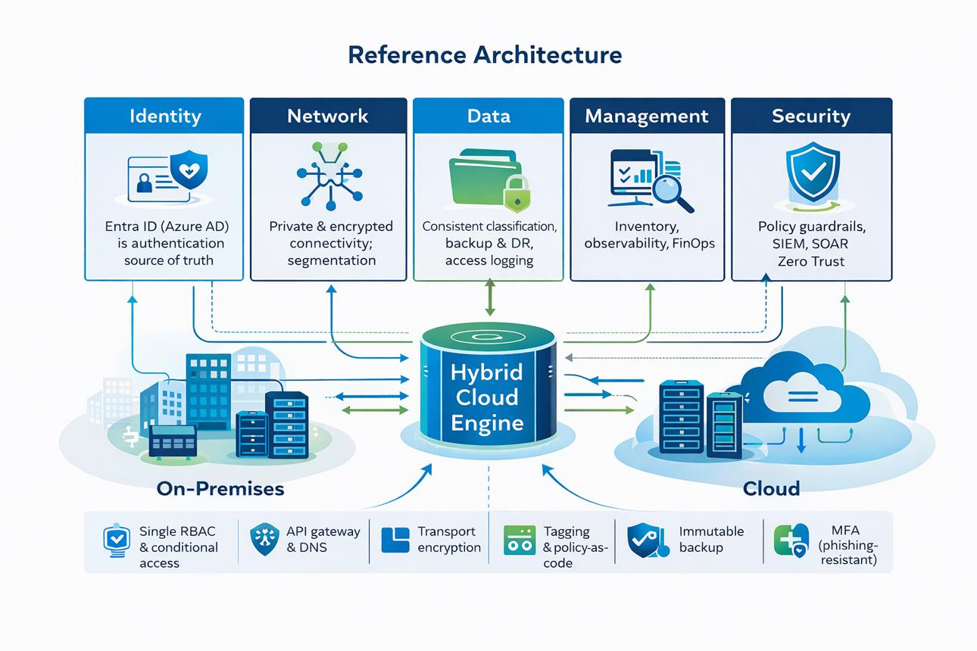
3. Unified identity across AD, cloud and SaaS
Reuse Audspect's AD mastery to model cloud-to-AD, SaaS-to-cloud and workload-identity paths. This is more valuable than treating each platform as an isolated scenario library.
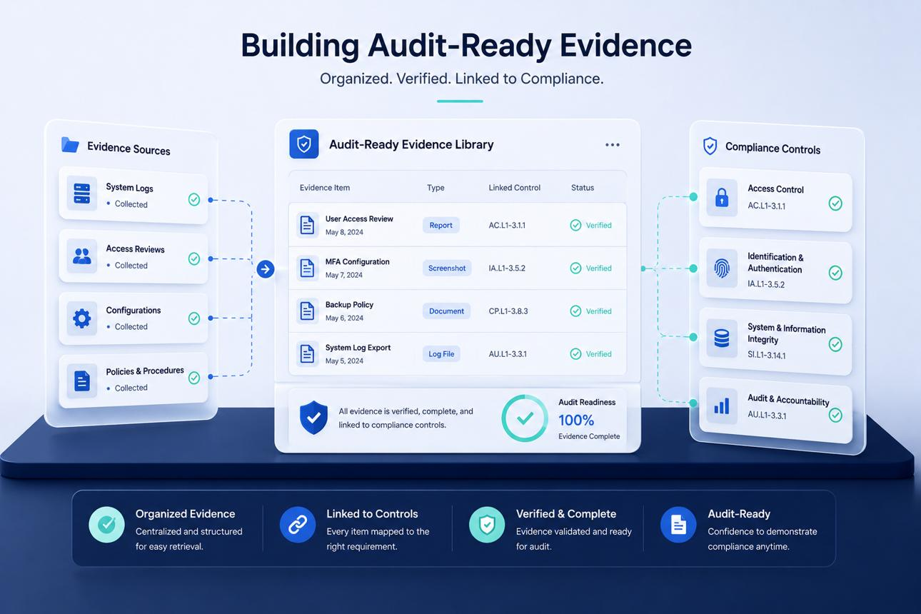
4. Audit-grade evidence
Preserve the test definition, scope, timestamps, execution result, supporting events, control verdict, limitations and remediation result. Let customers trace a management-level claim to the underlying evidence.
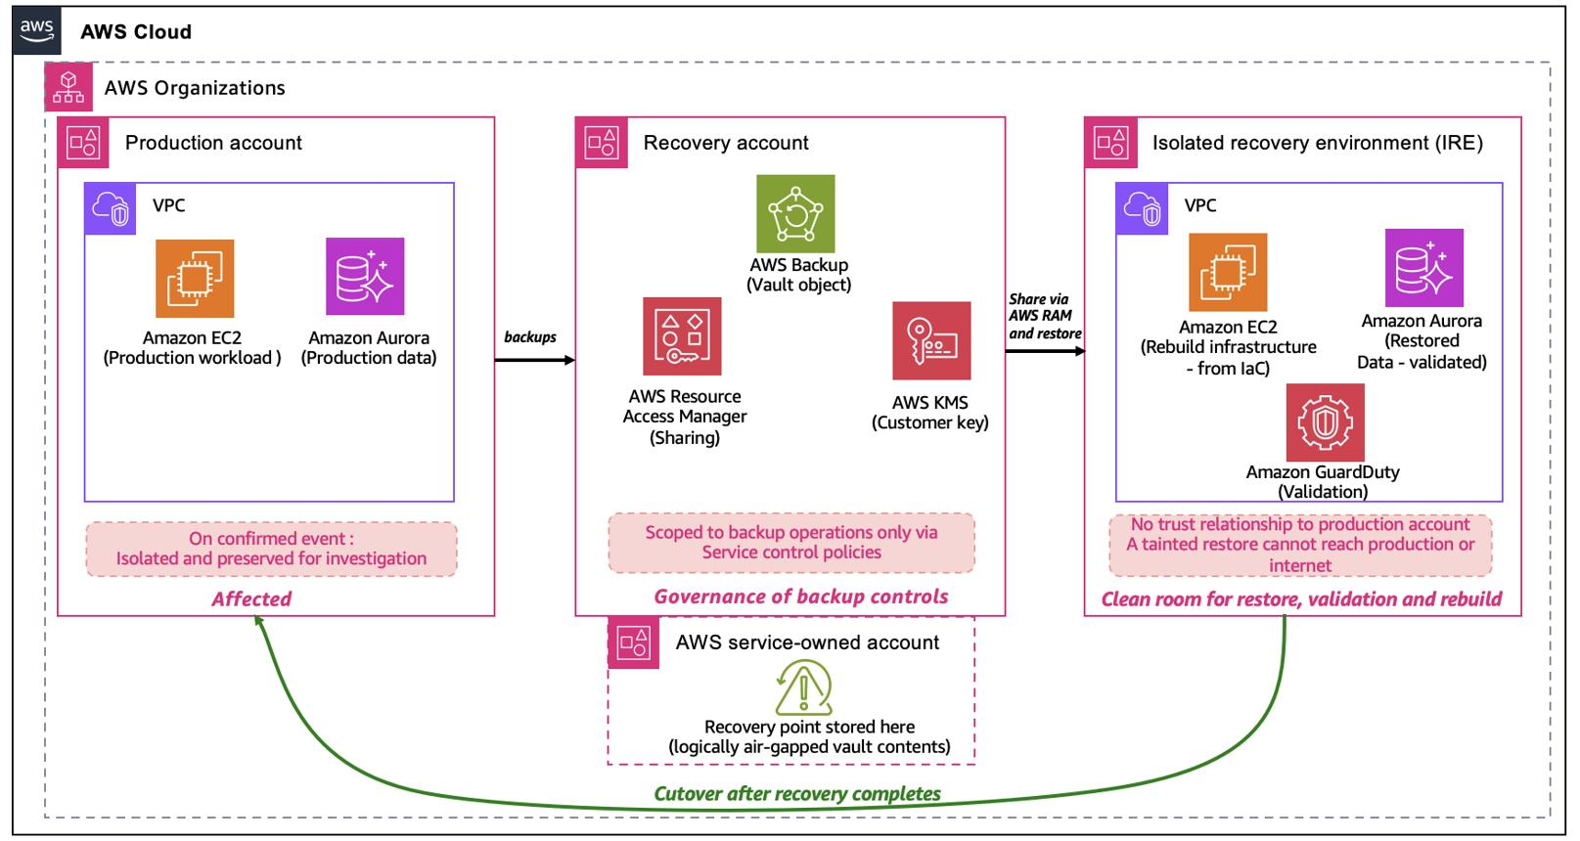
5. Cloud ransomware and recovery validation
Combine the existing ransomware direction with cloud identity, storage, backup permissions, immutable recovery controls and restoration evidence. Avoid merely checking that a backup job completed.
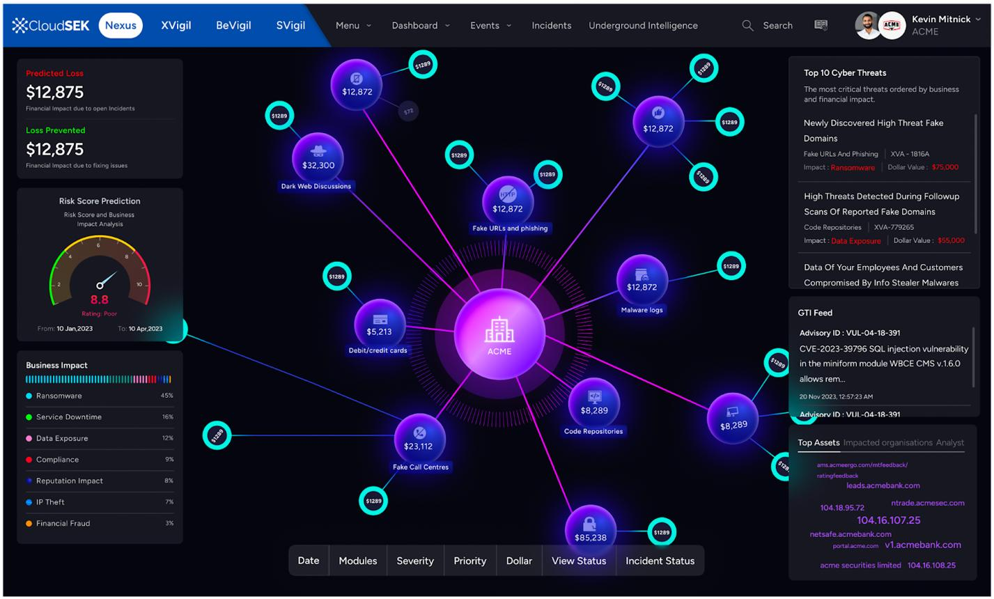
6. Risk ranked by business consequence
Prioritize paths affecting payment processing, lending, customer data, production engineering, patient records and critical services, rather than ranking everything by generic technical severity.
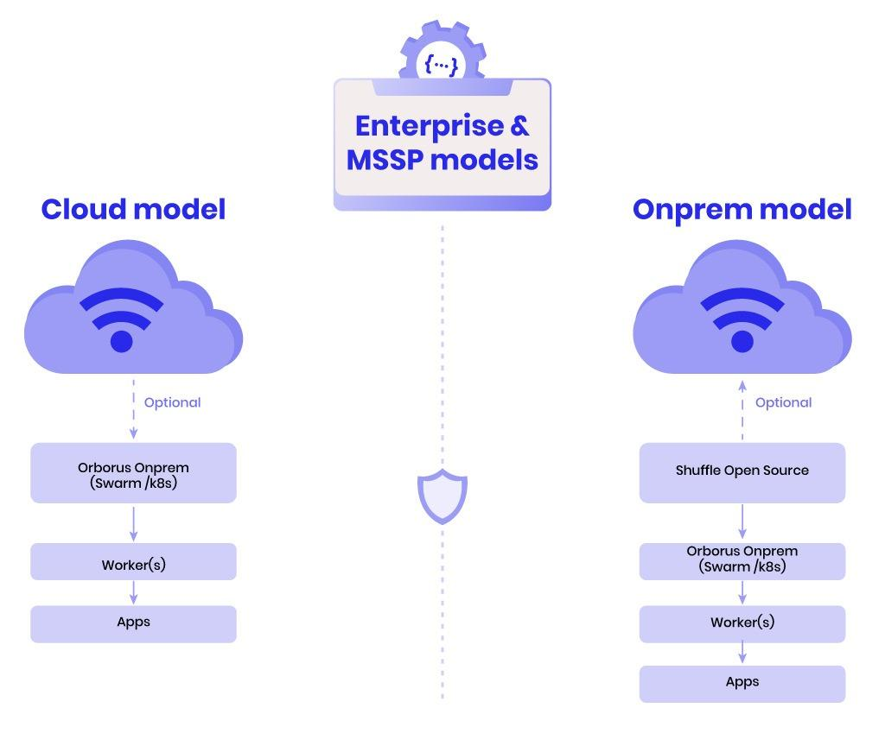
7. On-premises, single-tenant deployment
Offer a customer-hosted platform with local evidence retention and controlled access to cloud APIs. This can be an important differentiator for customers with data-handling, deployment and operational constraints.
The defensible advantage is not the number of attack techniques alone. It is the combination of provider semantics, validated attack-path relationships, real security-product integrations, reliable evidence correlation and repeatable enterprise outcomes.

10. Define measurable completion criteria
Cloud Mastery should not be declared complete because the team has written a large number of scenarios.
Use release gates such as these.
Measurement | What must be demonstrated
Scenario execution | Every published scenario has defined prerequisites, expected outcomes and repeatable tests.
Provider coverage | Each claimed provider feature has an explicit implementation and conformance status.
Evidence correctness | Every reported verdict is traceable to its evidence and validation method.
Control efficacy | Prevented, detected, responded-to and inconclusive outcomes are distinguishable.
Detection latency | Latency is measured only where a reliable event and correlation window exist.
Integration reliability | Adapters handle pagination, rate limits, authentication failures, delayed events and missing data.
Attack-path validity | Inferred paths are distinguished from paths validated through evidence or controlled execution.
Remediation verification | A failed test can be rerun and compared against the original evidence.
Safety and recovery | State-changing tests have enforced scope, approval, cleanup and failure-handling behavior.
Enterprise readiness | Campaigns, audit packs, upgrades and multi-account operations are tested under realistic conditions.
For each release, set numerical reliability and coverage thresholds only after collecting baseline measurements. A target such as “95% coverage” is meaningless until Audspect defines exactly what was eligible to be tested, what was actually tested and what evidence counts as coverage.

11. Regulatory and standards mapping
Build the mappings into the content and evidence architecture from the beginning.
Reference | How Audspect should use it
MITRE ATT&CK Cloud and SaaS matrices | Attack behavior, technique coverage and scenario relationships
CIS Benchmarks | Configuration-focused validation for supported platforms and services
Microsoft Cloud Security Benchmark | Azure and multicloud security-control objectives
NIST Cybersecurity Framework | Organizing control outcomes by governance, protection, detection, response and recovery
PCI DSS | Relevant controls for applicable payment-data environments
ISO/IEC 27001 | Mapping evidence to relevant information-security control objectives
RBI and SEBI requirements | Applicable India-specific governance, security, resilience and audit objectives
CBUAE, DFSA and FSRA requirements | Jurisdiction-specific cloud, outsourcing, risk and auditability objectives
Microsoft's benchmark documentation explicitly supports mappings to frameworks including NIST, CIS and PCI DSS, while also warning that a mapping does not automatically establish full compliance. Audspect should follow that distinction.
Microsoft Learn
+3

12. The immediate next step
I would not begin with a massive cloud roadmap implementation or 100+ YAML files. First, perform a Cloud Mastery baseline against the existing Audspect repository and its actual execution path.
The baseline should establish:
- What generic scenario, campaign, evidence and control-efficacy components can be reused without cloud-specific rewrites.
- Whether the existing ControlOutcome and evidence architecture can represent cloud provider events and asynchronous detection.
- Which cloud-specific primitives and models are missing.
- How cloud discovery credentials, customer onboarding, private networking and air-gapped deployment will work.
- Whether the current execution engine supports provider adapters, prerequisite resolution, bounded state-changing actions and reliable cleanup.
- What is already available for ransomware, AD, threat content and vendor-control integration that Cloud Mastery should reuse.
The output should be a repository-grounded gap analysis, followed by a phased implementation plan with explicit entry and exit criteria. That prevents the team from rebuilding existing capabilities or declaring integration maturity based on interfaces and fake providers alone.
My final recommendation: make AWS + Azure/Entra ID + hybrid AD the first coherent cloud attack-path and control-efficacy release. Establish one real provider integration end-to-end, then add the second provider and the vendor evidence layer. Build toward Kubernetes, SaaS, DevOps, cloud ransomware and GCP on the same foundation.
That gives Audspect a credible route from cloud simulation to enterprise cloud resilience validation — with a clear, testable definition of what it can prove, rather than a marketing claim that it covers everything.

