The Consolidated Board Duty Set for U.S. GSIBs
A Proposal — v0.1, illustrative draft
July 2026 · Michael Hsu · produced with the BoardDistill pipeline
Status. This document proposes a structure, not regulatory text. Every mapping in it is a reviewable, evidence-anchored finding; no agency has adopted any of it; quantitative values (thresholds, cycles, the reconciled independence test) are deliberately left to principals. It is written to be read cold — no prior context required.

Executive summary
Boards of the largest U.S. banks currently carry 227 distinct duty statements scattered across statutes, regulations, enforceable guidelines, supervisory guidance, and examination manuals issued by five agencies. Nearly every one is prudent alone; together they are cumulative policy sludge — burden from the pile, not from any rule.
This proposal reorganizes those 227 statements into 26 consolidated targets (drafted as six general governance mechanics stated once, plus twenty-four domain duties; four mechanics embed within the domain duties and several duties merge in the A→B crosswalk). Three moves do the work, and none of them weakens a safeguard:
- Restatements become cross-references. Where guidance or a manual repeats a rule verbatim, the repeat becomes a citation to the rule (161 statements consolidate this way, in whole or part).
- Parallel holding-company/bank duties become documented reliance. Both duties legally survive; the bank duty is satisfied by the parent framework where risk profiles are substantially the same, with a bank-specific addendum (11 statements fold).
- The recurring meta-duty is stated once. “Approve a framework, review it annually, receive reports” appears once as general mechanics instead of ~21 times.
What does not change: all six statutory-floor obligations (risk committee, stress-testing oversight, resolution planning, audit-committee independence, annual audit/ICFR, BSA/AML program) survive intact; every parallel-but-justified regime (FDICIA vs. Sarbanes-Oxley, FDIC resolvability, Regulation O, consumer compliance) survives by explicit relation; and 44 statements are retained as-is, including the board’s irreducible duty to hold management accountable. One area (incentive compensation, 11 statements) awaits a policy decision that only principals can make.
Why you can trust the mapping: 142 of the 227 statements were verified against primary sources with pinned verbatim quotations; zero fabricated or invented duties were found across four independent audit passes; every consolidation is expressed as a typed, auditable operation; and every judgment was made by a human and logged. Section 5 explains the apparatus.

1. How to read this proposal
Part I lists the six general mechanics (G1–G6). Part II lists the twenty-four domain duties (1–24), grouped by subject; each entry names any statutory floor it rests on. Section 4 details what changed and what deliberately did not. Section 5 sets out the verification record and its limits. Appendix A summarizes the full crosswalk; two companion artifacts — a filterable spreadsheet and a searchable HTML explorer — map each of the 227 current statements to its proposed home, with citations and evidence.
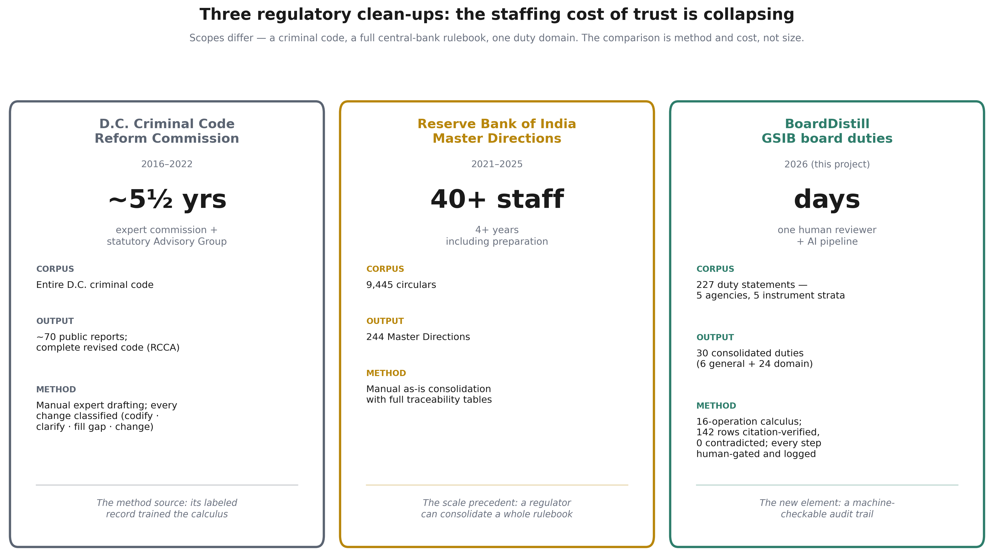
Two predecessors shape this work: the D.C. Criminal Code Reform Commission supplied the method (every change classified and evidenced); the Reserve Bank of India’s Master Directions supplied the scale precedent. The new element here is cost: an audit trail once affordable only to a 40-person team.

2. Part I — The General Part (six mechanics, stated once)
Mechanic | What it provides
G1 — Framework approval | For each enumerated framework or policy, the board (or its designated committee) approves initially and reviews on the stated cadence (default annual); the strictest applicable domain cadence prevails. Replaces the same sentence restated across ~21 clusters.
G2 — Reporting | The board receives periodic management reporting per framework, sufficient in scope and detail; below-threshold matters flow as aggregate reports.
G3 — Delegation and reliance | Committee execution is permitted where composition rules are met. A subsidiary-bank duty is deemed satisfied by the parent enterprise framework where risk profiles are substantially the same, documented, with a bank-specific addendum. The bank board's independent legal responsibility survives.
G4 — Records | One documentation standard for board and committee minutes, materials, votes, and planning-process records.
G5 — Effectiveness | One annual board self-assessment satisfying both OCC Heightened Standards III.F and Federal Reserve SR 21-3.
G6 — Canonical definitions | One definition each, cross-referenced by all instruments: independent director (reconciled test), risk appetite, critical activity (quantitative; value to be set by principals), material activities.

3. Part II — The twenty-four domain duties

Strategy & risk governance
1. Enterprise strategy & risk-governance approval
Approve the enterprise strategy and risk-governance framework, including the risk-appetite statement — one document, all risk dimensions, with liquidity tolerance and operational-disruption tolerance as distinct modules; subsidiary addendum via G3.
2. Risk committee
Maintain a risk committee meeting the single consolidated standard (charter, independent chair, quarterly CRO reporting); streamlined subsidiary certification.
Statutory floor: 12 U.S.C. 5365(h)
3. CRO appointment & compensation
Approve the appointment, removal, and compensation of the Chief Risk Officer once (Regulation YY home; OCC incorporates by reference); the OCC-specific independence-of-risk-review control is retained.

Audit & financial reporting
4. One audit committee
Maintain one audit committee whose composition satisfies FDICIA/Part 363, Sarbanes-Oxley §301, and exchange standards under the single independence definition (G6).
Statutory floors: SOX §301; FDI Act §36
5. Internal & external audit oversight
Through the audit committee: oversee internal audit (chief audit executive appointment, plan, budget, remediation) and the external audit relationship.
6. ICFR oversight
Oversee management's internal-control assessment, with the SOX 404(b) attestation deemed to satisfy the Part 363 assessment; designated-laws compliance retained as an annex; cycles aligned.
Floor satisfied, not deleted: FDI Act §36
7. Fiduciary audit
Where trust powers exist, the audit committee may satisfy the fiduciary-audit duty where composition overlaps (the existing 12 CFR 9.9 pattern, generalized).

Capital & liquidity
8. Capital plan, policy & actions
Approve the capital plan, capital policy, and capital actions; receive stress-test methodology (scenario design, model limitations) as reporting, not approval items.
Statutory floor: 12 U.S.C. 5365(i)
9. Liquidity risk tolerance
Approve the liquidity risk tolerance — one approval satisfying both Regulation YY and guidance.

Resilience
10. One resilience-planning cycle
Run one annual board cycle covering recovery planning, contingency funding, and resolution content as modules; approve the shared resolution submission with an FDIC-interest subsidiary annex.
Statutory floor: 12 U.S.C. 5365(d) — submission survives; only the format is shared

Credit & counterparty
11. Credit-risk governance
Approve the credit-risk governance framework (one interagency real-estate-lending standard; allowance and credit-review oversight folded into the risk-committee credit cycle).
12. Insider & affiliate duties — retained
Regulation O and Sections 23A/23B review processes are retained and coordinated, not merged: distinct statutory purposes.
Retained by design

Operations & technology
13. Information security
Approve one enterprise information-security program (replacing four parallel appendix approvals); one operational incident-notification standard (timeline selection is a principals' decision).
14. Third-party risk
Board attention only for relationships above the quantitative critical-activity threshold (G6; value to be set by principals); management approval plus aggregate board reporting below it; consumer service-provider oversight retained.
15. Operational resilience
Folded into the risk-appetite approval (duty 1) as a module — not a separate board cycle.
16. Model risk
Framework approval via the General-Part mechanic (G1); no separate board-level restatement.

Financial crime & consumer
17. BSA/AML program — retained
Approve the BSA/AML compliance program, unchanged; the examination manual cross-references the rule rather than restating it.
Statutory floor: 31 U.S.C. 5318(h); 12 U.S.C. 1818(s)
18. Consumer compliance — retained
Consumer-compliance oversight retained and coordinated; no consolidation (distinct statutory regime).
Retained by design

People & governance
19. Incentive compensation
The compensation committee oversees incentive-compensation arrangements. The Dodd-Frank §956 disposition (finalize a rule, rely on guidance, or repeal) is an open policy choice for principals; both regulatory branches are fully specified.
Open policy branch
20. CEO & senior-officer performance and succession
Set CEO objectives and accountability; oversee succession for the CEO and, per firm, the CRO and chief audit executive.
21. Director nomination, eligibility & continuity
One nomination and eligibility process; one interagency change-in-director notice procedure.
22. Director training
One consolidated training program, with the BSA module deemed to satisfy the statutory training pillar.
Floor satisfied via module
23. Board structure
Leadership, executive-committee limits, and committee charters through the General-Part mechanics, stated once.
24. Hold management accountable
The board's irreducible baseline duty — active oversight of management, retained verbatim and consolidated into nothing.
Retained by design

4. What changed — and what deliberately did not
Changed. Roughly 190 of the 227 statements cease to exist as separate obligations: restatements collapse into citations; mirror pairs become documented reliance; already-superseded remnants are formally repealed with a logged signal (fixing the silent-retraction pattern the underlying study identified).
Not changed. No statutory obligation is deleted or diluted. Binding force is conserved everywhere except one declared conversion (codifying the SR 12-17 governance expectations into Regulation YY — a deliberate, disclosed decision to draw the mandatory/guidance line, requiring notice-and-comment). Where two regimes serve distinct statutory purposes, both survive with the relationship stated rather than one absorbed.
Left to principals. The critical-activity threshold value; the resilience-cycle cadence; the exact reconciled independence formulation; the incentive-compensation branch; the incident-notification timeline. The method surfaces and frames these; it never decides them.

5. Why you can rely on this — and where its limits are
- Citation-verified: 142 of 227 statements verified against primary sources (eCFR, U.S. Code, agency releases) with verbatim quotations pinned and cached; re-verification is replayable.
- Zero fabrications: across four increasingly strict audit passes, no invented or fabricated duty was found in the inventory; the machine layer also caught and quarantined its own over-reach (unanchored claims never became findings).
- Floors enforced in code: a consolidation that would delete a statutory obligation is mechanically blocked, not merely discouraged.
- Human-decided: every consolidation carries a typed operation, an effect classification, and a logged human disposition; nothing reached final status by machine action.
Limits. 85 statements — mostly examination-manual and guidance paraphrases — remain unverified against primary text and carry proportionally lower evidentiary weight (each is flagged in the crosswalk). The proposal reflects publicly available instruments only; confidential supervisory expectations are outside its evidence base. And the target-state drafting here is illustrative: converting it to operative text is a rulemaking exercise for agencies, with the legal pathways (joint rulemaking, interagency statements, one statutory item) identified per duty in the companion roadmap.

6. Companion artifacts
- Crosswalk spreadsheet (gsib-board-duties_crosswalk_A-to-B_v0.1.xlsx): all 227 statements, filterable, each mapped to its target duty with citation, verification status, operation, and disposition.
- A→B explorer (gsib-board-duties_A-to-B_explorer.html): a searchable single-file viewer of the same mapping — search by citation, topic, or duty.
- Reform roadmap: every consolidation lever with the agency holding authority, the legal instrument required, and a feasibility ranking.
- Full audit trail: verification caches, operation records, and decision logs in the project repository.

Appendix A — Crosswalk summary by consolidated duty
Counts of today’s duty statements mapped to each proposed duty. Row-level detail (citations, quotes, operations) is in the spreadsheet and explorer.
ID | Consolidated duty (proposed) | Rows | Verified | Disposition(s)
T1 | Enterprise strategy, risk-governance framework & risk-appetite approval | 26 | 17 | Consolidated
T1 | Enterprise strategy, risk-governance framework & risk-appetite approval … | 5 | 3 | Folded
T2 | Risk committee — one consolidated standard + IDI certification | 6 | 5 | Consolidated
T3 | CRO appointment, removal & compensation (one approval; CRE independence … | 2 | 2 | Consolidated
T4-5 | One audit committee (single independence test); internal & external audi… | 21 | 13 | Consolidated
T6 | ICFR oversight — SOX 404(b) deemed to satisfy Part 363, designated-laws … | 4 | 4 | Consolidated
T7 | Fiduciary audit via the audit committee where composition overlaps | 2 | 2 | Consolidated
T8 | Capital plan, policy & actions approval; methodology as reporting | 20 | 17 | Consolidated
T9 | Liquidity risk-tolerance approval — one approval satisfies rule and guid… | 19 | 15 | Consolidated
T10 | One annual resilience-planning cycle; shared submission with IDI annex | 13 | 5 | Consolidated
T11 | Credit-risk governance framework approval (one RE-lending standard) | 6 | 2 | Consolidated
T12 | Insider/affiliate duties retained (Reg O / 23A-23B) — coordinated, not m… | 5 | 5 | Retained
T13 | One enterprise information-security program approval; single incident st… | 12 | 6 | Consolidated
T14 | Third-party oversight above quantitative critical-activity threshold | 7 | 5 | Consolidated
T16 | Model-risk framework via General-Part approval mechanic (G1) | 2 | 0 | Folded
T17 | BSA/AML program approval retained; manual cross-references the rule | 18 | 8 | Retained
T18 | Consumer-compliance oversight retained — coordinated, not consolidated | 15 | 2 | Retained
T19 | Incentive-compensation oversight; DFA 956 branch = open policy choice | 11 | 4 | Open branch
T21 | Director nomination, eligibility & continuity — one process, one notice … | 3 | 2 | Consolidated
T22 | One consolidated director-training program (BSA module preserves the flo… | 2 | 2 | Consolidated
T23 | Board structure & committee mechanics — stated once (G1/G4) | 4 | 4 | Folded
T24 | Hold management accountable — the irreducible baseline duty, retained ve… | 1 | 1 | Retained
G5 | General Part: one annual board self-assessment (App. D III.F + SR 21-3) | 3 | 3 | Consolidated
G6 | General Part: one canonical independent-director definition | 15 | 11 | Consolidated
R | Source-of-strength / charter-sanctity — statutory, retained as-is | 1 | 1 | Retained
R | Personal-liability provisions — retained as-is (not a consolidation targ… | 4 | 3 | Retained

