Reform Roadmap — Executive-Priority Scenario
Addendum v2.1-E · July 2026 · scenario analysis — assumes White House prioritization under the post-Slaughter removal framework
What this is. The baseline roadmap (v2.1) assumes agencies coordinate voluntarily: ~48 months, with interagency negotiation as the long pole. This addendum asks a different question: if the White House designated this consolidation an administration priority and used the full authority the Supreme Court recognized in June 2026, what would the process and timeline look like? Answer: the same 31 levers compress to roughly 18–24 months — not by skipping legal process, but by replacing sequential consensus with directed simultaneity and one omnibus rulemaking. The binding constraint shifts from coordination to litigation durability.

1. The changed legal landscape (what the scenario rests on)
- Trump v. Slaughter (June 29, 2026) overruled Humphrey's Executor: for-cause removal protection for heads of agencies exercising executive power is unconstitutional. FDIC and SEC leadership now serve at the President's pleasure — as a practical matter, their regulatory agendas are White House-directable. The OCC, a Treasury bureau, always was.
- Trump v. Cook (same day) preserved Federal Reserve governors' removal protection — but the Court expressly declined to extend the carve-out to Fed regulatory powers 'attenuated from monetary policy.' The Fed's supervisory and regulatory functions (everything in this corpus: Reg YY, SR letters, capital planning) sit in reserved-question territory.
- Already in place: Loper Bright (2024) ended Chevron deference — courts read the banking statutes de novo, so every consolidation must fit statutory text on its own; Corner Post (2024) keeps the APA challenge window open for newly affected parties, extending how long a rushed record stays exposed.
The scenario's Fed assumption, stated plainly: this timeline assumes the Fed participates cooperatively under priority pressure and aligned leadership — not that it is compelled. Attempting to compel Fed regulatory action by direction would draw the test case Cook reserved, and the prudent White House play is exactly the cooperative one assumed here.

2. What executive priority actually changes — and what it cannot

Changes
- Sequencing: an Executive Order replaces voluntary coordination with a Treasury-chaired task force (NEC/OIRA), one consolidated drafting team, and deadlines. The 48-month baseline's length was coordination, not law.
- Simultaneity: all guidance-layer actions (no APA required) issue in one 90-day sweep instead of an 18-month phase.
- One omnibus rulemaking: a single joint NPRM — one Federal Register document signed by FRB, OCC, and FDIC, with an SEC companion release — replaces six-plus sequential rulemakings. The vertical-reliance provisions ride in the same document with contingent effective dates, dissolving the baseline's Phase 4 dependency into drafting order rather than rule order.
- Decision-forcing: the principals' dials (critical-activity threshold, incident timeline, independence formulation, §956 branch) get a 120-day decision calendar. This is the compression only White House priority can buy — the baseline had no mechanism to force these choices.
- SEC alignment: post-Slaughter, the independence-definition and cyber-timeline items lose their 'longest pole' status; directed commissioners move on the administration calendar.

Cannot change
- Statutory floors: 12 U.S.C. 5365(h)/(d)/(i), SOX 301, FDI Act §36, BSA program statutes bind regardless of removal power. No EO touches them; the proposal never needed to.
- APA: notice-and-comment still governs the binding-force changes. The scenario uses 60-day comment (30 is lawful; 60 is durable) and interim final rules only for ministerial items with genuine good cause.
- Judicial review — now stiffer, not weaker: Loper Bright de novo statutory reading plus Corner Post's open challenge window mean a compressed record must be a strong record. This is where the project's audit trail earns its keep: a citation-verified crosswalk, typed effect classifications, and documented safeguard preservation are precisely the administrative record that survives arbitrary-and-capricious review at speed. The evidence base is the speed enabler.
- Exchange listing standards (NYSE/Nasdaq) move through SRO/SEC processes — accelerated by a directed SEC, but not by EO.
- Fed monetary-policy independence (Cook holding) — untouched and irrelevant here; nothing in the corpus is monetary policy.
- Durability beyond the administration: rules finished late in a term are exposed to Congressional Review Act repeal by a successor Congress; finishing the omnibus inside ~18 months is itself a durability strategy.

3. The compressed timeline (~18–24 months)
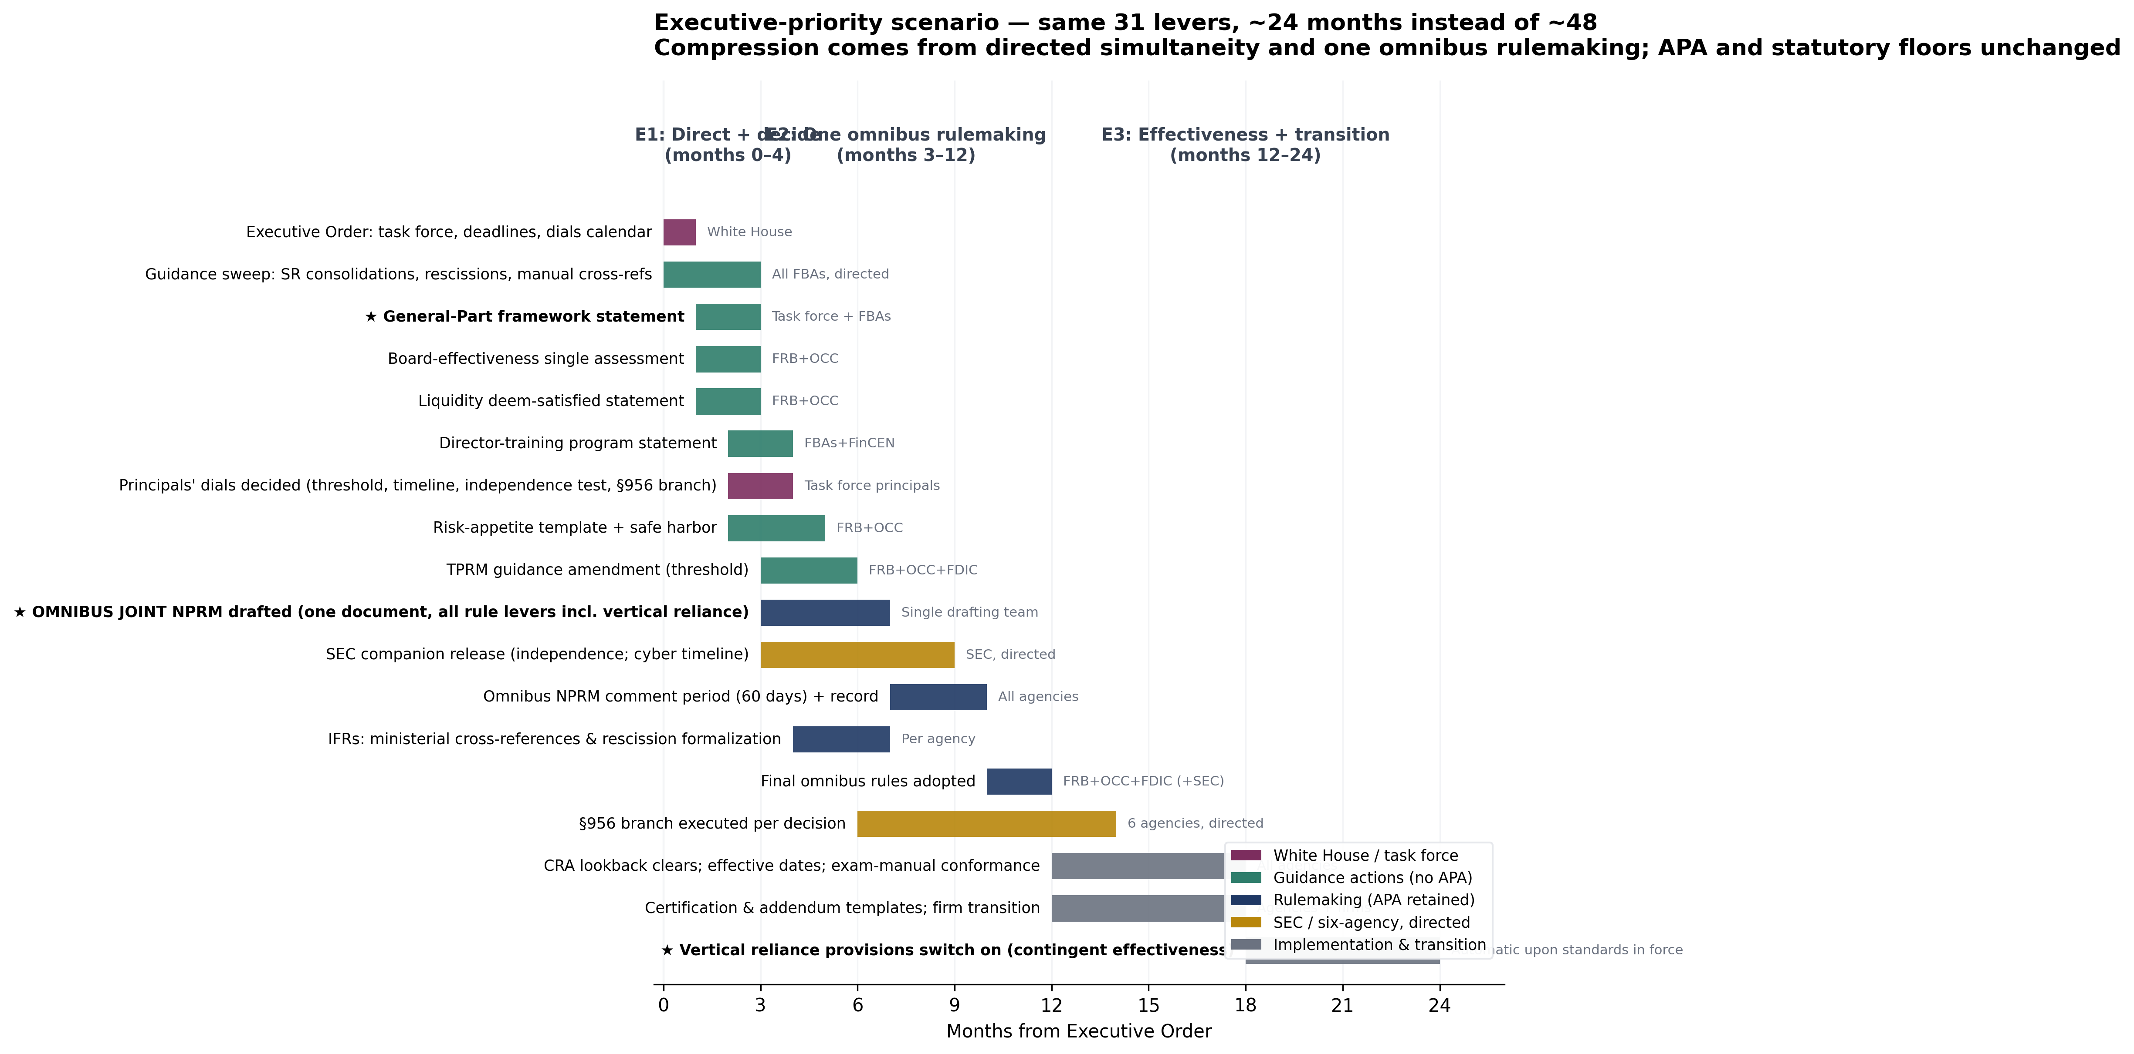

Phase E1 — Direct and decide (months 0–4)
- Day 0: Executive Order — designates the consolidation an administration regulatory priority; establishes the task force; adopts the verified crosswalk as the working baseline; sets the dials calendar.
- Months 0–3: the full guidance sweep — SR consolidations, formal rescissions with logged signals, manual cross-referencing, the General-Part framework statement (still the gating document), board-effectiveness, liquidity, training, risk-appetite template.
- Months 2–4: principals decide the four dials. Values remain human choices; the EO forces the calendar, not the answer.

Phase E2 — One omnibus rulemaking (months 3–12)
- Months 3–7: single drafting team produces the omnibus joint NPRM (risk-committee standard, CRO/CRE, Part 363 ICFR, credit RE standard, change-in-director, info-sec conformance, SR 12-17 codification, resilience cycle, vertical reliance with contingent effectiveness) + SEC companion release.
- Months 7–10: 60-day comment; record built on the verified evidence base.
- Months 10–12: final rules adopted. IFRs for ministerial cross-references run in parallel (months 4–7).

Phase E3 — Effectiveness and transition (months 12–24)
- Months 12–18: CRA lookback clears; effective dates; examiner-manual conformance; certification and addendum templates; firm transition.
- Months 18–24: vertical-reliance provisions switch on automatically as the consolidated standards they depend on take effect.

4. Honest risk register for the compressed path
- Fed participation is assumed, not compelled (Cook reserved question). Mitigation: cooperative posture; aligned Vice Chair for Supervision; nothing in the package threatens monetary-policy independence.
- Speed vs. record quality: every month cut from process is borne by the administrative record. Mitigation: the machine-verified crosswalk and effect classifications are attached to the NPRM as the technical appendix.
- Corner Post exposure: challenges can arrive years later from newly affected parties. Mitigation: same — record quality, plus severability clauses per lever so one loss does not unwind the package.
- Political durability: an executive-driven consolidation invites reversal by direction just as it was made by direction. The only permanent fix is the one thing this scenario still cannot buy: statutory codification. A closing recommendation, not a plan item — hand Congress the finished, evidence-verified consolidated set as a codification bill.

Sources (June–July 2026 decisions)
SCOTUSblog — Court allows Trump to fire FTC commissioner, overturns Humphrey's Executor (Trump v. Slaughter)
Supreme Court — Trump v. Cook, 25A312 (June 29, 2026)
Morgan Lewis — US Supreme Court Reshapes Independent Agency Removals, Carves Out Fed
Consumer Finance Monitor — Court Overrules Humphrey's Executor but Preserves Federal Reserve Independence
Conference Board — Trump v. Cook: Is the Fed Special?

