From 227 Duties to 30: The Method
A complete, non-technical account of how the consolidated board-duty proposal was produced — and why each step can be trusted
July 2026 · Michael Hsu · written for policymakers, regulators, and counsel — no technical background assumed
How to read this. Each chapter covers one stage of the work, and answers two questions: what question did this stage settle, and — the one that matters for trust — how would an error have been caught? The recurring theme is that none of the artificial-intelligence work here is trusted on its own authority. Every machine output is checked against something: a primary legal source, a hand-built answer key, a rule enforced in code, or a human decision that is recorded by name.
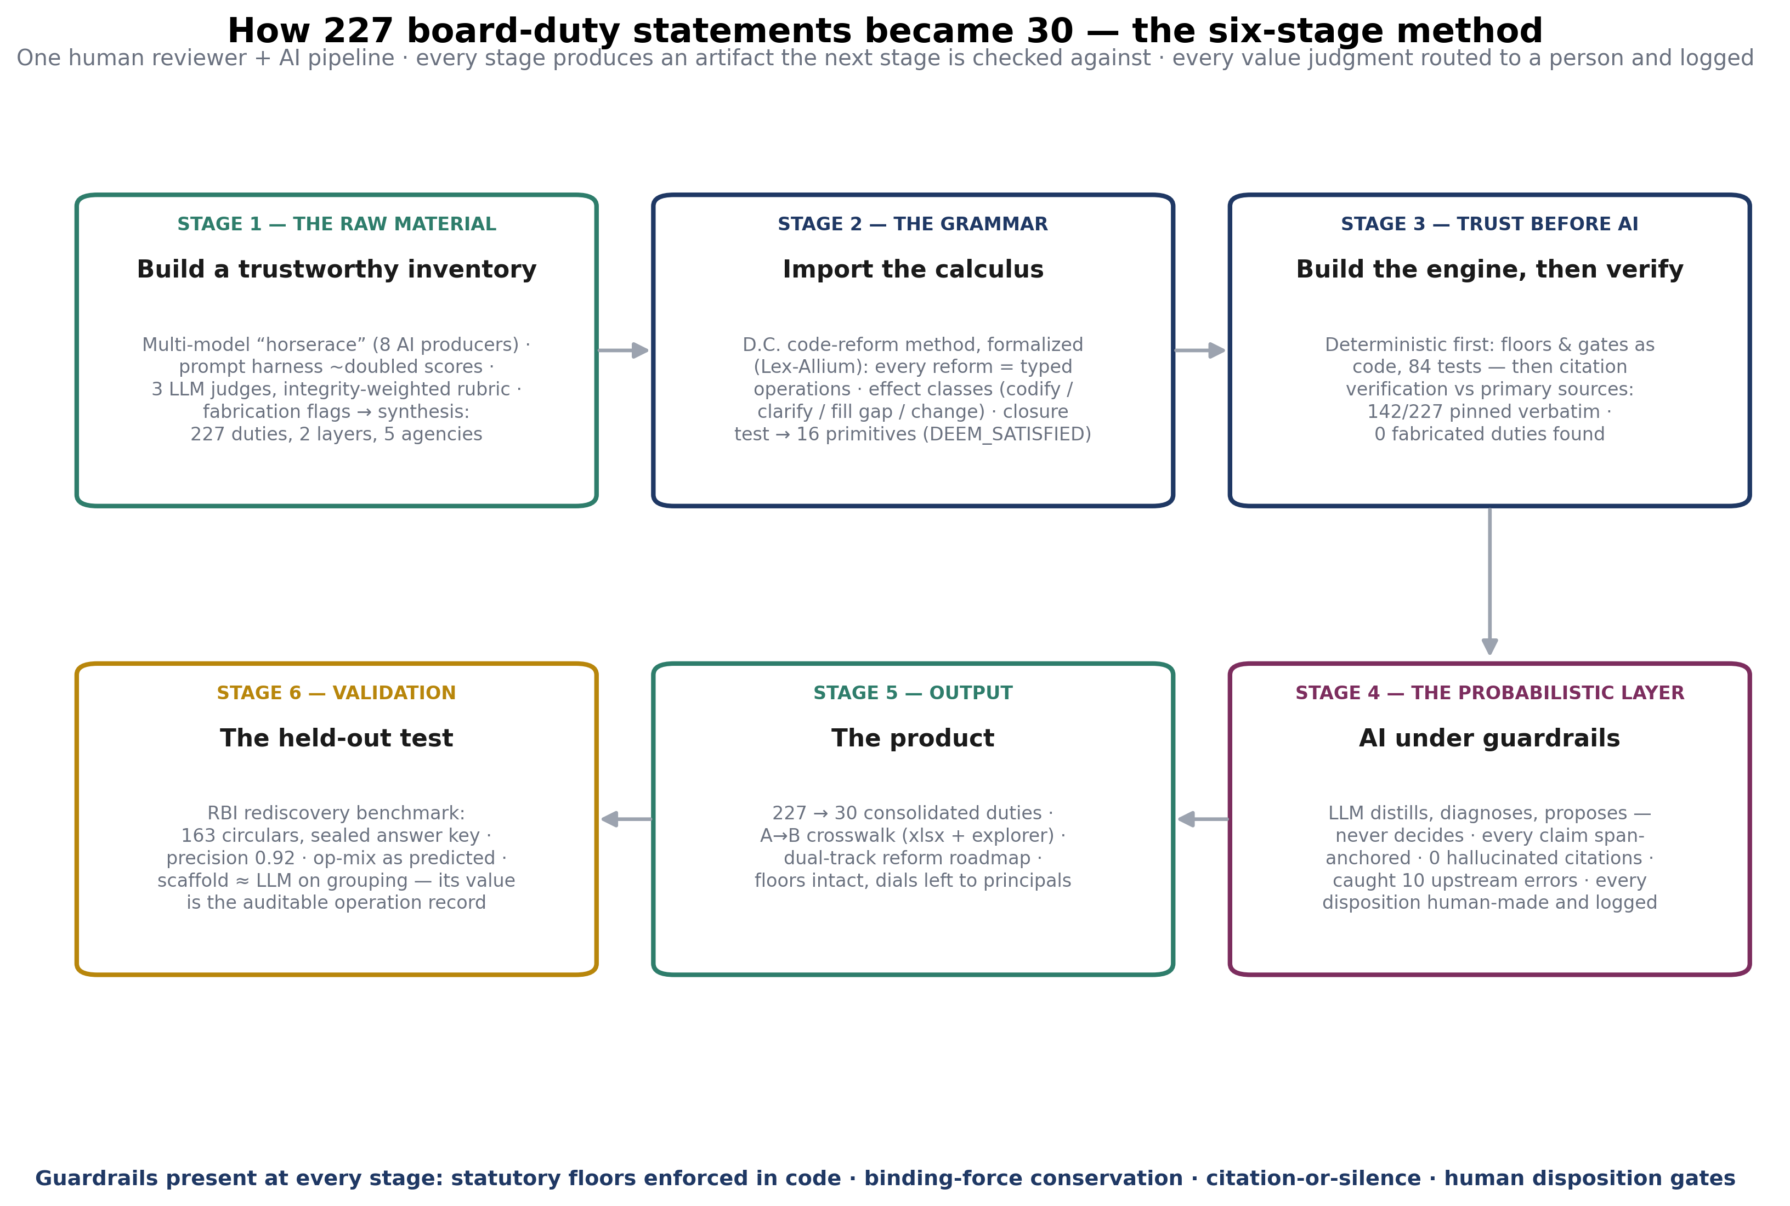

Chapter 1 — Building the raw material: the board-duty inventory
The question this stage settled: what obligations actually sit on GSIB boards today — all of them, with citations — and can AI-compiled research of this kind be trusted at all?
Everything downstream depends on a complete, citation-level inventory of board obligations, and producing one is genuinely hard. Duties are scattered across statutes, regulations, enforceable guidelines, supervisory guidance, and examination manuals from five agencies; every provision that says “the board should…” or “…such report shall go to the board” adds to the pile. Earlier-generation AI models, asked for this inventory, would look up a handful of familiar regulations — capital, liquidity, resolution — and miss most of the rest.
Two techniques made the difference, and both are as important as any later step.
First, the prompt harness. A three-sentence research request was expanded — using a specialized regulatory-AI platform's pre-research process — into a legally precise brief specifying the entity types (Category I holding companies and their insured depository subsidiaries), all five agencies, every board level (full board; audit, risk, compensation, governance committees; director classes), and eleven regulatory domains. That expansion alone roughly doubled the measured quality of frontier-model outputs against the same rubric. The lesson generalizes: with accumulated regulation, the question must be as structured as the answer you want.
Second, the horserace with independent judges. Rather than trusting any single model, the same brief went to eight AI producers (frontier models, open-weight models, and specialized legal platforms). Each report was then graded by three independent LLM judges — deliberately different systems, one with no retrieval at all as a control — against a fixed rubric weighted toward integrity: coverage (20 points), source and citation integrity (25), substantive accuracy and currency (20), sludge-analysis quality (15), structure (10), and calibration — honesty about limits (10). Separately, judges hunted for seven specific failure types with evidence required: fabricated sources, misattribution, stale-presented-as-current, invented obligations, false exhaustiveness, scope evasion, and unsupported legal conclusions. Any central integrity failure zeroed its dimension and set a reliability overlay that overrides the numeric score — a fluent report with unreliable citations cannot rank well.
Three findings from that exercise shaped everything after. Polish does not predict reliability — some fluent reports drew fabrication flags. Judges disagreed in strictness but not in ranking, which is why three judges suffice. And the best reports had complementary strengths, so the final step was synthesis: the strongest material from every report, cross-checked, merged into a single two-layer inventory — 227 duty statements, split into binding obligations and supervisory expectations, each with citation, actor, cadence, legal force, currency status, and a confidence grade. That inventory, with its duplicate-cluster analysis and draft reform ideas, is the input to everything in the chapters that follow.
How an error would have been caught: by the judges' evidence-required flags at this stage — and, more decisively, by the full citation verification in Chapter 6, which re-checked every surviving claim against primary sources. The final count: zero fabricated or invented duties across four increasingly strict audit passes.

Chapter 2 — Importing the grammar: the transformation calculus
The question this stage settled: is there a small, fixed vocabulary of moves that any regulatory consolidation is made of — so that a sprawling reform can be reviewed move by move instead of as a 300-page rewrite?
The idea comes from an unlikely source: criminal law. The District of Columbia's Criminal Code Reform Commission spent roughly five years rewriting the D.C. criminal code, and left behind an unusually complete record — some seventy reports in which every provision's changes were drafted, explained, and classified by their effect on current law. A prior project (StatuteDistill, with its specification language Lex-Allium) reverse-engineered that record and found something useful: the thousands of individual edits reduce to a small repertoire of basic operations. Merge two overlapping provisions. Split an overloaded one. Give one term one definition. Make an implicit requirement explicit. Retire an obsolete rule. Lift a recurring principle into a single general section. Relate two provisions that must both survive.
Each operation carries a classification of its legal effect: does it codify what the law already requires, clarify an ambiguity, fill a genuine gap, or change the law? That four-way classification is the honesty device of the entire method. It makes it impossible — structurally, not aspirationally — for a substantive change to hide inside routine housekeeping: anything classified as “change” is flagged, routed to a human, and must name the lawful pathway (such as notice-and-comment rulemaking) required to make it.
The Reserve Bank of India supplied the scale precedent: its 2021–2025 consolidation of 9,445 circulars into 244 Master Directions proved a financial regulator can consolidate an entire rulebook — with 40+ staff and years of preparation. The calculus is, in effect, a formalization of what the D.C. commission and the RBI did by hand.
How an error would have been caught: the vocabulary makes a testable claim — that every consolidation move can be expressed in it. That claim was tested twice (Chapters 4 and 8) and independently benchmarked (Chapter 9).

Chapter 3 — Porting to banking: what had to change
The question this stage settled: does a method built for criminal statutes transfer to bank regulation — and what breaks in translation?
A criminal offense and a board duty turn out to have the same anatomy. An offense is conduct, result, and circumstance elements with a mental state; a duty is an actor (which board body), a verb (approve, review, receive), an object (which framework or plan), a cadence, and a legal force. The banking translation required three genuine adaptations, each worth understanding because each reflects something real about bank regulation:
- The authority problem is different. Criminal law's hidden layer is case law — courts silently filling statutory gaps. Banking's hidden layer is the instrument hierarchy: statute above regulation above enforceable guideline above guidance above examination manual, with the crucial complication that guidance is formally non-binding yet supervisorily consequential. The method therefore treats legal force as a first-class property, and enforces a hard rule: no consolidation may silently convert guidance into rule or rule into guidance. Any binding-force conversion is a declared legal change requiring a lawful pathway.
- The floor is statutory. Some duties cannot be consolidated away by any agency: the Dodd-Frank risk-committee, stress-testing, and resolution-planning requirements; Sarbanes-Oxley audit-committee independence; the FDI Act annual audit; the BSA/AML program. These form a statutory floor enforced in code (Chapter 5): an operation that would delete a floor duty is mechanically blocked, not merely discouraged.
- Nobody owns the whole problem. Unlike a single legislature, five-plus agencies share this corpus. Every proposed operation therefore carries two extra fields: which agencies have authority to execute it, and what legal instrument it requires. Those fields are what later made the reform roadmap — and its dual-track timeline — possible.

Chapter 4 — The closure test: does the vocabulary cover the territory?
The question this stage settled: can every reform idea in the inventory actually be expressed in the operation vocabulary — and what's missing?
Before building anything, the method's central claim was tested by hand. Every “minimum reform lever” the inventory had identified for its three biggest duplicate clusters — risk governance, audit committee, capital planning, some 62 duty statements — was decomposed, one by one, into operation sequences with named operands, effect classes, and the agency holding authority.
The test surfaced exactly one missing operation, and it is the most banking-native idea in the method: DEEM_SATISFIED — “compliance with X is deemed to satisfy Y,” the safe-harbor move. It appears independently in five reform levers, including the largest structural reform in the corpus (letting a bank board rely on the parent company's enterprise framework where risk profiles are substantially the same). It cannot be expressed as a merge, because both duties must legally survive — the bank board's independent responsibility is statutory. An existing instance was even found in current law (the fiduciary-audit accommodation in 12 CFR 9.9), confirming the move is real, not invented. The vocabulary closed at sixteen operations and was re-tested at full corpus scale later (Chapter 8), where it held.
How an error would have been caught: this is the catch mechanism — a lever the vocabulary cannot express is called a residual and stops the process until a human examines it. Residuals are findings, not failures.

Chapter 5 — Building the engine: determinism before intelligence
The question this stage settled: can the safety rules be enforced by code rather than promises — before any AI enters the system?
The software was deliberately built backwards by AI-industry standards: the artificial intelligence came last. The first build contained no AI at all — a deterministic engine (same inputs, same outputs, every run) encoding the schema, the sixteen operations, and twelve invariants as executable rules with a test suite. The invariants are the constitution of the system, and the important ones read like supervisory principles because they are:
- Every legal claim must cite a source span — an uncited claim is a software bug, not a style problem.
- An effect classification requires a baseline to diff against; if none exists, the answer is “unresolved,” never a guess.
- No finding with an open normative flag — a policy choice, a statutory constraint, an interagency question — can reach final status without a recorded human decision.
- The statutory floor blocks deletion mechanically; binding-force conversion must be declared; every legal change must name its lawful pathway.
Only when 84 tests enforced all of this did anything probabilistic get switched on. The order matters: the guardrails were load-bearing before there was anything to guard.

Chapter 6 — Verification: the inventory earns its trust
The question this stage settled: is the AI-compiled inventory actually true — claim by claim, against primary sources?
The 227 statements were then verified against the primary sources themselves — the eCFR, the U.S. Code, agency releases — with the verbatim supporting text captured and cached for each verified claim, so every verification can be replayed. This took real engineering: regulations are easy to resolve; appendices (like the OCC's Heightened Standards), SR-letter attachment PDFs, and examination manuals required purpose-built resolvers. The results:
- 142 of 227 statements verified with pinned verbatim quotations; zero contradicted — no fabricated or invented duty was ever found.
- 85 statements — almost all citing guidance-manual paraphrases — remain unverified and are flagged as carrying lower evidentiary weight. This limitation is carried honestly through every downstream document.
- The verification found real defects of a subtler kind: six duties whose citations were sound but whose text binds management or officers, not the board (the Sarbanes-Oxley certification family) — the inventory had over-attributed them. They were re-tagged with the board's indirect oversight role stated separately, by human decision.
How an error would have been caught: this chapter is the catch. And its own errors — ten citations pinned to the wrong passage — were caught by the next layer, which is the best evidence the layers genuinely check each other.

Chapter 7 — The AI layer, under guardrails
The question this stage settled: what can a frontier model add beyond the deterministic pipeline — and can its known failure modes be contained?
With the rails in place, the language model was given three jobs: distill each verified duty into precise structure (exact verb, object, cadence) from its pinned source text; propose diagnostics (duplicates, undefined terms, ambiguous actors); and draft the consolidated duty language. Three containment rules governed all of it. Every claim had to anchor to a span in the cached sources — a model-memory citation is rejected mechanically. The mechanical rules (effect classification, force conversion, floors) run in code after every model proposal. And nothing the model produces can reach final status; it all lands in a review queue for human disposition.
The results justified the design. Across hundreds of anchored claims, the hallucinated-citation rate was zero — the gate never fired in anger, though it did catch and quarantine two over-reaching diagnostics before they became findings. More interestingly, the model caught the humans: on ten duties it refused to distill because the pinned excerpt did not support the stated duty, exposing the mispinned citations from the verification pass. And it produced two substantive empirical findings: 41 of 50 duties state no explicit board-action standard at all (the corpus's deepest ambiguity — what does “oversee” require?), and duplication comes in two distinct structures — same-text restatements across instruments, and parallel holding-company/bank mirror duties — which take entirely different reform tools.
Every review cycle ended the same way: a decision packet in plain English, each item with a recommendation, each human decision recorded by name with a rationale. Roughly sixty such dispositions were made across the project. That decision log is part of the deliverable.

Chapter 8 — Scale, and the product
The question this stage settled: does the method hold at full corpus scale — and what does it produce?
The proven pipeline then ran over the remaining ~155 statements in six domain waves: verify, distill, diagnose, classify, render. The corpus funnel: 227 statements → 142 verified → 141 distilled → 129 evidence-anchored findings, still with zero contradictions. All 22 remaining reform levers were decomposed; six initially resisted the vocabulary and were hand-examined — all six turned out to be expressible compositions (the test harness had been stricter than the claim), so the sixteen-operation vocabulary closed over the entire corpus with no additions. One honest domain finding: the BSA/AML and consumer-compliance wave verified at only 30%, because those duties live in examination manuals — the least addressable layer of the hierarchy. That is a fact about how those regimes are written, and a sludge finding in its own right.
The product is the release package: the consolidated duty set (six general governance mechanics plus twenty-four domain duties — roughly 30 statements replacing 227, with every floor intact and every parallel-but-justified regime preserved by explicit relation); the full A→B crosswalk in spreadsheet and searchable-explorer form; and the dual-track reform roadmap with agency work programs and timelines.

Chapter 9 — The held-out test: rediscovering the RBI's consolidation
The question this stage settled: does any of this generalize beyond one corpus, one country, one team's judgment?
The final step was a benchmark with a sealed answer key. 163 pre-consolidation RBI circulars — the raw material of four actual Master Directions — were pooled, pseudonymized, and fed to the engine, which had to propose the consolidation structure blind: what groups with what, what gets repealed, what survives. Its proposals were then scored against what the RBI actually did. Controls were strict: prompts never mentioned Master Directions; identifiers were masked; outputs were scanned for leakage; the answer key sat behind a code-enforced seal until scoring; and a plain language model ran the same task as a baseline, because the honest claim is the difference the method makes, not the raw score.
The result has two halves, and both are the finding. On pure grouping, the engine matched the RBI's topical structure with high precision (0.92) but was statistically indistinguishable from the plain model — the calculus does not out-cluster a capable LLM. What the scaffold produced that the plain model cannot: 131 span-anchored, auditable consolidation operations, three-quarters of them the four operations the theory predicted would dominate — a pre-registered prediction confirmed on the jurisdiction that inspired it. And where the engine “disagreed” by splitting coarse directions into purer sub-groups, the RBI's own later consolidation made the same splits. The method's value is not better clustering; it is a verifiable record of moves where there was previously only a finished document.

Chapter 10 — What this method guarantees, and what it does not
Guarantees, each enforced structurally rather than by promise:
- No invented law: every claim cites a cached primary-source span or is marked unresolved; the hallucination gate ran at zero across the project.
- No silent substance: every operation carries an effect classification; every “change” is flagged, human-decided, and names its lawful pathway.
- No deleted safeguards: the statutory floor is enforced in code; parallel regimes with distinct purposes survive by explicit relation.
- No machine policy-making: thresholds, tests, cadences, and the §956 branch — the dials — are never set by the tool; roughly sixty human dispositions are logged by name.
- Reproducibility: the verification caches, model-response caches, decision logs, and version history allow the entire pipeline to be replayed offline.
Not guaranteed, stated plainly:
- The 85 unverified statements (guidance-manual strata) carry lower evidentiary weight, flagged row by row.
- The evidence base is as-published law. Confidential supervisory expectations — MRAs, examination findings — are outside it. An agency running this internally would close that gap; outside researchers cannot.
- The consolidated duty set is an illustrative draft, not proposed regulatory text; converting it into operative instruments is the rulemaking work the roadmap sequences.
- Timeline estimates in the roadmap are planning judgments from instrument type and dependency structure — reasonable, and clearly labeled as the assumptions they are.
The one-sentence summary: the artificial intelligence made this work fast; the verification architecture — floors in code, citation-or-silence, effect classification, human gates, and a held-out benchmark — is what makes it usable. Speed without that architecture is just a faster way to produce something no regulator could rely on.

Chapter 11 — What it cost: a token accounting
The question this chapter answers: what did stages 2–6 actually consume in computation — and where did it go?
Because every model call in the analysis pipeline was cached and committed, one layer of this answer is measured rather than estimated. The other layer — the AI agent sessions that orchestrated the work — leaves no telemetry in the repository, so those figures are reasoned estimates with real uncertainty (a factor of two to three either way). Both layers are reported; the ratio between them is the finding.

Layer 1 — The analysis itself (measured or reported per stage)
- Stages 2–3 (calculus port, closure test, engine build, citation verification): zero model tokens — by design. The vocabulary work was done by hand, the engine is deterministic code, and verification is retrieval plus comparison, not generation.
- Stage 4 (the AI layer over the pilot clusters): 68 calls, ~244,000 tokens (205k input / 39k output) — exact, from the run report.
- Stage 5 (corpus scale-out): ~180 calls, an estimated 550–700,000 tokens — call count exact, token figure extrapolated from the stage-4 per-call profile.
- Stage 6 (RBI benchmark, engine plus baseline over 163 circulars): ~200–300 calls, an estimated 700,000–1,200,000 tokens.
Total for the regulatory analysis proper: roughly 450–550 model calls and approximately 1.5–2 million tokens — every one of them cached in the repository, keyed by prompt hash, and replayable offline.

Layer 2 — The orchestration (estimated)
The analysis calls were made by AI coding agents that read the specifications, wrote and tested the software, ran the pipelines, and wrote the reports — seven long agent sessions for the build and stages, plus the planning-and-review session that produced the specifications and human decision packets. Agentic sessions are input-dominated: each working turn re-reads a large and growing context, mostly served from prompt cache. Reasonable arithmetic — seven sessions of 50–150 turns at 100–200,000 tokens of context per turn — puts the orchestration layer at roughly 100–250 million tokens processed, of which perhaps 25–60 million were fresh (non-cache-served) tokens.

The ratio is the finding
End to end, stages 2–6 processed on the order of 150–300 million tokens — and the actual regulatory analysis accounted for about 2 million of them, under 1.5 percent. More than 98 percent of the computation was scaffolding: agents reading specifications, writing and testing code, and re-reading their own artifacts. Three implications follow.
- The analysis layer is cheap and auditable. The ~2 million tokens that constitute the legal-analytical work are committed to the repository call by call. Re-verifying the entire analytical record costs nothing; extending it costs on the order of tens of dollars, not staff-years.
- The overhead is scaffolding, not analysis — and scaffolding costs fall fast. The 98 percent was spent building a reusable engine and its guardrails. A second corpus run on the same engine skips most of it; this is why the adapter recipe in the replication guide is short.
- The comparison to the alternative is not close. The RBI's equivalent exercise consumed 40-plus staff over multiple years. Even at the top of the estimate range, and even priced at premium model rates, the computation here costs less than a single staff-week — the binding constraint on regulatory clean-up has moved from analytical labor to review capacity and institutional will.
Caveat, stated plainly: the Layer 2 figures are estimates. The repository preserves no session telemetry, and the honest uncertainty is two- to three-fold. The Layer 1 figures — the ones that bear on the trustworthiness of the analysis — are measured.

