The Method in Three Pages
How 227 GSIB board-duty statements became a 30-duty consolidation proposal — with an audit trail a regulator could rely on · July 2026
The problem. Large-bank boards carry 227 distinct duty statements from five agencies across five layers of legal instrument. Nearly all are sensible alone; together they are cumulative policy sludge. Cleaning this up has historically taken commission-scale effort — five years for the D.C. criminal code, 40+ staff for the Reserve Bank of India's rulebook — because the binding constraint was never analysis; it was trustworthy analysis.
The approach in one sentence. Build a citation-level inventory with adversarial AI cross-checking; express every reform as typed operations from a 16-move vocabulary with each move classified by legal effect; enforce the safety rules (statutory floors, no silent guidance-to-rule conversion, citation-or-silence) in code; let AI propose but never decide; and validate the whole method against a sealed answer key from a real consolidation.
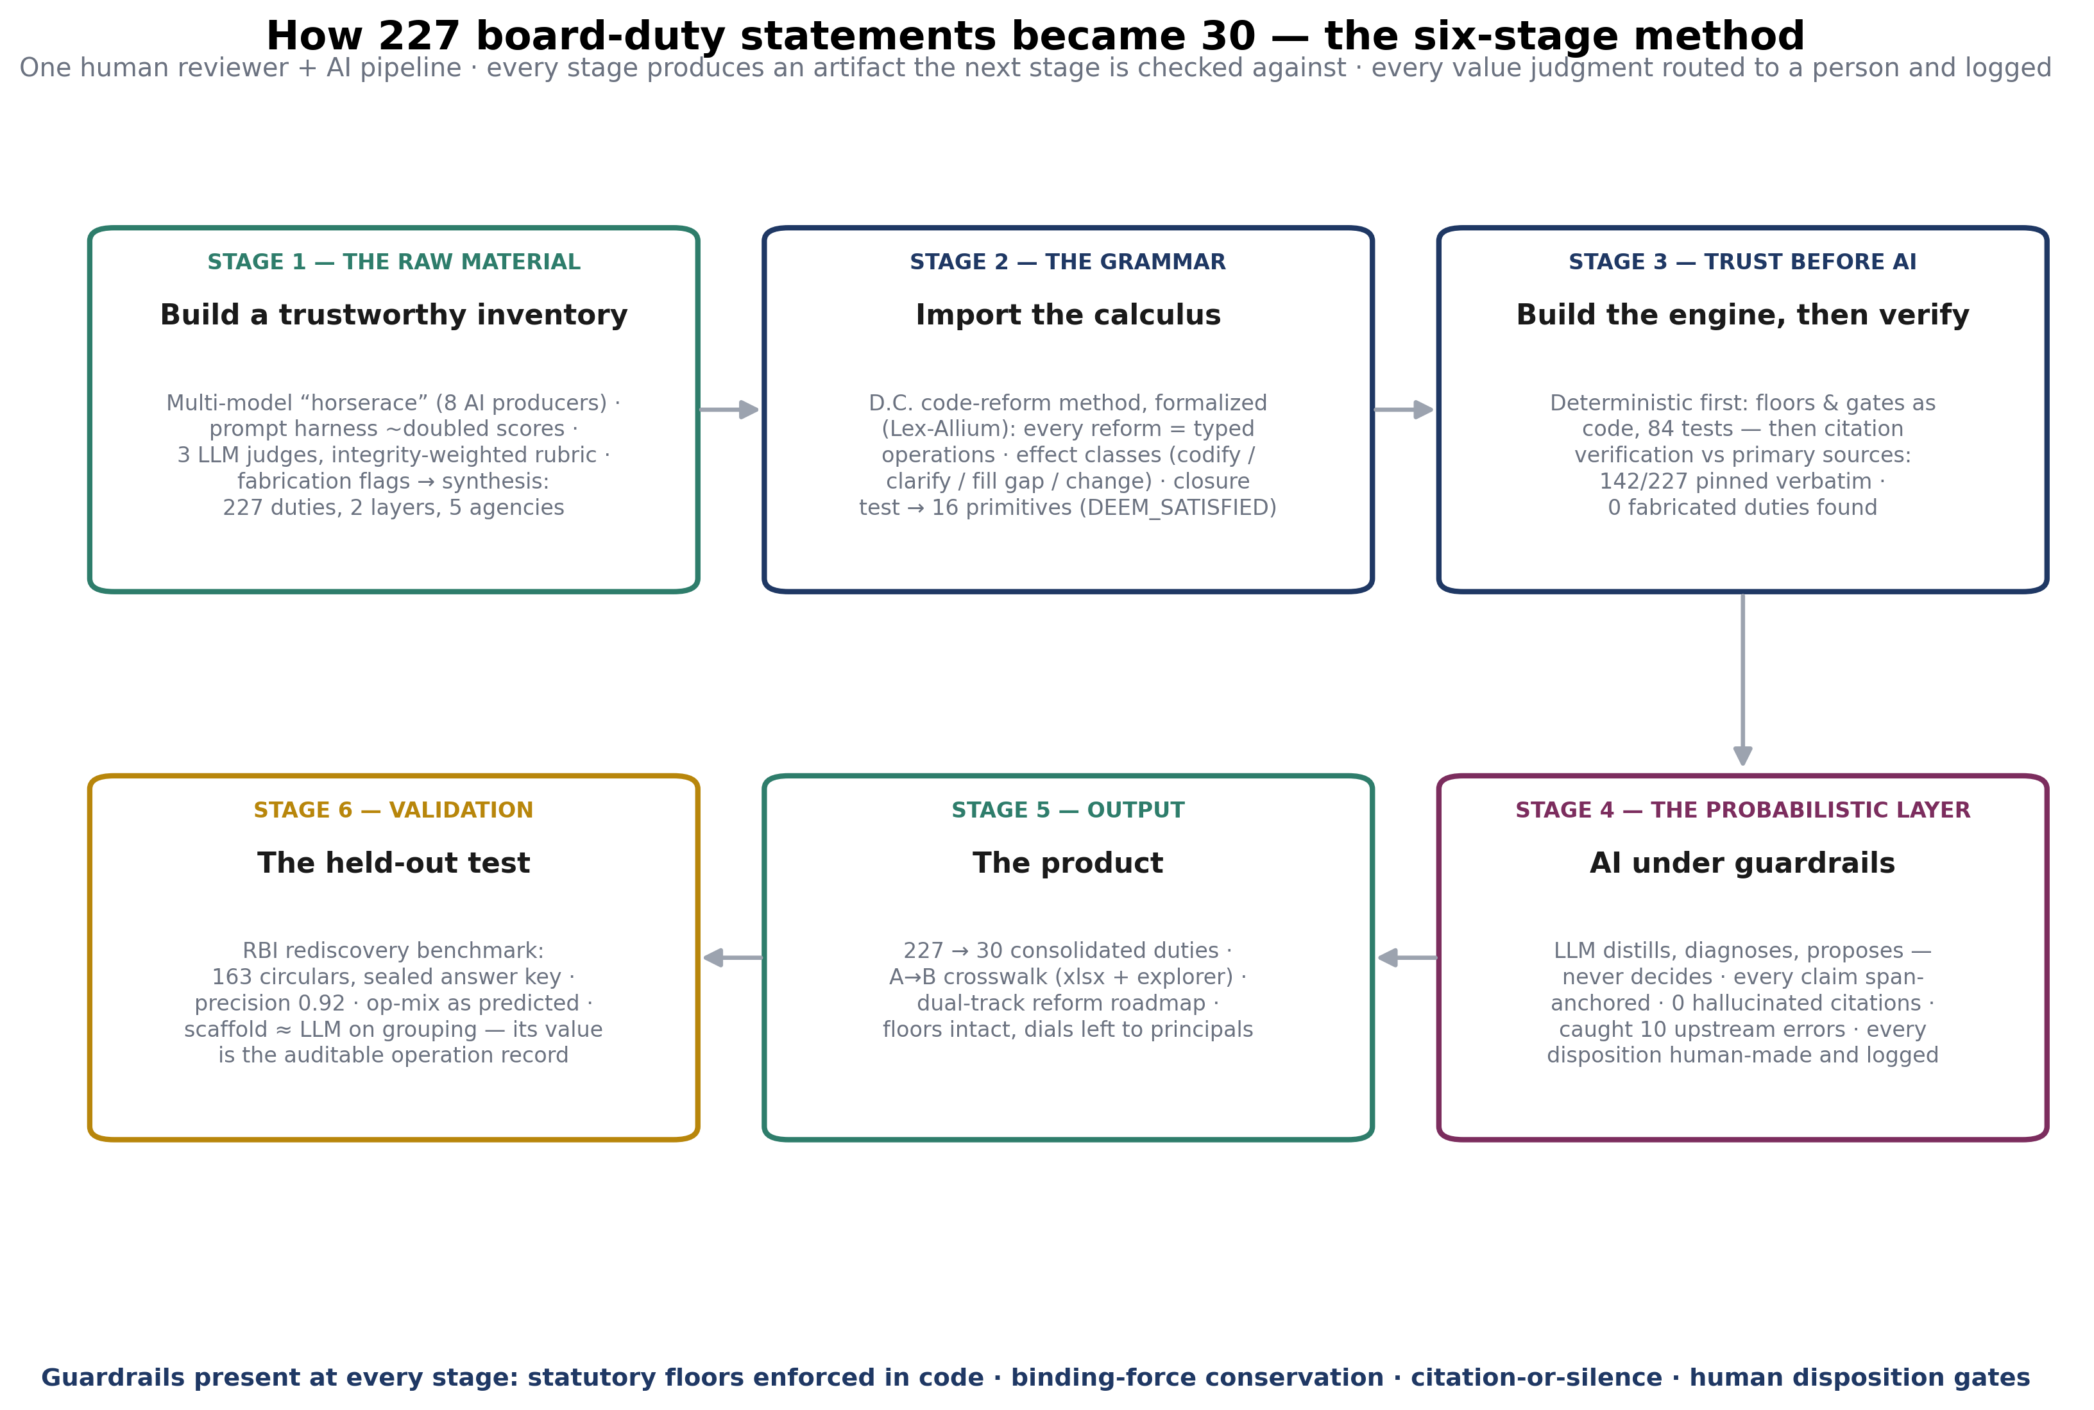

The numbers that matter
- 227 duty statements → 30 consolidated (6 general mechanics + 24 domain duties); every statutory-floor obligation intact; every parallel-but-justified regime preserved by explicit relation.
- 142 of 227 statements verified verbatim against primary sources; zero fabricated or invented duties across four audit passes; the 85 unverified rows (exam-manual strata) are flagged, not hidden.
- Zero hallucinated citations from the AI layer — every model claim had to anchor to a cached source span or it was rejected mechanically.
- ~60 human decisions, logged by name: every effect-class judgment, every threshold left to principals, every consolidation direction.
- Held-out validation: on 163 pooled, pseudonymized RBI circulars with a sealed answer key, the engine matched the RBI's structure at 0.92 precision and produced what a plain model cannot — 131 auditable operations, 75% in the four moves the theory predicted.

Why it can be trusted (the five structural guarantees)
- No invented law — citation-or-silence, enforced in code.
- No silent substance — every move classified codify / clarify / fill gap / change; every change names its lawful pathway.
- No deleted safeguards — the statutory floor blocks deletion mechanically.
- No machine policy-making — dials (thresholds, tests, the §956 branch) are decided by people, on the record.
- Reproducible — verification caches, model caches, decision logs, and version history replay the entire pipeline offline.
The bottom line. AI collapsed the staffing cost of regulatory clean-up from commission-scale to days. The verification architecture is what converts that speed into something a policymaker can act on. Companion documents: the consolidation proposal, the A→B crosswalk and explorer, the dual-track reform roadmap, and the full-length method narrative (From 227 Duties to 30: The Method).

