GSIB Board Duties — Reform Roadmap
v2.2 · July 2026 · dual-track: baseline coordination and executive priority · three views · companion to the Consolidated Board Duty Set (v0.1, draft)
What this is. All 31 consolidation levers from the 227-statement corpus, in three views (feasibility · agency · timeline) and on two implementation tracks throughout:
- BASELINE — voluntary interagency coordination: agencies sequence the work by consensus. ~48 months; the long pole is waiting, not law.
- EXECUTIVE PRIORITY — directed simultaneity under the June 2026 removal framework (Trump v. Slaughter; Trump v. Cook): an Executive Order task force, one omnibus rulemaking, dials forced on a 120-day calendar. ~24 months. Full legal basis, assumptions, and risk register: the v2.1-E addendum.
The two tracks contain identical levers, identical APA comment, and identical statutory floors. What differs is who sequences the work and how many rulemaking vehicles carry it. Every lever entry below shows both windows; the timeline view shows both tracks in full.
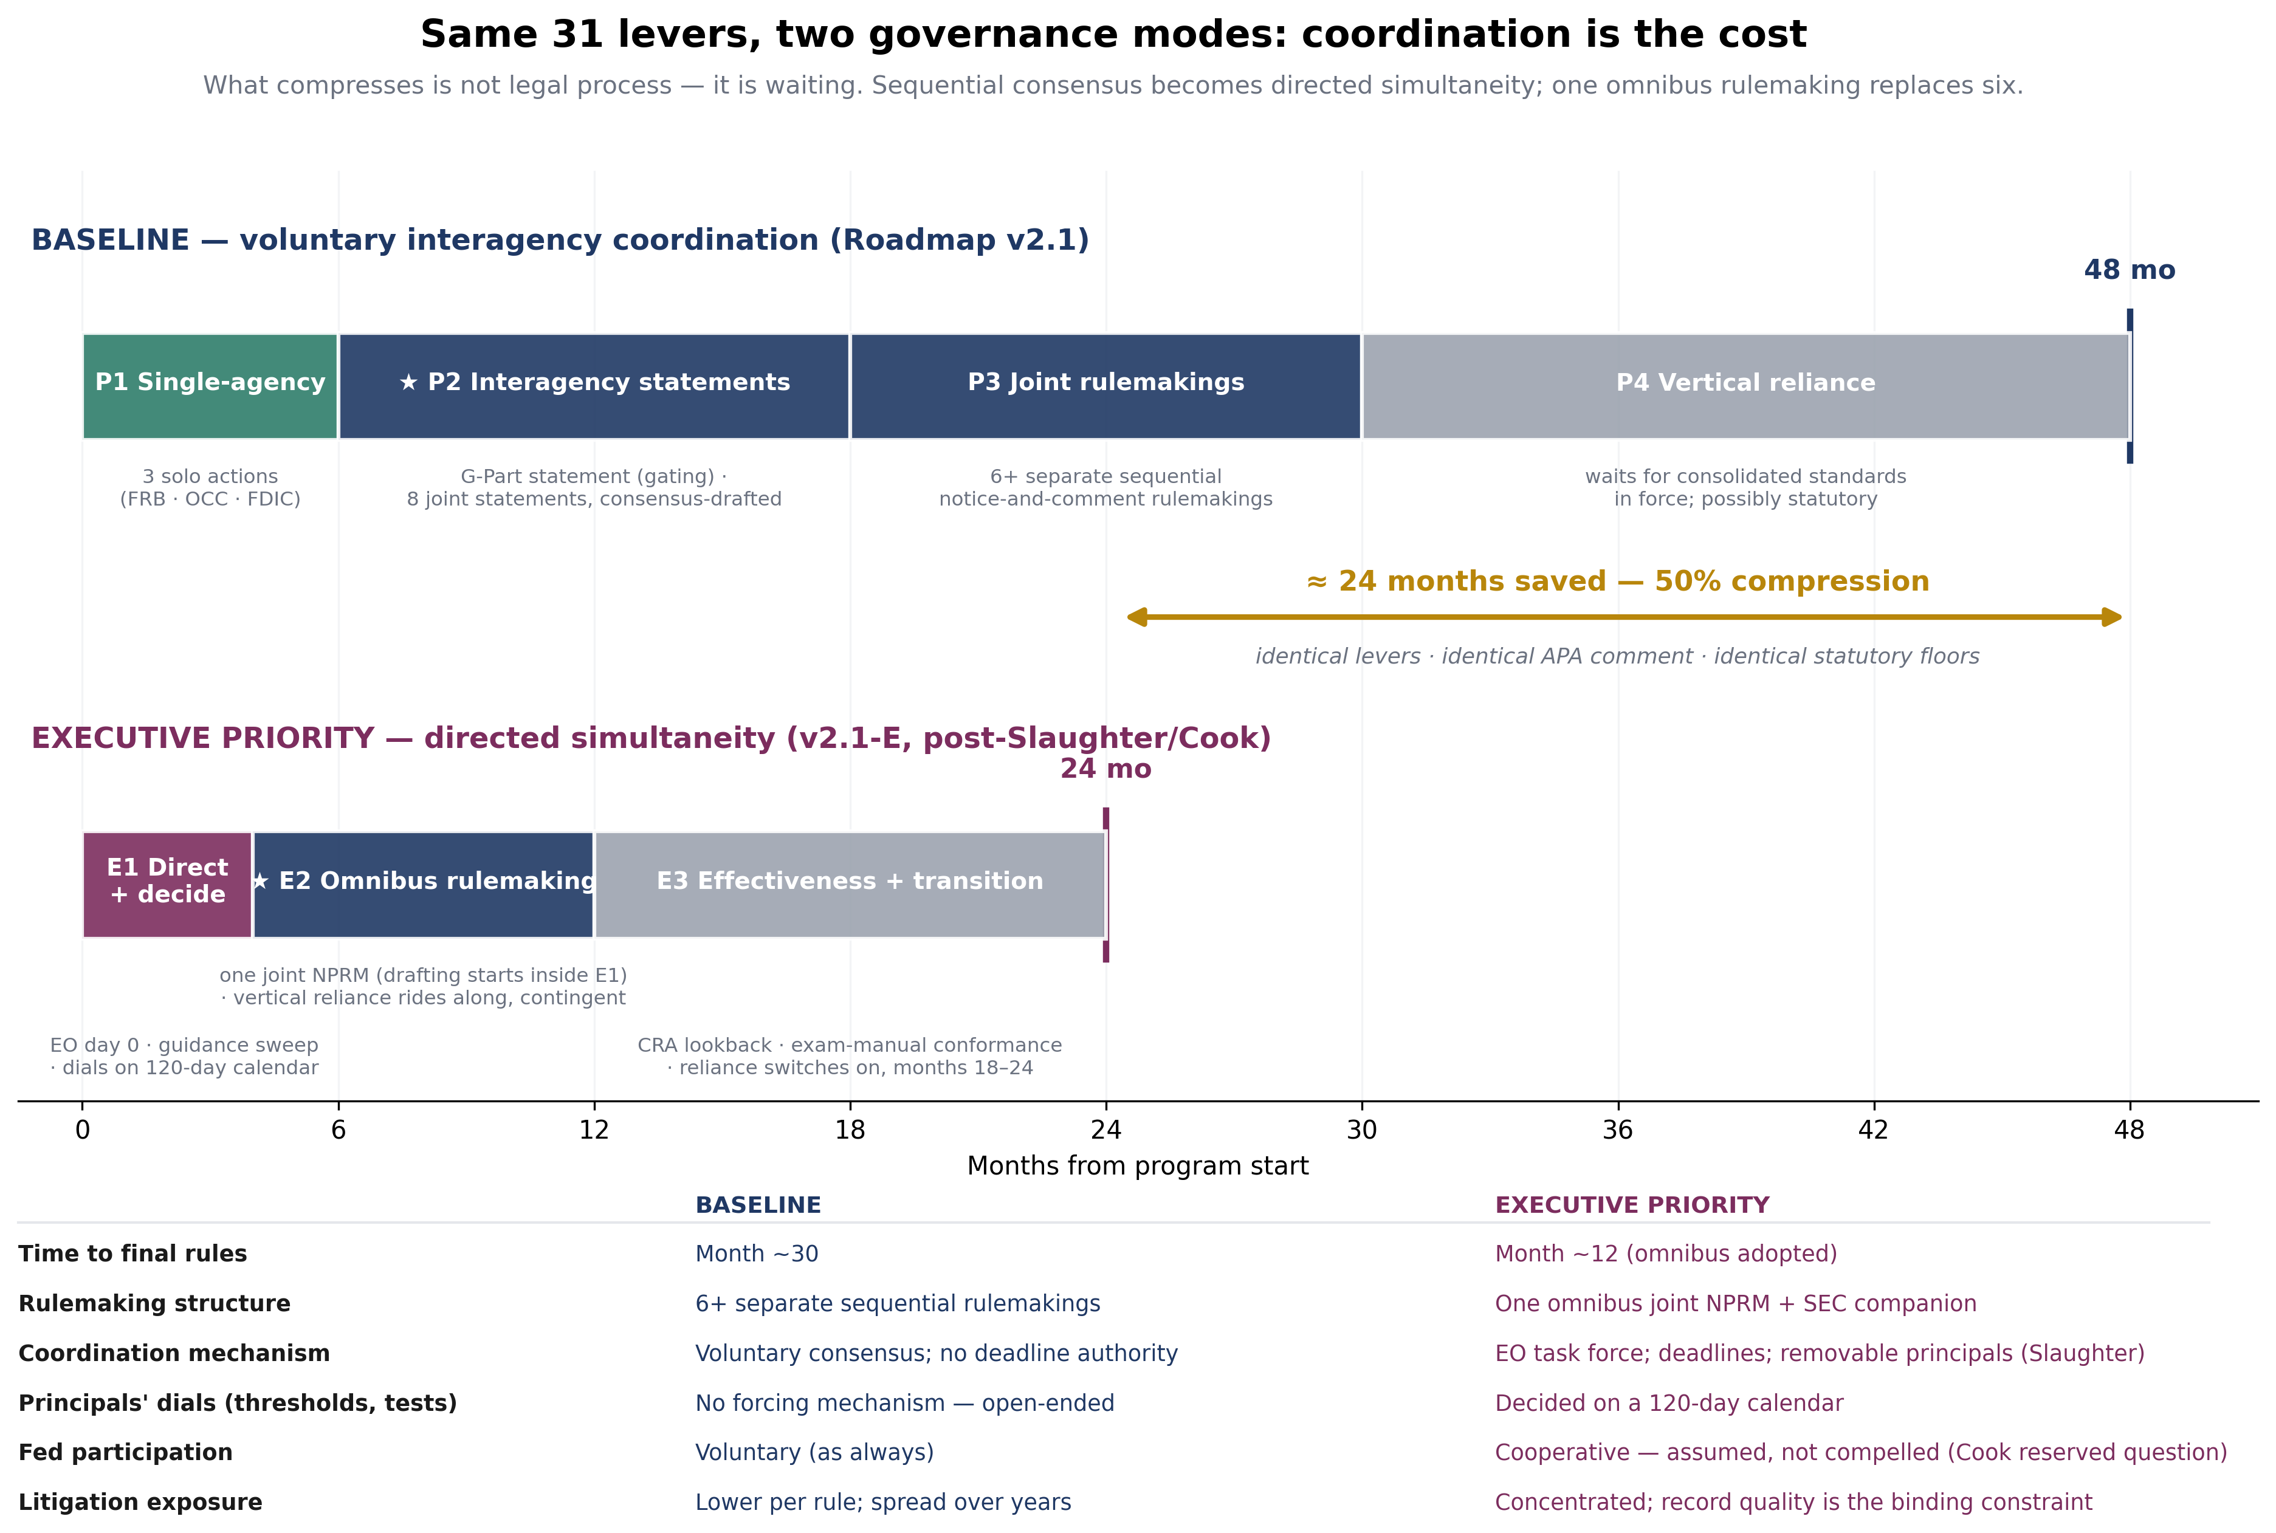

View 1 — By feasibility (what is legally easiest)
Track-independent: legal difficulty does not change with governance mode; only the calendar does.

Tier 1 — Guidance consolidation
Capital planning & stress testing — Separate board capital-action decisions from technical methodology reporting
Effect: clarify Lead: FRB Instrument: guidance action plus conforming rule note Status: ready
Baseline: months 0–6 · Executive: months 4–12 (E2)
No coordination needed; guidance action + conforming note. Executive track: Folded into the omnibus joint NPRM: drafted months 3–7, 60-day comment, final by month 12.

Tier 2 — Interagency statements & coordination
Audit committee & independence — Single 'independent director' definition; one audit committee satisfies all regimes
Effect: change Lead: FRB+OCC+FDIC+SEC Instrument: interagency statement plus SEC coordination Status: ready
Baseline: months 12–30 · Executive: months 0–4 (E1)
Depends on: Independence definition. Finalizes the Phase 2 definition work into rules/listing-standard cross-refs. Executive track: Issued in the 90-day guidance sweep (extended to month 4 where a principals’ dial is a prerequisite).
Board self-assessment / effectiveness — Single interagency board-effectiveness assessment.
Effect: change Lead: FRB+OCC Instrument: interagency statement Status: ready
Baseline: months 6–12 · Executive: months 0–4 (E1)
Joint statement; near-identical source texts. Executive track: Issued in the 90-day guidance sweep (extended to month 4 where a principals’ dial is a prerequisite).
Director independence (cross-cutting) — Single cross-referenced prudential independence definition.
Effect: change Lead: FRB+OCC+FDIC+SEC Instrument: interagency statement Status: ready
Baseline: months 6–24 · Executive: months 0–4 (E1)
Start early — SEC coordination is the longest pole; finalizes in Phase 3. Executive track: Issued in the 90-day guidance sweep (extended to month 4 where a principals’ dial is a prerequisite).
Director training — One consolidated director-training program covering all topics.
Effect: change Lead: FRB+OCC+FDIC+FinCEN Instrument: interagency statement Status: ready
Baseline: months 9–18 · Executive: months 0–4 (E1)
Statement; BSA module preserves the statutory training pillar. Executive track: Issued in the 90-day guidance sweep (extended to month 4 where a principals’ dial is a prerequisite).
Insider / affiliate / related-party — Coordinate related-party review processes.
Effect: n/a Lead: FRB+SEC Instrument: interagency statement Status: non-target
Baseline: months 6–18 · Executive: months 0–4 (E1)
Coordination only; no consolidation (distinct statutes). Executive track: Issued in the 90-day guidance sweep (extended to month 4 where a principals’ dial is a prerequisite).
Liquidity risk management — One board liquidity approval satisfies rule and guidance.
Effect: change Lead: FRB+OCC Instrument: interagency statement Status: ready
Baseline: months 6–15 · Executive: months 0–4 (E1)
Depends on: G-Part statement. Deem-satisfied statement citing the General-Part mechanics. Executive track: Issued in the 90-day guidance sweep (extended to month 4 where a principals’ dial is a prerequisite).
Risk appetite statement — Interagency risk-appetite template + safe harbor that one board-approved statement satisfies all.
Effect: change Lead: FRB+OCC Instrument: interagency statement Status: ready
Baseline: months 6–18 · Executive: months 0–4 (E1)
Depends on: G-Part statement. Template published with the framework statement; safe harbor may need a conforming rule note (Phase 3). Executive track: Issued in the 90-day guidance sweep (extended to month 4 where a principals’ dial is a prerequisite).
Risk-governance framework / strategy — One enterprise framework approval with an IDI addendum (expanded App. D reliance accommodation)
Effect: change Lead: FRB+OCC Instrument: interagency statement plus rule safe harbor Status: ready
Baseline: months 9–18 · Executive: months 4–12 (E2)
Depends on: G-Part statement. Statement + safe harbor now; feeds the Phase 4 structural expansion. Executive track: Folded into the omnibus joint NPRM: drafted months 3–7, 60-day comment, final by month 12.
Risk-governance framework / strategy — Single interagency board-effectiveness assessment
Effect: codify Lead: FRB+OCC Instrument: joint statement Status: ready
Baseline: months 6–12 · Executive: months 0–4 (E1)
Duplicate lever entry (MVP D7) — same action. Executive track: Issued in the 90-day guidance sweep (extended to month 4 where a principals’ dial is a prerequisite).
Third-party risk management — Quantitative 'critical activity' threshold for board attention; management approval + aggregate reporting othe…
Effect: clarify Lead: FRB+OCC+FDIC Instrument: interagency statement Status: ready
Baseline: months 9–18 · Executive: months 0–4 (E1)
Depends on: Threshold value (principals). Amends the 2023 interagency guidance; threshold value is a principals decision. Executive track: Issued in the 90-day guidance sweep (extended to month 4 where a principals’ dial is a prerequisite).

Tier 3 — Rule harmonization
BSA/AML program — Cross-reference manual to the rule; avoid restating. v2.1: resolve the two unreconciled pending rewrites (2024…
Effect: n/a Lead: FinCEN+FBAs Instrument: rule apa Status: non-target
Baseline: months 6–18 · Executive: months 4–12 (E2)
Reconcile the two pending BSA rewrites before layering compounds; then manual cross-references. Executive track: Folded into the omnibus joint NPRM: drafted months 3–7, 60-day comment, final by month 12.
CRO / CRE appointment & compensation — Consolidate into Reg YY; OCC incorporates by reference.
Effect: clarify Lead: FRB+OCC Instrument: joint rulemaking Status: ready
Baseline: months 12–27 · Executive: months 4–12 (E2)
Depends on: Risk-committee standard. CRO/CRE rides the same Reg YY amendment cycle. Executive track: Folded into the omnibus joint NPRM: drafted months 3–7, 60-day comment, final by month 12.
Credit risk governance — One interagency real-estate-lending standard; fold ACL/credit-review into the risk-committee credit cycle.
Effect: change Lead: FRB+OCC+FDIC Instrument: joint rulemaking Status: ready
Baseline: months 15–30 · Executive: months 4–12 (E2)
Depends on: Risk-committee standard. Credit cycle folds into the consolidated committee standard. Executive track: Folded into the omnibus joint NPRM: drafted months 3–7, 60-day comment, final by month 12.
Director eligibility & continuity — Single interagency change-in-director notice procedure.
Effect: change Lead: FRB+OCC Instrument: joint rulemaking Status: ready
Baseline: months 12–24 · Executive: months 4–12 (E2)
Modest joint rulemaking. Executive track: Folded into the omnibus joint NPRM: drafted months 3–7, 60-day comment, final by month 12.
Fiduciary (trust) governance — Permit the §36/Part 363 audit committee to satisfy the fiduciary-audit duty where composition overlaps.
Effect: change Lead: OCC Instrument: rule apa Status: ready
Baseline: months 0–9 · Executive: months 4–12 (E2)
Single-agency 12 CFR 9 amendment. Executive track: Folded into the omnibus joint NPRM: drafted months 3–7, 60-day comment, final by month 12.
Information security & cybersecurity — One enterprise info-security program approval; joint SEC/banking statement on cyber oversight. v2.1: the 36-ho…
Effect: change Lead: FRB+OCC+FDIC+SEC Instrument: joint rulemaking Status: ready
Baseline: months 12–30 · Executive: months 4–12 (E2)
Depends on: Timeline selection (principals). Conform four appendices; the incident-timeline choice is a principals decision. Executive track: Folded into the omnibus joint NPRM: drafted months 3–7, 60-day comment, final by month 12.
Internal control over financial reporting — SOX 404(b) satisfies FDICIA ICFR by cross-reference; align cycles
Effect: change Lead: FDIC Instrument: rule amendment(Part 363) Status: ready
Baseline: months 0–12 · Executive: months 4–12 (E2)
Single-agency Part 363 amendment; start immediately, lands in Phase 2 window. Executive track: Folded into the omnibus joint NPRM: drafted months 3–7, 60-day comment, final by month 12.
Operational resilience / business continuity — Fold into the enterprise risk-appetite approval.
Effect: codify Lead: FRB+OCC Instrument: joint rulemaking Status: ready
Baseline: months 12–24 · Executive: months 4–12 (E2)
Depends on: Risk-appetite template. Operational-resilience fold rides the risk-appetite instruments. Executive track: Folded into the omnibus joint NPRM: drafted months 3–7, 60-day comment, final by month 12.
Resolution, recovery & contingency funding — Single 'resilience planning' board cycle; shared resolution submission with an IDI annex.
Effect: clarify Lead: FRB+FDIC Instrument: joint rulemaking Status: ready
Baseline: months 15–33 · Executive: months 4–12 (E2)
Depends on: G-Part statement. Joint rulemaking; FDIC annex preserves the distinct resolvability interest. Executive track: Folded into the omnibus joint NPRM: drafted months 3–7, 60-day comment, final by month 12.
Risk committee architecture — One risk-committee standard at the consolidated level + streamlined IDI certification
Effect: change Lead: FRB+OCC Instrument: joint rulemaking Status: ready
Baseline: months 12–30 · Executive: months 4–12 (E2)
Depends on: Independence definition. Joint rulemaking; App. D cross-references Reg YY; certification template from Phase 2. Executive track: Folded into the omnibus joint NPRM: drafted months 3–7, 60-day comment, final by month 12.
Risk-governance framework / strategy — Codify SR 12-17 governance content into Reg YY; retire the letter
Effect: change Lead: FRB Instrument: rule amendment notice and comment Status: ready
Baseline: months 15–30 · Executive: months 4–12 (E2)
Depends on: G-Part statement. Notice-and-comment; the declared guidance-to-rule conversion; retires the letter with a logged signal. Executive track: Folded into the omnibus joint NPRM: drafted months 3–7, 60-day comment, final by month 12.

Tier 5 — Vertical rationalization (structural)
cross-cutting (largest structural lever) — Vertical HC/IDI rationalization via expanded reliance accommodation (schema, per mirror pair)
Effect: change Lead: FRB+OCC+FDIC Instrument: rulemaking possibly statutory Status: ready
Baseline: months 24–48 · Executive: months 4–24 (E2→E3)
Depends on: Risk-committee standard; Risk-appetite template; Enterprise framework statement. The structural prize; requires consolidated enterprise standards in force first; statutory at the margin. Executive track: Rides the omnibus NPRM with contingent effective dates; switches on months 18–24 as the standards it relies on take effect.

Tier 6 — Retained, open, and non-target items
Consumer compliance (CMS) — Coordinate CMS expectations; CFPB now lightly enforced (2026).
Effect: n/a Lead: FBAs+CFPB Status: non-target
Baseline: months 9–18 · Executive: months 0–4 (E1)
Coordination item. Executive track: Issued in the 90-day guidance sweep (extended to month 4 where a principals’ dial is a prerequisite).
Incentive compensation — Finalize one 956 framework or rely on guidance; SEC independence satisfies the prudential element.
Effect: n/a Lead: 6 agencies (principals) Status: open branch
Baseline: months 0–48 · Executive: months 2–12 (E1→E2)
Open policy branch; either branch slots into Phase 3 mechanics once decided. Executive track: Branch decided months 2–4 on the dials calendar; chosen branch executed inside the omnibus (or by directed withdrawal).
Model risk governance — Confirm the Heightened Standards do not re-impose the dropped board duty. v2.1: SR 26-2 and OCC Bulletin 2026-…
Effect: n/a Status: non-target
No implementation action (retained / documented non-target).
Personal & individual-director liability — Not a consolidation target; documented to show how personal liability compounds the cost of duplicative mandat…
Effect: n/a Status: non-target
No implementation action (retained / documented non-target).
Safety-and-soundness baseline — Treat as baseline; avoid re-imposing in domain rules.
Effect: n/a Status: non-target
No implementation action (retained / documented non-target).
Source of strength / charter sanctity — Clarify the interaction for overlapping directors.
Effect: n/a Status: non-target
No implementation action (retained / documented non-target).
Unique structural duties — Retain; distinct purpose.
Effect: n/a Status: non-target
No implementation action (retained / documented non-target).
cross-cutting — Recurring meta-duty (approve framework / review annually / receive reports) -> General Part
Effect: fill_gap Lead: Interagency WG Instrument: varies Status: ready
Baseline: months 6–15 · Executive: months 1–3 (E1)
THE G-PART STATEMENT: the framework statement each later instrument cross-references. Gating item for Phases 2-4. Executive track: THE GATING ITEM both tracks share — issued in the guidance sweep, month 1–3 instead of 6–15.

View 2 — By agency (each regulator's work program, both tracks)
Solo vs. joint under the baseline; under the executive track the same items are task-force-coordinated, with FDIC and SEC principals removable (Slaughter) and Fed cooperation assumed, not compelled (Cook).

FRB (24 actions)
Can act alone:
Capital planning & stress testing — Separate board capital-action decisions from technical methodology reporting
Effect: clarify Lead: FRB Instrument: guidance action plus conforming rule note Status: ready
Baseline: months 0–6 · Executive: months 4–12 (E2)
No coordination needed; guidance action + conforming note. Executive track: Folded into the omnibus joint NPRM: drafted months 3–7, 60-day comment, final by month 12.
Risk-governance framework / strategy — Codify SR 12-17 governance content into Reg YY; retire the letter
Effect: change Lead: FRB Instrument: rule amendment notice and comment Status: ready
Baseline: months 15–30 · Executive: months 4–12 (E2)
Depends on: G-Part statement. Notice-and-comment; the declared guidance-to-rule conversion; retires the letter with a logged signal. Executive track: Folded into the omnibus joint NPRM: drafted months 3–7, 60-day comment, final by month 12.
Joint actions:
Incentive compensation — Finalize one 956 framework or rely on guidance; SEC independence satisfies the prudential element.
Effect: n/a Lead: 6 agencies (principals) Status: open branch
Baseline: months 0–48 · Executive: months 2–12 (E1→E2)
Open policy branch; either branch slots into Phase 3 mechanics once decided. Executive track: Branch decided months 2–4 on the dials calendar; chosen branch executed inside the omnibus (or by directed withdrawal).
Board self-assessment / effectiveness — Single interagency board-effectiveness assessment.
Effect: change Lead: FRB+OCC Instrument: interagency statement Status: ready
Baseline: months 6–12 · Executive: months 0–4 (E1)
Joint statement; near-identical source texts. Executive track: Issued in the 90-day guidance sweep (extended to month 4 where a principals’ dial is a prerequisite).
Director independence (cross-cutting) — Single cross-referenced prudential independence definition.
Effect: change Lead: FRB+OCC+FDIC+SEC Instrument: interagency statement Status: ready
Baseline: months 6–24 · Executive: months 0–4 (E1)
Start early — SEC coordination is the longest pole; finalizes in Phase 3. Executive track: Issued in the 90-day guidance sweep (extended to month 4 where a principals’ dial is a prerequisite).
Insider / affiliate / related-party — Coordinate related-party review processes.
Effect: n/a Lead: FRB+SEC Instrument: interagency statement Status: non-target
Baseline: months 6–18 · Executive: months 0–4 (E1)
Coordination only; no consolidation (distinct statutes). Executive track: Issued in the 90-day guidance sweep (extended to month 4 where a principals’ dial is a prerequisite).
Liquidity risk management — One board liquidity approval satisfies rule and guidance.
Effect: change Lead: FRB+OCC Instrument: interagency statement Status: ready
Baseline: months 6–15 · Executive: months 0–4 (E1)
Depends on: G-Part statement. Deem-satisfied statement citing the General-Part mechanics. Executive track: Issued in the 90-day guidance sweep (extended to month 4 where a principals’ dial is a prerequisite).
Risk appetite statement — Interagency risk-appetite template + safe harbor that one board-approved statement satisfies all.
Effect: change Lead: FRB+OCC Instrument: interagency statement Status: ready
Baseline: months 6–18 · Executive: months 0–4 (E1)
Depends on: G-Part statement. Template published with the framework statement; safe harbor may need a conforming rule note (Phase 3). Executive track: Issued in the 90-day guidance sweep (extended to month 4 where a principals’ dial is a prerequisite).
Risk-governance framework / strategy — Single interagency board-effectiveness assessment
Effect: codify Lead: FRB+OCC Instrument: joint statement Status: ready
Baseline: months 6–12 · Executive: months 0–4 (E1)
Duplicate lever entry (MVP D7) — same action. Executive track: Issued in the 90-day guidance sweep (extended to month 4 where a principals’ dial is a prerequisite).
BSA/AML program — Cross-reference manual to the rule; avoid restating. v2.1: resolve the two unreconciled pending rewrites (2024…
Effect: n/a Lead: FinCEN+FBAs Instrument: rule apa Status: non-target
Baseline: months 6–18 · Executive: months 4–12 (E2)
Reconcile the two pending BSA rewrites before layering compounds; then manual cross-references. Executive track: Folded into the omnibus joint NPRM: drafted months 3–7, 60-day comment, final by month 12.
cross-cutting — Recurring meta-duty (approve framework / review annually / receive reports) -> General Part
Effect: fill_gap Lead: Interagency WG Instrument: varies Status: ready
Baseline: months 6–15 · Executive: months 1–3 (E1)
THE G-PART STATEMENT: the framework statement each later instrument cross-references. Gating item for Phases 2-4. Executive track: THE GATING ITEM both tracks share — issued in the guidance sweep, month 1–3 instead of 6–15.
Director training — One consolidated director-training program covering all topics.
Effect: change Lead: FRB+OCC+FDIC+FinCEN Instrument: interagency statement Status: ready
Baseline: months 9–18 · Executive: months 0–4 (E1)
Statement; BSA module preserves the statutory training pillar. Executive track: Issued in the 90-day guidance sweep (extended to month 4 where a principals’ dial is a prerequisite).
Risk-governance framework / strategy — One enterprise framework approval with an IDI addendum (expanded App. D reliance accommodation)
Effect: change Lead: FRB+OCC Instrument: interagency statement plus rule safe harbor Status: ready
Baseline: months 9–18 · Executive: months 4–12 (E2)
Depends on: G-Part statement. Statement + safe harbor now; feeds the Phase 4 structural expansion. Executive track: Folded into the omnibus joint NPRM: drafted months 3–7, 60-day comment, final by month 12.
Third-party risk management — Quantitative 'critical activity' threshold for board attention; management approval + aggregate reporting othe…
Effect: clarify Lead: FRB+OCC+FDIC Instrument: interagency statement Status: ready
Baseline: months 9–18 · Executive: months 0–4 (E1)
Depends on: Threshold value (principals). Amends the 2023 interagency guidance; threshold value is a principals decision. Executive track: Issued in the 90-day guidance sweep (extended to month 4 where a principals’ dial is a prerequisite).
Consumer compliance (CMS) — Coordinate CMS expectations; CFPB now lightly enforced (2026).
Effect: n/a Lead: FBAs+CFPB Status: non-target
Baseline: months 9–18 · Executive: months 0–4 (E1)
Coordination item. Executive track: Issued in the 90-day guidance sweep (extended to month 4 where a principals’ dial is a prerequisite).
Audit committee & independence — Single 'independent director' definition; one audit committee satisfies all regimes
Effect: change Lead: FRB+OCC+FDIC+SEC Instrument: interagency statement plus SEC coordination Status: ready
Baseline: months 12–30 · Executive: months 0–4 (E1)
Depends on: Independence definition. Finalizes the Phase 2 definition work into rules/listing-standard cross-refs. Executive track: Issued in the 90-day guidance sweep (extended to month 4 where a principals’ dial is a prerequisite).
CRO / CRE appointment & compensation — Consolidate into Reg YY; OCC incorporates by reference.
Effect: clarify Lead: FRB+OCC Instrument: joint rulemaking Status: ready
Baseline: months 12–27 · Executive: months 4–12 (E2)
Depends on: Risk-committee standard. CRO/CRE rides the same Reg YY amendment cycle. Executive track: Folded into the omnibus joint NPRM: drafted months 3–7, 60-day comment, final by month 12.
Director eligibility & continuity — Single interagency change-in-director notice procedure.
Effect: change Lead: FRB+OCC Instrument: joint rulemaking Status: ready
Baseline: months 12–24 · Executive: months 4–12 (E2)
Modest joint rulemaking. Executive track: Folded into the omnibus joint NPRM: drafted months 3–7, 60-day comment, final by month 12.
Information security & cybersecurity — One enterprise info-security program approval; joint SEC/banking statement on cyber oversight. v2.1: the 36-ho…
Effect: change Lead: FRB+OCC+FDIC+SEC Instrument: joint rulemaking Status: ready
Baseline: months 12–30 · Executive: months 4–12 (E2)
Depends on: Timeline selection (principals). Conform four appendices; the incident-timeline choice is a principals decision. Executive track: Folded into the omnibus joint NPRM: drafted months 3–7, 60-day comment, final by month 12.
Operational resilience / business continuity — Fold into the enterprise risk-appetite approval.
Effect: codify Lead: FRB+OCC Instrument: joint rulemaking Status: ready
Baseline: months 12–24 · Executive: months 4–12 (E2)
Depends on: Risk-appetite template. Operational-resilience fold rides the risk-appetite instruments. Executive track: Folded into the omnibus joint NPRM: drafted months 3–7, 60-day comment, final by month 12.
Risk committee architecture — One risk-committee standard at the consolidated level + streamlined IDI certification
Effect: change Lead: FRB+OCC Instrument: joint rulemaking Status: ready
Baseline: months 12–30 · Executive: months 4–12 (E2)
Depends on: Independence definition. Joint rulemaking; App. D cross-references Reg YY; certification template from Phase 2. Executive track: Folded into the omnibus joint NPRM: drafted months 3–7, 60-day comment, final by month 12.
Credit risk governance — One interagency real-estate-lending standard; fold ACL/credit-review into the risk-committee credit cycle.
Effect: change Lead: FRB+OCC+FDIC Instrument: joint rulemaking Status: ready
Baseline: months 15–30 · Executive: months 4–12 (E2)
Depends on: Risk-committee standard. Credit cycle folds into the consolidated committee standard. Executive track: Folded into the omnibus joint NPRM: drafted months 3–7, 60-day comment, final by month 12.
Resolution, recovery & contingency funding — Single 'resilience planning' board cycle; shared resolution submission with an IDI annex.
Effect: clarify Lead: FRB+FDIC Instrument: joint rulemaking Status: ready
Baseline: months 15–33 · Executive: months 4–12 (E2)
Depends on: G-Part statement. Joint rulemaking; FDIC annex preserves the distinct resolvability interest. Executive track: Folded into the omnibus joint NPRM: drafted months 3–7, 60-day comment, final by month 12.
cross-cutting (largest structural lever) — Vertical HC/IDI rationalization via expanded reliance accommodation (schema, per mirror pair)
Effect: change Lead: FRB+OCC+FDIC Instrument: rulemaking possibly statutory Status: ready
Baseline: months 24–48 · Executive: months 4–24 (E2→E3)
Depends on: Risk-committee standard; Risk-appetite template; Enterprise framework statement. The structural prize; requires consolidated enterprise standards in force first; statutory at the margin. Executive track: Rides the omnibus NPRM with contingent effective dates; switches on months 18–24 as the standards it relies on take effect.

OCC (21 actions)
Can act alone:
Fiduciary (trust) governance — Permit the §36/Part 363 audit committee to satisfy the fiduciary-audit duty where composition overlaps.
Effect: change Lead: OCC Instrument: rule apa Status: ready
Baseline: months 0–9 · Executive: months 4–12 (E2)
Single-agency 12 CFR 9 amendment. Executive track: Folded into the omnibus joint NPRM: drafted months 3–7, 60-day comment, final by month 12.
Joint actions:
Incentive compensation — Finalize one 956 framework or rely on guidance; SEC independence satisfies the prudential element.
Effect: n/a Lead: 6 agencies (principals) Status: open branch
Baseline: months 0–48 · Executive: months 2–12 (E1→E2)
Open policy branch; either branch slots into Phase 3 mechanics once decided. Executive track: Branch decided months 2–4 on the dials calendar; chosen branch executed inside the omnibus (or by directed withdrawal).
Board self-assessment / effectiveness — Single interagency board-effectiveness assessment.
Effect: change Lead: FRB+OCC Instrument: interagency statement Status: ready
Baseline: months 6–12 · Executive: months 0–4 (E1)
Joint statement; near-identical source texts. Executive track: Issued in the 90-day guidance sweep (extended to month 4 where a principals’ dial is a prerequisite).
Director independence (cross-cutting) — Single cross-referenced prudential independence definition.
Effect: change Lead: FRB+OCC+FDIC+SEC Instrument: interagency statement Status: ready
Baseline: months 6–24 · Executive: months 0–4 (E1)
Start early — SEC coordination is the longest pole; finalizes in Phase 3. Executive track: Issued in the 90-day guidance sweep (extended to month 4 where a principals’ dial is a prerequisite).
Liquidity risk management — One board liquidity approval satisfies rule and guidance.
Effect: change Lead: FRB+OCC Instrument: interagency statement Status: ready
Baseline: months 6–15 · Executive: months 0–4 (E1)
Depends on: G-Part statement. Deem-satisfied statement citing the General-Part mechanics. Executive track: Issued in the 90-day guidance sweep (extended to month 4 where a principals’ dial is a prerequisite).
Risk appetite statement — Interagency risk-appetite template + safe harbor that one board-approved statement satisfies all.
Effect: change Lead: FRB+OCC Instrument: interagency statement Status: ready
Baseline: months 6–18 · Executive: months 0–4 (E1)
Depends on: G-Part statement. Template published with the framework statement; safe harbor may need a conforming rule note (Phase 3). Executive track: Issued in the 90-day guidance sweep (extended to month 4 where a principals’ dial is a prerequisite).
Risk-governance framework / strategy — Single interagency board-effectiveness assessment
Effect: codify Lead: FRB+OCC Instrument: joint statement Status: ready
Baseline: months 6–12 · Executive: months 0–4 (E1)
Duplicate lever entry (MVP D7) — same action. Executive track: Issued in the 90-day guidance sweep (extended to month 4 where a principals’ dial is a prerequisite).
BSA/AML program — Cross-reference manual to the rule; avoid restating. v2.1: resolve the two unreconciled pending rewrites (2024…
Effect: n/a Lead: FinCEN+FBAs Instrument: rule apa Status: non-target
Baseline: months 6–18 · Executive: months 4–12 (E2)
Reconcile the two pending BSA rewrites before layering compounds; then manual cross-references. Executive track: Folded into the omnibus joint NPRM: drafted months 3–7, 60-day comment, final by month 12.
cross-cutting — Recurring meta-duty (approve framework / review annually / receive reports) -> General Part
Effect: fill_gap Lead: Interagency WG Instrument: varies Status: ready
Baseline: months 6–15 · Executive: months 1–3 (E1)
THE G-PART STATEMENT: the framework statement each later instrument cross-references. Gating item for Phases 2-4. Executive track: THE GATING ITEM both tracks share — issued in the guidance sweep, month 1–3 instead of 6–15.
Director training — One consolidated director-training program covering all topics.
Effect: change Lead: FRB+OCC+FDIC+FinCEN Instrument: interagency statement Status: ready
Baseline: months 9–18 · Executive: months 0–4 (E1)
Statement; BSA module preserves the statutory training pillar. Executive track: Issued in the 90-day guidance sweep (extended to month 4 where a principals’ dial is a prerequisite).
Risk-governance framework / strategy — One enterprise framework approval with an IDI addendum (expanded App. D reliance accommodation)
Effect: change Lead: FRB+OCC Instrument: interagency statement plus rule safe harbor Status: ready
Baseline: months 9–18 · Executive: months 4–12 (E2)
Depends on: G-Part statement. Statement + safe harbor now; feeds the Phase 4 structural expansion. Executive track: Folded into the omnibus joint NPRM: drafted months 3–7, 60-day comment, final by month 12.
Third-party risk management — Quantitative 'critical activity' threshold for board attention; management approval + aggregate reporting othe…
Effect: clarify Lead: FRB+OCC+FDIC Instrument: interagency statement Status: ready
Baseline: months 9–18 · Executive: months 0–4 (E1)
Depends on: Threshold value (principals). Amends the 2023 interagency guidance; threshold value is a principals decision. Executive track: Issued in the 90-day guidance sweep (extended to month 4 where a principals’ dial is a prerequisite).
Consumer compliance (CMS) — Coordinate CMS expectations; CFPB now lightly enforced (2026).
Effect: n/a Lead: FBAs+CFPB Status: non-target
Baseline: months 9–18 · Executive: months 0–4 (E1)
Coordination item. Executive track: Issued in the 90-day guidance sweep (extended to month 4 where a principals’ dial is a prerequisite).
Audit committee & independence — Single 'independent director' definition; one audit committee satisfies all regimes
Effect: change Lead: FRB+OCC+FDIC+SEC Instrument: interagency statement plus SEC coordination Status: ready
Baseline: months 12–30 · Executive: months 0–4 (E1)
Depends on: Independence definition. Finalizes the Phase 2 definition work into rules/listing-standard cross-refs. Executive track: Issued in the 90-day guidance sweep (extended to month 4 where a principals’ dial is a prerequisite).
CRO / CRE appointment & compensation — Consolidate into Reg YY; OCC incorporates by reference.
Effect: clarify Lead: FRB+OCC Instrument: joint rulemaking Status: ready
Baseline: months 12–27 · Executive: months 4–12 (E2)
Depends on: Risk-committee standard. CRO/CRE rides the same Reg YY amendment cycle. Executive track: Folded into the omnibus joint NPRM: drafted months 3–7, 60-day comment, final by month 12.
Director eligibility & continuity — Single interagency change-in-director notice procedure.
Effect: change Lead: FRB+OCC Instrument: joint rulemaking Status: ready
Baseline: months 12–24 · Executive: months 4–12 (E2)
Modest joint rulemaking. Executive track: Folded into the omnibus joint NPRM: drafted months 3–7, 60-day comment, final by month 12.
Information security & cybersecurity — One enterprise info-security program approval; joint SEC/banking statement on cyber oversight. v2.1: the 36-ho…
Effect: change Lead: FRB+OCC+FDIC+SEC Instrument: joint rulemaking Status: ready
Baseline: months 12–30 · Executive: months 4–12 (E2)
Depends on: Timeline selection (principals). Conform four appendices; the incident-timeline choice is a principals decision. Executive track: Folded into the omnibus joint NPRM: drafted months 3–7, 60-day comment, final by month 12.
Operational resilience / business continuity — Fold into the enterprise risk-appetite approval.
Effect: codify Lead: FRB+OCC Instrument: joint rulemaking Status: ready
Baseline: months 12–24 · Executive: months 4–12 (E2)
Depends on: Risk-appetite template. Operational-resilience fold rides the risk-appetite instruments. Executive track: Folded into the omnibus joint NPRM: drafted months 3–7, 60-day comment, final by month 12.
Risk committee architecture — One risk-committee standard at the consolidated level + streamlined IDI certification
Effect: change Lead: FRB+OCC Instrument: joint rulemaking Status: ready
Baseline: months 12–30 · Executive: months 4–12 (E2)
Depends on: Independence definition. Joint rulemaking; App. D cross-references Reg YY; certification template from Phase 2. Executive track: Folded into the omnibus joint NPRM: drafted months 3–7, 60-day comment, final by month 12.
Credit risk governance — One interagency real-estate-lending standard; fold ACL/credit-review into the risk-committee credit cycle.
Effect: change Lead: FRB+OCC+FDIC Instrument: joint rulemaking Status: ready
Baseline: months 15–30 · Executive: months 4–12 (E2)
Depends on: Risk-committee standard. Credit cycle folds into the consolidated committee standard. Executive track: Folded into the omnibus joint NPRM: drafted months 3–7, 60-day comment, final by month 12.
cross-cutting (largest structural lever) — Vertical HC/IDI rationalization via expanded reliance accommodation (schema, per mirror pair)
Effect: change Lead: FRB+OCC+FDIC Instrument: rulemaking possibly statutory Status: ready
Baseline: months 24–48 · Executive: months 4–24 (E2→E3)
Depends on: Risk-committee standard; Risk-appetite template; Enterprise framework statement. The structural prize; requires consolidated enterprise standards in force first; statutory at the margin. Executive track: Rides the omnibus NPRM with contingent effective dates; switches on months 18–24 as the standards it relies on take effect.

FDIC (13 actions)
Can act alone:
Internal control over financial reporting — SOX 404(b) satisfies FDICIA ICFR by cross-reference; align cycles
Effect: change Lead: FDIC Instrument: rule amendment(Part 363) Status: ready
Baseline: months 0–12 · Executive: months 4–12 (E2)
Single-agency Part 363 amendment; start immediately, lands in Phase 2 window. Executive track: Folded into the omnibus joint NPRM: drafted months 3–7, 60-day comment, final by month 12.
Joint actions:
Incentive compensation — Finalize one 956 framework or rely on guidance; SEC independence satisfies the prudential element.
Effect: n/a Lead: 6 agencies (principals) Status: open branch
Baseline: months 0–48 · Executive: months 2–12 (E1→E2)
Open policy branch; either branch slots into Phase 3 mechanics once decided. Executive track: Branch decided months 2–4 on the dials calendar; chosen branch executed inside the omnibus (or by directed withdrawal).
Director independence (cross-cutting) — Single cross-referenced prudential independence definition.
Effect: change Lead: FRB+OCC+FDIC+SEC Instrument: interagency statement Status: ready
Baseline: months 6–24 · Executive: months 0–4 (E1)
Start early — SEC coordination is the longest pole; finalizes in Phase 3. Executive track: Issued in the 90-day guidance sweep (extended to month 4 where a principals’ dial is a prerequisite).
BSA/AML program — Cross-reference manual to the rule; avoid restating. v2.1: resolve the two unreconciled pending rewrites (2024…
Effect: n/a Lead: FinCEN+FBAs Instrument: rule apa Status: non-target
Baseline: months 6–18 · Executive: months 4–12 (E2)
Reconcile the two pending BSA rewrites before layering compounds; then manual cross-references. Executive track: Folded into the omnibus joint NPRM: drafted months 3–7, 60-day comment, final by month 12.
cross-cutting — Recurring meta-duty (approve framework / review annually / receive reports) -> General Part
Effect: fill_gap Lead: Interagency WG Instrument: varies Status: ready
Baseline: months 6–15 · Executive: months 1–3 (E1)
THE G-PART STATEMENT: the framework statement each later instrument cross-references. Gating item for Phases 2-4. Executive track: THE GATING ITEM both tracks share — issued in the guidance sweep, month 1–3 instead of 6–15.
Director training — One consolidated director-training program covering all topics.
Effect: change Lead: FRB+OCC+FDIC+FinCEN Instrument: interagency statement Status: ready
Baseline: months 9–18 · Executive: months 0–4 (E1)
Statement; BSA module preserves the statutory training pillar. Executive track: Issued in the 90-day guidance sweep (extended to month 4 where a principals’ dial is a prerequisite).
Third-party risk management — Quantitative 'critical activity' threshold for board attention; management approval + aggregate reporting othe…
Effect: clarify Lead: FRB+OCC+FDIC Instrument: interagency statement Status: ready
Baseline: months 9–18 · Executive: months 0–4 (E1)
Depends on: Threshold value (principals). Amends the 2023 interagency guidance; threshold value is a principals decision. Executive track: Issued in the 90-day guidance sweep (extended to month 4 where a principals’ dial is a prerequisite).
Consumer compliance (CMS) — Coordinate CMS expectations; CFPB now lightly enforced (2026).
Effect: n/a Lead: FBAs+CFPB Status: non-target
Baseline: months 9–18 · Executive: months 0–4 (E1)
Coordination item. Executive track: Issued in the 90-day guidance sweep (extended to month 4 where a principals’ dial is a prerequisite).
Audit committee & independence — Single 'independent director' definition; one audit committee satisfies all regimes
Effect: change Lead: FRB+OCC+FDIC+SEC Instrument: interagency statement plus SEC coordination Status: ready
Baseline: months 12–30 · Executive: months 0–4 (E1)
Depends on: Independence definition. Finalizes the Phase 2 definition work into rules/listing-standard cross-refs. Executive track: Issued in the 90-day guidance sweep (extended to month 4 where a principals’ dial is a prerequisite).
Information security & cybersecurity — One enterprise info-security program approval; joint SEC/banking statement on cyber oversight. v2.1: the 36-ho…
Effect: change Lead: FRB+OCC+FDIC+SEC Instrument: joint rulemaking Status: ready
Baseline: months 12–30 · Executive: months 4–12 (E2)
Depends on: Timeline selection (principals). Conform four appendices; the incident-timeline choice is a principals decision. Executive track: Folded into the omnibus joint NPRM: drafted months 3–7, 60-day comment, final by month 12.
Credit risk governance — One interagency real-estate-lending standard; fold ACL/credit-review into the risk-committee credit cycle.
Effect: change Lead: FRB+OCC+FDIC Instrument: joint rulemaking Status: ready
Baseline: months 15–30 · Executive: months 4–12 (E2)
Depends on: Risk-committee standard. Credit cycle folds into the consolidated committee standard. Executive track: Folded into the omnibus joint NPRM: drafted months 3–7, 60-day comment, final by month 12.
Resolution, recovery & contingency funding — Single 'resilience planning' board cycle; shared resolution submission with an IDI annex.
Effect: clarify Lead: FRB+FDIC Instrument: joint rulemaking Status: ready
Baseline: months 15–33 · Executive: months 4–12 (E2)
Depends on: G-Part statement. Joint rulemaking; FDIC annex preserves the distinct resolvability interest. Executive track: Folded into the omnibus joint NPRM: drafted months 3–7, 60-day comment, final by month 12.
cross-cutting (largest structural lever) — Vertical HC/IDI rationalization via expanded reliance accommodation (schema, per mirror pair)
Effect: change Lead: FRB+OCC+FDIC Instrument: rulemaking possibly statutory Status: ready
Baseline: months 24–48 · Executive: months 4–24 (E2→E3)
Depends on: Risk-committee standard; Risk-appetite template; Enterprise framework statement. The structural prize; requires consolidated enterprise standards in force first; statutory at the margin. Executive track: Rides the omnibus NPRM with contingent effective dates; switches on months 18–24 as the standards it relies on take effect.

SEC (5 actions)
Joint actions:
Incentive compensation — Finalize one 956 framework or rely on guidance; SEC independence satisfies the prudential element.
Effect: n/a Lead: 6 agencies (principals) Status: open branch
Baseline: months 0–48 · Executive: months 2–12 (E1→E2)
Open policy branch; either branch slots into Phase 3 mechanics once decided. Executive track: Branch decided months 2–4 on the dials calendar; chosen branch executed inside the omnibus (or by directed withdrawal).
Director independence (cross-cutting) — Single cross-referenced prudential independence definition.
Effect: change Lead: FRB+OCC+FDIC+SEC Instrument: interagency statement Status: ready
Baseline: months 6–24 · Executive: months 0–4 (E1)
Start early — SEC coordination is the longest pole; finalizes in Phase 3. Executive track: Issued in the 90-day guidance sweep (extended to month 4 where a principals’ dial is a prerequisite).
Insider / affiliate / related-party — Coordinate related-party review processes.
Effect: n/a Lead: FRB+SEC Instrument: interagency statement Status: non-target
Baseline: months 6–18 · Executive: months 0–4 (E1)
Coordination only; no consolidation (distinct statutes). Executive track: Issued in the 90-day guidance sweep (extended to month 4 where a principals’ dial is a prerequisite).
Audit committee & independence — Single 'independent director' definition; one audit committee satisfies all regimes
Effect: change Lead: FRB+OCC+FDIC+SEC Instrument: interagency statement plus SEC coordination Status: ready
Baseline: months 12–30 · Executive: months 0–4 (E1)
Depends on: Independence definition. Finalizes the Phase 2 definition work into rules/listing-standard cross-refs. Executive track: Issued in the 90-day guidance sweep (extended to month 4 where a principals’ dial is a prerequisite).
Information security & cybersecurity — One enterprise info-security program approval; joint SEC/banking statement on cyber oversight. v2.1: the 36-ho…
Effect: change Lead: FRB+OCC+FDIC+SEC Instrument: joint rulemaking Status: ready
Baseline: months 12–30 · Executive: months 4–12 (E2)
Depends on: Timeline selection (principals). Conform four appendices; the incident-timeline choice is a principals decision. Executive track: Folded into the omnibus joint NPRM: drafted months 3–7, 60-day comment, final by month 12.

FinCEN (2 actions)
Joint actions:
BSA/AML program — Cross-reference manual to the rule; avoid restating. v2.1: resolve the two unreconciled pending rewrites (2024…
Effect: n/a Lead: FinCEN+FBAs Instrument: rule apa Status: non-target
Baseline: months 6–18 · Executive: months 4–12 (E2)
Reconcile the two pending BSA rewrites before layering compounds; then manual cross-references. Executive track: Folded into the omnibus joint NPRM: drafted months 3–7, 60-day comment, final by month 12.
Director training — One consolidated director-training program covering all topics.
Effect: change Lead: FRB+OCC+FDIC+FinCEN Instrument: interagency statement Status: ready
Baseline: months 9–18 · Executive: months 0–4 (E1)
Statement; BSA module preserves the statutory training pillar. Executive track: Issued in the 90-day guidance sweep (extended to month 4 where a principals’ dial is a prerequisite).

CFPB (1 actions)
Joint actions:
Consumer compliance (CMS) — Coordinate CMS expectations; CFPB now lightly enforced (2026).
Effect: n/a Lead: FBAs+CFPB Status: non-target
Baseline: months 9–18 · Executive: months 0–4 (E1)
Coordination item. Executive track: Issued in the 90-day guidance sweep (extended to month 4 where a principals’ dial is a prerequisite).

View 3 — By timeline: Track A (baseline coordination)
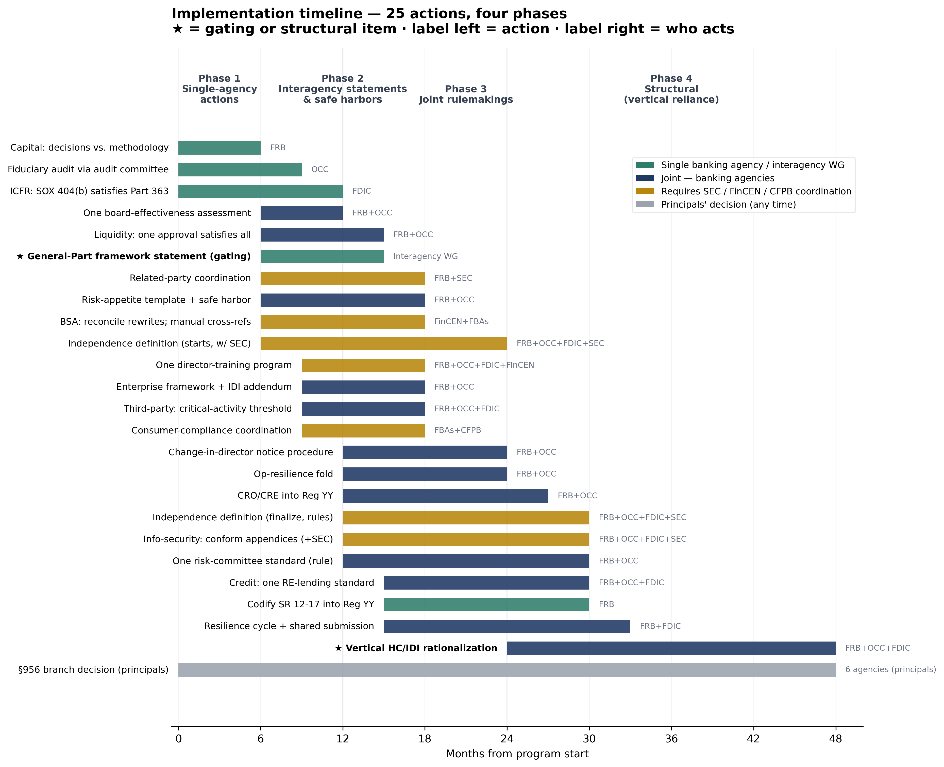

Phase 1 — Single-agency actions (months 0–6)
Three agencies act unilaterally; the working group stands up in parallel.
- Separate board capital-action decisions from technical methodology reporting (months 0–6)
- Permit the §36/Part 363 audit committee to satisfy the fiduciary-audit duty where composition overlaps. (months 0–9)
- SOX 404(b) satisfies FDICIA ICFR by cross-reference; align cycles (months 0–12)

Phase 2 — Interagency statements & safe harbors (months 6–18)
The gating General-Part framework statement lands here.
- Single interagency board-effectiveness assessment. (months 6–12)
- Single cross-referenced prudential independence definition. (months 6–24)
- Coordinate related-party review processes. (months 6–18)
- One board liquidity approval satisfies rule and guidance. (months 6–15)
- Interagency risk-appetite template + safe harbor that one board-approved statement satisfies all. (months 6–18)
- Single interagency board-effectiveness assessment (months 6–12)
- Cross-reference manual to the rule; avoid restating. v2.1: resolve the two unreconciled pending rewrites (2024… (months 6–18)
- Recurring meta-duty (approve framework / review annually / receive reports) -> General Part (months 6–15)
- One consolidated director-training program covering all topics. (months 9–18)
- One enterprise framework approval with an IDI addendum (expanded App. D reliance accommodation) (months 9–18)
- Quantitative 'critical activity' threshold for board attention; management approval + aggregate reporting othe… (months 9–18)
- Coordinate CMS expectations; CFPB now lightly enforced (2026). (months 9–18)

Phase 3 — Joint rulemakings (months 12–30)
Six-plus notice-and-comment rulemakings, sequential in practice.
- Single 'independent director' definition; one audit committee satisfies all regimes (months 12–30)
- Consolidate into Reg YY; OCC incorporates by reference. (months 12–27)
- Single interagency change-in-director notice procedure. (months 12–24)
- One enterprise info-security program approval; joint SEC/banking statement on cyber oversight. v2.1: the 36-ho… (months 12–30)
- Fold into the enterprise risk-appetite approval. (months 12–24)
- One risk-committee standard at the consolidated level + streamlined IDI certification (months 12–30)
- One interagency real-estate-lending standard; fold ACL/credit-review into the risk-committee credit cycle. (months 15–30)
- Single 'resilience planning' board cycle; shared resolution submission with an IDI annex. (months 15–33)
- Codify SR 12-17 governance content into Reg YY; retire the letter (months 15–30)

Phase 4 — Structural: vertical HC/IDI reliance (months 24–48)
Requires the consolidated standards to be in force first.
- Vertical HC/IDI rationalization via expanded reliance accommodation (schema, per mirror pair) (months 24–48)

Principals' decisions (any time)
No forcing mechanism on this track.
- Finalize one 956 framework or rely on guidance; SEC independence satisfies the prudential element. (months 0–48)

View 3 — By timeline: Track B (executive priority)
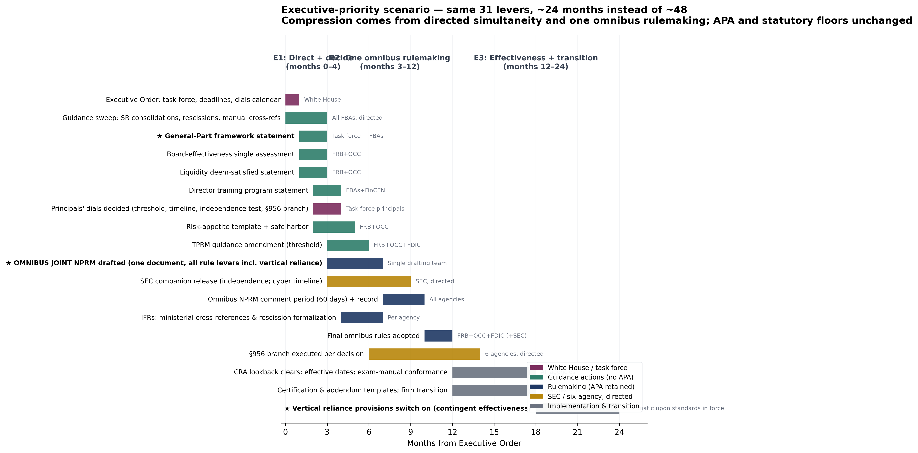

Phase E1 — Direct and decide (months 0–4)
EO day 0; the full guidance sweep; the four principals' dials forced on a 120-day calendar. Contains the same gating General-Part statement — issued in month 1–3 instead of 6–15.
- Single 'independent director' definition; one audit committee satisfies all regimes (months 0–4)
- Single interagency board-effectiveness assessment. (months 0–4)
- Single cross-referenced prudential independence definition. (months 0–4)
- One consolidated director-training program covering all topics. (months 0–4)
- Coordinate related-party review processes. (months 0–4)
- One board liquidity approval satisfies rule and guidance. (months 0–4)
- Interagency risk-appetite template + safe harbor that one board-approved statement satisfies all. (months 0–4)
- Single interagency board-effectiveness assessment (months 0–4)
- Quantitative 'critical activity' threshold for board attention; management approval + aggregate reporting othe… (months 0–4)
- Coordinate CMS expectations; CFPB now lightly enforced (2026). (months 0–4)
- Recurring meta-duty (approve framework / review annually / receive reports) -> General Part (months 1–3)

Spanning E1→E2
Decided early, executed in the omnibus.
- Finalize one 956 framework or rely on guidance; SEC independence satisfies the prudential element. (months 2–12)

Phase E2 — One omnibus rulemaking (months 3–12)
Every rule-level lever rides a single joint NPRM (SEC companion alongside); 60-day comment; final by month 12.
- Separate board capital-action decisions from technical methodology reporting (months 4–12)
- One enterprise framework approval with an IDI addendum (expanded App. D reliance accommodation) (months 4–12)
- Cross-reference manual to the rule; avoid restating. v2.1: resolve the two unreconciled pending rewrites (2024… (months 4–12)
- Consolidate into Reg YY; OCC incorporates by reference. (months 4–12)
- One interagency real-estate-lending standard; fold ACL/credit-review into the risk-committee credit cycle. (months 4–12)
- Single interagency change-in-director notice procedure. (months 4–12)
- Permit the §36/Part 363 audit committee to satisfy the fiduciary-audit duty where composition overlaps. (months 4–12)
- One enterprise info-security program approval; joint SEC/banking statement on cyber oversight. v2.1: the 36-ho… (months 4–12)
- SOX 404(b) satisfies FDICIA ICFR by cross-reference; align cycles (months 4–12)
- Fold into the enterprise risk-appetite approval. (months 4–12)
- Single 'resilience planning' board cycle; shared resolution submission with an IDI annex. (months 4–12)
- One risk-committee standard at the consolidated level + streamlined IDI certification (months 4–12)
- Codify SR 12-17 governance content into Reg YY; retire the letter (months 4–12)

Phase E2→E3 — Contingent structural provisions
Adopted in the omnibus, effective months 18–24 as the standards they rely on take force.
- Vertical HC/IDI rationalization via expanded reliance accommodation (schema, per mirror pair) (months 4–24)

Phase E3 — Effectiveness and transition (months 12–24)
CRA lookback; effective dates; examiner-manual conformance; certification and addendum templates; contingent reliance provisions switch on.

Dependency notes (both tracks)
- The General-Part framework statement gates everything downstream on both tracks; the executive track simply issues it in month 1–3 rather than 6–15.
- The independence definition gates the risk-committee and audit-committee consolidations. Baseline: longest pole (SEC coordination). Executive: SEC principals removable post-Slaughter; runs on the task-force calendar.
- Vertical reliance depends on consolidated standards being in force. Baseline: a separate Phase 4. Executive: adopted in the omnibus with contingent effective dates — the dependency becomes drafting order, not rule order.
- The principals' dials (critical-activity threshold, incident timeline, independence formulation, §956 branch) are prerequisites inside later items on both tracks; only the executive track has a mechanism to force them.
- Track choice is itself a policy decision with a trade: the executive track buys ~24 months at the price of concentrated litigation exposure and reliance on cooperative Fed participation (Cook reserved question). Record quality — this project's verified evidence base — is the mitigant either way.

