Power BI Dashboard Documentation: Clothing Inventory Analysis

This document outlines the functionalities and key insights provided by the Power BI dashboard for your clothing store. The dashboard focuses on analyzing your inventory, sales performance, and customer preferences to optimize your business strategies.
NOTE: The data used in the dashboard is for illustrative purposes only and may not represent the exact inventory of a clothing store. It might not include all the information relevant to your business. However, this dashboard acts as a foundation. With real data from your store, you can easily customize it and add more charts and graphs to get a clearer picture of your inventory.
1. Data Overview
Data Source(s): This sample dashboard uses hypothetical data created to reflect a typical clothing store's inventory.
Data Refresh Schedule: In a real-world scenario, ideally, the data would be updated daily through an automated process (often called an "autoloader"). This ensures the dashboard reflects the most recent sales and inventory information at the end of each business day.
2. Dashboard Layout
The dashboard is designed to provide a comprehensive overview of your clothing store's performance across various aspects. Here's a breakdown of the key sections and visualizations:
Inventory & Budget: This section have different cards that displays the total budget allocated for purchasing clothes, the total number of items in stock, and the overall profit generated.

Sourcing & Profitability by State: A bar graph visually compares the cost of acquiring clothes from different states with the profit generated from selling those clothes. This helps identify areas with higher profit margins.

Category Performance: Another bar graph dives deeper into the performance of different clothing categories. It showcases the quantity of each type of clothing purchased (e.g., t-shirts, saree, jeans etc.), the total cost associated with that category, and the profit generated from selling those items.

Payment Methods: A donut chart (sometimes called a ring chart) illustrates the breakdown of sales by payment method, such as cash, debit card, credit card, or UPI. This helps understand customer payment preferences.

Top Profit Products: This section highlights the top five clothing items with the highest profit margins, allowing you to focus on promoting these high-performing products.

Customer Feedback: A line chart visualizes the average customer rating for each clothing item, providing insights into customer satisfaction.

Sales Trends: A column chart tracks sales performance over time, revealing seasonal trends or sales fluctuations by month.

Product Mix: A pie chart portrays the distribution of sales across different clothing items, offering a visual understanding of your product mix.

Store Performance: A table details the performance of your two stores. It includes the number of outlets, profit generated by each store, and the total value of inventory held in each location. This allows for easy comparison and identification of high-performing stores.

Profitability by Region: A final bar chart, combined with a line chart, presents a detailed breakdown of total sales, total profit, state and city names, and vendor information. This comprehensive view helps analyze regional performance and identify profitable vendor partnerships.

Profit Trend & Forecast: This section incorporates a line chart that visually depicts the historical trend of your store's profit and provides a forecast for the next month's profit. This forecasting functionality helps you anticipate future sales performance and make informed decisions about inventory levels and potential marketing initiatives.

This layout empowers you to monitor inventory levels, analyze sales trends, and gain valuable insights into customer behavior and preferences. By leveraging this information, you can optimize your purchasing strategies, marketing efforts, and overall business decisions.

3. Key Performance Indicators (KPIs)
Sales Performance

Total Budget: This metric represents the total amount of money your store allocated for purchasing clothes. It provides a benchmark for measuring spending against sales and profit. In your example, the total budget is ₹438,000.

Total Items: This KPI indicates the total number of clothing items currently in your store's inventory. It's crucial for managing stock levels and ensuring you have enough items to meet customer demand. In your case, the total number of items is 5,615.

Total Profit: This metric represents the total profit earned after selling clothes. It's calculated by subtracting the total cost of goods sold from your total sales revenue. In your example, the total profit is ₹37,000.

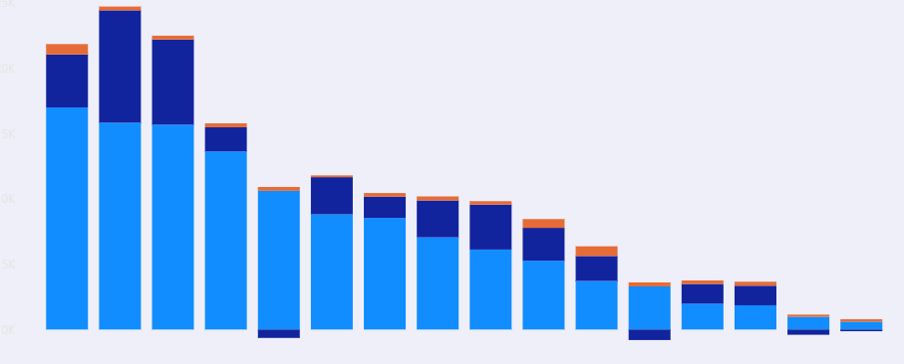

Including a graph like "Profit vs. Quantity vs. Cost" is highly beneficial because it visually portrays the relationship between these three factors. By analyzing this graph, you can identify high-profit categories and optimize purchasing strategies. Additionally, the line chart depicting the profit trend & forecast can further guide your planning by providing insights into anticipated sales performance for the next month. On the X-axis (horizontal axis), you have different clothing categories (e.g., sarees, hoodies, t-shirts, jeans). The Y-axis (vertical axis) uses three colors to represent:

Sky Blue: The total amount spent on purchasing each clothing category.
Blue: The profit generated from selling each clothing category.
Orange: The number of clothing items in each category currently in your inventory.

By analyzing this graph, you can identify:
High-Profit Categories: Categories positioned high on the sky blue line (profit) relative to the blue line (cost) represent your most profitable products.
Overstocked or Understocked Categories: Categories with a significant difference between the orange line (quantity) and the sky blue line (profit) might indicate overstocking (low profit compared to high quantity) or understocking (high profit compared to low quantity) situations.

Inventory Management
Total Items: This metric indicates the total number of clothing items currently in your store's inventory, which is currently at 5,615. This data is crucial for managing stock levels and ensuring you have enough items to meet customer demand without overstocking.
Average Cost: This KPI represents the average price you paid for the total clothes per category in your inventory. In your case, the average cost is ₹21,000. This information helps you understand your overall spending on inventory and identify areas for potential cost optimization.
Stock Sourcing and Profit Margin: This section provides valuable insights into the profitability of sourcing clothes from different locations. The bar graph you included shows:
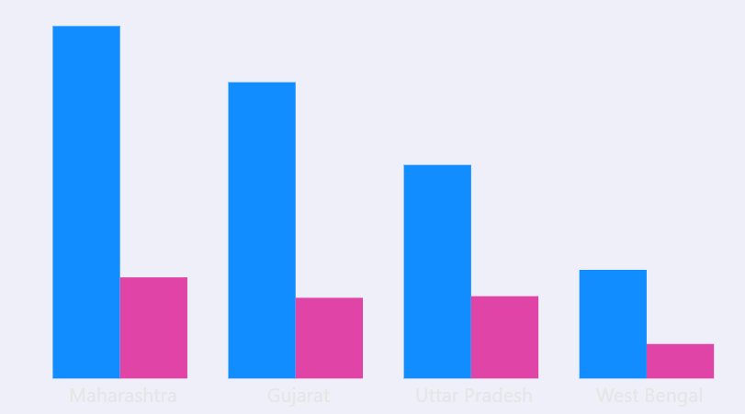

X-axis: Different states where you source clothes (e.g., Maharashtra, Gujarat, Uttar Pradesh).
Y-axis (Blue): Total cost of sourcing clothes from each state. This helps identify which states are the most expensive to source from.
Y-axis (Purple): Profit margin generated from selling clothes sourced from each state. This highlights which states offer the highest profit margins.

By analyzing this graph, you can identify the most cost-effective and profitable sourcing locations. You can then focus on building stronger relationships with vendors in those areas and potentially negotiate better prices to further improve your profit margins.

Customer Insights
Customer Rating by Product: This section provides insights into customer satisfaction with different product categories. It displays the average customer rating (on a 5-star scale) for each clothing type in your store. In your example, the average customer rating is 3.2 stars. By analyzing these ratings, you can identify which clothing categories are most popular with your customers and which ones might need improvement.
Top Profitable Items: This section highlights the clothing categories that generate the highest profit margins for your business.

4. Additional Considerations

Filter by Quarter: The dashboard provides a time filter in the form of a horizontal bar containing four buttons. These buttons allow users to segment the data by quarter (Q1, Q2, Q3, and Q4), which is helpful for analyzing sales trends and performance over specific quarters of the year. For example, clicking on "Q1" would display sales and inventory data for January to March.
Shop Selection: A dropdown menu allows users to select a specific shop (out of your two stores) to view individual store performance. This functionality is beneficial for comparing sales, inventory levels, and profitability between your stores.
Monthly Drill-Down: The dashboard offers a dropdown menu listing all twelve months (January to December). Selecting a specific month from this menu will provide a more granular view of the data for that month. This allows users to explore sales performance, inventory fluctuations, and customer insights for chosen months.

By incorporating these filters and drill-down functionalities, the dashboard empowers users to conduct more focused analysis and gain deeper insights into specific areas of your clothing store's performance.
5. Conclusion
This Power BI dashboard serves as a powerful tool for effectively managing your clothing store inventory and optimizing your business strategies. By leveraging the insights gleaned from the various visualizations and data points

