**MIT xPRO Data Engineering Certificate**

**Bootstrap**

Bootstrap is another useful framework that helps developers enhance web pages. For example, Bootstrap helps to enhance the functionality and appearance of the navigation bar.

<https://getbootstrap.com/docs/5.3/getting-started/introduction/>



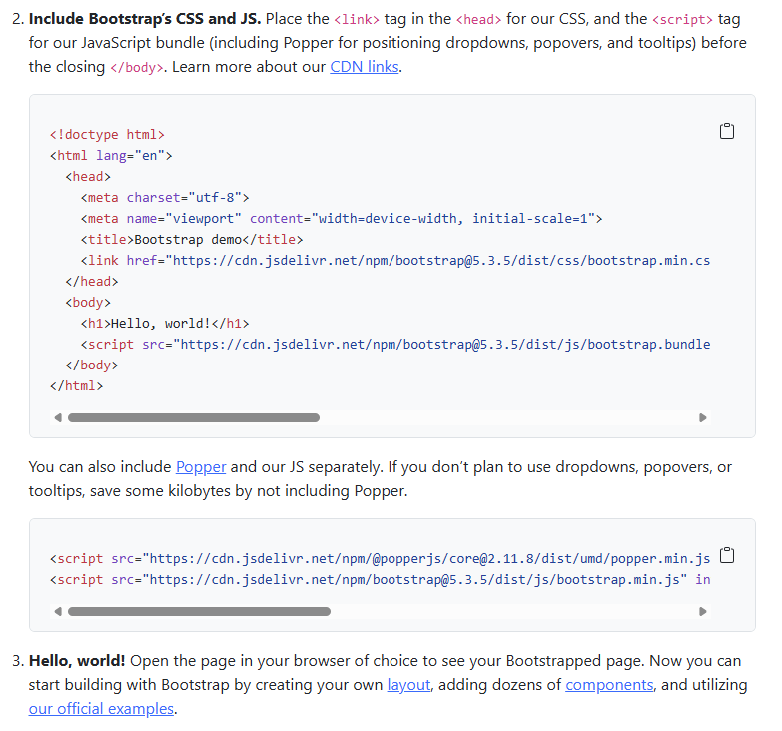

**What Is Bootstrap?**

In simple terms, Bootstrap is another useful framework that helps developers enhance web pages. It uses HTML, CSS (Cascading Style Sheets - a language used to describe the presentation of a document written in a markup language e.g. HTML or XML), and JavaScript to create and build web pages and web applications. Using Bootstrap, you will be able create a more advanced navigation bar or insert tables in your web page application.

**How to Create a Standard Bootstrap Table**

A basic Bootstrap table has a light padding and only rows as dividers. There are many styles of tables that you can create: <https://www.w3schools.com/bootstrap/bootstrap_tables.asp>

Below is an example that shows you how to create a table, .table-striped, with rows of alternating colors.

| **First Name Last Name Student ID** |
| --- |
| Mary Smith 100001 |
| John Dan 100002 |
| Jessica Cooper 100003 |

The code to generate a table like the one above is given by:

<!DOCTYPE html>  
<html lang="en">  
<head>  
 <title>Bootstrap Example</title>  
 <meta charset="utf-8">  
 <meta name="viewport" content="width=device-width, initial-scale=1">  
 <link rel="stylesheet" href="https://maxcdn.bootstrapcdn.com/bootstrap/3.4.1/css/bootstrap.min.css">  
 <script src="https://ajax.googleapis.com/ajax/libs/jquery/3.5.1/jquery.min.js"></script>  
 <script src="https://maxcdn.bootstrapcdn.com/bootstrap/3.4.1/js/bootstrap.min.js"></script>  
</head>  
<body>  
<div class="container">   
 <table class="table table-striped">  
 <thead>  
 <tr>  
 <th>First Name</th>  
 <th>Last Name</th>  
 <th>Student ID</th>  
 </tr>  
 </thead>  
 <tbody>  
 <tr>  
 <td>Mary</td>  
 <td>Smith</td>  
 <td>100001</td>  
 </tr>  
 <tr>  
 <td>John</td>  
 <td>Dan</td>  
 <td>100002</td>  
 </tr>  
 <tr>  
 <td>Jessica</td>  
 <td>Cooper</td>  
 <td>100003</td>  
 </tr>  
 </tbody>  
 </table>  
</div>  
</body>  
</html>

In conclusion, one of the reasons why you would want to create a Bootstrap table on your web page is to enhance it. It also gives the user the ability to access and read the content more easily.