**MIT xPRO Data Engineering Certificate**

**Cookies**

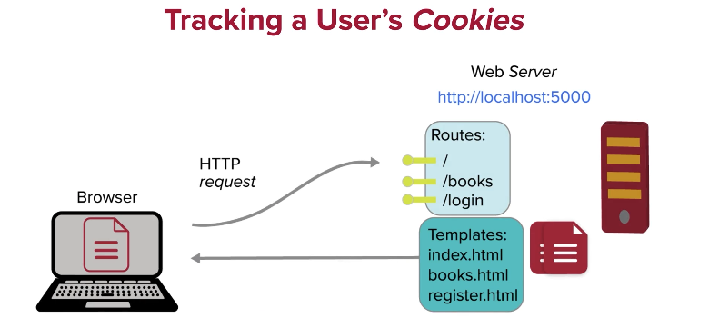

When a user is asked to log-in, the credentials are checked to see whether that user is allowed to log in. Session cookies are used to track users whilst they are logged in, so a user doesn’t have to log in each time they make a request during a session.

To create session cookies you create a secret key:

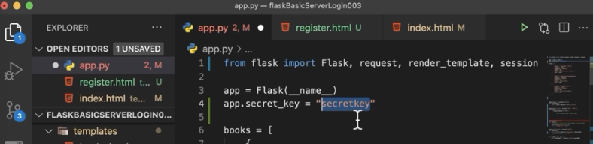

These are the permitted users and their passwords:



This is code to check if user credentials are allowed:

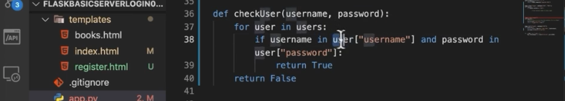

This code sets up the login route and picks up the data posted to the form in the register.html template, and the credentials pass, it sets a session cookie:.

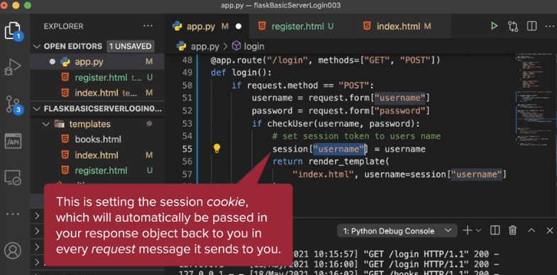

If the credentials don’t pass, or the request method is ‘GET’, we send the user off to register:

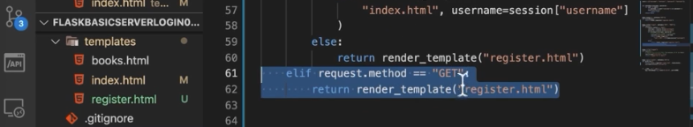

The log out route destroys the session cookie:

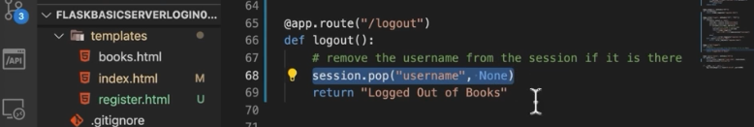

The default route also sends users to register:

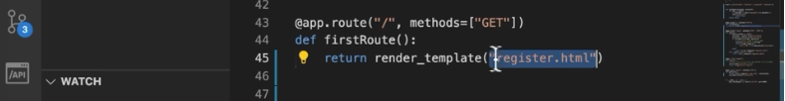

You can see the session cookie created in the DevTools window (Ctrl + Shift + I):

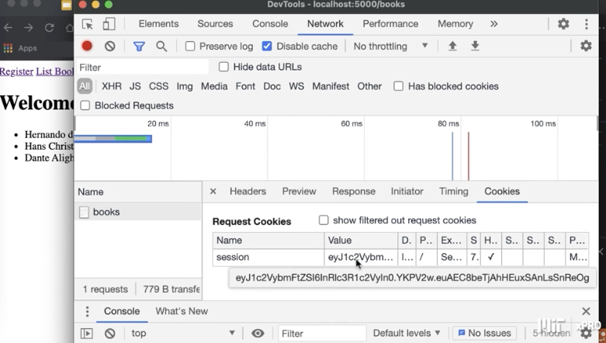

Or you can view them here:

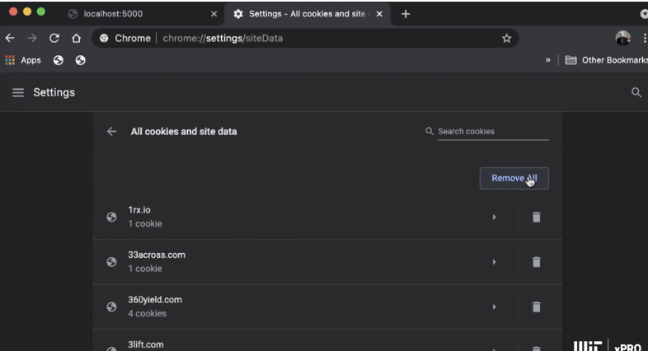

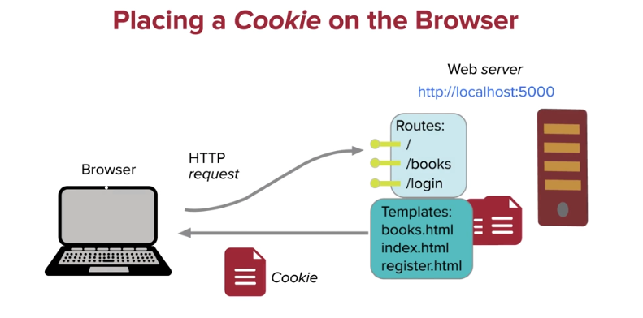

To set a cookie at login (without it being set as a session cookie), you create a response object, and add the cookie to the response object:

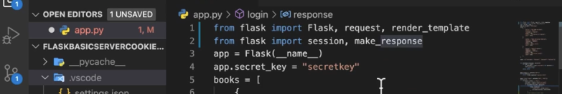

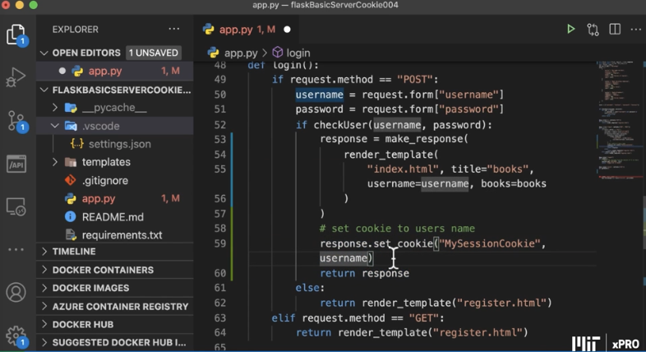

This code gets the cookie when a user GET requests the books route:

