**MIT xPRO Data Engineering Certificate**

**Document Object Model (DOM)**

**What Is the DOM?**

Imagine a scenario in which you want to change both the radio channel and the volume on your sound system in your home. One way to do this is to use a remote control device to interact with your sound system. Using the remote, you can make the changes and communicate them to your sound system.

In a similar way, you can use JavaScript to act on the DOM to create an HTML page that defines a website. For example, you can change the color of the title on your webpage by simply changing your JavaScript code. These changes will be reflected on the DOM and, therefore, will be automatically updated on your website.

Using a DOM enables you to make any relevant changes to the web page without having to change the actual web code or the corresponding HTML page. The DOM serves as a bridge to communicate the changes made through JavaScript code to the website. For example, if you would like to change the top bar on a website, you would first need to make changes to your JavaScript code, then communicate that to the website via the DOM.

The DOM is also used when dealing with unstructured data in an HTML format. In this case, you can use the DOM to parse and read through the data to derive some information about it. In particular, you may want to understand which HTML *tags* enclose the type of data you are interested in so that you can access and visualize it.

**How Is the DOM Structured?**

The DOM is a structural representation of your website. No matter what you want your web page to look like, the DOM always follows a tree-like structure. The figure below depicts an example of a DOM:

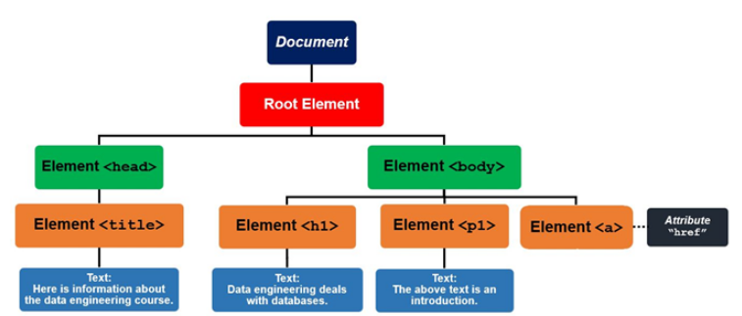

The above DOM is defined by the code below:

<html lang="en" dir="ltr">

<head>

<title>Here is information about the data engineering course.

</title>

</head>

<body>

<h1>Data engineering deals with databases.

</h1>

<p>The above text is an introduction.</p>

</body>

</html>

As you can see, the <title> *tag* is inside of the <head> *tag*. The text, “Here is information about the data engineering course.” will be the title of the web page in the header section. The <body> *tag* includes the main content of the web page.

The <html> *node* acts as the parent *node* to the <head> and <body> *nodes*. The <head> and <body> *nodes* act as parent *nodes* to the <title> and <h1>, <p>, and <a> *nodes*, respectively. You can add more *nodes* depending on how you want your web page to appear. An HTML *attribute* can be thought of as an additional value that configures any element within an HTML page. For example, in the diagram above, the element <a> is used to refer to a hyperlink. Typically, this element will have an href *attribute* that specifies the URL link to the linked source in the hyperlink.