**MIT xPRO Data Engineering Certificate**

**Markdown**

**What Is Markdown?**

Web pages contain documents that are annotated and formatted to provide content that is visually appealing to help the reader connect with the information on the web page. Markup language offers the capability of adding features to the text, such as headings, images, lists, and links to other content, that make the text more appealing and easier to read. This mini-lesson will provide some examples of Markdown and HTML.

**How to Write Markdown Syntax**

Below is a series of examples of how to write Markdown syntax. Note that for some examples, you are also provided with the equivalent HTML tags.

**Headings**Use the syntax below to create headings for sections in the Jupyter Notebook.  
  
The code above renders:



**Emphasis**The code below shows how to emphasize (bold) text using Markdown. Notice the different options.  
  
The code above renders:  


**Italics**The code below shows how to italicize text using Markdown. Notice the different options.  
  
The code below renders:  


**Block Quote**The code below shows how to create block quotes in Markdown.  
  
The code above renders:  


**Ordered Lists**The code below shows how to create ordered lists in Markdown.  
  
The code above renders:  


**Unordered Lists (Bullet Points)**The code below shows how to create unordered lists in Markdown.  
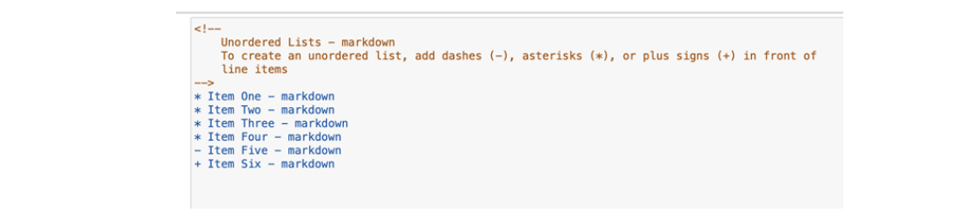  
The code above renders:  


**Links**The example below shows how to display links in Markdown:  
  
The code above renders:  


**Images**The code below shows how to include images in Markdown:  
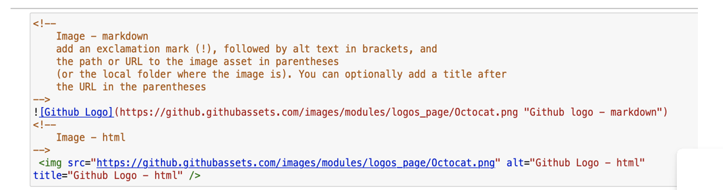  
The code above renders:  


**Tables**The code below shows how to create a table using Markdown.  
  
The code above renders:  
  
You can put several elements together by creating a Table of Contents for your document.  
First, create an *anchor* tag in one of the Markdown cells being referenced in your Table of Contents:  
  
Note that the ID needs to be unique for each Markdown cell that your Table of Contents will reference. When you render the cell, the *anchor* will be hidden:  
  
To create a Table of Contents, you will need to work with links and lists together:  
  
This is how the Table of Contents is rendered:  
  
When you select a link, you are taken to the cell referenced in the Table of Contents. This is convenient because there is no need to scroll through the document to try to find the cell.  
Now you are ready to start using Markdown scripts to create visually appealing documents. Markdown will be an invaluable tool for you when you start preparing your portfolio to show your work to industry professionals.