MIT xPRO Data Engineering Certificate

Matplotlib

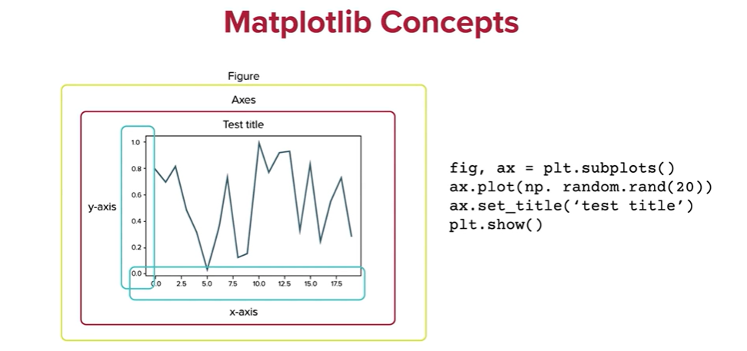

Why Is Plotting Important?
Data visualization and plotting is the discipline of understanding and detecting underlying patterns, properties, and trends in data using visual representations.
Therefore, data visualization and graphing libraries, such as Matplotlib, can help you understand the information that is present in your data.
Python offers multiple graphing libraries, and each one is designed to serve a different discipline. Arguably, the most popular Python plotting library is Matplotlib.
What Is Matplotlib?
Matplotlib is a library for producing publication-quality figures. Matplotlib was initially designed by John D. Hunter in 2003 to serve two purposes:
- Allow for interactive, cross-platform control of figures and plots.
- Produce static graphics files easily without a graphical user interface (GUI).
Matplotlib, much like Python itself, gives users complete control over the appearance of their plots while also offering a powerful default system.
The Matplotlib Object Hierarchy
One important big-picture Matplotlib concept is its object hierarchy.
As you have seen in the previous video, a plot can be created using the plt.plot() command.
This one-liner hides the fact that a plot is really a hierarchy of nested Python objects. A hierarchy means that there is a tree-like structure of Matplotlib objects underlying each plot.

The Matplotlib graphic above consists of a number of components. “A Figure object is the outermost container for a Matplotlib graphic, which can contain multiple axes objects. You can think of the Figure object as a box-like container holding one or more axes (actual plots). Below the axes in the hierarchy are smaller objects such as the actual Y-axis and X-axis of a plot, individual lines, legends, and text boxes” (Solomon 2021). Almost every element of a chart can be customized in Python as an object.
Elements in a Plot
As mentioned above, Matplotlib graphics can contain many elements that one can customize depending on their needs.
The figure below includes an extensive showcase of the elements in a plot.
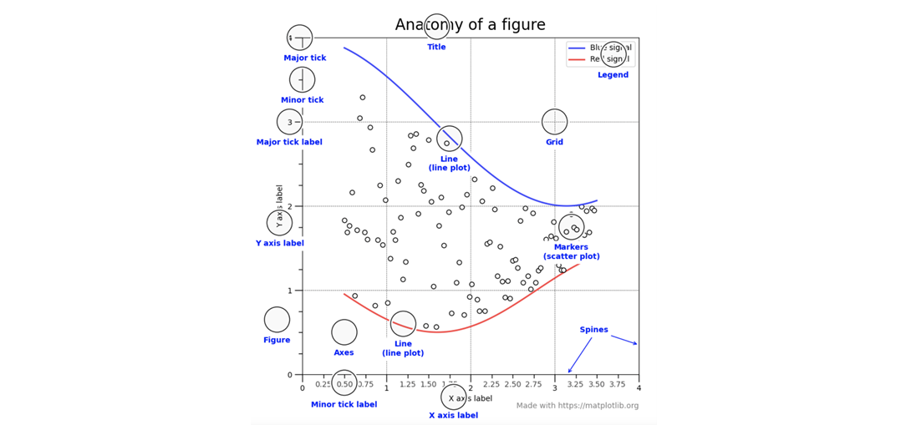
In the figure above,
- Title denotes the title of the plot.
- Grid sets the visibility of a grid inside the plot.
- The X-axis and Y-axis labels denote the names given to the axes in the plot.
- Spines are lines noting the data area boundaries.
- Ticks are markers denoting data points on axes.
- Tick labels refer to the value of the data points on axes.
- Legend denotes the legend, which describes what the plot contains.

Line Plots
A line plot is a type of chart that displays information as a series of data points called “markers” connected by straight line segments. Line graphs are used to track changes over short or long periods of time. They can also be used to compare data sets over the same period of time for more than one group (a series).
In a line plot:
- The X-axis requires a quantitative variable.
- The Y-axis values must be numbers and can be interpreted (formatted) as decimals, percentages, or currency values.
- Variables have contiguous values.
To generate a line plot, use the command: ax.plot() (Matplotlib 2021).
For example, the syntax

generates

Bar Plots
A bar plot (or bar chart) is one of the most common types of graphics. It shows the relationship between a numeric and a categorical variable. Each entity of the categorical variable is represented as a bar. The size of the bar represents its numeric value.
- Like line charts, bar graphs are used to compare data between different groups or to track changes over time.
- Bar graphs can display multiple groups in the same bar in a stacked visual that shows the graph’s composition along the Y-axis.
In Matplotlib, the bar() function is used to create bar plots (Matplotlib 2021).
The parameters to be used with the axes object of the bar() function are as follows:
bar(x, height, width, bottom, align)
The example below shows how to create a bar plot given a data set:
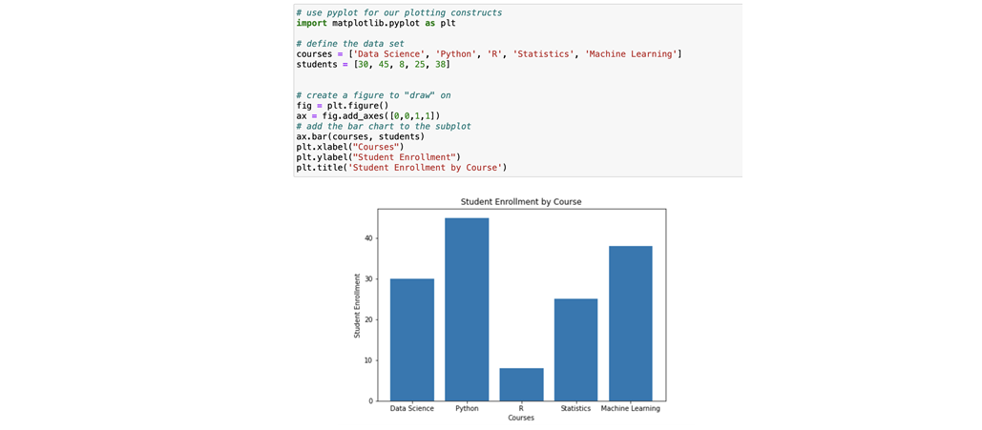
Scatter Plots
A scatter plot is used to determine relationships between two different data dimensions. In a scatter plot, the X-axis is used to measure one dimension (or variable), and the Y-axis is used to measure the other. If both variables increase at the same time, they have a positive relationship. If one variable decreases while the other increases, they have a negative relationship. Sometimes, the variables don't follow any pattern and have no relationship.
In Matplotlib, use the scatter() function to create scatter plots (Matplotlib 2021).
The parameters to be used with the axes object of the scatter() function are as follows:
scatter(x_coords, y_coords, shape, colors, alpha)
The example below shows how to create a scatter plot in Matplotlib:
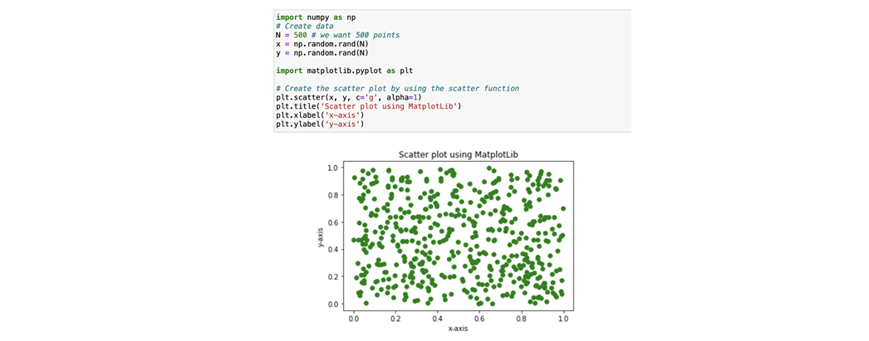
Histograms
A histogram is a display of statistical information that uses rectangles to show the frequency of data items in successive numerical intervals of equal size.
In the most common form of histogram, the independent variable is plotted along the horizontal axis, and the dependent variable is plotted along the vertical axis.
In Matplotlib, use the plt.hist() function to create histogram plots (Matplotlib 2021).
The parameters to be used with the axes object of the plt.hist() function are as follows:
hist(x_values, bins, color, transparency)
The example below shows how to create a histogram in Matplotlib:
