



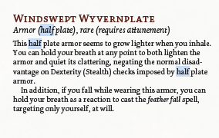



The Watcher's Blade   
Sentient, Artifact, Lawful Neutral  
  
this sword has charges equal to your wisdom or charisma modifier whatever is higher  
  
this sword acts as a +3 longsword  
  
on hit this sword does an additional 2d6 radiant damage  
  
on dawn this sword regains 1d4+1 charges

2 charges

as a reaction you can expend a charge to take damage an ally would take within 60 ft of you from one attack or spell  
  
exalted  
  
awakened

