Final Project Word

Matt, Rachel, Shayna, Sherry

December 8, 2019

library(tidyverse)

## -- Attaching packages --------------------------------------------------------- tidyverse 1.2.1 --

## v ggplot2 3.2.1 v purrr 0.3.2  
## v tibble 2.1.3 v dplyr 0.8.3  
## v tidyr 1.0.0 v stringr 1.4.0  
## v readr 1.3.1 v forcats 0.4.0

## -- Conflicts ------------------------------------------------------------ tidyverse_conflicts() --  
## x dplyr::filter() masks stats::filter()  
## x dplyr::lag() masks stats::lag()

library(flexdashboard)

# read in data  
clues <- read_tsv("./data/master_season1-35.tsv")

## Parsed with column specification:  
## cols(  
## round = col_double(),  
## value = col_double(),  
## daily_double = col_character(),  
## category = col_character(),  
## comments = col_character(),  
## answer = col_character(),  
## question = col_character(),  
## air_date = col_date(format = ""),  
## notes = col_character()  
## )

answers <- clues %>%   
 select(category, answer, question)  
  
#filter years out of answers, create new column, arrange descending  
years_data <- answers %>%   
 mutate(years = str_extract(answer, "[0-9]{4}")) %>%  
 filter(str_count(years)==4)%>%   
 arrange(desc(years)) %>%   
 slice(413:84470) %>%   
 group_by(years)   
  
 years_data1 <- years_data %>%   
 summarize(count = n()) %>%   
 arrange(desc(count)) %>%   
 ungroup()

# transform years column to numeric  
years2 <- transform(years_data1, years = as.numeric(years))  
  
years2

## years count  
## 1 1996 1087  
## 2 1999 1024  
## 3 1997 1023  
## 4 1980 999  
## 5 2000 994  
## 6 1960 975  
## 7 1995 961  
## 8 1990 906  
## 9 1998 891  
## 10 1970 868  
## 11 1989 831  
## 12 1984 830  
## 13 1988 818  
## 14 1986 816  
## 15 1994 812  
## 16 1992 803  
## 17 2001 797  
## 18 1987 744  
## 19 1991 739  
## 20 1950 735  
## 21 1993 733  
## 22 2008 731  
## 23 1968 723  
## 24 2003 721  
## 25 1964 697  
## 26 2009 684  
## 27 1962 659  
## 28 2002 657  
## 29 1967 655  
## 30 1985 645  
## 31 1973 644  
## 32 1930 642  
## 33 1969 640  
## 34 2004 640  
## 35 1971 636  
## 36 1975 636  
## 37 2005 634  
## 38 1979 626  
## 39 2006 625  
## 40 1976 622  
## 41 1961 621  
## 42 1920 617  
## 43 1982 617  
## 44 1978 605  
## 45 2010 594  
## 46 2007 591  
## 47 1974 589  
## 48 1940 588  
## 49 1972 586  
## 50 2011 581  
## 51 1963 574  
## 52 1977 573  
## 53 1981 568  
## 54 1965 561  
## 55 2012 553  
## 56 1983 551  
## 57 2013 539  
## 58 1959 518  
## 59 1954 493  
## 60 1939 484  
## 61 1966 483  
## 62 1957 481  
## 63 1956 473  
## 64 1948 470  
## 65 1947 469  
## 66 1955 453  
## 67 1945 448  
## 68 1953 446  
## 69 1952 445  
## 70 2014 440  
## 71 1958 420  
## 72 2015 419  
## 73 1946 402  
## 74 1936 399  
## 75 1949 388  
## 76 1935 380  
## 77 1941 377  
## 78 2016 372  
## 79 1951 356  
## 80 1942 354  
## 81 1912 349  
## 82 1937 346  
## 83 1934 334  
## 84 1900 331  
## 85 1890 324  
## 86 1933 317  
## 87 1929 315  
## 88 1944 310  
## 89 2017 310  
## 90 1938 308  
## 91 1932 305  
## 92 1800 303  
## 93 1901 292  
## 94 1870 277  
## 95 1913 276  
## 96 1917 271  
## 97 1919 271  
## 98 1928 270  
## 99 1927 261  
## 100 1924 259  
## 101 1931 255  
## 102 1904 250  
## 103 1923 250  
## 104 1850 249  
## 105 1922 248  
## 106 1865 245  
## 107 1860 244  
## 108 1776 233  
## 109 1880 233  
## 110 1926 233  
## 111 2018 232  
## 112 1898 230  
## 113 1914 228  
## 114 1863 227  
## 115 1862 224  
## 116 1903 222  
## 117 1916 222  
## 118 1910 218  
## 119 1915 218  
## 120 1918 218  
## 121 1889 217  
## 122 1861 216  
## 123 1925 216  
## 124 1943 216  
## 125 1896 209  
## 126 1812 203  
## 127 1876 203  
## 128 1902 201  
## 129 1864 199  
## 130 1905 198  
## 131 1893 192  
## 132 1881 191  
## 133 1840 190  
## 134 1906 189  
## 135 1909 189  
## 136 1867 188  
## 137 1921 188  
## 138 1892 187  
## 139 1830 185  
## 140 1895 185  
## 141 1908 185  
## 142 1789 179  
## 143 1911 179  
## 144 1899 178  
## 145 1869 177  
## 146 1775 176  
## 147 1897 173  
## 148 1871 172  
## 149 1848 169  
## 150 1888 167  
## 151 1886 166  
## 152 1859 162  
## 153 1907 160  
## 154 1820 157  
## 155 1851 150  
## 156 1872 148  
## 157 1849 143  
## 158 1883 142  
## 159 1847 139  
## 160 1894 137  
## 161 1846 136  
## 162 1868 135  
## 163 1887 135  
## 164 1600 134  
## 165 1857 134  
## 166 1790 133  
## 167 1500 132  
## 168 1814 132  
## 169 1882 132  
## 170 1885 131  
## 171 1877 128  
## 172 1770 127  
## 173 1804 127  
## 174 1836 126  
## 175 1000 125  
## 176 1858 125  
## 177 1891 125  
## 178 1700 122  
## 179 1815 122  
## 180 1875 121  
## 181 1879 120  
## 182 1777 119  
## 183 1884 117  
## 184 1856 115  
## 185 1854 114  
## 186 1873 112  
## 187 1787 111  
## 188 1844 110  
## 189 1793 109  
## 190 1866 107  
## 191 1845 105  
## 192 1852 105  
## 193 1831 103  
## 194 1792 102  
## 195 1878 101  
## 196 1853 99  
## 197 1874 99  
## 198 1832 98  
## 199 1837 98  
## 200 1855 98  
## 201 1841 96  
## 202 1805 94  
## 203 1783 92  
## 204 1825 91  
## 205 1794 90  
## 206 1842 90  
## 207 1620 87  
## 208 1798 87  
## 209 1492 86  
## 210 1801 86  
## 211 1843 86  
## 212 1821 85  
## 213 1835 85  
## 214 1813 83  
## 215 1819 82  
## 216 1791 79  
## 217 1824 79  
## 218 1803 77  
## 219 1817 77  
## 220 1839 75  
## 221 1806 74  
## 222 1829 73  
## 223 1807 72  
## 224 1826 71  
## 225 1774 70  
## 226 1780 70  
## 227 1809 69  
## 228 1811 69  
## 229 1818 69  
## 230 1781 68  
## 231 1797 67  
## 232 1833 67  
## 233 1778 66  
## 234 1838 65  
## 235 1795 63  
## 236 1802 63  
## 237 1823 63  
## 238 1828 63  
## 239 1400 59  
## 240 1779 59  
## 241 1786 59  
## 242 1799 59  
## 243 1822 59  
## 244 1521 57  
## 245 1610 57  
## 246 1810 57  
## 247 1300 55  
## 248 1808 55  
## 249 1816 55  
## 250 1834 55  
## 251 1773 52  
## 252 1200 51  
## 253 1609 51  
## 254 1513 50  
## 255 1765 50  
## 256 1660 49  
## 257 1760 49  
## 258 1796 49  
## 259 1066 48  
## 260 1754 43  
## 261 1755 43  
## 262 1788 43  
## 263 1666 42  
## 264 1785 42  
## 265 1690 41  
## 266 1741 41  
## 267 1759 41  
## 268 1763 41  
## 269 1827 41  
## 270 1519 40  
## 271 1605 40  
## 272 1750 40  
## 273 1630 39  
## 274 1769 39  
## 275 1740 38  
## 276 2019 38  
## 277 1762 37  
## 278 1764 37  
## 279 1768 37  
## 280 1485 36  
## 281 1520 36  
## 282 1613 36  
## 283 1682 36  
## 284 1701 36  
## 285 1756 36  
## 286 1533 35  
## 287 1588 35  
## 288 1642 35  
## 289 1692 35  
## 290 1720 35  
## 291 1782 35  
## 292 1784 35  
## 293 1676 34  
## 294 1100 33  
## 295 1587 33  
## 296 1650 33  
## 297 1215 32  
## 298 1607 32  
## 299 1616 32  
## 300 1649 32  
## 301 1726 32  
## 302 1493 31  
## 303 1603 31  
## 304 1621 31  
## 305 1742 31  
## 306 1749 31  
## 307 1415 30  
## 308 1497 30  
## 309 1535 30  
## 310 1453 29  
## 311 1504 29  
## 312 1598 29  
## 313 1730 29  
## 314 1611 28  
## 315 1703 28  
## 316 1718 28  
## 317 1498 27  
## 318 1534 27  
## 319 1542 27  
## 320 1618 27  
## 321 1643 27  
## 322 1540 26  
## 323 1550 26  
## 324 1614 26  
## 325 1653 26  
## 326 1719 26  
## 327 1735 26  
## 328 1752 26  
## 329 1633 25  
## 330 1732 25  
## 331 1450 24  
## 332 1640 24  
## 333 1673 24  
## 334 1704 24  
## 335 1517 23  
## 336 1524 23  
## 337 1541 23  
## 338 1543 23  
## 339 1547 23  
## 340 1590 23  
## 341 1623 23  
## 342 1644 23  
## 343 1648 23  
## 344 1667 23  
## 345 1722 23  
## 346 1767 23  
## 347 1516 22  
## 348 1530 22  
## 349 1572 22  
## 350 1608 22  
## 351 1638 22  
## 352 1659 22  
## 353 1665 22  
## 354 1669 22  
## 355 1670 22  
## 356 1697 22  
## 357 1714 22  
## 358 1723 22  
## 359 1604 21  
## 360 1680 21  
## 361 1683 21  
## 362 1699 21  
## 363 1713 21  
## 364 1733 21  
## 365 1757 21  
## 366 1431 20  
## 367 1483 20  
## 368 1553 20  
## 369 1565 20  
## 370 1619 20  
## 371 1632 20  
## 372 1687 20  
## 373 1717 20  
## 374 1766 20  
## 375 1494 19  
## 376 1582 19  
## 377 1585 19  
## 378 1601 19  
## 379 1624 19  
## 380 1634 19  
## 381 1656 19  
## 382 1664 19  
## 383 1688 19  
## 384 1689 19  
## 385 1725 19  
## 386 1745 19  
## 387 1751 19  
## 388 1758 19  
## 389 1054 18  
## 390 1240 18  
## 391 1536 18  
## 392 1564 18  
## 393 1599 18  
## 394 1631 18  
## 395 1672 18  
## 396 1715 18  
## 397 1721 18  
## 398 1727 18  
## 399 1368 17  
## 400 1429 17  
## 401 1501 17  
## 402 1554 17  
## 403 1571 17  
## 404 1636 17  
## 405 1693 17  
## 406 1706 17  
## 407 1737 17  
## 408 1753 17  
## 409 1578 16  
## 410 1668 16  
## 411 1675 16  
## 412 1711 16  
## 413 1736 16  
## 414 1170 15  
## 415 1250 15  
## 416 1482 15  
## 417 1570 15  
## 418 1589 15  
## 419 1606 15  
## 420 1637 15  
## 421 1652 15  
## 422 1694 15  
## 423 1698 15  
## 424 1710 15  
## 425 1743 15  
## 426 1761 15  
## 427 1314 14  
## 428 1490 14  
## 429 1502 14  
## 430 1522 14  
## 431 1525 14  
## 432 1593 14  
## 433 1595 14  
## 434 1626 14  
## 435 1654 14  
## 436 1685 14  
## 437 1702 14  
## 438 1705 14  
## 439 1707 14  
## 440 1729 14  
## 441 1771 14  
## 442 1469 13  
## 443 1506 13  
## 444 1562 13  
## 445 1580 13  
## 446 1596 13  
## 447 1602 13  
## 448 1628 13  
## 449 1712 13  
## 450 1739 13  
## 451 1748 13  
## 452 1772 13  
## 453 1099 12  
## 454 1348 12  
## 455 1478 12  
## 456 1499 12  
## 457 1503 12  
## 458 1505 12  
## 459 1508 12  
## 460 1512 12  
## 461 1531 12  
## 462 1559 12  
## 463 1577 12  
## 464 1579 12  
## 465 1612 12  
## 466 1615 12  
## 467 1635 12  
## 468 1661 12  
## 469 1674 12  
## 470 1678 12  
## 471 1746 12  
## 472 1040 11  
## 473 1191 11  
## 474 1192 11  
## 475 1480 11  
## 476 1488 11  
## 477 1532 11  
## 478 1581 11  
## 479 1622 11  
## 480 1625 11  
## 481 1655 11  
## 482 1662 11  
## 483 1671 11  
## 484 1716 11  
## 485 1738 11  
## 486 1747 11  
## 487 1265 10  
## 488 1297 10  
## 489 1386 10  
## 490 1509 10  
## 491 1526 10  
## 492 1537 10  
## 493 1538 10  
## 494 1558 10  
## 495 1567 10  
## 496 1584 10  
## 497 1592 10  
## 498 1617 10  
## 499 1658 10  
## 500 1731 10  
## 501 1734 10  
## 502 1744 10  
## 503 1001 9  
## 504 1189 9  
## 505 1204 9  
## 506 1206 9  
## 507 1291 9  
## 508 1337 9  
## 509 1381 9  
## 510 1491 9  
## 511 1507 9  
## 512 1523 9  
## 513 1529 9  
## 514 1566 9  
## 515 1569 9  
## 516 1586 9  
## 517 1639 9  
## 518 1651 9  
## 519 1691 9  
## 520 1695 9  
## 521 1709 9  
## 522 1150 8  
## 523 1154 8  
## 524 1199 8  
## 525 1212 8  
## 526 1270 8  
## 527 1279 8  
## 528 1301 8  
## 529 1309 8  
## 530 1420 8  
## 531 1455 8  
## 532 1486 8  
## 533 1514 8  
## 534 1556 8  
## 535 1560 8  
## 536 1597 8  
## 537 1647 8  
## 538 1681 8  
## 539 1708 8  
## 540 1724 8  
## 541 1085 7  
## 542 1227 7  
## 543 1274 7  
## 544 1275 7  
## 545 1290 7  
## 546 1307 7  
## 547 1346 7  
## 548 1347 7  
## 549 1360 7  
## 550 1430 7  
## 551 1449 7  
## 552 1451 7  
## 553 1452 7  
## 554 1527 7  
## 555 1539 7  
## 556 1545 7  
## 557 1549 7  
## 558 1557 7  
## 559 1561 7  
## 560 1575 7  
## 561 1645 7  
## 562 1663 7  
## 563 1679 7  
## 564 1696 7  
## 565 1728 7  
## 566 1057 6  
## 567 1060 6  
## 568 1087 6  
## 569 1095 6  
## 570 1096 6  
## 571 1137 6  
## 572 1173 6  
## 573 1258 6  
## 574 1282 6  
## 575 1294 6  
## 576 1305 6  
## 577 1306 6  
## 578 1325 6  
## 579 1340 6  
## 580 1370 6  
## 581 1378 6  
## 582 1380 6  
## 583 1421 6  
## 584 1470 6  
## 585 1471 6  
## 586 1481 6  
## 587 1546 6  
## 588 1555 6  
## 589 1629 6  
## 590 1641 6  
## 591 1657 6  
## 592 1677 6  
## 593 1684 6  
## 594 1686 6  
## 595 1023 5  
## 596 1050 5  
## 597 1086 5  
## 598 1094 5  
## 599 1147 5  
## 600 1190 5  
## 601 1209 5  
## 602 1216 5  
## 603 1219 5  
## 604 1248 5  
## 605 1257 5  
## 606 1271 5  
## 607 1281 5  
## 608 1292 5  
## 609 1295 5  
## 610 1302 5  
## 611 1321 5  
## 612 1328 5  
## 613 1333 5  
## 614 1341 5  
## 615 1355 5  
## 616 1356 5  
## 617 1377 5  
## 618 1389 5  
## 619 1390 5  
## 620 1394 5  
## 621 1397 5  
## 622 1402 5  
## 623 1403 5  
## 624 1413 5  
## 625 1440 5  
## 626 1460 5  
## 627 1461 5  
## 628 1484 5  
## 629 1496 5  
## 630 1568 5  
## 631 1573 5  
## 632 1576 5  
## 633 1028 4  
## 634 1065 4  
## 635 1080 4  
## 636 1084 4  
## 637 1140 4  
## 638 1187 4  
## 639 1198 4  
## 640 1202 4  
## 641 1220 4  
## 642 1226 4  
## 643 1252 4  
## 644 1253 4  
## 645 1260 4  
## 646 1280 4  
## 647 1284 4  
## 648 1324 4  
## 649 1327 4  
## 650 1354 4  
## 651 1376 4  
## 652 1399 4  
## 653 1438 4  
## 654 1446 4  
## 655 1456 4  
## 656 1457 4  
## 657 1462 4  
## 658 1472 4  
## 659 1474 4  
## 660 1475 4  
## 661 1477 4  
## 662 1510 4  
## 663 1552 4  
## 664 1594 4  
## 665 1627 4  
## 666 1002 3  
## 667 1004 3  
## 668 1010 3  
## 669 1020 3  
## 670 1027 3  
## 671 1069 3  
## 672 1072 3  
## 673 1078 3  
## 674 1083 3  
## 675 1090 3  
## 676 1097 3  
## 677 1098 3  
## 678 1122 3  
## 679 1138 3  
## 680 1139 3  
## 681 1143 3  
## 682 1152 3  
## 683 1160 3  
## 684 1163 3  
## 685 1167 3  
## 686 1169 3  
## 687 1174 3  
## 688 1184 3  
## 689 1194 3  
## 690 1222 3  
## 691 1223 3  
## 692 1224 3  
## 693 1234 3  
## 694 1241 3  
## 695 1273 3  
## 696 1276 3  
## 697 1298 3  
## 698 1308 3  
## 699 1313 3  
## 700 1323 3  
## 701 1330 3  
## 702 1349 3  
## 703 1350 3  
## 704 1353 3  
## 705 1385 3  
## 706 1387 3  
## 707 1392 3  
## 708 1401 3  
## 709 1405 3  
## 710 1409 3  
## 711 1410 3  
## 712 1411 3  
## 713 1434 3  
## 714 1448 3  
## 715 1459 3  
## 716 1473 3  
## 717 1479 3  
## 718 1495 3  
## 719 1511 3  
## 720 1548 3  
## 721 1551 3  
## 722 1574 3  
## 723 1005 2  
## 724 1007 2  
## 725 1011 2  
## 726 1013 2  
## 727 1014 2  
## 728 1016 2  
## 729 1030 2  
## 730 1035 2  
## 731 1042 2  
## 732 1051 2  
## 733 1061 2  
## 734 1070 2  
## 735 1088 2  
## 736 1102 2  
## 737 1109 2  
## 738 1119 2  
## 739 1130 2  
## 740 1141 2  
## 741 1156 2  
## 742 1157 2  
## 743 1161 2  
## 744 1162 2  
## 745 1166 2  
## 746 1171 2  
## 747 1176 2  
## 748 1180 2  
## 749 1181 2  
## 750 1185 2  
## 751 1201 2  
## 752 1207 2  
## 753 1208 2  
## 754 1210 2  
## 755 1211 2  
## 756 1225 2  
## 757 1232 2  
## 758 1237 2  
## 759 1254 2  
## 760 1272 2  
## 761 1278 2  
## 762 1283 2  
## 763 1287 2  
## 764 1293 2  
## 765 1296 2  
## 766 1299 2  
## 767 1316 2  
## 768 1317 2  
## 769 1319 2  
## 770 1322 2  
## 771 1329 2  
## 772 1332 2  
## 773 1345 2  
## 774 1358 2  
## 775 1361 2  
## 776 1363 2  
## 777 1364 2  
## 778 1367 2  
## 779 1375 2  
## 780 1382 2  
## 781 1393 2  
## 782 1398 2  
## 783 1404 2  
## 784 1407 2  
## 785 1408 2  
## 786 1416 2  
## 787 1417 2  
## 788 1422 2  
## 789 1423 2  
## 790 1424 2  
## 791 1425 2  
## 792 1427 2  
## 793 1428 2  
## 794 1432 2  
## 795 1433 2  
## 796 1445 2  
## 797 1465 2  
## 798 1468 2  
## 799 1476 2  
## 800 1487 2  
## 801 1515 2  
## 802 1528 2  
## 803 1544 2  
## 804 1591 2  
## 805 1646 2  
## 806 1003 1  
## 807 1008 1  
## 808 1012 1  
## 809 1015 1  
## 810 1017 1  
## 811 1018 1  
## 812 1019 1  
## 813 1022 1  
## 814 1024 1  
## 815 1025 1  
## 816 1026 1  
## 817 1031 1  
## 818 1032 1  
## 819 1038 1  
## 820 1045 1  
## 821 1047 1  
## 822 1059 1  
## 823 1071 1  
## 824 1073 1  
## 825 1079 1  
## 826 1081 1  
## 827 1089 1  
## 828 1091 1  
## 829 1092 1  
## 830 1093 1  
## 831 1101 1  
## 832 1111 1  
## 833 1113 1  
## 834 1115 1  
## 835 1120 1  
## 836 1126 1  
## 837 1128 1  
## 838 1129 1  
## 839 1133 1  
## 840 1135 1  
## 841 1142 1  
## 842 1144 1  
## 843 1148 1  
## 844 1155 1  
## 845 1159 1  
## 846 1177 1  
## 847 1178 1  
## 848 1179 1  
## 849 1183 1  
## 850 1186 1  
## 851 1193 1  
## 852 1197 1  
## 853 1218 1  
## 854 1228 1  
## 855 1230 1  
## 856 1231 1  
## 857 1235 1  
## 858 1236 1  
## 859 1238 1  
## 860 1239 1  
## 861 1242 1  
## 862 1243 1  
## 863 1249 1  
## 864 1251 1  
## 865 1262 1  
## 866 1263 1  
## 867 1264 1  
## 868 1266 1  
## 869 1267 1  
## 870 1268 1  
## 871 1285 1  
## 872 1289 1  
## 873 1303 1  
## 874 1304 1  
## 875 1310 1  
## 876 1311 1  
## 877 1312 1  
## 878 1318 1  
## 879 1320 1  
## 880 1326 1  
## 881 1334 1  
## 882 1335 1  
## 883 1339 1  
## 884 1342 1  
## 885 1343 1  
## 886 1359 1  
## 887 1362 1  
## 888 1365 1  
## 889 1372 1  
## 890 1373 1  
## 891 1384 1  
## 892 1391 1  
## 893 1395 1  
## 894 1406 1  
## 895 1412 1  
## 896 1414 1  
## 897 1419 1  
## 898 1437 1  
## 899 1442 1  
## 900 1444 1  
## 901 1447 1  
## 902 1454 1  
## 903 1458 1  
## 904 1518 1  
## 905 1563 1

# check data class  
sapply(years2, mode)

## years count   
## "numeric" "numeric"

# try out a variety of sample plots   
  
ggplot(data = years2)+  
 stat_count(mapping = aes(x = years), color = "dark green")

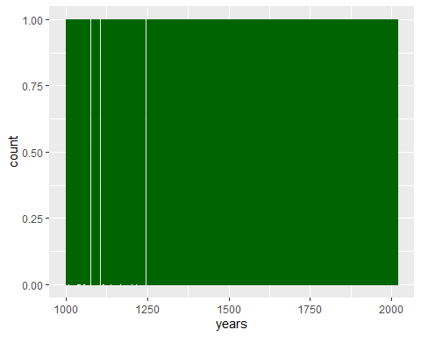

ggplot(years2, aes(x = years)) +  
 stat_count(mapping = aes(x = years))

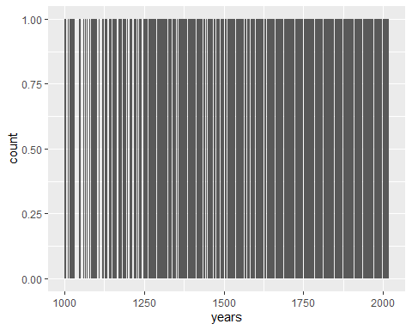

ggplot(years2, aes(x = years, y = count)) +  
 geom_point()

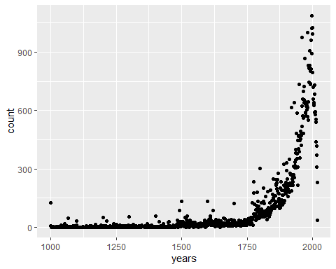

ggplot(years2, aes(x = years, y = count)) +  
 geom_col()

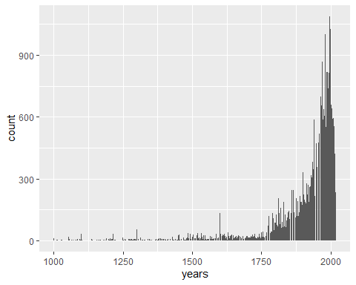

ggplot(years2, aes(x = years)) +  
 geom_histogram()

## `stat_bin()` using `bins = 30`. Pick better value with `binwidth`.

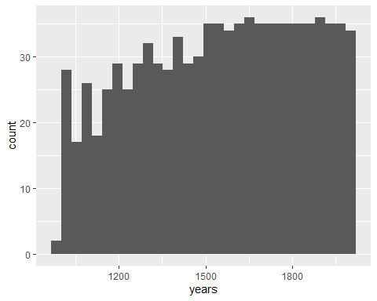

# Plots to use in Flex dashboard

# add two plots to flex dashboard - reference_plot and line_plot  
  
# add to flex dashboard  
library(ggthemes)  
reference_plot <-   
 ggplot(years2, aes(x = years, y = count)) +  
 geom_point()+  
 coord_cartesian(xlim = c(1800,2019))+  
 geom_vline(xintercept=1996,colour="blue")+  
 geom_text(aes(x=1996,label="1996",y=1087,vjust=0,hjust=0),  
 colour="black",  
 text=element_text(size=11))+  
 geom_text(x=1995,label=  
 "US Olympics",y=200,angle=90,vjust=0,hjust=0)+  
 geom_vline(xintercept=1861,colour="blue")+  
 geom_text(x=1860, label=  
 "American Civil War",y=350,angle=90,vjust=0,hjust=0)+  
 geom_vline(xintercept=1914,colour="blue")+  
 geom_text(x=1913,label="WWI",y=500,angle=90,vjust=0,hjust=0)+  
 geom_vline(xintercept=1939,colour="blue")+  
 geom_text(x=1938,label="WWII",y=500,angle=90,vjust=0,hjust=0)+  
 geom_vline(xintercept=1955,colour="blue")+  
 geom_text(x=1954,label="Vietnam",y=100,angle=90,vjust=0,hjust=0)+  
 geom_vline(xintercept=2005,colour="blue")+  
 geom_text(x=2004,label="911 Attacks",y=200,angle=90,vjust=0,hjust=0)+  
 geom_vline(xintercept=1963,colour="blue")+  
 geom_text(x=1962,label=  
 "JFK Assassination",y=100,angle=90,vjust=0,hjust=0)+  
 geom_vline(xintercept=1986,colour="blue")+  
 geom_text(x=1985,label=  
 "Challenger Disaster",y=175,angle=90,vjust=0,hjust=0)+  
 xlab("Years")+  
 ylab("Number of times year given in clue")+  
 ggtitle("Four digit years found in Jeopardy clues,Season 1-35",  
 subtitle = "Truncated from 1800-2019")+  
 theme_few()

## Warning: Ignoring unknown parameters: text

reference_plot

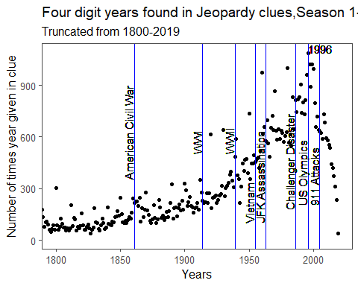

#library(plotly)  
#plot_ly(years2, type = "scatter", x = ~ years, y = ~count)  
  
# include this on flex dashboard  
line_plot <- ggplot(years2, aes(x = years, y = count)) +  
 geom_line() +  
 xlab("Years") +  
 ylab("Number of times year given in clue")+  
 ggtitle("Four digit years found in Jeopardy clues, Season 1-35") +  
 theme_few()  
  
line_plot

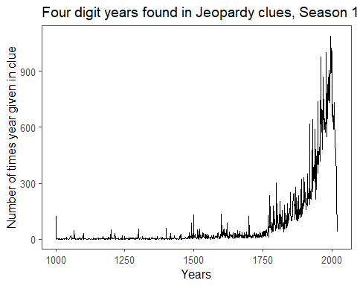

# pull out top 10 ranking years   
top_10 <- years_data1 %>%   
 slice(1:10)  
print(top_10)

## # A tibble: 10 x 2  
## years count  
## <chr> <int>  
## 1 1996 1087  
## 2 1999 1024  
## 3 1997 1023  
## 4 1980 999  
## 5 2000 994  
## 6 1960 975  
## 7 1995 961  
## 8 1990 906  
## 9 1998 891  
## 10 1970 868

#use in flex dashboard  
library(knitr)  
top_10_table <-   
 kable(top_10,   
 align = c("r","r"),  
 caption = "Top 10 most mentioned years")  
  
top_10_table

Top 10 most mentioned years

|  |  |
| --- | --- |
| years | count |
| 1996 | 1087 |
| 1999 | 1024 |
| 1997 | 1023 |
| 1980 | 999 |
| 2000 | 994 |
| 1960 | 975 |
| 1995 | 961 |
| 1990 | 906 |
| 1998 | 891 |
| 1970 | 868 |

# perform binom.test  
# use in flexdashboard  
sum_stats <- years2 %>%   
summarize(mean_count = mean(count))  
sum_stats

## mean_count  
## 1 92.88177

#proportion of answers that have years from total dataset  
mean_prop <-   
 nrow(years_data)/nrow(clues)  
print(mean_prop)

## [1] 0.2404123

prop_96 <-  
 1087/nrow(years_data)  
print(prop_96)

## [1] 0.01293155

library(broom)  
binom.test(x = 1087, n = nrow(years_data), p = 0.006) %>%   
 tidy()

## # A tibble: 1 x 8  
## estimate statistic p.value parameter conf.low conf.high method  
## <dbl> <dbl> <dbl> <dbl> <dbl> <dbl> <chr>   
## 1 0.0129 1087 1.14e-112 84058 0.0122 0.0137 Exact~  
## # ... with 1 more variable: alternative <chr>