R Homework 5

Matthew Hughes

November 11, 2019

cities <- read_csv("../data/homicide-data.csv")

## Parsed with column specification:  
## cols(  
## uid = col_character(),  
## reported_date = col_double(),  
## victim_last = col_character(),  
## victim_first = col_character(),  
## victim_race = col_character(),  
## victim_age = col_character(),  
## victim_sex = col_character(),  
## city = col_character(),  
## state = col_character(),  
## lat = col_double(),  
## lon = col_double(),  
## disposition = col_character()  
## )

denver <- cities %>%   
 filter(city == "Denver") %>%   
 select(lat, lon, disposition, victim_race)  
denver

## # A tibble: 312 x 4  
## lat lon disposition victim_race  
## <dbl> <dbl> <chr> <chr>   
## 1 39.7 -105. Closed without arrest White   
## 2 39.7 -105. Closed by arrest Hispanic   
## 3 39.8 -105. Closed by arrest Other   
## 4 39.8 -105. Open/No arrest Black   
## 5 39.8 -105. Open/No arrest Black   
## 6 39.7 -105. Closed by arrest Hispanic   
## 7 39.6 -105. Closed without arrest White   
## 8 39.7 -105. Closed without arrest Hispanic   
## 9 39.7 -105. Closed by arrest Asian   
## 10 39.7 -105. Closed by arrest White   
## # ... with 302 more rows

denver <- denver %>%   
 group_by(victim_race) %>%   
 mutate(count = n()) %>% #This function counted the number of homicides per race.  
 arrange(desc(count)) %>% #This showed the race with the highest number of homicides on top.   
 ungroup() %>% #Ungrouping keeps the data clean.   
 filter(victim_race == c("Black", "White", "Hispanic"))   
denver

## # A tibble: 100 x 5  
## lat lon disposition victim_race count  
## <dbl> <dbl> <chr> <chr> <int>  
## 1 39.8 -105. Open/No arrest Black 113  
## 2 39.8 -105. Closed by arrest Black 113  
## 3 39.8 -105. Open/No arrest Black 113  
## 4 39.7 -105. Open/No arrest Black 113  
## 5 39.8 -105. Closed by arrest Black 113  
## 6 39.7 -105. Closed without arrest Black 113  
## 7 39.8 -105. Closed by arrest Black 113  
## 8 39.8 -105. Closed by arrest Black 113  
## 9 39.8 -105. Open/No arrest Black 113  
## 10 39.8 -105. Closed without arrest Black 113  
## # ... with 90 more rows

denver_crs <- denver %>%   
 filter(!is.na(lat)) %>%   
 st_as_sf(coords = c("lon", "lat")) %>%   
 st_set_crs(4269)

denver_zip <- zctas(cb = TRUE, starts_with = "802",   
 class = "sf")  
plot(denver_zip)

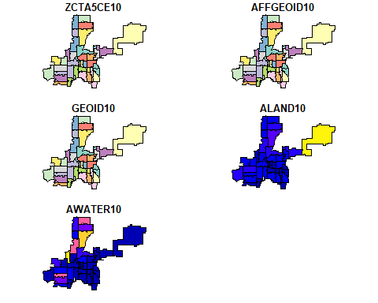

#Separating the homicides into unsolved and solved.   
denver_disp <- denver_crs %>%   
 mutate(disposition = factor(disposition, levels = c("Closed without arrest",  
 "Closed by arrest",   
 "Open/No arrest"),  
 labels = c("unsolved", "unsolved", "solved")))  
denver_disp

## Simple feature collection with 100 features and 3 fields  
## geometry type: POINT  
## dimension: XY  
## bbox: xmin: -105.0603 ymin: 39.63327 xmax: -104.7514 ymax: 39.79665  
## epsg (SRID): 4269  
## proj4string: +proj=longlat +ellps=GRS80 +towgs84=0,0,0,0,0,0,0 +no_defs  
## # A tibble: 100 x 4  
## disposition victim_race count geometry  
## * <fct> <chr> <int> <POINT [°]>  
## 1 solved Black 113 (-104.9499 39.76179)  
## 2 unsolved Black 113 (-104.9309 39.75934)  
## 3 solved Black 113 (-104.9592 39.76442)  
## 4 solved Black 113 (-104.9108 39.73973)  
## 5 unsolved Black 113 (-104.8104 39.77525)  
## 6 unsolved Black 113 (-104.9003 39.6991)  
## 7 unsolved Black 113 (-104.9645 39.76563)  
## 8 unsolved Black 113 (-104.9915 39.75154)  
## 9 solved Black 113 (-104.9256 39.76356)  
## 10 unsolved Black 113 (-104.9887 39.755)  
## # ... with 90 more rows

denver_map <- ggplot() +   
 geom_sf(data = denver_zip, color = "lightgray") +   
 geom_sf(data = denver_disp, aes(color = factor(victim_race)), show.legend = 'point')+  
 facet_wrap(~disposition, ncol = 1)+  
 ggtitle("Homicide cases in Denver, CO", subtitle = "(By Zipcode)")+  
 labs(x = "Longitude", "Latitude")+  
 theme(axis.text.x = element_text(angle = 90, hjust = 1))+  
 labs(colour = "Victim Race")   
denver_map

