SIMPLE User Guide
SIMPLE Platform version 2.5

September 2012

Introduction
This document walks you through the SIMPLE software.

Logging In
Before you can access any simulations you must first log in to the Platform.
- Open the SIMPLE platform URL for your institution
- Enter your username and password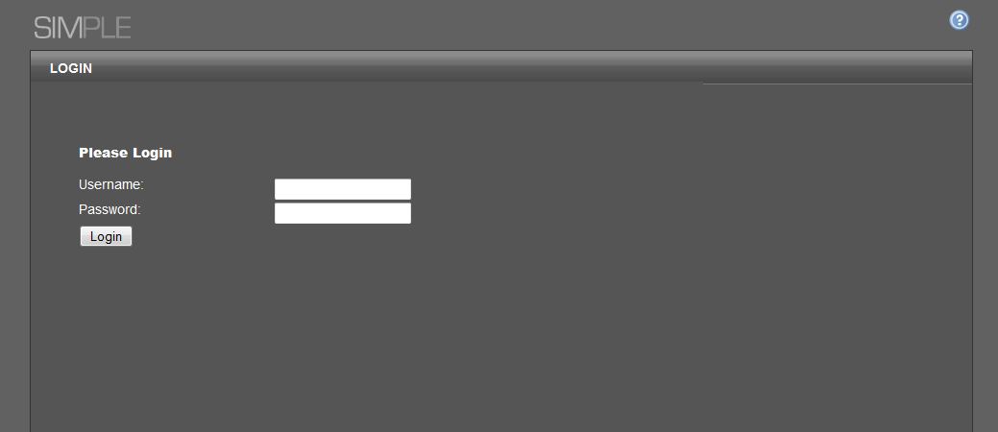
- Click Login.
If you have entered a valid username & password you will be logged in and taken to your personal Dashboard page. This contains a news feed, which may contain course information or system updates, as well as a list of all simulations you have permissions for. There may also be other widgets.
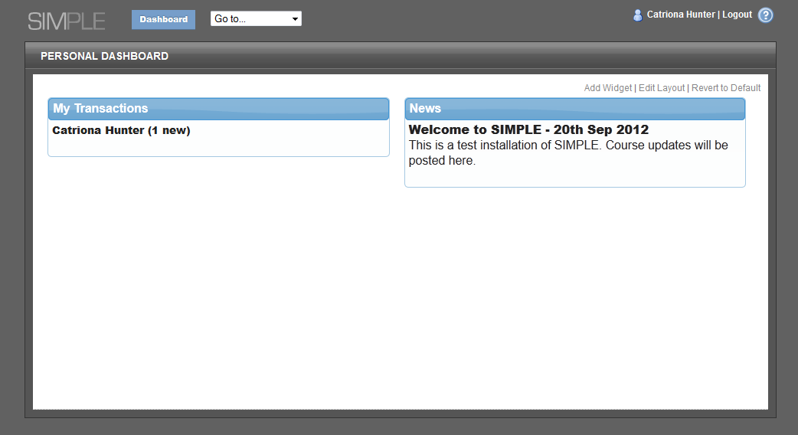
Any simulations which have unread items will be in bold, and will have the amount of unread items in brackets next to the simulation name. (This number includes all items that have been received, sent, or uploaded).
Your name is displayed at the top-right of the screen. Clicking this will take you to the Edit Profile page, where you can change your password and edit details such as your email address and avatar.
There is as a dropdown list of your simulations at the top of the screen. This allows you to switch between simulations at any time.

The Office Environment
When you access a Simulation you are automatically placed in the Office Environment looking at the Received correspondence folder. This folder contains all of the documents that you have received arrange in reverse-chronological order (i.e. newest items are at the top).
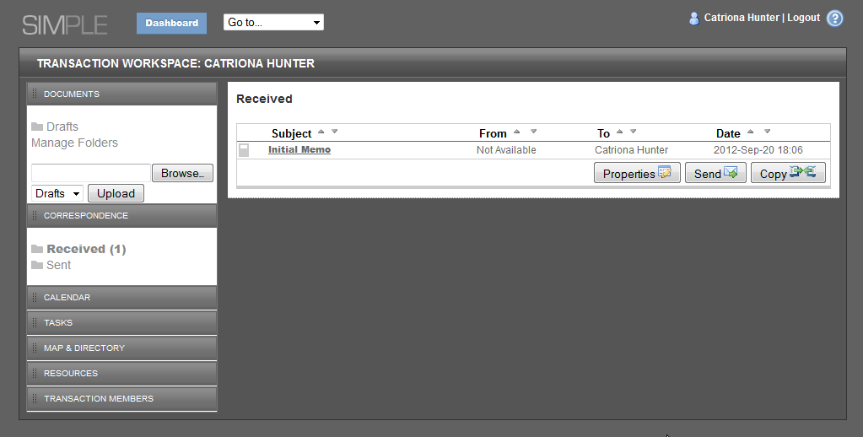
The Sent correspondence folder is similar, but contains the documents that you have sent.
The Documents box in the left hand sidebar of the Office Environment allows you to switch folders, and manage (i.e. create and delete) your own Folders. There is also a handy upload function, to quickly upload documents to your folders.

Calendar & Tasks
The Calendar and Tasks side bars allow you to access the time management features of the Office Environment. Here you can create appointments in the Calendar and allocate tasks.
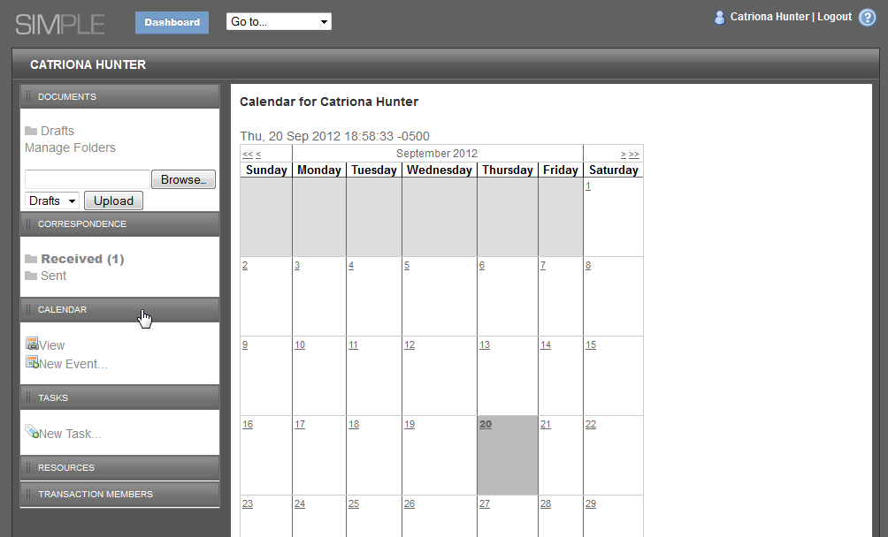

Map & Directory
The Map is a graphical view of the area in which a Simulation is taking place. From here you can see the locations of the institutions and businesses that you may have to deal with in the Simulation.
You can zoom in and out of the map to reveal more information. Clicking on a marker will display additional information about the target (e.g. the website of an organisation that you need to get some information from).
To return to the Office Environment from the Map either, click on the Back link below the Map.

The Directory serves as a “phone book” of all the characters in a Simulation and displays contact details for each one.
Note: Not all of the people you will interact with will appear in the Directory, you may only be introduced to them over the course of the Simulation.
To return to the Office Environment from the Directory, click on the Back link.

Resources
The Resources sidebar shows all of the resources that are available for you to use in the Simulation. Resources may contain template documents that can be saved to your desktop, and then edited and uploaded to your folders. It may also contain reference material or hyperlinks to websites to help in your research.
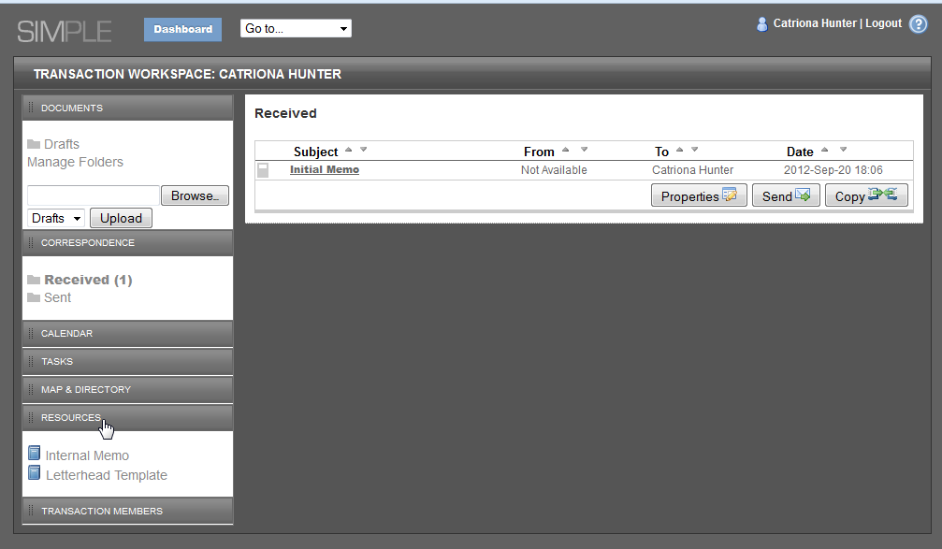

Members
The last box in the sidebar displays a list of members of the Simulation (e.g. the names of the other people in your group or “firm”). Clicking on a name leads to a public profile page for that user.
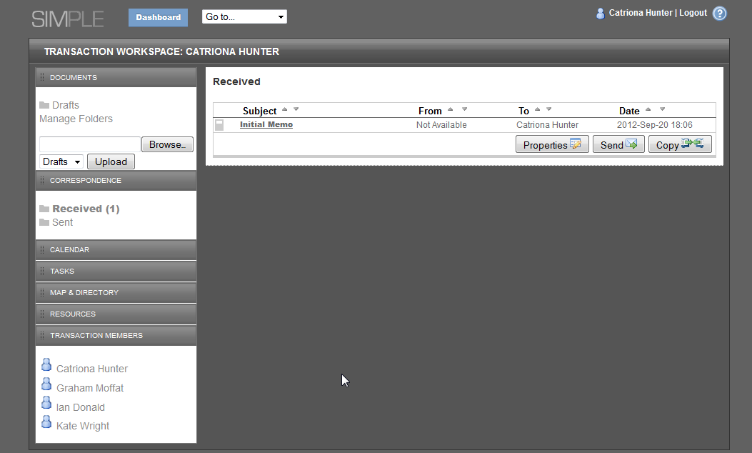

Using the Office Environment
Over the course of a Simulation new items will appear in your Received folder. These documents will provide you with the information you need to know, or replies to your correspondence.

Writing Documents
All of the documents that you write must be created “off-line” (e.g. a letter must be written in a word processor like Microsoft Word).
When you have completed and saved a document and want to make it available to other members of the Simulation, or to send it to another character you must upload the document to the Platform.

Uploading Documents
You can only upload documents to Folders that you (or other members of the Simulation) have created or to the Drafts folder. Documents cannot be uploaded to the Sent or Received correspondence folders.
The quickest way to upload a document is to click the Browse button in the Documents panel, and select a document. Then choose a folder from the dropdown (or leave as Drafts), and click Upload. 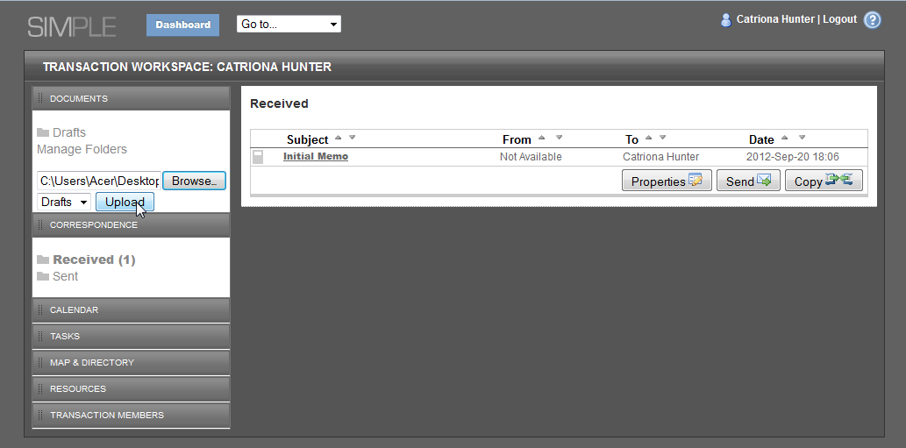

The view then switches to the folder with the uploaded document.
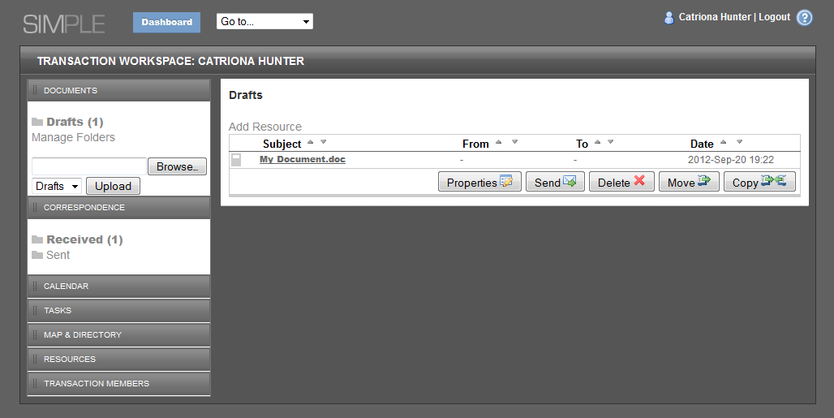

Note: iPad uploads work differently. See the iPad-specific instructions for how to upload a document.

Reading a Document
To read a document, you must first download it to your computer.
- Open a Folder
- Click on the Document’s Name (the Subject column).
- Save the document to your computer.
- Locate the downloaded file and open it.

Making Changes to a Document
To make a change to a document you must first download the document (See Reading a Document).
- Open the document that you wish to make changes to
- Save your changes on your computer.
- Open the folder which contains the original document you have now changed.
- Click on the “Properties” icon:
- The Document’s Properties window appears.
- Click on Browse… and select the document you have changed on your computer.
- Click on Save.

Once the document has been uploaded you will be taken to the Folder that it located in.

Sending Documents
- Open the folder containing the Document you want to send.
- Click on the Send Icon.
- The Send Document dialog appears
- Select a Recipient from the directory list displayed or type an address in the To: field.
- Click Send to send or Cancel if you no longer wish to send the document.
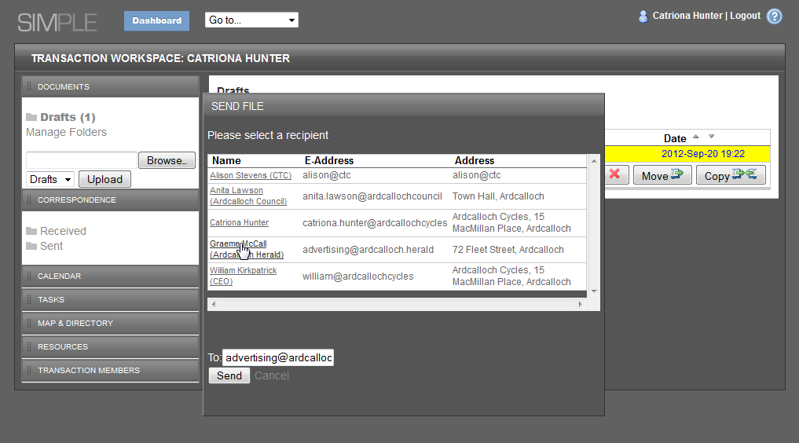
Note: Every time you send a document a read-only copy of the item sent is kept in the Sent folder.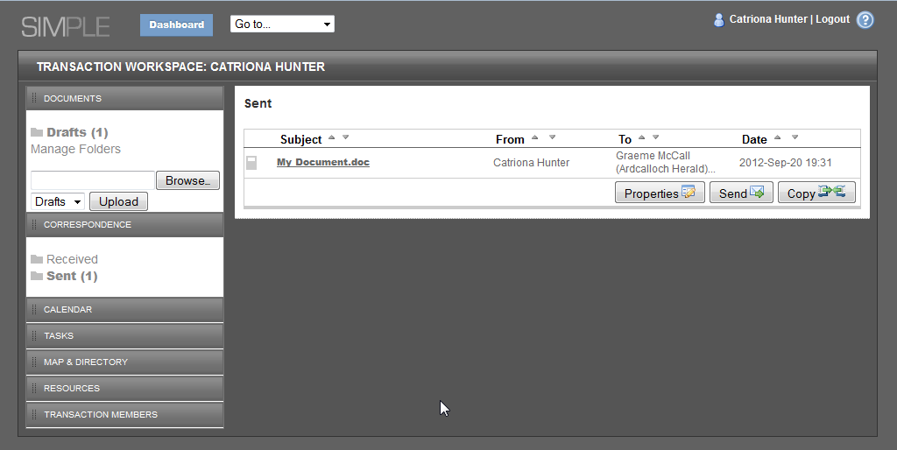

Folder Management
Every Simulation contains a number of Folders in which files are saved.
Note: This feature may be disabled by the Simulation’s Author.
The Drafts folder is the default location for you to upload your files.
There may be additional folders, depending on the Simulation and you may create additional folders to help you organise your work (providing the Simulation creator has allowed this).

Adding New Folders
- Select a Simulation and open the Office Environment.
- Click on the Manage Folders link in the Folders side bar.
- The Folder Manager appears:
- Type a folder name,
- Click Add
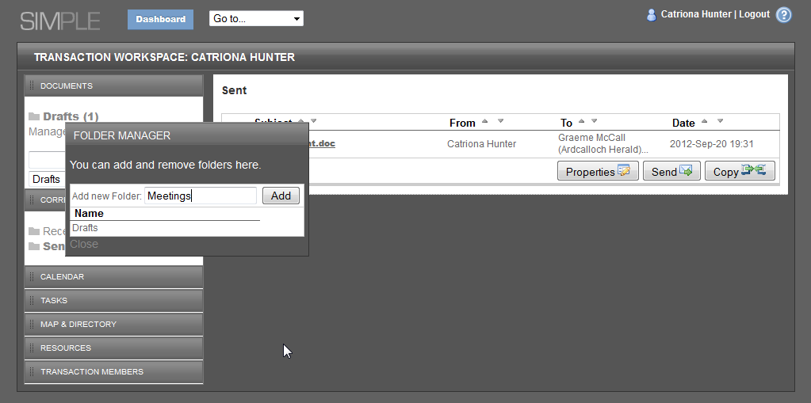
Any folders that you create will allow you to add and remove items from them.
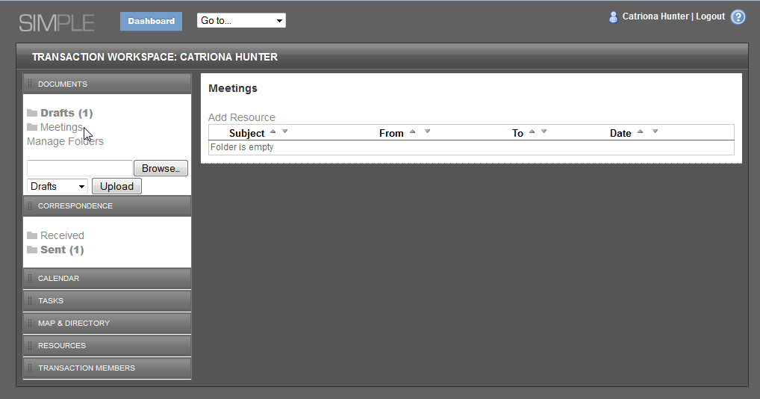

Renaming or Deleting Folders
- Select a Simulation and open the Office Environment.
- Click on the Manage Folders link in the Folders side bar.
- The Folder Manager appears:
- Change appropriate folder name and click Save or click Delete (next to the appropriate folder) to remove it.
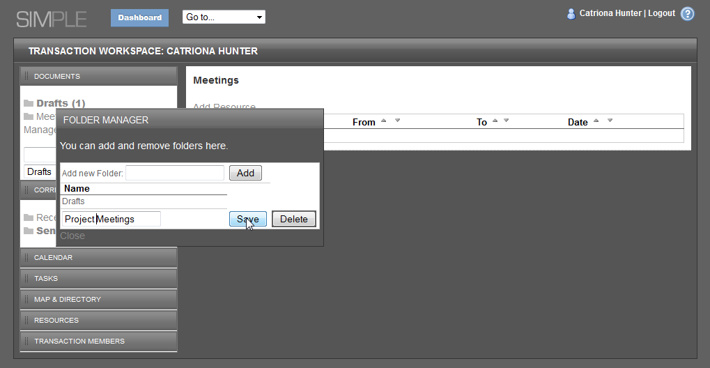

Time Management
The Office Environment provides a calendar to allow you to organise your time.
Note: These features may be disabled by a Simulation’s Author

Adding a New Event
- Click on New Event in the Calendar area in the side bar.
- Enter a Subject,
- Enter a Location
- Enter a Description
- 5. Enter a start date & time (or click on to choose the date)
- 6. Enter an end date & time (or click on to choose the date)
- (Optional) Select a date & time to be reminded at
- (Optional) Enter a reminder message.
- Click Save to save the event or Close to cancel.
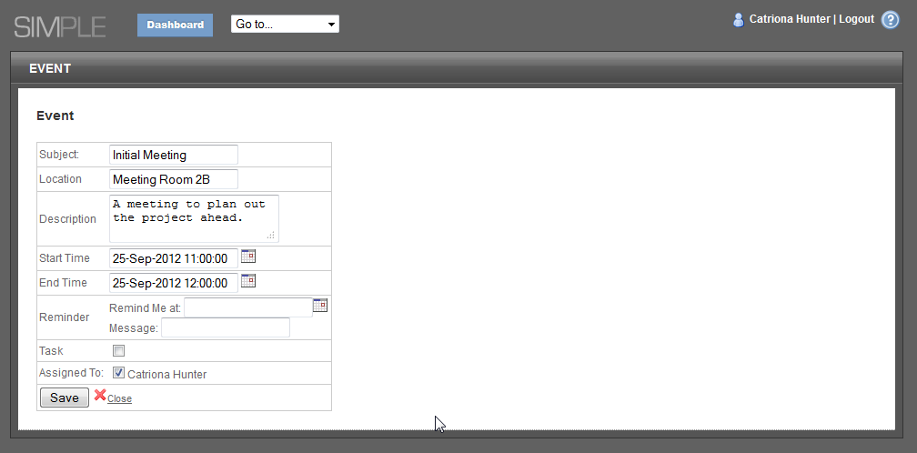

Adding a New Task
A task is a special version of an event, which can be assigned to members of the Simulation.
- Click on New Task in the Tasks area of the side bar.
- Enter a Subject
- Enter a Location
- Enter a Description
- Enter a start date & time (or click on to choose the date)
- Enter an end date & time (or click on to choose the date)
- (Optional) Select a date & time to be reminded at
- (Optional) Enter a reminder message.
- Select a user to assign the task to.
- Click Save to save the event or Close to cancel.

Marking a Task Complete
- Open the Task
- Click on the Completed check box.
- Click Save.

Changing a Task or Event
- Open the Task or Event you want to change.
- Click on the Edit link
- Make the changes to the topic
- Click on Save to save the changes.

